BHARAT INSTITUTE OF ENGINEERING AND TECHNOLOGY

THERMAL NOTES

3RD SEM

Er.SATYANARAYN PRADHAN
- Performance of Ic engine
  - Mechanical Efficiency:
Mechanical efficiency is defined as the ratio of brake power (delivered power) to the indicated power (power provided to the piston)
Mathematically
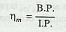

Indicated thermal efficiency:
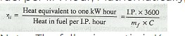
It is the ratio of the heat equivalent to one kW hour to the heat in the fuel per I.P. hour, Mathematically, indicated thermal efficiency,

Relative efficiency:
Relative efficiency is also known as efficiency ratio. The relative efficiency of an I. C. engine is the ratio of the indicated thermal efficiency to the air standard efficiency.
Brake thermal efficiency:
It is the ratio of the heat equivalent to one kW hour to the heat in the fuel per B.P. hour. Mathematically, brake thermal efficiency,
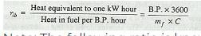

Overall efficiency:

It is the ratio of the work obtained at the crankshaft in a given time to the energy supplied by the fuel during the same time. Mathematically, overall efficiency,
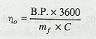
B.P. = Brake power in kW,
mf = Mass of fuel consumed in kg per hour, and C = Calorific valve of fuel in kJ / kg of fuel.
Mean effective pressure:
The mean effective pressure (MEP) is a quantity relating to the operation of a reciprocating engine and is a measure of an engine's capacity to do work that is independent of engine displacement.
Mathematically MEP= Work done/ Swept volume

Specific fuel consumption:

- The fuel consumption characterstics of an engine generally expressed in terms of specific fuel consumption per Kw-hr
- It is an important parameter that reflects how good the engine performance is.
- It is inversely proportional to the thermal efficiency of the engine.
- The brake-specific fuel consumption(bsfc) and indicated-specific fuel consumption(isfc) is the specific fuel consumption on the basis of brake power(bp) and indicated power (ip) respectively.

  - Air–fuel ratio :
Air-fuel ratio is commonly used in the gas turbine industry as well as in government studies of internal combustion engine, and refers to the ratio of air to the fuel.
Internal combustion engines burn fuel to create kinetic energy. The burning of fuel is basically the reaction of fuel with oxygen in the air. The amount of oxygen present in the cylinder is the limiting factor for the amount of fuel that can be burnt. If there’s too much fuel present, not all fuel will be burnt and un-burnt fuel will be pushed out through the exhaust valve.

The carburettor controls the fuel/air mixture on a motorbike, and you often hear ‘lean’ and ‘rich’ being used to describe the fuel/air mixture. Let’s look at what effect this ratio has on the engine.
Firstly, there’s a theoretically optimal fuel/air mixture. This is called the stoichiometric mass/volume and it tells you how much air (ie. oxygen) you need to completely burn an amount of fuel. If you have less air than this, the mixture is rich. If you have too much air, the mixture is lean. You can look at it in terms of fuel. Too much fuel gives a rich mixture, too little gives a lean mixture.

For Example:
15.0:1 = Lean
14.7:1 = Stoichiometric
13.0:1 = Rich

The stoichiometric mass is related to the carbon/hydrogren ratio in your fuel. This makes sense, since each carbon atom needs two oxygen atoms to make CO2, and each hydrogren needs on average half an oxygen atom. So you can presumably just add up the number of carbon and hydrogen atoms and do a bit of maths to work out how many oxygen atoms you’re going to need.

If you have the ‘perfect’ amount of oxygen for your petrol you can expect to get about 45 mega-joules of energy for every kilogram of petrol you’ve got. However, engines aren’t perfectly efficient. For a start, to get the maximum amount of work out of the explosion, you’d have to let the gases expand until they’ve cooled down to the surrounding air temperature (look up Carnot cycles somewhere). In a real engine, the gases only get to expand as long as the piston is moving down. When the exhaust port opens, and the piston moves up to put the exhaust gases out, the gases are still hot. That’s why the exhaust pipe gets hot!

Calorific value of fuel:
Calorific value is defined as the amount of heat energy released during complete combustion of a unit mass of a fuel. It is expressed in kJ/kg.

Gross calorific value (GCV) or Higher Heating Value (HCV) is the amount of heat released by the complete combustion of a unit of fuel. It assumes all water vapour produced during combustion process is fully condensed.
Net Calorific Value (NCV) or lower heating value (LHV) or lower calorific value (LCV) is determined by subtracting the heat of vaporization of the water vapour from the higher heating value. It assumes water vapour leaves with the combustion products without fully being condensed. Fuel should be purchased based on NCV.

1.2 Work out problems to determine efficiencies and specific fuel consumption:
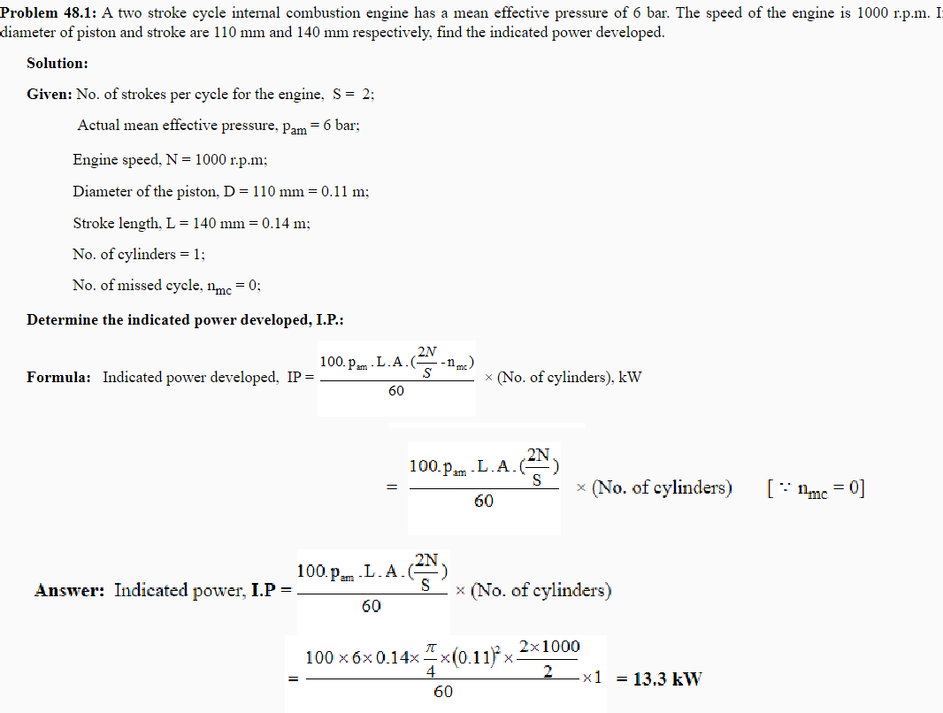

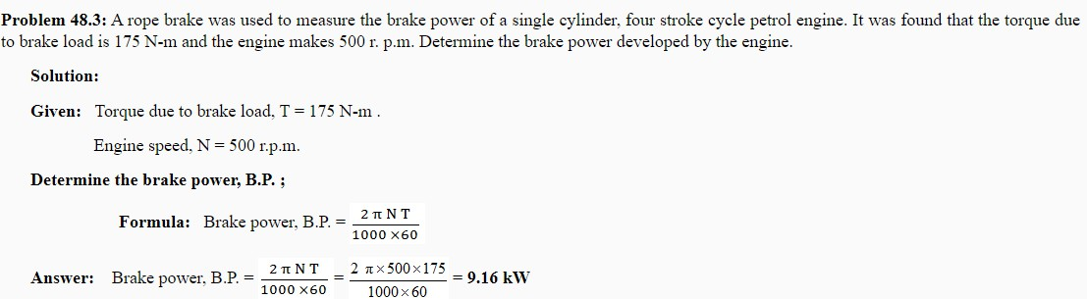

Questions for exercise/assignment:
Short questions
- Define Mechanical efficiency?
- Define indicated power?
- Define brake power?
- Define specific fuel consumption?
- Define Air fuel ratio?
Long questions
- Write short notes on Air-fuel ratio?
- Find out mechanical efficiency and frictional power of four stroke petrol engine with IP 60 KW AND BP 25 kw?

References:
  - https://learnmech.com/what-is-air-fuel-fuel-air-ratio-ric/
  - https://www.energypurse.com/calorific-value-of-fuel-and-its-calculation/
  - http://ecoursesonline.iasri.res.in/mod/page/view.php?id=2464
  - https://www.aboutmech.com/2016/01/efficiency-of-ic-engine.html

- Air compressor
  - Functions of air compressor and its industrial uses:
All air compressors perform the same basic function — they increase the pressure and reduce the volume of a gas, like air.

Compressed air is used for:
- Packing and palleting products.
- Closing and checking devices.
- Filling equipment for drinks.
- Cooling and freezing products.

Compressors are used throughout industry to provide shop or instrument air; to power air tools, paint sprayers, and abrasive blast equipment; to phase shift refrigerants for air conditioning and refrigeration; to propel gas through pipelines; etc

  - Classifications of air compressor
Following are the types of air compressors:
    - Reciprocating air compressor
    - Rotary air compressor
    - Centrifugal air compressor
    - Axial air compressor
  - Describe parts and working principle of reciprocating air compressor:
A reciprocating air compressor is a type of positive displacement compressor that uses a piston. The piston is driven by the crankshaft to transfer the high-pressure gases into the cylinder.
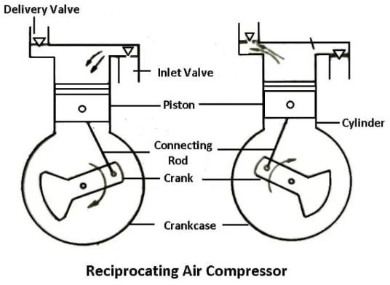

In these types of air compressors, initially, the gas enters from the suction manifold. This gas is flowing through a compression cylinder where it gets compressed by an attached piston. It is driven in a reciprocating motion by the application of a crankshaft, and it is released.
A typical reciprocating compressor is commonly used in automotive industries to generate 5 to 30 horsepower. A large type of reciprocating compressor creates up to 1000 horsepower that equals 750 KW, and it is used in the large petroleum iWhen compared to a regular diaphragm compressor, it has a longer lifespan and requires quiet maintenance because of continuous use. A reciprocating compressor is used in gas pipelines, chemical plants, air conditioning, and refrigeration plants.ndustry.

  - Terminology of air compressor:

Bore: bore is the diameter of the circular opening at its end
Stoke length: The stroke length is how far the piston travels in the cylinder
FAD stands for Free Air Delivery, and this is the volume of compressed air that an air compressor will actually discharge as a result of the compression process. CFM (FAD) is typically a third less than CFM (Displacement)
Vometric efficiency:
The volumetric efficiency represents the efficiency of a compressor cylinder to compress gas. It may be defined as the ratio of the volume of gas actually delivered to the piston displacement, corrected to suction temperature and pressure

  - Derive the work done for single stage and two stage compressor with or without clearance volume:
The working of reciprocating compressor includes three operations, suction, compression, and discharge of compressed fluid. thus there are three work is included in a cycle of reciprocating compressor, work of piston during the suction of fluid/ refrigerant, work of piston during the compression of fluid as well as work during the discharge of compressed fluid. Mathematically the work done by the reciprocating compressor is equal to the work done by compressor during compression and discharge minus the work done during the suction fluid.
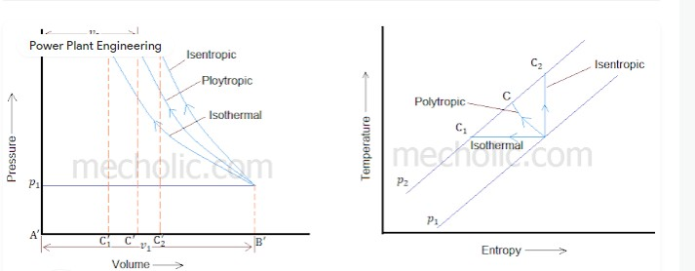

Consider a single stage, single acting reciprocating compressor without clearance volume. The following figure shows the PV and TS diagram of this compressor. The compression process may be isentropic, polytropic, or isothermal

Let p1= Suction pressure (pressure before compression) v1 = Suction volume
T1= Suction temperature
p2, v2, T2 are the corresponding pressure, volume, and temperature after compression. r is compression ratio (p1/p2)
Work done during isothermal compression
The line AB represents suction of fluid, area under AB (ie ABB'A') represent work done during the suction process

W1= p1 v1

BC1 represent compression of fluid when piston moving from bottom dead center to top dead center. When the pressure inside the cylinder reaches p2, the discharge valve opens. Further movement piston towards the

top dead center cause the compressed air to discharge. C1D represent discharging of fluid.

Work done during compression is W2 = Area of BC1C1'B'
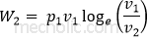

Work done during discharge W3= Area C1DA'C1' W3= p2v2
Work done by the compressor during the one complete cycle of operation is equal to W= W3+W2-W1
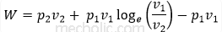

Since p1v1 = p2v2
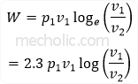

But p1v1 = mRT1 and
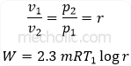

Work done during polytropic compression (PV^{n} = constant)
The work done during the compression is equal to area under BCC'B'
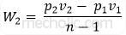

Work done W= W3+W2-W1
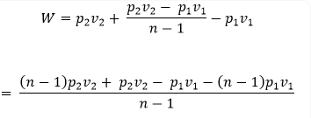
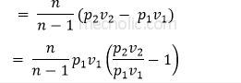

For polytropic compression p v n = p v n, n is ploytropic index
1 1 2 2
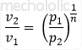

Put the value of v2/v1 in equation of work done
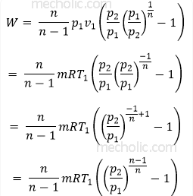
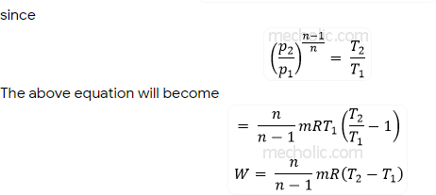

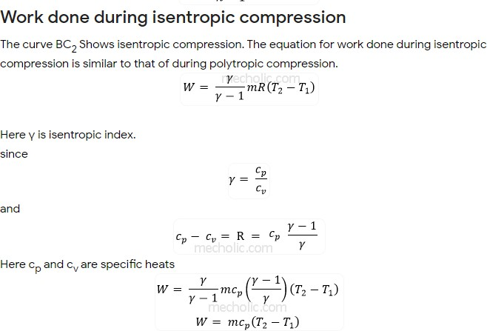

Derive the work done for two stage compressor with or without clearance volume:

Thermodynamic Analysis of Reciprocating Compressor

Compression of air in compressor may be carried out in three different ways of thermodynamic processes such as isothermal compression, polytropic compression or adiabatic compression. Figure (2) shows the thermodynamic cycle involved in compression. Clearance volume is provided in reciprocating compressor. Purpose of clearance volume in cylinder is twofold. One is to accommodate valve mechanism and anotherone is to prevent collision of piston with cylinder head.

On p-V diagram process 4–1 shows the suction process followed by compression during 1–2, discharge process 2–3 and expansion of clearane air 3-4 (if clearance volume is provided).
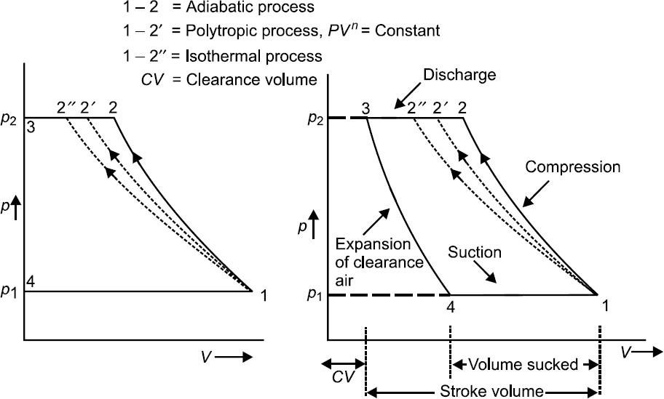

(a) (b)
Fig. (2) Compression cycle on p-V diagram (a) without clearance volume (b) with clearance volume
Air enters compressor at pressure 𝑝1and is compressed up to 𝑝2. Compression work requirement can be estimated from the area bounded by the curves comprising the cycle. Area on p–V diagram shows that work requirement shall be minimum with isothermal process 1 − 2′′. Work requirement is maximum with process 1–2 i.e. adiabatic process. As an engineer one shall attempt to minimise the requirement of compression-work. Therefore, ideally compression should occur isothermally for minimum work input. In practice, it is not possible to realise isothermal compression. Reason is maintaining constant temperature during compression is very difficult. Generally, compressors run at substantially high speed while isothermal compression requires compressor to run at very slow speed so that heat produced during compression is dissipated out and temperature remains constant. High running speed of compressor lead

compression process near to adiabatic or polytropic process. It is thus obvious that actual compression process should be compared with isothermal compression process. A mathematical parameter called isothermal efficiency is defined for quantifying the degree of deviation of actual compression process (adiabatic or polytropic process) from ideal compression process (isothermal compression process). Isothermal efficiency is defined as the ratio of isothermal work to actual indicated work in reciprocating compressor.

𝐼𝑠𝑜𝑡ℎ𝑒𝑟𝑚𝑎𝑙 𝐸𝑓𝑓𝑖𝑐𝑖𝑒𝑛𝑐𝑦 =
𝐼𝑠𝑜𝑡ℎ𝑒𝑟𝑚𝑎𝑙 𝑊𝑜𝑟𝑘

𝐴𝑐𝑡𝑢𝑎𝑙 𝐼𝑛𝑑𝑖𝑐𝑎𝑡𝑒𝑑 𝑊𝑜𝑟𝑘

Compression process following three different processes is also shown on T-s diagram in Fig. (3).
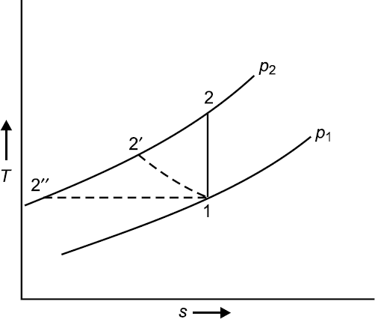

Fig. (3) Compression process on T-S diagram.
Compression Work, 𝑾𝑪 (without clearance volume)- Assuming compression process follow
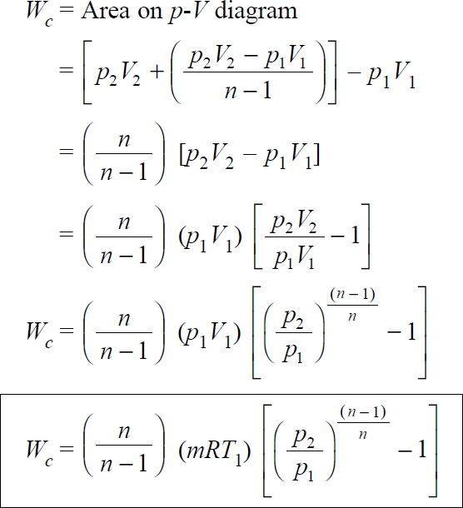

polytropic process i.e. 𝑝𝑉𝑛 = 𝐶

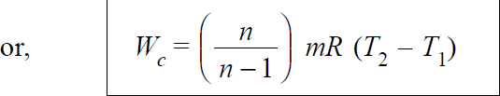

In case of compressor having isothermal compression process, n=1 i.e. 𝑝1𝑉1 = 𝑝2𝑉2

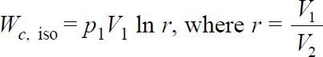
In case, compressor follow adiabatic compression process, 𝑛 = 𝛾
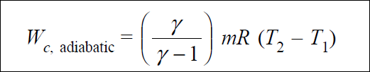

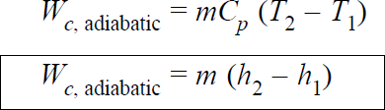
Or,

Hence isothermal efficiency
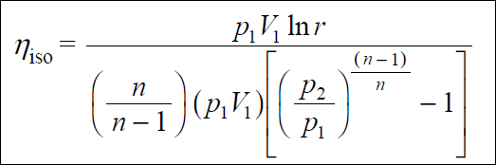

As an engineer one should attempt to design a compressor which efficiency approaches 100%, thereby meaning that actual work of compression should approach isothermal work of compression. This can beachieved by adopting following method

- Provide fins over the surface of cylinder. Fins facilitate quick heat transfer from air (which is being compressed) to atmosphere.
- Water jacket may be provided around compressor cylinder so that heat can be picked by cooling watercirculating through water jacket.
- Water may also be injected at the end of compression process in order to cool the air beingcompressed.
- In case of multistage compression in different compressors operating serially, the air leaving one compressor may be cooled up to ambient state or somewhat high temperature before being injectedinto subsequent compressor.
All these methods restrict the temperature rise during compression. Hence actual compression process approaches to isothermal compression.

Compression Work, 𝑾𝑪 (with clearance volume)- With clearance volume the cycle is represented on Fig.(2-b). The work done for compression of air polytropically can be given by the area enclosed in cycle 1–2–3– 4.

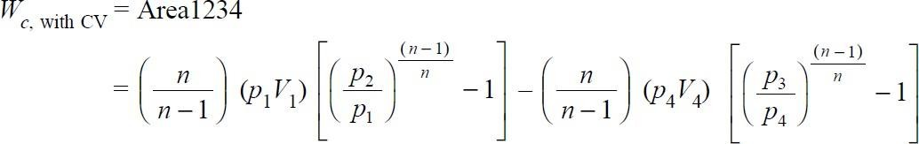
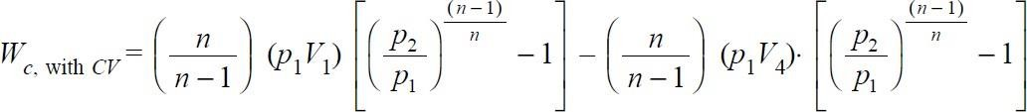

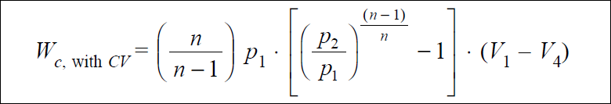

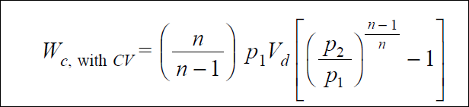

This (V1 – V4), say 𝑉𝑑, is actually the volume of air inhaled in the cycle and delivered subsequently.

Assuming air behaves as a perfect gas. Now temperature and pressure can be related as

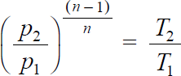
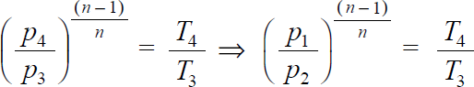
And

Substituting,
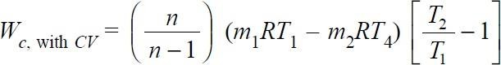
Ideally there shall be no change in temperature during suction and delivery i.e. 𝑇1 = 𝑇4 & 𝑇2 = 𝑇3. Above equation can be written as

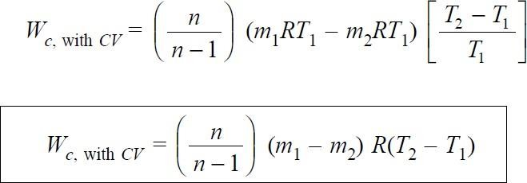
Or

Where (𝑚1 − 𝑚2) indicates the mass of air sucked or delivered. For unit mass of air delivered the work done per kg of air can be given as,

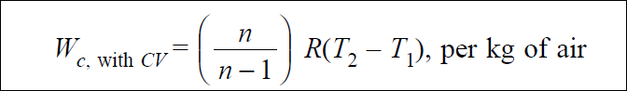

Thus from above expressions it is obvious that the clearance volume reduces the effective swept volume i.e. the mass of air handled but the work done per kg of air delivered remains unaffected.
Power required to run the compressor
For single acting compressor,
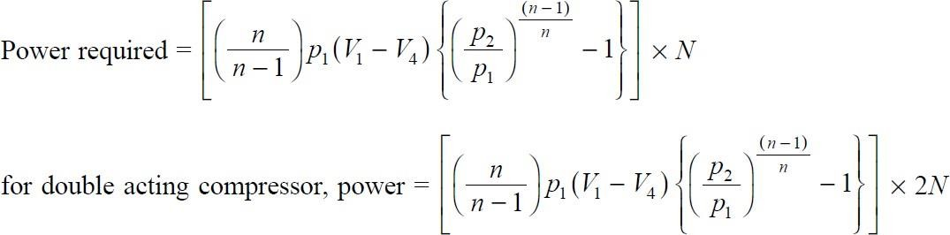

Questions for exercise/assignment:
  - Define FAD?
  - Define bore and stroke length of compressor?
  - Mention different industrial use of compressor?
  - Classify compressor?
  - Draw PV & TS diagram of single stage reciprocating compressor? Long questions
    - Derive work done of single stage reciprocating air compressor?
    - Derive work done of two stage reciprocating air compressor?

References:
- https://www.theengineerspost.com/types-of-air-compressors/
- https://www.mecholic.com/2019/03/work-done-by-reciprocating- compressor.html#:~:text=Mathematically%20the%20work%20done%20b y,during%20the%20suction%20of%20fluid.&text=p2%2C%20v2%2C%20T, volume%2C%20and%20temperature%20after%20compression.

- Properties of steam
  - Difference between gas and vapour:
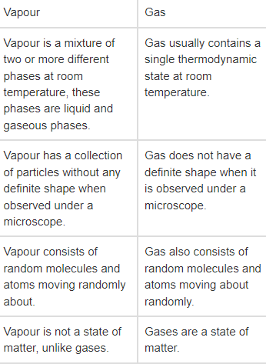
  - Formation of steam:

Generation of One Kg of Steam at a Given Pressure from Water Initially At 0°C:
Let us decide upon the pressure under which one kg of water is to be heated. After fixing the pressure we can know the saturation temperature for this pressure from steam tables and thus, water should be heated to this temperature before steam will be generated.
illustrates the three stages in the formation of steam, at some constant pressure, namely:

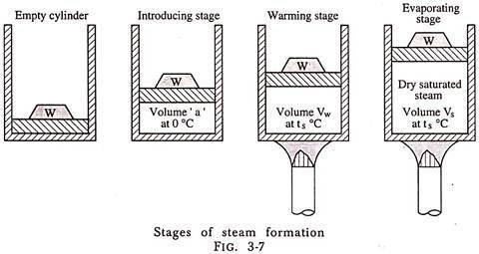
- Introducing Stage:
During this stage 1 kg of water at 0°C is pumped into the cylinder against an absolute pressure P, the pressure of steam generation. This pressure is caused by the weight placed on piston and pressure of atmosphere. The energy expended by the pump to deliver 1 kg of water of volume ‘a’ m³ at 0°C equals P × a (joules). This energy appears as pressure energy of the water in the cylinder and could be made to do work by virtue of its pressure.
- Warming Stage:
During this stage heat is added to the water so that its temperature from 0°C is raised to ts (the temperature at which steam will begin to form under absolute pressure P) and to
increase the volume of 1 kg of water from ‘a’ to vf, where vf is the volume of 1 kg of water at the temperature ts and absolute pressure P. The heat supplied during this warming stage is called Sensible Heat because it can be detected by the sense of touch and produces a rise in temperature (ts – 0)°C to be seen on a thermometer.
he sensible heat supplied in the warming stage is used for two purposes:
  - To increase the temperature of 1 kg of water from 0°C to ts. This heat is utilized for increasing the internal energy of water.
  - To do external work dw (vf – a) Joules in increasing the volume of water from ‘a’ to vf against the absolute pressure P which acts constantly on the piston.
By First Law of Thermodynamics as applied to non-flow process, heat supplied = change in internal energy + external work done by water.
∴ Sensible heat = hf — (uf – uo) + P (vf – a).
If the changes in internal energy are reckoned from 0°C, u0 will be zero and we get sensible heat-hf = uf + P (vf – a).

- Evaporating Stage:

During this stage further heat is supplied to 1 kg of water at tsat, the saturation temperature corresponding to the constant pressure P. The volume changes from vf to vg. During this stage heat is added at constant temperature and this heat is utilized in changing the state of water. The external work done during this stage = P (vg – vf).
Because the heat added during this stage cannot be recorded by a rise in temperature on the thermometer, it is called Latent Heat (hidden heat) or heat of vaporization i.e., hfg.

The latent heat is, therefore, used for two purposes:
  - To overcome the internal molecular resistance of the water by changing it from water into steam.
  - To force back the piston to increase the volume from that of water to that of steam.
By First Law of Thermodynamics as applied to non-flow process, heat supplied = change in internal energy + external work done.
∴ Heat of vaporization = hfg = (ug – uf) + P (vg – vf).
Thus, we see that energy is supplied in three stages to generate steam at a pressure P from water at 0°C.
  - Properties of Steam:
The properties of steam are interrelated. If we know certain properties, the other properties may be found out. For example, if the pressure of saturated steam is observed by the pressure gauge, its temperature can be found from steam tables in which the results of various experiments have been tabulated.
All other properties of a given mass of steam can be known when any two properties such as the pressure and dryness fraction of steam for saturated steam and pressure and degree of superheat for superheated steam are known.
If the steam is dry and saturated then only pressure should be known to determine all the properties. Thus, in order to observe the above two properties of steam, pressure gauges and steam calorimeters or thermometers are used at suitable points.

Dryness Fraction of Saturated Steam:
We have seen that steam in contact with water contains liquid particles in suspension. Thus, the steam consists of dry saturated steam and water particles in suspension. The dryness fraction of steam is defined as the ratio of the mass of dry steam in a certain quantity of steam to the mass of total wet steam. It is generally denoted by the letter x.
The dryness fraction of a wet steam may also be defined as the amount of dry steam in unit amount of wet steam.
If 1 kg of wet mercury vapour contains 0.12 kg of droplets of liquid mercury, it has a dryness fraction of (1 – 0.12) = 0.88.

Use of Steam Tables:
The values tabulated in the steam tables are determined accurately by experiments. These values form the basis for many calculations concerned with steam engineering. These tables are to be used because

vapours do not obey general gas law. The values given in the tables are for one kg of dry saturated steam but these values can also be employed for wet steam calculations.
In order to determine the properties of steam at some intermediate pressure between those given in tables, we interpolate assuming the linear relation between these values. The method is very simple and at the same time accurate.

Sensible Heat:
If is denoted by the letter hf in steam tables. It is the quantity of heat in kJ required to raise the temperature of 1 kg of water from 0°C to the saturation temperature at which water begins to boil at the given pressure P. The pressures are given in bar (10⁵ N/m²) absolute.
In changing water to steam under constant pressure, the temperature of water must be brought upto its boiling point at the given pressure before it can evaporate. Sometimes sensible heat is called the liquid heat or liquid enthalpy. Sensible heat of water hf may be found approximately by multiplying its specific heat by its saturation temperature.
Actually the specific heat of water is not constant but it increases with increase in the saturation temperature i.e., with increase in the pressure. The value of hf given in the steam tables accounts for the variation in the specific heat of water.
It is always, preferable to refer to the tables for accurate values. It should be noted that enthalpy values given in tables are not absolute values. These are simple changes in values from the reference state. It values of enthalpy will be positive and below the reference state values of enthalpy if given will be negative. A similar situation arises with temperature measurements. It should be noted that with vapours, other than steam, tables are prepared having their own reference states.

Latent Heat of Vaporization:
It is denoted by the letter hfg in steam tables. It is the quantity of heat required to convert 1 kg of water at saturation temperature for a given pressure to one kg of dry saturated steam, at that pressure. The value of latent heat of vaporization decreases as the pressure increases and it becomes zero when the critical pressure is reached.
The enthalpy of a vapour depends on how the vapour is heated. The enthalpy given in the tables is for heating at constant pressure.
Hsat = hg = hf + hfg.
Enthalpy of Steam:

Enthalpy of Wet Steam:
If the dryness fraction of steam is known, with the help of steam tables we can get the value of total heat for wet steam by the formula given below:
Hwet = hf + x hfg
where Hwet = enthalpy of 1 kg of wet steam hf = sensible heat of 1 kg of steam

x = dryness fraction of steam
and hfg = enthalpy of vaporization 1 kg of dry saturated steam.

Enthalpy of Superheated Steam:
From dry saturated condition a vapour receives superheat and its temperature rises above saturation temperature tsat. It has now entered the superheat phase. The enthalpy added during the superheat phase is the superheat enthalpy. The total enthalpy of superheated vapour will be the sum of the enthalpy of dry saturated vapour and the superheat enthalpy.

When steam is superheated, its temperature is known and when its pressure is known the enthalpy of 1 kg of steam can be obtained by the use of the formula given below:
Hsup = hf + hfg + Cp (tsup – tsat)
where Hsup = enthalpy of 1 kg of superheated steam hf = sensible heat of 1 kg of steam
hfg = enthalpy of vaporization 1 kg of dry saturated steam
Cp = mean specific heat of superheated steam at constant pressure tsup = temperature of superheated steam
and tsat = saturation temperature corresponding to the pressure of steam generation. Since we know that-
hg = hf + hfg
where hg is the enthalpy of one kg of dry saturated steam, the above formula can be written as Hsup = hg + Cp (tsup – tsat).
The difference (tsup – tsat) is called the degree of superheat, e.g., steam at a pressure of 10 bar has a saturation temperature of 179.9°C and if the temperature of steam is 200°C the degree of superheat is 200 – 179.9 = 20.1°C.
The value of mean specific heat of superheated steam Cp depends upon the degree of superheat and the pressure of steam generation. The average value of Cp for superheated steam is 2.0934 kJ/kg-K. The values of h for a given value of pressure P and temperature tsup.

  - Use of steam table and Mollier chart for unknown properties:
Steam Tables
Extensive properties at saturated liquid and saturated vapor state
In steam tables, extensive properties at saturated liquid and at saturated vapor for 1 kg of liquid/vapor are given as shown in Table 21.1(a) and Table 21.1(b). In Table 21.1(a) these properties are listed with reference to saturation temperature and in Table 21.1(b) with reference to saturation pressure.
Therefore, it is more convenient to use Table 21.1(a) when temperature is given and Table 21.1(b) when pressure is given. In both the tables, the values of specific volume (vf), enthalpy (hf), and entropy (sf) of water in saturated liquid state and values of specific volume (vg), enthalpy (hg), and entropy (sg) of steam in saturated vapor state are directly noted down. The values of internal energy (uf) of water in saturated liquid state and values of internal energy (ug) of steam in saturated vapor state are calculated by using following relations.
uf = hf - pvf and ug = hg – pvg

Extensive properties of wet steam i.e. in the liquid + vapor region
For wet steam, the values of specific volume (v), internal energy (u), enthalpy (h), and entropy (s) are calculated with the following relations.
v = x.vg + (1 -x).vf
or v = vf + x .vfg where vfg = vg – vf
For substances such as water, at pressures far below the critical point, the specific-volume (v) equations may often be simplified to
v = x.vg
because vf is very small in comparison to vg. This is not of course permissible when x is very small.
h = x.hg + (1 -x).hf = hf + x. hfg where hfg (Latent heat of evaporation) = (hg – hf)
u = h – p. v
s = x.sg + (1 -x).sf = sf + x .sfg where sfg = sg – sf
In the above equations, all the properties of water in saturated liquid state and steam in saturated vapor state are found as discussed in the previous section of “Extensive properties at saturated liquid and
saturated vapor state”.

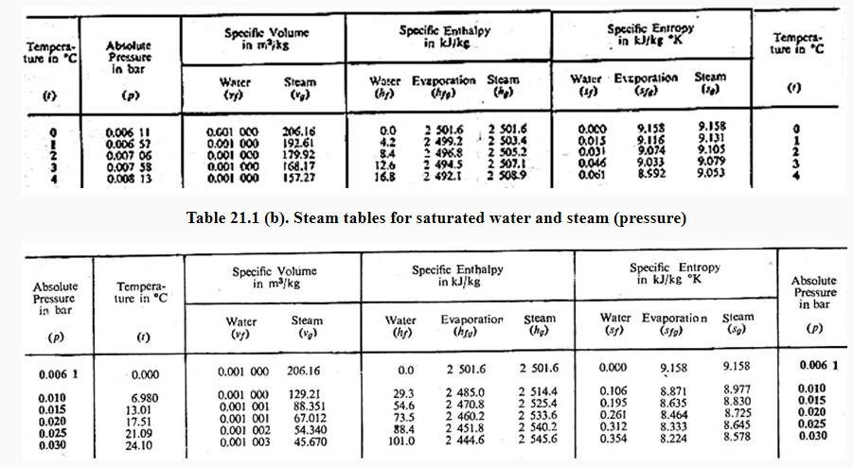
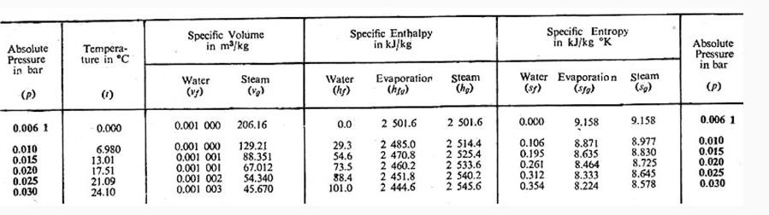
Extensive properties in superheated vapor state (vapor region)
The properties of superheated steam are given as shown in Table 21.2 (a, b, c) separately. They depend not only on pressure but also on the superheating temperature Tsup. The values of specific volume of superheated steam (vsup), enthalpy of superheated steam (hsup), and entropy of superheated steam (ssup) are directly noted down from Table 21.2 (a), Table 21.2 (b) and Table 21.2 (c), respectively. The values of internal energy of superheated steam (usup) is calculated by using the following relation.

usup = hsup – pvsup
Steam tables for saturated water and steam (temperature)

Steam tables for saturated water and steam (pressure)

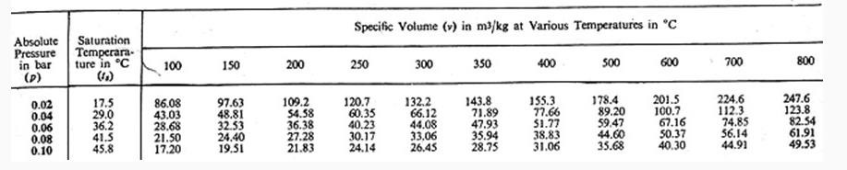
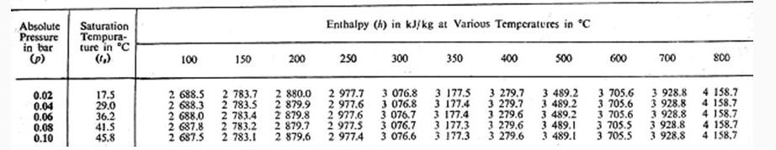
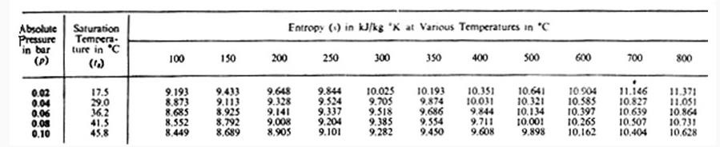
Steam tables for specific volume of superheated steam

Steam tables for enthalpy of superheated steam

Steam tables for entropy of superheated steam

Mollier or Enthalpy-Entropy (h-s) diagram:
The Mollier diagram is a is plot of enthalpy (h) versus entropy (s) as shown in Fig. It is also known as the h-s diagram. This diagram has a series of constant temperature lines, constant pressure lines, constant quality lines, and constant volume lines. The Mollier diagram is used only when quality is greater than 50% and for superheated steam. For any state, at least two properties should be known to determine the other unknown properties of steam at that state.
The commercially available Mollier diagram is truncated from a point beyond the critical point i.e. it shows only a portion of this diagram which is drawn in colors. In such truncated diagram property of liquid cannot be read.

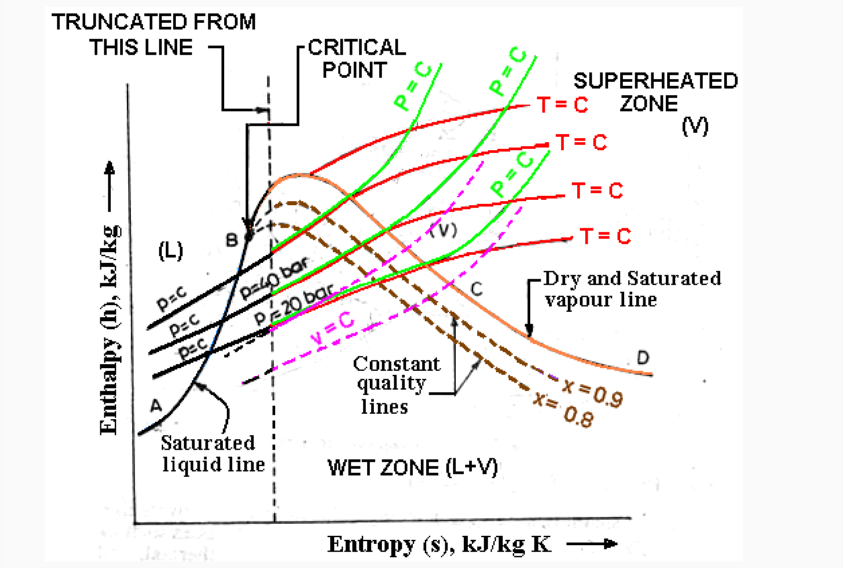

  - Flow and non flow processes of vapour :
The boundary of a non-flow process can be fixed, moving or imaginary.
These are compression and expansion processes on gases in a cylinder with complete leak proof. In these there is only energy transfer with zero mass transfer.
These non flow processes can be the followings:
- constant pressure process While heating at constant pressure dU = δq—p dv
In an isobaric compression, heat is stored in the form of enthalpy. ( note the use of δ and d in the equation).
δ is used with heat supplied or rejected
d for change in a quantity such as volume or internal energy
- constant volume process δq = dU since δW =0
During a iso-choric (Constant volume) process, work done is zero and the total energy changes into internal energy

- constant temperature process δq=δW since dU =0.
- reversible adiabatic process
During a reversible adiabatic process, there is no friction.
No heat is supplied or rejected. Therefore δW = dU since δQ=0 A process with no heat gain or heat loss is an adiabatic process.
- poly-tropic process
During a poly-tropic process, δQ =δW –work lost in friction
p V ^{n} = C is a mathematical form of a poly-tropic process in which no parameter is constant.
- constant internal energy process
When gravity, magnetic, electrical, motion and capillary effects are negligible. Then the total energy (E) is equal to the internal energy (U).

Flow Processes
Flow process is one in which there is energy and mass transfer across the boundary of the system. All flow systems are OPEN systems since energy and work cross their boundaries.
Following are the flow processes.

from inlet of compressor to its outlet in a refrigeration system

work Done in a poly-tropic compression (Open system) W=∫–v dp = n(p2v2–p1v1)/(n-1)
work Done in a poly-tropic compression (closed system)
W=∫p dv =(p2v2–p1v1)/(n-1)
Work done in an open system is n times the work done in a closed system

- Through a nozzle
- flow across a turbine
- Flow in a pipe
Flow processes are of two types. Steady Flow System
When properties are constant with respect to time it is called a steady flow systems. All the experimental data is recorded under steady flow conditions. Steady flow energy equation is a heat balance for the system.
Non Steady Flow System
When properties vary with respect to time it is called a non-steady flow systems. Nothing useful can be found under unsteady flow conditions.

  - Representation of PV, TS & HS diagram:
Constant Pressure Process:

    - p-v, T-s, and h-s Representation. Assume that steam undergoes a constant pressure heating process from its initial state to final state. Let the initial condition of steam be in the wet region as point 1 at pressure p1 having dryness fraction x1 and the final condition in the superheat region as point 2 at pressure p2 (= p1) and super heating temperature tsup,2 as shown in Fig. 22.1 on p-v, T-s and h-s diagrams.
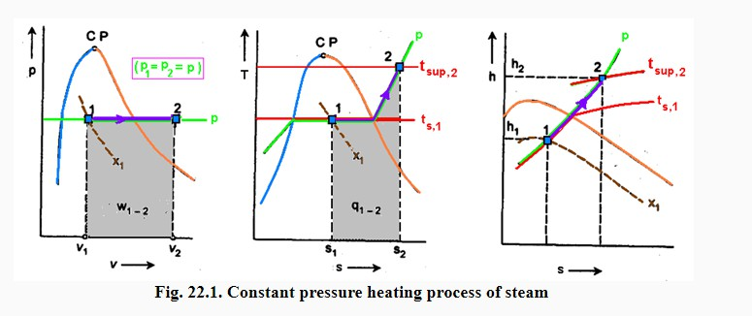

Constant Volume Process:
(a) p-v, T-s and h-s Representation: Assume that steam undergoes a constant volume cooling process from the initial condition of superheated steam and be defined by pressure
p₁ and super heating temperature t_{sup,1} to the final condition of steam at pressure p₂ and dryness traction x₂ as shown on p-v and T-s diagrams .

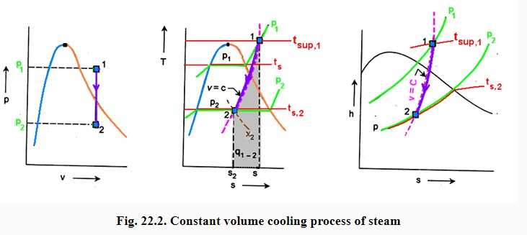

Isothermal Process:
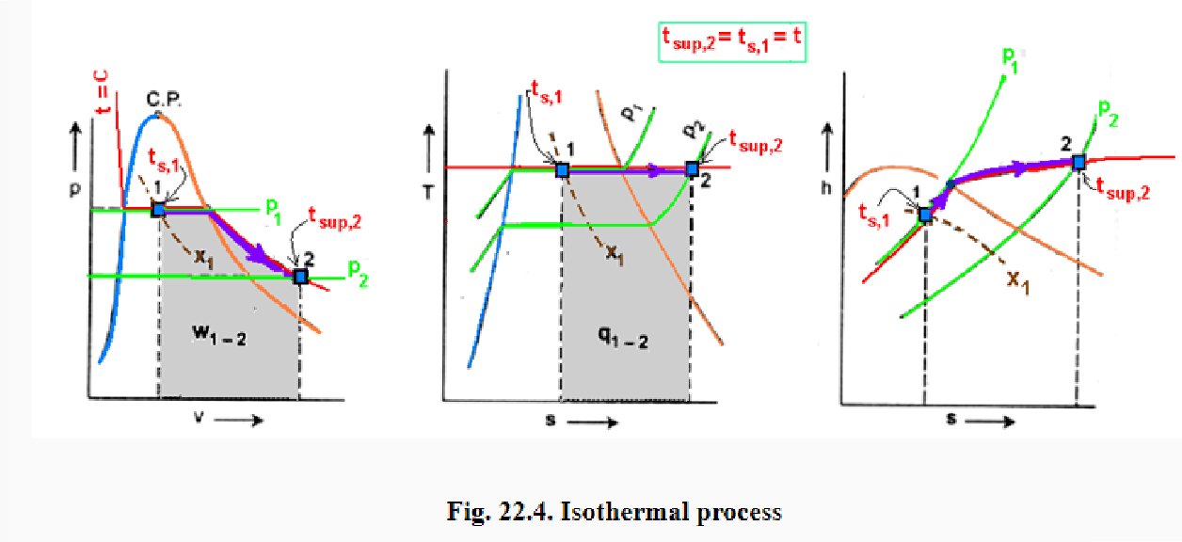
a) p-v, T-s and h-s Representation: Assume that steam undergoes an isothermal expansion process from the initial condition of wet steam at pressure p1 and dryness fraction x1 to the final condition of superheated steam and be defined by pressure p2 and super heating temperature tsup,2 as shown in Fig.

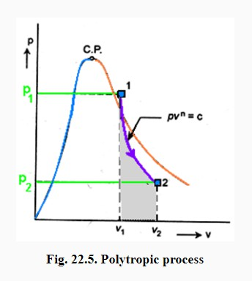
Polytropic Process:

(a) p-v Representation: Assume that steam undergoes a polytropic expansion process following the law pv^{n} = c from pressure p1 to p2. It is to be noted that steam does not behave as perfect gas obeying pv = RT. The equation pv^{n}= c is merely a statement of pressure-volume relationship during a reversible polytropic process. The non-flow polytropic process has application in steam engines, etc. This process is represented as 1-2 on p-v diagram shown in Fig. 22.5 in which the initial condition is superheated steam at pressure p1 and super heating temperature tsup,1 to the final condition of wet steam at pressure
p2 and dryness traction x2.

Throttling Process:
As described earlier, the throttling process involves passing of a higher pressure fluid through a narrow constriction resulting in reduction in pressure and temperature, increase in specific volume, increase in entropy and without any change in enthalpy.
The important characteristic of the throttling process is that enthalpy remains constant.

The process is adiabatic and no heat flow from or to the system but it not reversible.
Examples: Steam stop valve and throttle valve installed at the entry of steam turbine in power plants. When flow of steam takes place through these valves, throttling process occurs.

  - Simple numerical :
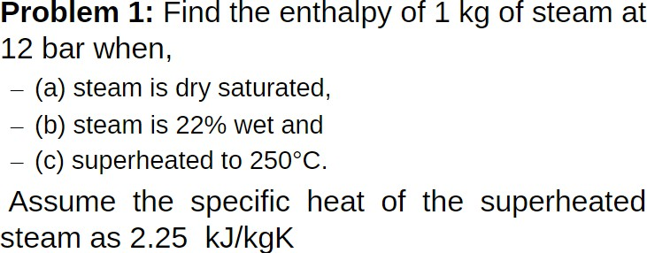

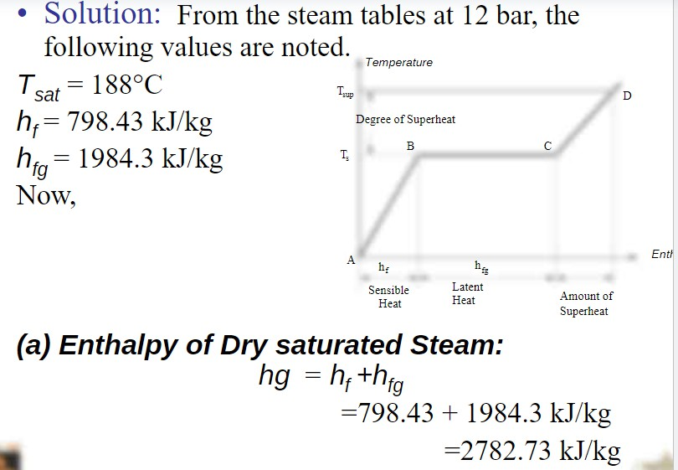

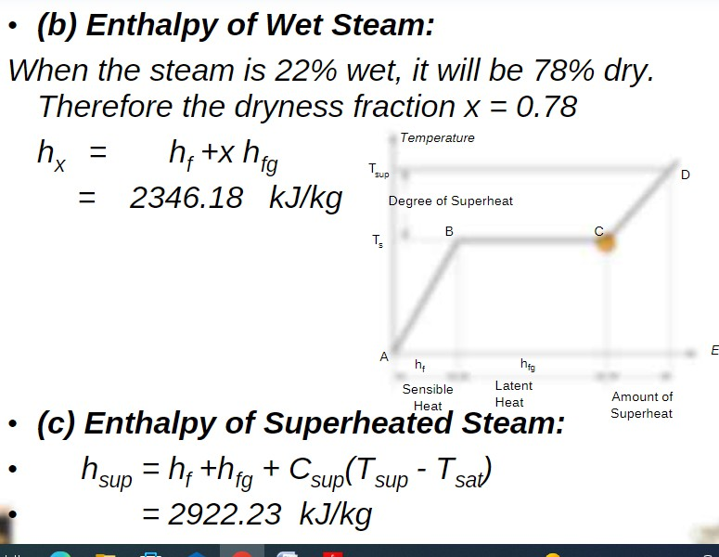

Questions for exercise/assignment:
Short questions
- Diffference between gas and vapour?
- Define sensible heat?
- Define latent heat?
- Define enthalpy? Long questions
- Briefly explain formation of steam ?

References:
- https://www.coursehero.com/file/34263328/Unit-1-Properties-of-steam- numericalspdf/
- https://www.engineeringenotes.com/thermal-engineering/steam- engine-thermal-engineering/steam-formation-conditions-properties-and- enthalpy-thermodynamics/50988
- https://www.teachoo.com/12521/3426/Difference-between-Gas-and- Vapour/category/Extra-Questions/
- http://ecoursesonline.iasri.res.in/mod/page/view.php?id=2410#:~:text=It
%20is%20advisable%20to%20use,states%20under%20steam%20generati on%20section.
- https://mesubjects.net/non-flow-processes/

- Steam Generator
  - Classification and types of Boiler
TYPES OF BOILERS The boilers can be classified according to the following criteria. According to flow of water and hot gases. 1. Water tube.

- Fire tube. In water tube boilers, water circulates through the tubes and hot products of combustion flow over these tubes.

In fire tube boiler the hot products of combustion pass through the tubes, which are surrounded, by water. Fire tube boilers have low initial cost, and are more compacts. But they are more likely to explosion, water volume is large and due to poor circulation they cannot meet quickly the change in steam demand. For the same output the outer shell of fire tube boilers is much larger than the shell of water-tube boiler. Water tube boilers require less weight of metal for a given size, are less liable to explosion, produce higher pressure, are accessible and can response quickly to change in steam demand. Tubes and drums of water-tube boilers are smaller than that of fire-tube boilers and due to smaller size of drum higher pressure can be used easily. Water-tube boilers require lesser floor space. The efficiency of water-tube boilers is more.

Water tube boilers are classified as follows. 1. Horizontal straight tube boilers

(a) Longitudinal drum (b) Cross-drum.

- Bent tube boilers

(a) Two drum (b) Three drum (c) Low head three drum (d) Four drum.

- Cyclone fired boilers

Various advantages of water tube boilers are as follows.

  - High pressure of the order of 140 kg/cm2 can be obtained.
  - Heating surface is large. Therefore steam can be generated easily.
  - Large heating surface can be obtained by use of large number of tubes.
  - Because of high movement of water in the tubes the rate of heat transfer becomes large resulting into a greater efficiency.

Fire tube boilers are classified as follows. l. External furnace:

    - Horizontal return tubular
    - Short fire box

    - Compact.

- Internal furnace:

  - Horizontal tubular

(a) Short firebox (b) Locomotive (c) Compact (d) Scotch

  - Vertical tubular.

    - Straight vertical shell, vertical tube (b) Cochran (vertical shell) horizontal tube.

Various advantages of fire tube boilers are as follows. (i) Low cost (ii)Fluctuations of steam demand can be met easily
  - It is compact in size.

According to position of furnace.

(i) Internally fired (ii) Externally fired

In internally fired boilers the grate combustion chamber are enclosed within the boiler shell whereas in case of extremely fired boilers and furnace and grate are separated from the boiler shell.

  - Important terms for Boiler
Following are important terms used in steam boilers:

    - Boiler Shell
    - Combustion Chamber
    - Grate
    - Furnace
    - Heating surface
    - Mountings
    - Accessories

  - Comparison between Fire Tube and Water Tube Boiler
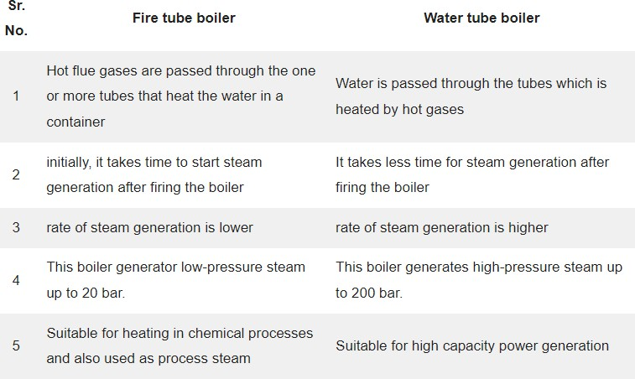
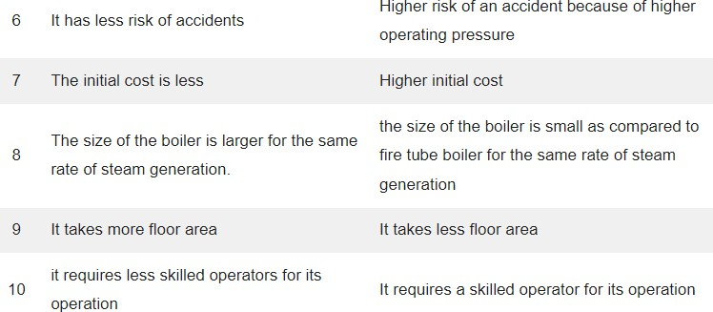

  - Description and working of Cochran Boiler

Cochran Boiler
Cochran Boiler is a multi-tubular vertical fire tube boiler having a number of horizontal fire tubes. It is the modification of a simple vertical boiler where the heating surface has been
increased by means of a number of fire tubes. The efficiency of this boiler is much better than the simple vertical boiler.

Parts of Cochran Boiler:
A Cochran Boiler is consisted of following parts:

- Shell
- Grate
- Combustion Chamber
- Fire tubes
- Fire hole
- Firebox (Furnace)
- Chimney
- Man Hole
- Flue pipe
- Fire Brick Lining
- Feed Check Valve
- Blow Off Valve
- Ash Pit
- Smoke Box Door
- Anti Priming Pipe
- Crown
- Pressure Gauge
- Safety Valve
- Water Level Indicator
- Water Level Gauge
- Fusible Plug
- Stop Valve

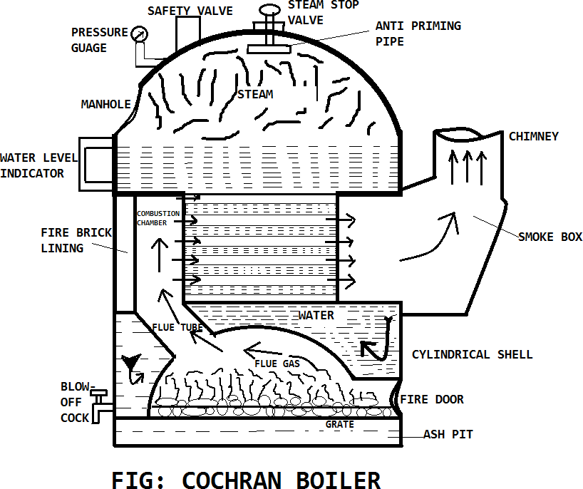

1 Shell:
The main body of the boiler is known as a shell. It is hemispherical on the top, where space is provided for steam.

This hemispherical top gives a higher volume to area ratio which increases the steam capacity.

#2 Grate:
In the grate section, solid fuel is stored, it is designed so well that air can easily flow through it, and also the ashes fall from the grate quite easily. In this section, the fire is placed.

#3 Combustion Chamber:
It is lined with fire bricks on the side of the shell to prevent overheating of the boiler. Hot gases enter the fire tubes from the flue pipe through the combustion chamber. The combustion chamber is connected to the furnace.

#4 Fire Tubes:
There are various fire tubes whose one end is connected to the furnace and other to the chimney. Sevaral horizontal fire tubes are provided to increased the heating surface.

#5 Fire Hole:
The small hole is provided at the bottom of the combustion chamber to place fuel is known as a fire hole.

#6 Fire Box (Furnace):
It works as a mediator of fire tubes and combustion chamber.

It is also dome-shaped like the shell so that the gases can be deflected back till they are passed out through the flue pipe to the combustion chamber.

#7 Chimney:
It is provided for the exit of flue gases to the atmosphere from the smokebox.

#8 Man Hole:
It is provided for the inspection and repair of the interior of the boiler shell.

#9 Flue Pipe:
It is a short passage connecting the firebox with the combustion chamber.

#10 Fire Brick Lining:
It is a special type of brick ling use in Cochran Boiler to reduce the convection of heat from the outer surface of the boiler. Fire Brick is generally made of fire clay.

#11 Feed Check Valve:
It is used to control the flow of water inside the boiler, it also helps to restrict the backflow of water.

#12 Blow Off Valve:
It is used to blow off the settle down impurities, mud, and sediments present in the boiler water.

#13 Ash Pit:
It is a chamber inside a boiler where ashes are stored.

#14 Smoke Box Door:
It is used to clean the smoke box deposits materials.

#15 Anti Priming Pipe:
Sometimes water droplets come out with the steam, so to prevent the droplets from carried out by the steam the Anti Priming Pipe is used.

#16 Crown:
It is hemispherical dome-shaped section of a boiler, where burning of fuel happens.

#17 Pressure Gauge:
It measures the pressure of steam inside the boiler.

#18 Safety Valve:
It blows off the extra steam when the steam pressure inside the boiler reaches above safety level.

#19 Water Level Indicator:
The position of the water level in the Cochran boiler is indicated by the water level indicator.

#20 Water Level Gauge:
It glass tube fitted out side of the boiler to check the water level inside the boiler.

#21 Fusible Plug:
It is one type of safety measure. If the inside temperature of the boiler cross the limit, then for safety purpose this Fusible Plug melts and the water comes into the boiler furnace and extinguish the fire.

#22 Stop Valve:
Stop valve is used to transfer steam to the desired location when it is required. Otherwise, it stops the steam in the boiler.

Working Principle of Cochran Boiler:
The Cochran boiler works as same as other fire tube boiler.

First, The coal is placed at the grate through the fire hole.

Then the air is entering into the combustion chamber through the atmosphere and fuel is sparked through fire hole.

Then flue gases start flowing into the hemispherical dome-shaped combustion chamber. This flue gases further moves into the fire pipes.

Heat is exchanged from flue gases to the water into the fire tubes.

The steam produce collected into the upper side of the shell and taken out by when the required pressure generated.

The flue gases now send to the chimney through a firebox where it leaves into the atmosphere.

Now, this process repeats and runs continuously. The steam generates used into the small industrial processed.

Applications of Cochran Boiler:
The application of Cochran boiler are:

- Variety of process applications industries.
- Chemical processing divisions.
- Pulp and Paper manufacturing plants.
- Refining units.
Besides, they are frequently employed in power generation plants where large quantities of steam (ranging up to 500 kg/s) having high pressures i.e. approximately 16 megapascals (160 bar) and high temperatures reaching up to 550 °C are generally required.

Features of Cochran boiler:
These are some features of Cochran Boiler:

- In the Cochran boiler, any type of fuel can be used.
- It is best suitable for small capacity requirements.
- It gives about 70% thermal efficiency with coal firing and about 75% thermal efficiency with oil firing.
- The ratio of the grate area to the heating surface area varies from 10: 1 to 25:1.

Description and working of Babcock and Wilcox Boiler:

Babcock and Wilcox Boiler Parts:
A Babcock and Willcox Boiler Parts or Construction consists of:

- Drum
- Water Tubes
- Uptake and Downtake header
- Grate
- furnace
- Baffles
- Superheater
- Mud box
- Inspection Door
- Water Level Indicator
- Pressure Gauge
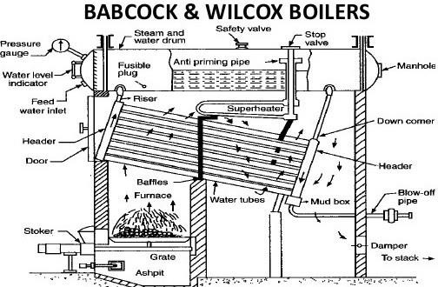
Drum:
This is a horizontal axis drum which contains water and steam.

Water tubes:
Water tubes are placed between the drum and furnace in an inclined position (at an angle of 10 to 15 degrees) to promote water circulation.

Uptake and Downtake Header:
This is present at the front end of the boiler and connected to the front end of the drum. It transports the steam from the water tubes to the drum. and

This is present at the rear end of the boiler and connects the water tubes to the rear end of the drum. It receives water from the drum.

Grate:
Coal is fed to the grate through the fire door.

Furnace:
The furnace is kept below the uptake-header.

Baffles:
The fire-brick baffles, two in number, are provided to deflect the hot flue gases.

Superheater:
It increases the temperature of saturated steam to the required temperature before discharging it from the steam stop valve.

Mud Box:
This is used to collect the mud present in the water.

Mud box is provided at the bottom end of the down-take header.

Inspection Door:
Inspection doors are provided for cleaning and inspection of the boiler.

Water Level Indicator:
The water level indicator shows the level of water within the drum.

Pressure Gauge:
The pressure gauge is used to check the pressure of steam within the boiler drum.

Working Principle of Babcock and Wilcox Boiler:
The working of Babcock and Wilcox boiler is first the water starts to come in the water tubes from the drum through down take header with the help of a boiler feed pump which continues to feed the water against the drum pressure.

The water present in the inclined water tubes gets heated up by the hot flue gases produced by the burning of coal on the fire grate.

These fuel gases are uniformly heated the water tube with the help of a baffle plate which works deflect the flues gas uniform throughout the tubes which absorbed the heating maximum from the flue gases.

As the hot flue gases come in contact with water tubes, It exchanges the heat with heater and converts into the steam.

Continuous circulation of water from the drum to the water tubes and water tubes to the drum is thus maintained.

The circulation of water is maintained by convective current and it’s known as Natural Circulation.

The Steam generated is moved upward, due to density difference and through the up-take header, it gets collected at the upper side in the boiler drum.

Anti-priming pipe inside the drum which works separates the moisture from the steam and sends it’s to the superheater.

The superheater receives the water-free steam from an anti-priming pipe. It increases the temperature of the steam to the desired level and transfers it to the main steam stop valve of the boiler.

The superheated steam stop valve is either collected in a steam drum or send it’s inside the steam turbine for electricity generation.

Applications Babcock and Wilcox Boiler:
The main application Babcock and Wilcox boiler to produce high-pressure steam in power generation industries.

4.6 Boiler Mountings and accessories
Boiler Mountings
These are the fittings, which are necessarily mounted on the boiler itself and mandatorily required for the safe and proper operation of boiler. Various boiler mountings are being discussed here one by one.

Water level indicator

Function
Water level indicator is fitted outside the boiler shell to indicate the water level in the boiler through a glass tube. In any type of boiler, water should remain at the designed level. If the water falls below the level due to change of phase into steam and simultaneously fresh water does not fill in by some reason, the hot surface may expose to steam only and overheat. This is because the heat transfers co-efficient of steam is very less as compared to water. Due to overheat, damage of tube surface may occur. To avoid this situation, level of water in the boiler needs to be constantly monitored & maintained by boiler operator by keeping watch on water level indicator.

Construction
As shown in the , two horizontal tubes made of gun metal extend from the boiler shell in such a way that top one is connected to steam space and bottom one is connected to water space of the boiler. These are connected at the other end by a vertical glass tube contained in a hollow casting in such a way that water and steam come out in the glass tube and their interface is visible through it. Each gun metal tube is also provided with a cock to control the flow of water/steam to the glass tube. One drain cock is fitted at the bottom for cleaning purpose. The horizontal metal tubes also contain one metal ball each which normally rests on a hemispherical groove in the tubes. In case the water/steam rush with high speed as may be if glass tube breaks by accident, this ball lifts up from its normal position and block a hole which connects the metal tube with glass tube and stops the flow.

Working
Working of water level indicator or water gauge is very simple. When the cocks are opened, boiling water and steam from the boiler shell flow into the hard glass tube and maintain the same level as in the boiler which is visible to operator. When the water level falls down beyond a safe limit, operator may switch on the feed pump to fill more water in the boiler shell. In the water and steam passages in the gun metal tubes, a metal ball rest in the cavity made in the passage. In case of breakage of glass tubes by accident, water and steam contained at high pressure in the boiler rush with high speed towards broken glass tube due to large pressure difference between inside and outside of boiler. Due to this, the ball resting in the cavity made in the passage lifts and rushes towards the end of gun metal tube and blocks the passage of steam or water flow. Then immediately the cock can be closed and glass tube can be replaced safely.

Pressure Gauge

Function
A pressure gauge is used to indicate the pressure of steam in the boiler. It is generally mounted on the front top of the boiler. Pressure gauge is of two types as (i) Bourdon Tube Pressure Gauge (ii) Diaphragm type pressure gauge. Both these gauges have a dial in which a needle moves over a circular scale under the influence of pressure. At atmospheric pressure it gives zero reading. Some gauges indicate only the

positive pressure but some are compound and indicate negative pressure or vacuum also. Looking at the gauge, boiler operator can check the safe working pressure of the boiler and can take necessary steps to keep the pressure within safe limits. If pressure increases and crosses the safe limit due to any reason, the boiler shell material may fail and it can burst causing damage to life and property. Thus it is very important to constantly monitor pressure in a boiler with the help of pressure gauge.

Construction & working
A bourdon tube pressure gauge is normally used, the construction of which is shown in the

The bourdon tube is an elliptical spring material tube made with special quality bronze. One end of tube is connected to gauge connector and other end is closed and free to move. A needle is attached to the free end of tube through a small gear mechanism. With the movement of tube under pressure, needle rotates on the circular scale. The movement of tube & hence needle is proportionate to the rise in pressure and so calibrated with scale.

The pressure gauge connector is attached to the boiler shell through a U-tube siphon and three way cocks. In the U-tube, condensate remains filled and so live steam does not come in direct content of bourdon tube but it push or exert pressure on the condensate which further stretch bourdon tube. Steam is not allowed a direct contact with the gauge due to high temperature effect on the pressure recording. The three way cock is used to give an entire connection for inspectors pressure gauge.

Spring loaded safety valve

Function
Spring loaded safety valve is a safely mounting fitted on the boiler shell and is essentially required on the boiler shell to safeguard the boiler against high pressure. It is a vital part of boiler and always be in good working condition to protect the boiler from bursting under high pressure and so to save life and property.

Construction
As shown in fig it consists of two openings or valve seats which are closed by two valves attached to a single lever. The lever is pivoted at one end and attached to a spring at the middle. The spring is fixed at the bottom end with the overall body of valve. Due to spring force, the liver and hence valves remain seated on the valve seats and do not allow the steam to escape. When the pressure force of steam exceeds the spring pulling force, valve & lever are lifted and steam escape thus decreasing the pressure below the safe limit. On decreasing the pressure valves sit again on their seats and thus stop the steam flow from the boiler. Sometimes, the lever may also be lifted manually to release steam if required.

Fusible plug

Function
The function of fusible plug is to protect the boiler from damage due to overheating of boiler tubes by low water level.

Construction
As shown in Fig., it is simply a hollow gun metal plug screwed into the fire box crown. This hollow gun metal plug is separated from the main metal plug by an annulus fusible material. This material is protected from fire side by means of a flange.

Working
When the water in the boiler is at its normal level, fusible plug remains submerged in water and its temperature does not exceed its melting temperature, because its heat is transferred to water easily. If under some unwanted condition, water level comes down to unsafe limit; fusible plug is exposed to steam in place of water. On the other side it is exposed to fire. So its temperature exceeds its melting point due to very low heat transfer to steam and it melts down. Immediately steam and water under high pressure rush to the fire box and extinguish the fire.

Blow-off-cock

Function
It is a controllable valve opening at the bottom of water space in the boiler and is used to blow off some water from the bottom which carries mud or other sediments settled during the operation of boiler. It is also used to completely empty the water when the boiler is shut off for cleaning purpose or for inspection and repair.

Construction and working
The construction is as shown in fig. It has a casing having a passage with one side flange to connect with boiler shell. The passage is blocked by a cone shape plug having a cross rectangular hole. Sealing is made with a top and bottom asbestos packing filled in grooves on plug. The shank of the plug passes through a gland and stuffing box in the cover. On the top portion of the shank a box spanner can be fitted to rotate the shank and plug by 90⁰ to either open or close the blow-off-cock. The working is also clearly visible on playing the animation.

Feed-check-valve

Function
The feed check valve is fitted in the feed water line of the boiler after the feed pump. Its function is to allow the water to flow in the boiler when the discharge pressure of feed pump is more than the inside steam pressure of boiler and prevent the back flow in case the feed pump pressure is less than boiler pressure. Feed check valve is fitted slightly below the normal water level in the boiler.

Construction
The construction of feed check valve is as shown in fig 25.6 In the casing of valve there is a check valve which can move up or down on its seat under the pressure of water. When supply pressure of feed water acting at the bottom of check valve is more, valve lifts up and allows the water to fill in the boiler. When supply pressure drops by stopping of feed pump, the boiler pressure acts on the top of valve and it sits on its gun metal seat and stops back flow of the boiler water out of the boiler shell.

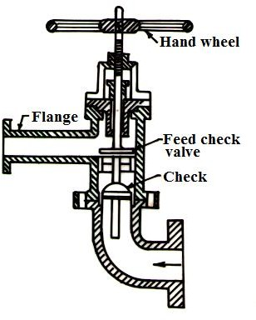

Fig.6 Feed check valve
- Steam stop valve

Function
It is fitted over the boiler in between the steam space and steam supply line. Its function is to regulate the steam supply from boiler to the steam line.

Construction and working
The construction of steam stop valve is as shown in fig 25.7. Its casing has a L-shaped steam flow passage. It consists of a valve and valve seat to stop or allow
the steam flow.
The valve is attached to a spindle and handle. Spindle passes through packing in the stuffing box to prevent leakage. The spindle has external threads in the top portion and moves in the internal threats of a fix nut. By rotating clockwise and anticlockwise the spindle and valve moves down and up thus closing or opening the valves.

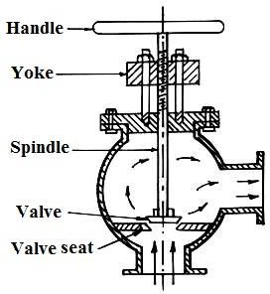

Steam stop valve

Boiler Accessories
Boiler accessories are the components which are attached to the boiler (Not mounted on it) and are essentially for working of boiler and for increasing its efficiency. Various boiler accessories are discussed as below
1 Feed pump
Feed pump is placed nearby the boiler and is used to feed water to boiler working at a high pressure. The job of feed pump is not just put the water in the boiler but as boiler is working at high pressure, discharge pressure of feed pump must be sufficiently higher than this to push the water inside the boiler.

Construction & working
The feed pump used in boiler is of two types (i) Reciprocating type (ii) Rotary type. Both these types are positive displacement type to discharge against high pressure. The discharge pressure of a single stage centrifugal pump is not high enough to overcome the high pressure of boiler so multistage centrifugal pump is used as a boiler feed pump.
In stationary low pressure boiler used in processing industries, a multistage centrifugal pump run by an electrical motor is more suitable. In multistage centrifugal pump, a number of centrifugal casing are so attached to each other that the impeller of each is mounted on the same shaft run by an electrical motor and discharge of 1st stage goes to 2nd stage and of 2nd to 3rd stage and so on. As shown in fig , in each stage the pressure of water goes on increasing and discharge

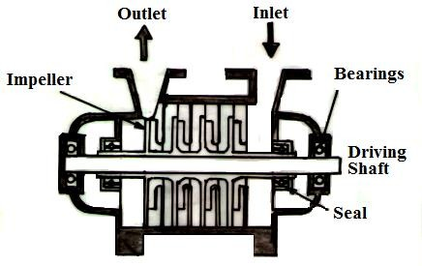
pressure of final stage is so high as to overcome the internal pressure of boiler. Theses pumps have independent working and have smooth operation.
Fig. Multistage centrifugal pumps
- Economizer

Function
An economizer is a specially constructed heat exchanger for harnessing the heat energy of outgoing flue gases and utilizing it in preheating of boiler feed water. It saves the heat energy and so the fuel and decreases the operating cost of boiler by increasing its thermal efficiency.

Construction & working
Economizers are of two types as (i) External type (ii) Internal type. The external type economizer is constructed and installed apart from the boiler and the flue gases from the boiler are directed to flow through it before escaping through chimney. A vertical tube external economizer is shown in fig .

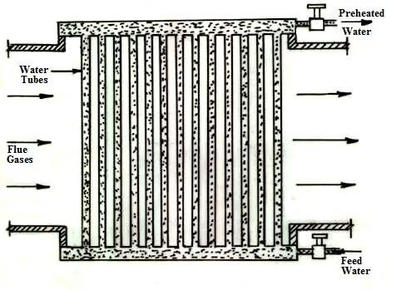
Fig. External economizer
It is employed for boilers of medium pressure range. Here a number of vertical tubes made of cast iron are connected to common headers at the bottom and top. Feed water flow into the bottom header and then through the vertical tubes flow out from the top header. Hot flue gases escaping from the boiler are directed to flow across the outside surface of tubes thus indirectly heating the feed water flowing inside. To avoid deposit of soot over the tube surface, tubular scrapers are fitted over the tubes. These are operated by chain and pulley system and while moving up and down slowly scrap the soot over the wall of tubes and so increase the heat transfer rate. An internal tube economizer is fitted inside the boiler and is an integral part of it.

Advantages of Economizer
  - Stresses produced in the boiler material due to temperature difference of boiler material and feed water are reduced because of increase in feed water temperature.
  - Evaporative capacity of boiler increases as less heat will be required to generate steam if feed water temperature is already high due to preheating.
  - Overall efficiency of boiler increases because of more steam produced per kg of fuel burnt.
- Air Pre-heater

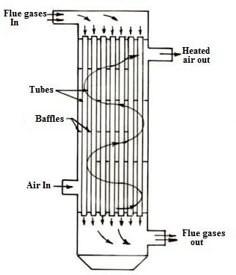
Fig. Air Pre-heater (Tubular Type)

Function
The function of air pre-heater is to further utilize the heat of flue gases after coming out of economizer to preheat the air used in furnace or oil burner.

Construction
It is a plate type or tubular type or storage heat exchanger, in which flue gases pass through the tubes on one side of plate and air pass on other side. In storage type a rotor fitted with mesh or matrix alternatively come in the passage of flue gases and air thus exchanging heat. A tubular type air-heater is as shown in fig 25.10
4 Super heater
The function of super heater is to increase the temperature of steam beyond its saturation temperature. It is a type of heat exchanger. Hot flue gases coming out of burner are first directed through super heater before the boiler. The main advantage of superheating of steam comes in power plants, where steam is expanded through a turbine. But in a processing industry superheating is required only to avoid condensation in pipes. Thus super heater has less advantage or use in a processing industry and many times not used but not always.

Questions for exercise/assignment:
Short questions
- Define boiler?
- Define grate?
- Mention two different mountings used with boiler?
- Define fire tube boiler?
- Define air preheater?
Long questions
- Describe the construction and working of Cochran boiler.
- Describe the construction and working of Babcock-wilcox boiler.
- Briefly explain Burdon tube pressure gauge.

References:
- https://themechanicalengineering.com/cochran-boiler/
- https://www.theengineerspost.com/babcock-and-wilcox-boiler/
- https://mechanicalenotes.com/boiler/

- Steam power cycle
  - Carnot Vapour Cycle
In a vapour cycle, all the theory remains the same as thermodynamic cycle except the working substance, which is steam. The steam may be in any form, i.e. wet, dry or saturated or superheated.

A Carnot cycle steam as a working substance is represented on the p-v and T-s diagram in

Carnot Vapour Cycle P-V Diagram
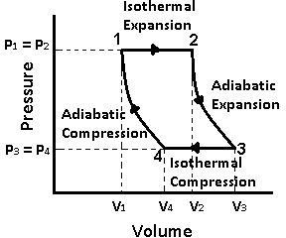

Carnot Vapour Cycle T-S Diagram
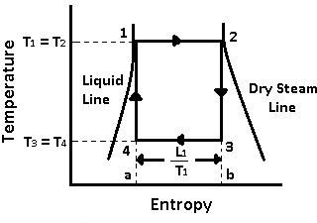

  - Carnot Vapour Cycle Processes
The cycle is completed by the following four processes:

- 1-2 Process (Isothermal Expansion)

- 2-3 Process (Adiabatic Expansion)
- 3-4 Process (Isothermal Compression)
- 4-1 Process (Adiabatic Compression)

Process 1-2 (Isothermal Expansion)

  - The water is isothermally converted into dry saturated steam, at a constant temperature (T1) and pressure (p1).
  - Dry state of steam is expressed in point 2.
  - It means that the temperature T2 (i.e., at point 2) and pressure p2 (i.e., at point 2) is equal to temperature T1 and pressure p2 respectively.
  - This isothermal expansion is represented by curve 1-2 on p-v and T-s diagram in the figure.
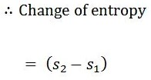
  - We know that the heat is absorbed by water during its conversion into dry steam is its latent heat (L1).

We also know that the area 12 ba in the T-s diagram represents the heat absorbed to some scale, during the isothermal expansion.

Heat absorbed during an isothermal expansion (area 12 ba)

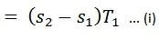

Process 2-3 (Adiabatic Expansion)

The dry steam now expands adiabatically. The pressure and temperature drop from p2 to p3 and T2 to T3. As no heat is supplied or rejected during this process, there is no change of entropy. The adiabatic expansion is represented by the curve 2-3 as shown in the figure.

Read also: Important Terms Used In Thermodynamics

Process 3-4 (Isothermal Compression)

  - The wet steam is now isothermally compressed at constant temperature (T3) and pressure (p3).
  - It means that the temperature T4 (i.e., at point 4) and pressure p4 (i.e., at point 4) is equal to the temperature T3 and pressure p3 respectively.

  - This isothermal compression is represented by the curve 3-4 on p-v and T-s diagrams as shown iWsoethkenromwinatlthhcaoetmfaipgreurearse3s.-io4ni.n the T-s diagram represents the heat rejected to some scale during the

Heat rejected during isothermal compression (area 34 ba)

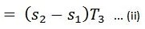

Process 4-1 (Adiabatic Compression)

  - The wet steam at point D is finally compressed adiabatically, till it returns back to its original state (point 1).
  - The pressure and temperature rise from p4 to p1 and T4 to T1 respectively.
  - The adiabatic compression is represented by the curve 4-1 as shown in the figure.
  - Since no heat is absorbed or rejected, therefore entropy remains constant. This completes the cycle.
We know that work done during the cycle
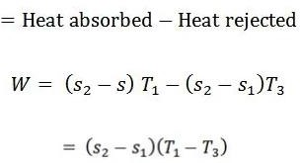

And the efficiency of the Carnot cycle,

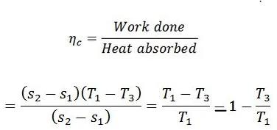

  - Rankine Cycle
5.3.1
The Rankine cycle is a modified form of Carnot cycle, in which the isothermal compression (3-4) is continued unit the steam is condensed into water. A Carnot cycle, using steam as a working substance, is represented or p-v and t-s diagram as shown in the figure.
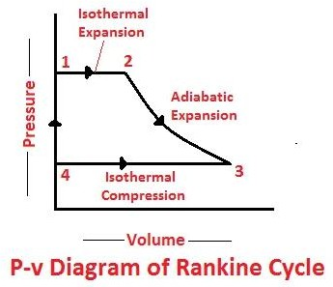

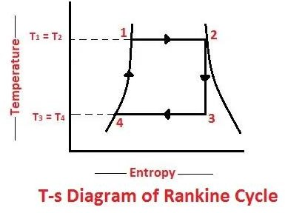

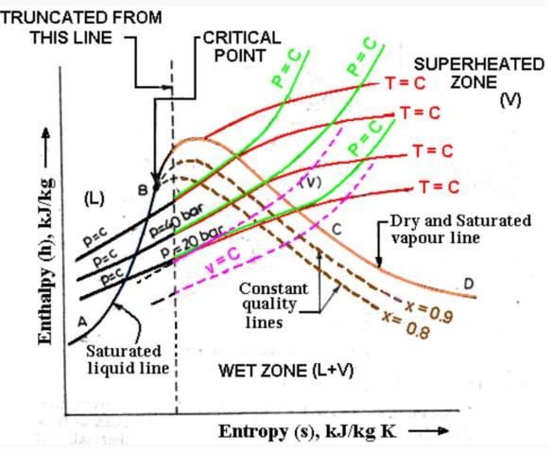

The following are the four stages of an ideal Rankine cycle:

    - Isothermal expansion
    - Adiabatic expansion
    - Isothermal compression
    - Warming operation

Isothermal Expansion
The water is isothermally converted into dry saturated steam at a constant temperature (T1) and pressure (P1). The dry state of steam is expressed in point
- It means that the temperature T2 (i. e. at point 2) and pressure P2 (i. e. at point 2) is equal to temperature T1 and pressure P1 respectively.

This isothermal expansion is represented by curve 1-2 in p-v and t-s diagrams in Fig. We know that the heat absorbed during isothermal expansion by water dring its conversion

Adiabatic Expansion
The dry saturated steam now expands adiabatically. The pressure and temperature fall from P2 and T2 to T3 respectively with a dryness fraction x2. As no heat is supplied or rejected during this process, there is no change of entropy. The adiabatic expansion is represented by the curve 2-3 as shown in Fig.

Isothermal Compression
The wet steam is now isothermally compressed at constant temperature (T3) and pressure (p3) unit the whole steam is condensed into water. IT means that the temperature T4 (i.e. at point 4) and pressure P4 is equal to the temperature T3 and pressure P3 respectively.

The isothermal compression is represented by curve 3-4 on p-v and T-s diagram in Fig. The heat rejected by steam is its latent heat ( equal to x3 L3).

Warming Operation
The water is now warmed at constant volume from temperature T4 to T1. Its pressure also rises from P4 to P1. The heat absorbed by water dring this operation is equal to the sensible heat or liquid heat corresponding to the pressure P1 i. e. equal to sensible heat at point 1 minus sensible heat at point 4 (i.e. equal to h1- h4).

But sensible heat at point 4 is equal to at point 3. Thus heat absorbed during warming operation equal to (h1-h3)
= Heat absorbed during isothermal expansion+ Heat absorbed during the warming operation
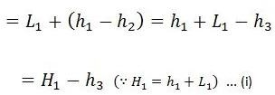

And heat rejected during the cycle

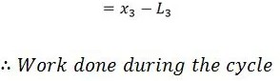

= Heat absorbed – Heat rejected
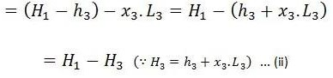

And efficiency (also called Rankine efficiency),

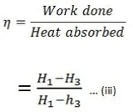

Questions for exercise/assignment:
Short questions
  - Draw PV & TS diagram of Carnot cycle?
  - Draw PV & TS diagram of Rankine cycle?
Long questions
    - Describe the Carnot cycle with vapor with help of PV,TS & HS diagrams and deduce a formula for its thermal efficiency.
    - Describe the Rankine cycle with vapor with help of PV,TS & HS diagrams and deduce a formula for its thermal efficiency.

Refernces:

https://www.theengineerspost.com/carnot-vapour- cycle/
- https://www.theengineerspost.com/rankine-cycle/

Heat Transfer
  - Modes of Heat Treatment:
There is a total of 3 Modes of Heat transfer which is:

- Conduction
- Convection and
- Radiation

Conduction:
In Conduction, the heat or energy is transferred by a direct contact like when any heated object you touch with your hand the conduction process take place.

When we heat the Iron at one side the other side automatically gets heated because the molecules present in it travels to another side and heated that area too. So we can say Conduction is equal to Direct contact.

It is defined as the transfer of heat by means of molecular agitation within a material without any motion of the material as a whole

Convection:
In convection, the heat or energy is transferred by mass motion of fluid which might be air or water when heated fluid is caused to move away from the source of heat-carrying energy with it.

Example:

When the heat is provided to water at the bottom the pot is heated, the water particles move faster, and they also move farther apart. So now the heated water becomes less dense and we know the less- dense fluid will float on top of a more dense one. Now, the heated water rises in the pot. The surrounding cooler water flows into its place. This flow creates circular motion, known as convection currents.

Radiation:
The Radiation is defined as Everybody emits radiation in the form of an electromagnetic wave or rays or particles. In this process does not require a medium to transfer the Thermal (Heat) energy.

Example:

In summer when you go in the field and for a time you stand there you will feel heat up because of sun emits the heat and your body skin receives. That is how the radiation process works.

  - Fourier law of heat conduction:
Fourier's law states that the negative gradient of temperature and the time rate of heat transfer is proportional to the area at right angles of that gradient through which the heat flows. Fourier's law is the other name of the law of heat conduction.
Fourier’s law differential form is as follows:

Where,

- q is the local heat flux density in W.m2
- k is the conductivity of the material in W.m-1.K-1
- ▽T is the temperature gradient in K.m-1
Thermal Conductivity(k)
Thermal conductivity can be defined as the rate at which heat is transferred by conduction through a unit cross-section area of a material, when a temperature gradient exits perpendicular to the area.
  - Newtons Law of cooling:
Newton’s law of cooling explains the rate at which an object/entity changes its temperature when it is exposed to radiation. This change is almost proportional

to the difference between the object’s temperature and its surroundings’ temperature, given that this difference is quite small.
  - Stefans-Boltzmann law of radiation:

According to Stefan Boltzmann law, the amount of radiation emitted per unit time from an area A of a black body at absolute temperature T is directly proportional to the fourth power of the temperature.
Mathematically W = ε σT⁴
where emissivity ε is equal to 1 for black bodies and less than 1 for grey bodies, σ being the Stefan constant.
Kirchoff's Law of Radiation:

At a given temperature, the ratio of the emissive power of a body to its absorptive power is constant and is equal to the emissive power of a black body at the same temperature. aE=Eb.
  - Black body radiation
Blackbody radiation refers to the spectrum of light emitted by any heated object; common examples include the heating element of a toaster and the filament of a light bulb.
Emissivity:
Emissivity is defined as the ratio of the energy radiated from a material's surface to that radiated from a perfect emitter, known as a blackbody, at the same temperature and wavelength and under the same viewing conditions. It is a dimensionless number between 0 (for a perfect reflector) and 1 (for a perfect emitter).
Absorptivity:
Absorptivity is defined as the fraction of the amount of incident radiation that is absorbed by the surface.
Transmissivity:
The transmissivity describes the proportion of electromagnetic radiation which is transmitted through the body, and has values between 0 and 1. The remaining portion of the radiation is either reflected or absorbed by the body. This gives the relationship: α+ρ+τ=1.
Questions for exercise/assignment: Short questions

- Define Fourier law of heat conduction ?
- Define Newton’s law of cooling ?
- Difine Kirchoff’s law ?
- Define absorptivity ?
- Define emissivity ?
Long questions
- State the modes of heat transfer and explain it ?
- Briefly explain Newton’s law of cooling ?
- Briefly explain Fourier law of heat conduction ?

References:
  - https://www.tutorialspoint.com/modes-of-heat-transfer-conduction-convection-and-radiation
  - https://byjus.com/physics/fouriers-law/
  - https://knowledge.carolina.com/physical-science/physics/newtons-law-of-cooling/
  - https://en.wikipedia.org/wiki/Stefan%E2%80%93Boltzmann_law
  - https://www.vedantu.com/question-answer/state-kirchhoffs-law-of-radiation-and-prove-it-class-11- physics-cbse-5f3f9f2a7367fe538f457be6
Previous semester questions for practice

