DEPARTMENT OF MECHANICAL ENGINEERING

LECTURE NOTES

ON

HYDRAULIC MACHINE & INDUSTRIAL FLUID POWER

5th SEMESTER, MECHANICAL

By

Er. Dharmendra Kumar Sahu
Lecture in Mechanical Engineering
B.IE.T, MOHADA (BAM)

CONTENT

Chapter No. | Title | Page No.
Chapter-1 | Hydraulic Turbines | 03 - 23
Chapter-2 | Centrifugal Pumps | 24 - 31
Chapter-3 | Reciprocating Pumps | 32 - 38
Chapter-4 | Pneumatic System | 39 - 44
Chapter-5 | Hydraulic System | 45 - 73

HYDRAULIC TURBINE

Introduction to Hydraulic machines:
- These are the machines in which force is transmitted by means of motion of fluid under pressure.
- These can convert hydraulic energy to mechanical energy or mechanical energy to hydraulic energy.
- The hydraulic system works on the principle of Pascal's law. This law states that, the pressure in an enclosed fluid is uniform in all the directions.
- Examples: Hydraulic turbines, Pumps, cranes, forklifts, bulldozers

Hydraulic turbine:
- It is a hydraulic machine.
- It uses energy of flowing water (hydraulic energy) and converts it into mechanical energy (in the form of rotation of runner)
- Shaft power available at the shaft of the Turbine is utilized to run Generator to produce electricity.

Classification of turbine:
- According to the type of energy at inlet
  - Impulse turbine
    - An impulse turbine is a turbine in which the water entering the runner possesses kinetic energy only. In this, the rotation of the runner occurs due to the impulse action of water. (Pelton Turbine)
  - Reaction turbine
    - A reaction turbine is a turbine in which the water entering the runner possesses pressure as well as kinetic energy. In this, the rotation of runner occurs due to the pressure difference between the inlet and outlet of the runner. (Francis and KaplanTurbine)
- According to the direction of flow through runner
  - Tangential flow turbine
    - When the flow of water is tangential to the wheel circle, the turbine is called tangential flow turbine. (Pelton Turbine)
  - Radial flow turbine
    - When the water moves along the vanes towards the axis of rotation of the runner or away from it, the turbine is called radial flow turbine. When the flow is towards the axis of rotation, the turbine is called an inward flow turbine. When the flow is away from the axis of rotation, the turbine is called an outward flow turbine. (Francis Turbine)
  - Axial flow turbine
    - When the water flows parallel to the axis of rotation, the turbine is called an axial or parallel flow turbine. (Kaplan Turbine/Propeller Turbine)

  - Mixed flow turbine
    - When the water enters radially inwards at inlet and discharge at outlet in a direction parallel to the axis of rotation of the runner, the turbine is called mixed flow turbine. (Moden Francis Turbine)
- According to the head at the inlet of turbine
  - High head turbine
    - When a turbine works under a head of more than 250 m. (Pelton Turbine)
  - Medium head turbine
    - When a turbine works under a head of 45 m – 250 m. (Francis Turbine)
  - Low head turbine
    - When a turbine works under a head of less than 45 m. (Kaplan Turbine)
- According to the specific speed of the turbine
  - Low specific speed turbine
    - The specific speed up to 30 (Pelton Turbine)
  - Medium specific speed turbine
    - The specific speed varies from 50 to 250 (Francis Turbine)
  - High specific head turbine
    - specific speed is more than 250 (Kaplan Turbine)

Impulse Turbine – Pelton Wheel:
- Pelton turbine is a tangential flow impulse turbine.
- It works at high head and requires low flow of water.
- It converts pressure energy into kinetic energy in in one or more nozzles.
- It is driven by high velocity jets of water coming out from a nozzle directed on to vanes or buckets attached to a wheel.
- The impulse provided by the jets is used to spins the turbine wheel and removes kinetic energy from the fluid flow.
- Pressure of water remains atmospheric inside the turbine.

Construction of Pelton Wheel:
Major Components component of Pelton wheel are described below.
- Casing:
- Casing prevents the splashing of water and helps in discharge of water from the nozzle to the tailrace. It protects the turbine from dust and dirt.
- Nozzle and Spear Mechanism:
- Nozzle produces high velocity jets of water and converts pressure energy into kinetic energy.

- The spear mechanism controls the water flow into the turbine and control the turbine speed according to load. It minimizes energy loss at inlet and provides smooth flow.
- Break Nozzle:
- It is used to produce and supply breaking jet of water. It directs the water on the bucket to stop the runner to rest in a short time
- Runner/Rotor:
- It is a circular disc mounted by a number of equally spaced buckets which are fixed on its periphery. Each bucket consists of two symmetrical halves having shape of semi-ellipsoidal cup.
- It provides rotational energy when jet of water having kinetic energy strike the buckets.
- Penstock:
- It is the channel or pipeline that connect the high head source water to the power station
- Governing Mechanism:
- It controls the speed and power output of the turbine by controlling the flow of water
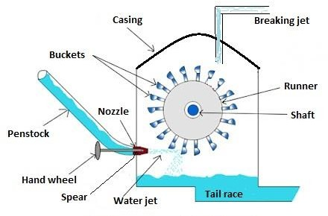

Working Principle:
- Water is coming from the storage reservoir through a penstock to the inlet of the nozzle.
- Nozzle converts the hydraulic energy of the water into kinetic energy and produces high velocity of jet.
- The jet of water released from the nozzle strikes on the buckets mounted on the runner.
- Water jet strikes over the runner bucket and imparts a very high impulsive force on the buckets for a small amount of time to rotate the runner and so mechanical energy develops.
- Pressure of water remains atmospheric inside the turbine.

Velocity triangle of Impulse turbine:

Consider the following terms for understanding the velocity triangle.

At inlet velocity triangle: | At outlet velocity triangle:
V1 = absolute velocity of water | V2 = absolute velocity of water
u1 = peripheral velocity of runner (bucket speed) | u2 = peripheral velocity of runner (bucket speed)
Vr1 = relative velocity of water | Vr2 = relative velocity of water
Vw1 = velocity of whirl | Vw2 = velocity of whirl
Vf1 = velocity of flow | Vf2 = velocity of flow
α = angle between the direction of the jet and the direction of motion of the vane (guide blade angle) | β = angle between the direction of the jet and the direction of motion of the vane (guide blade angle)
θ = angle made by the relative velocity Vr1 with the direction of motion (vane angle) | φ = angle made by the relative velocity Vr2 with the direction of motion (vane angle)
From inlet velocity triangle we obtain: | From outlet velocity triangle we obtain:
α = 0, θ =0, Vf1 =0  V1 = Vw1 = u1 + Vr1 and Vr1 = V1 - u1 | Vr2 = Vr1  Vw2 = Vr2 cos φ – u2
u = u1 = u2 = πDN/60, where D = diameter of wheel, N = speed in r.p.m

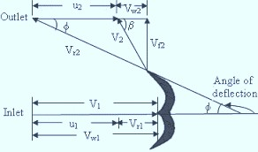
(Velocity triangle of Pelton turbine)

Work done and power developed of a Pelton wheel:

Let, F = force exerted by the jet of water in the direction of motion
= mass x change in velocity in the direction of force
= m x (Vw1 + Vw2) = ρaV1 x (Vw1 + Vw2) Where: ρ = density of water;
a = area of jet = ^{𝜋} × 𝑑²
4
d = diameter of jet
Let, W = Net work done by the jet on runner per second = F x u
= ρaV1 x (Vw1 + Vw2) x u
Work done per second per unit weight of water striking = 𝝆𝒂𝑽𝟏×(𝑽𝒘𝟏 +𝑽𝒘𝟐)×𝒖 = (𝑽𝒘𝟏+𝑽𝒘𝟐)×𝒖
𝝆𝒂𝑽𝟏×𝒈 𝒈

NOTE:
Gross head (Hg): - Difference between the water level at head race and tail race Net head (H): - Head available at the inlet (Effective head)
Absolute velocity can be obtained as: 𝑉₁ = 𝐶_{𝑉} √2𝑔𝐻
Cv = coefficient of velocity of the nozzle

Velocity of wheel (bucket speed) = 𝑢 = ∅ × √2𝑔𝐻
∅ is the speed ratio

Efficiencies of turbine:

Hydraulic efficiency (𝜼_{𝒉}):

η = Work done per sec ond
= ρaV1 × (Vw1 ± Vw2 )× u = 2 × (Vw1 ± Vw2 )× u

^{h} Kinetic energy
1 × (ρaV )×V ² 1

It can also be obtained as:
V
2
2 1 1

η = Runner Power
ρaV1
=
- (Vw1 ± Vw2 )× u kW
1000
= ρQ
- (Vw1 ± Vw2
)× u

^{h} Water Power

= (Vw1 ± Vw2 )× u
g H
ρg Q H kW
1000

ρg Q H

Mechanical efficiency (𝜼_{𝒎}):
η = Shaft Power = ( P )

^{m} Runner Power ρaV × Vw ± Vw × u
1 1 2
- Volumetric efficiency (𝜂_{𝑚}):

η = volumeof water actually striking the runner = Qa

V

- Overall efficiency (𝜂_{𝑚}):
total water givenbythe jet to theturbine Q

Relationship between efficiencies:

ηh =
Shaft Power Water Power
= P
ρg Q H

ηO

Problem from Pelton Turbine:

=ηh ×ηm ×ηv

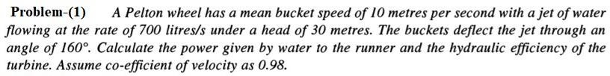
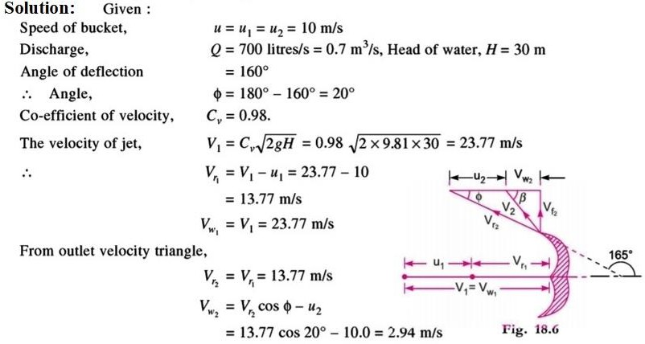
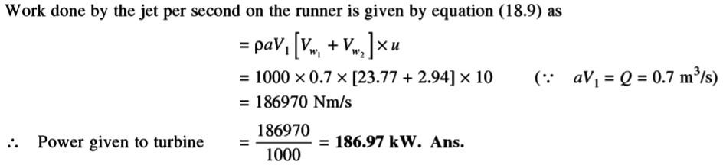

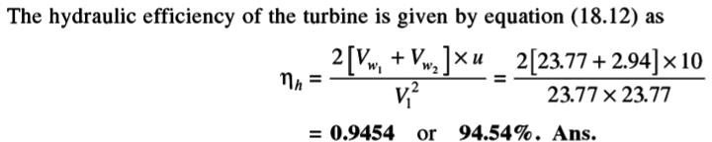

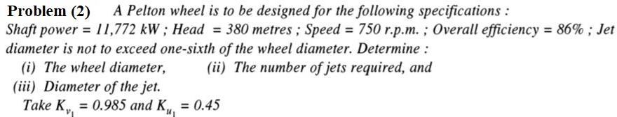
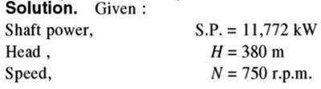
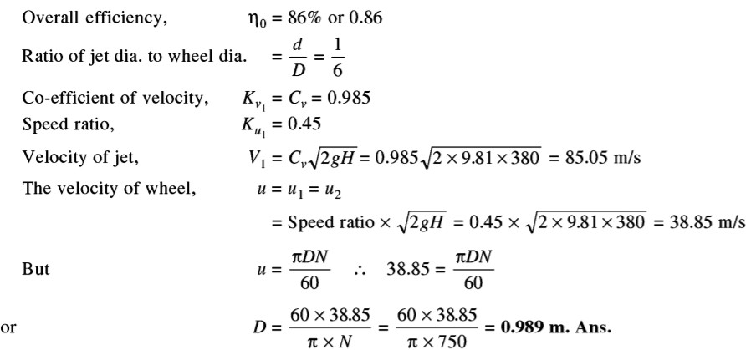
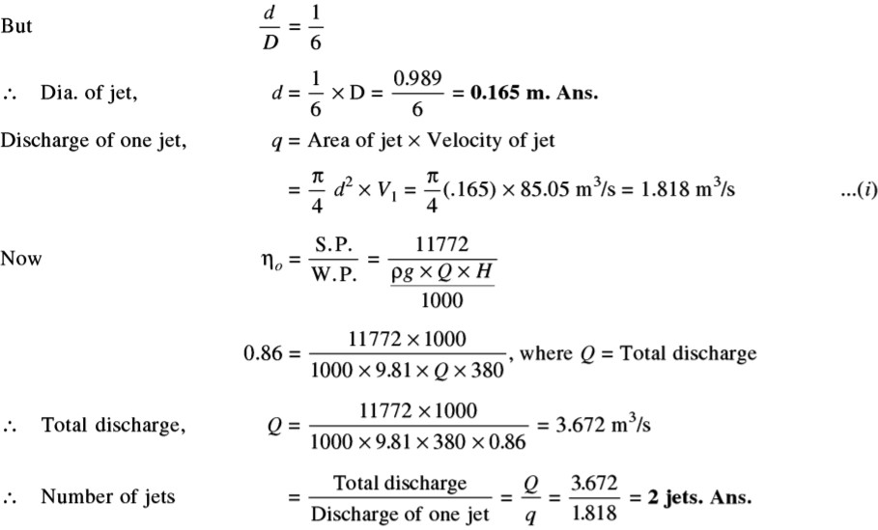

Reaction Turbine – Francis Turbine:
- Francis turbine is a medium head inward radial flow reaction turbine.
- Modern Francis turbine is an inward mixed flow reaction turbine. In this turbine, the water under pressure enters radially to the impeller blades while exits axially.
- When water flows radially from outward to inward, the turbine is called inward radial flow turbine
- When water flows radially from inward to outward, the turbine is called Outward radial flow turbine.
- An inward mixed flow reaction turbine, is a combination of impulse and reaction turbine where blades rotate using both reaction and impulse force of water flowing through them.

Construction of Francis Turbine:
Major Components component of Francis turbine are described below.

Spiral/Scroll Casing:
  - Its cross-sectional area is maximum at inlet and minimum at exit.
  - It encloses the turbine runner completely and prevents the splashing of water.
  - It maintains constant velocity throughout the circumference.

Runner with fixed blades:
  - It is a circular wheel with a series of radially curved vanes which are fixed on its periphery.
  - It provides rotational energy due to impulse and reaction effects on runner.

Penstock:
  - It is the channels or pipelines which conveys water from source to the power station

Governing Mechanism:
  - It controls the speed and power output of the turbine by changing the position of guide blades to vary the water flow rate at variation of loads.

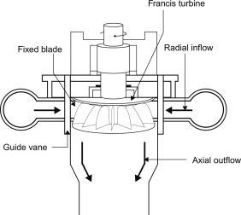

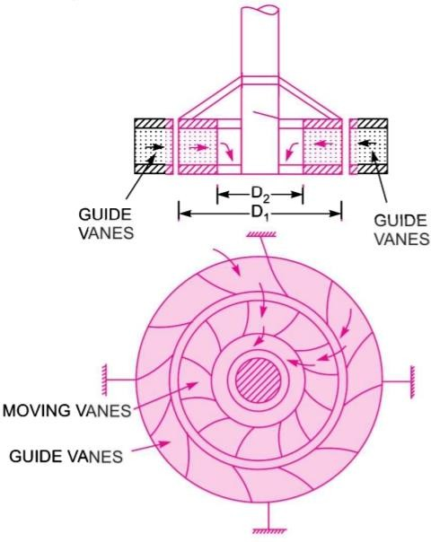 | 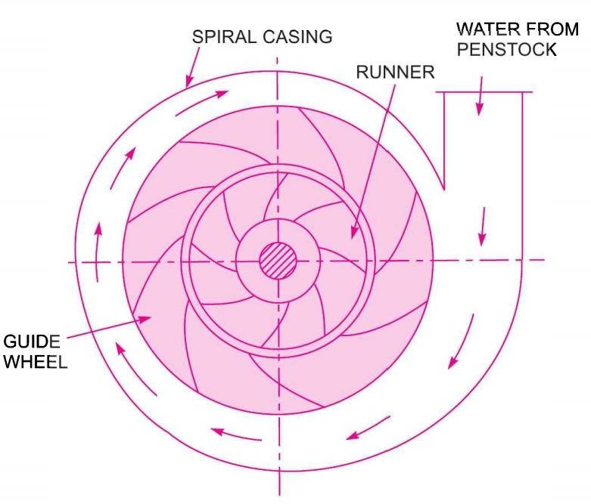  (FRANCIS TURBINE)

Working Principle:
- In modern Francis turbine; water enters into the turbine with both pressure and kinetic energy.
- When water flows through the stationary parts, a part of its pressure energy is converted into kinetic energy. When water flows over the moving parts, there is change in pressure, absolute velocity and direction.
- The pressure difference between the blade and runner is known as the reaction pressure. This pressure results the motion of the runner.

Velocity triangle of Francis turbine:
Consider the following terms for understanding the velocity triangle.

At inlet velocity triangle: | At outlet velocity triangle:
V1 = absolute velocity of water | V2 = absolute velocity of water
u1 = peripheral velocity of runner (bucket speed) | u2 = peripheral velocity of runner (bucket speed)
Vr1 = relative velocity of water | Vr2 = relative velocity of water
Vw1 = velocity of whirl | Vw2 = velocity of whirl
Vf1 = velocity of flow | Vf2 = velocity of flow
α = angle between the direction of the jet and the direction of motion of the vane (guide blade angle) | β = angle between the direction of the jet and the direction of motion of the vane (guide blade angle)
θ = angle made by the relative velocity Vr1 with the direction of motion (vane angle) | φ = angle made by the relative velocity Vr2 with the direction of motion (vane angle)

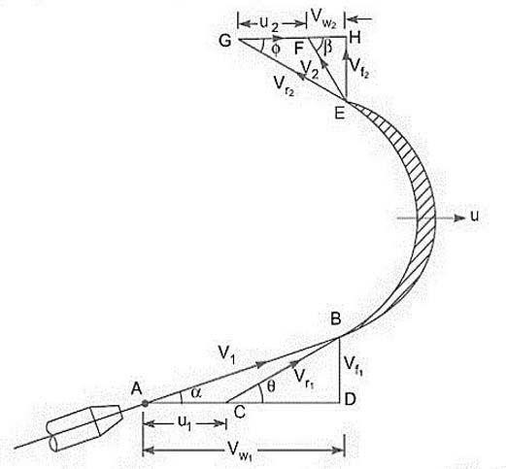
(Velocity triangle of Francis turbine)

From inlet velocity triangle we obtain: | From outlet velocity triangle we obtain:
u1 = πD1N1/60 | u2 = πD2N2/60
where D = diameter of wheel, N = speed in r.p.m

Work done and power developed of a Pelton wheel:
Let, F = force exerted by the jet of water in the direction of motion
= mass x change in velocity in the direction of force
= m x (Vw1 + Vw2) = ρaV1 x (Vw1 + Vw2) Where: ρ = density of water;
a = area of jet = ^{𝜋} × 𝑑²
4
d = diameter of jet
Let, W = Net work done by the jet on runner per second
= ρaV1 x (Vw1 x u1 + Vw2 x u2)
Work done per second per unit weight of water striking = 𝝆𝒂𝑽𝟏×(𝑽𝒘𝟏 𝒖𝟏+𝑽𝒘𝟐𝒖𝟐) = (𝑽𝒘𝟏𝒖𝟏+𝑽𝒘𝟐𝒖𝟐)
𝝆𝒂𝑽𝟏×𝒈 𝒈
For radial discharge: β = 90⁰ and Vw2 = 0; Output is maximum
Therefore: Work done per second per unit weight of water striking = 𝑉𝑤1𝑢1
𝑔

Hydraulic efficiency:

η = Runner Power = ρaV1 × (Vw1 u1 ± Vw2 u2 ) = Vw1 u1 ± Vw2 u2
^{h} Water Power ρg Q H g H

For radial discharge: when Vw2 = 0;

η = Vw1 u1

NOTE:
speed ratio = u1
2 g H

^{h} g H

flow ratio = V 1
2 g H
f

Discharge of the turbine = Q = π x D1 x B1 x Vf1 = π x D2 x B2 x Vf2
D1 and D2 are the diameter of runner at inlet and outlet respectively B1 and B2 are the width of runner at inlet and outlet respectively
Vf1 and Vf2 are the velocity of flow at the inlet and outlet respectively

Problems from Francis Turbine
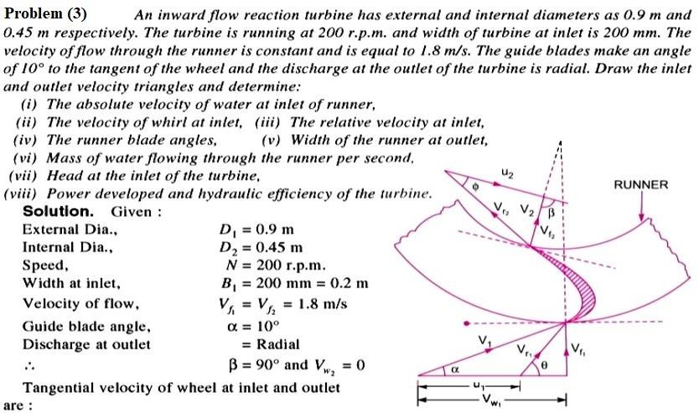

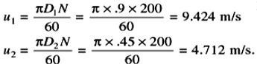
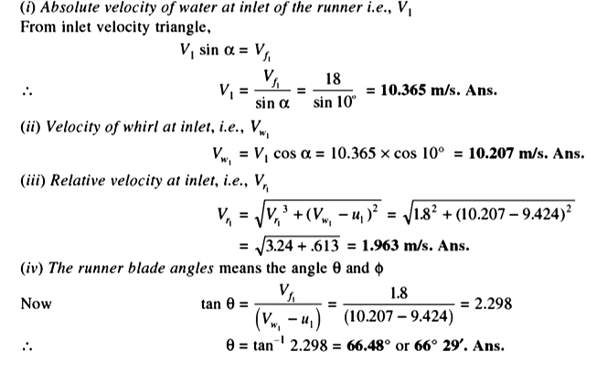
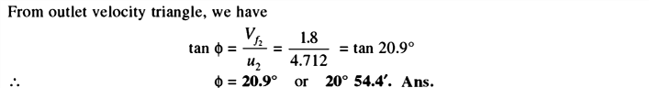
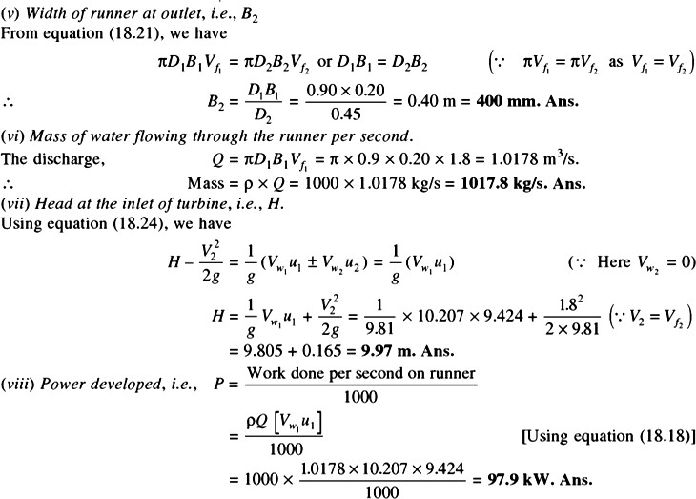
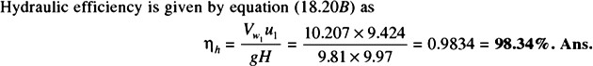

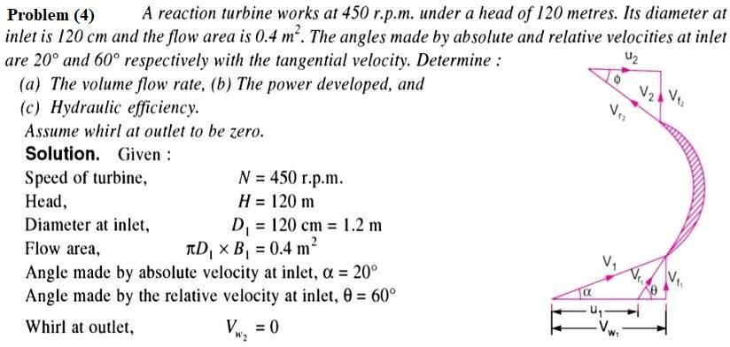
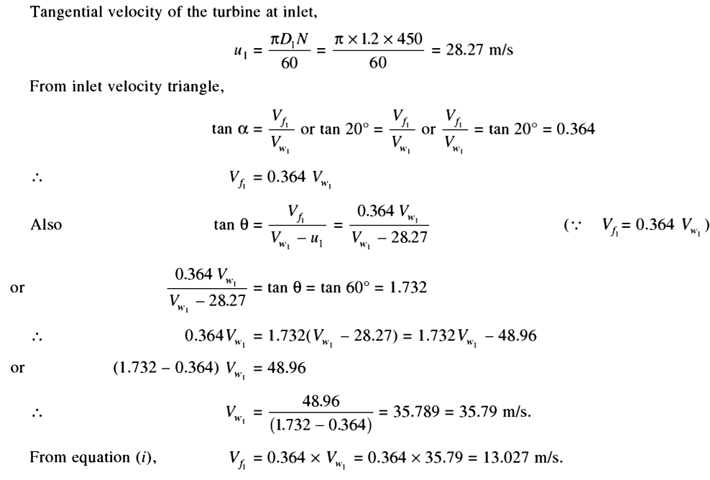
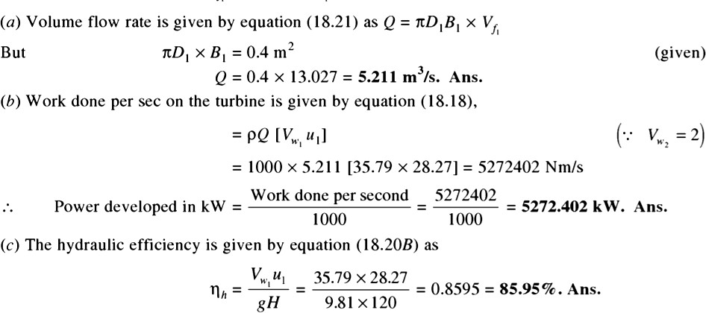

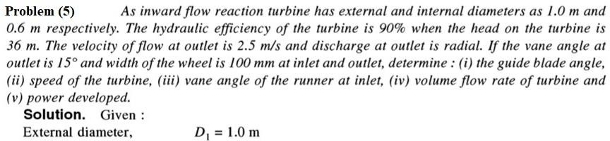
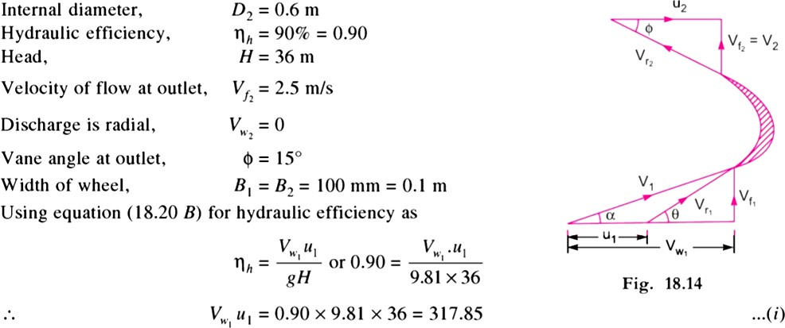
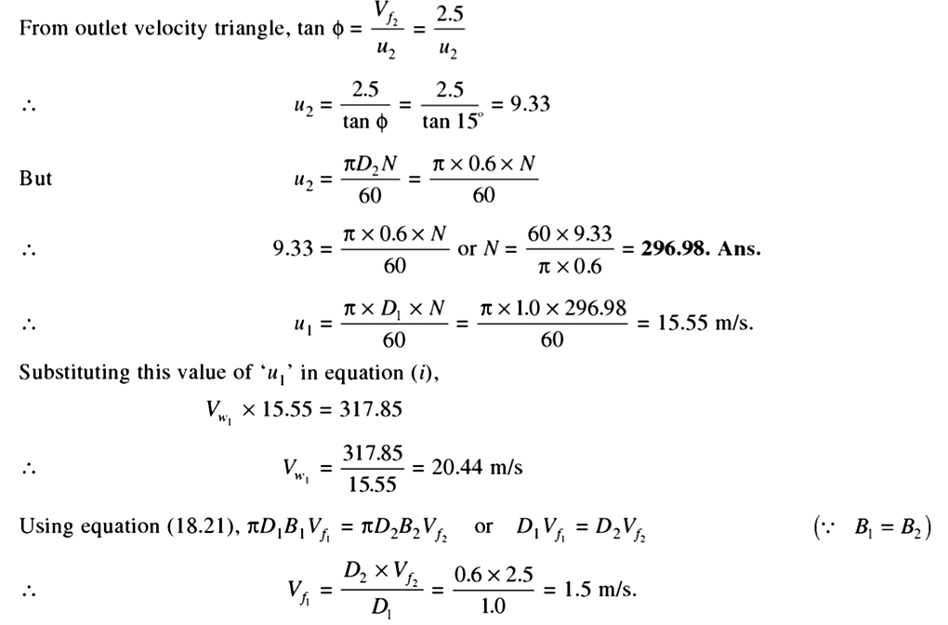

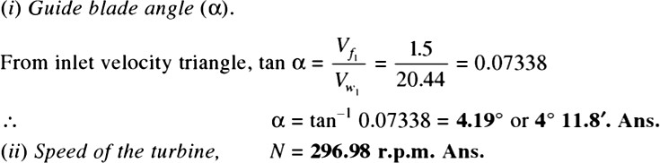
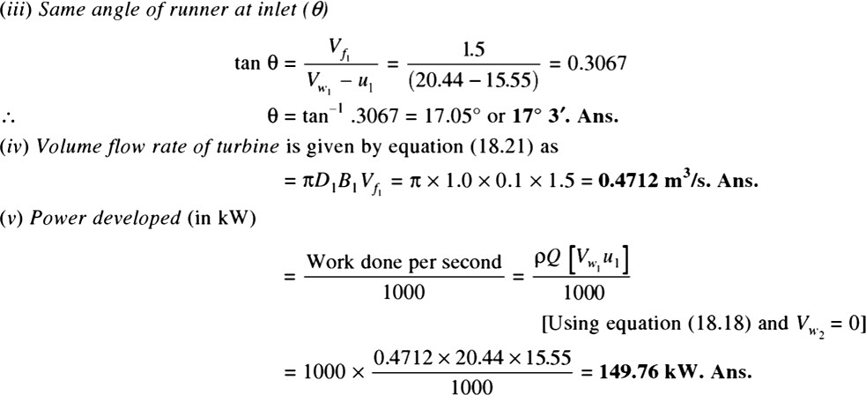
Axial flow reaction Turbine:
- In an axial flow reaction turbine water flows parallel to the axis of rotation of the shaft of the turbine.
- It has a vertical shaft with larger lower end known as hub/boss.
- Vanes are fixed on the hub and so the hub works like a runner.
- It requires large quantity of water at low head

Classification of Axial flow reaction Turbine:
Axial flow reactions are classified as:
  - Propellor turbine
    - Propeller turbine is the axial flow reaction turbine which has not adjustable fixed vanes.
  - Kaplan turbine
    - Kaplan turbine is the axial flow reaction turbine which has adjustable vanes.

Kaplan Turbine:
- It is an axial flow reaction turbine in which water flows parallel to the axis of rotation of the shaft of the turbine. The water enters the runner of turbine in an axial direction and leaves the runner axially.
- It has a vertical shaft with larger lower end known as hub/boss.
- Vanes are fixed on the hub and so the hub works like a runner.
- It requires large quantity of water at low head

Construction of Kaplan Turbine:
It consists of the following major parts.
- Scroll Casing:
- It encloses the turbine runner completely and prevents the splashing of water.
- Cross-section of scroll casing decreases uniformly to maintain the pressure of water such that the flow pressure is not lost.
- From the scroll casing the guide vanes direct the water to the runner.
- Guide vanes mechanism:
- The guide vanes are adjustable and can be adjusted to meet the required flow rate.
- Guide vanes also control the swirl of the water flow.
- Hub with vanes:
- The vanes are fixed on the hub and hence hub acts as a runner for the axial flow reaction turbine.
- Draft tube:
- The draft tube is a connecting pipe whose inlet is fitted at the outlet of the turbine.
- The diameter of the draft tube is small near its inlet and large near its outlet. The outlet of the draft tube is always submerged in water.
- It converts the kinetic energy of the water to static pressure at the outlet of the turbine. So pressure of the exit fluid increases. This helps to avoid the dissipation of the kinetic energy of the exit water. It improves the capacity of the turbine.

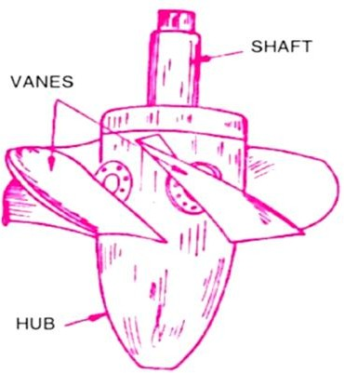 | 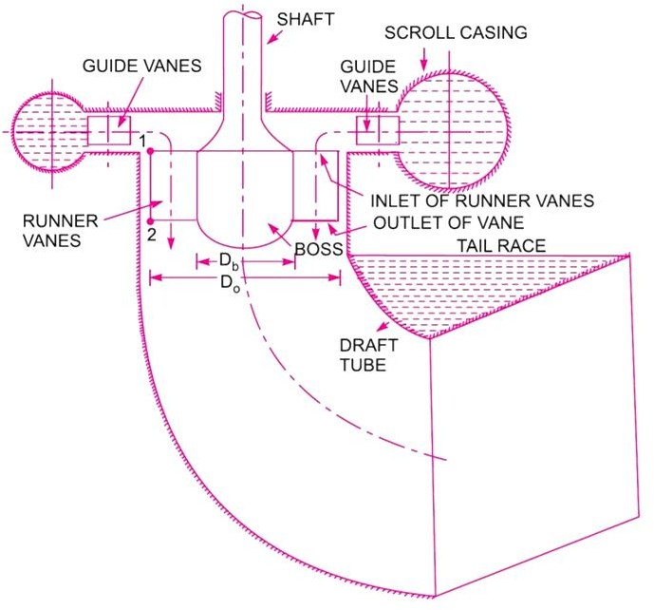
 | (KAPLAN TURBINE)

Key points for Kaplan Turbine:
- Discharge through the runner: 𝑄 = 𝜋 × (𝐷² − 𝐷²) × 𝑉

4 𝑜 𝑏
Where:Do = diameter of the runner Db = diameter of the hub/boss Vf1 = velocity of flow at inlet
𝑓1

- Area of flow at inlet = Area of flow at outlet = 𝐴 = 𝜋 × (𝐷² − 𝐷²)
4 𝑜 𝑏

- Peripheral velocity at inlet and outlet are equal: 𝑢₁
= 𝑢₂
= 𝜋𝐷𝑜𝑁
60

- Velocity of flow at inlet (Vf1) = Velocity of flow at outlet (Vf2)
- Speed ratio = ^{𝑢1}
√2𝑔𝐻
- Flow ratio = 𝑉𝑓1
√2𝑔𝐻

- Water power = ^{𝜌𝑔𝑄𝐻}
1000
- Runner Power = ¹ × 𝑉𝑤1 𝑢1 + 𝑉𝑤1𝑢2
𝑔 1000

- Hydraulic efficiency = 𝑉𝑤1𝑢1
𝑔𝐻
(for radial discharge)

- Overall efficiency = ^{𝑆𝑃}
𝑊𝑃

- Specific speed pf turbine = 𝑁_{𝑠}

= 𝑁√𝑃
𝐻5⁄4

Problems from Kaplan Turbine:
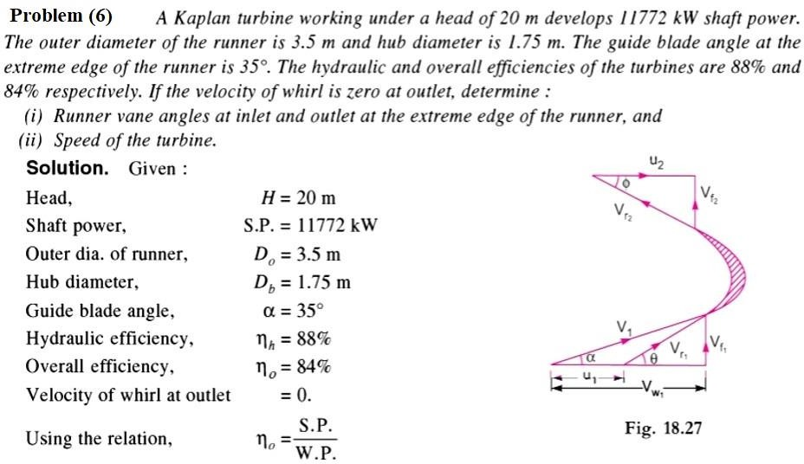

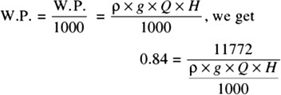
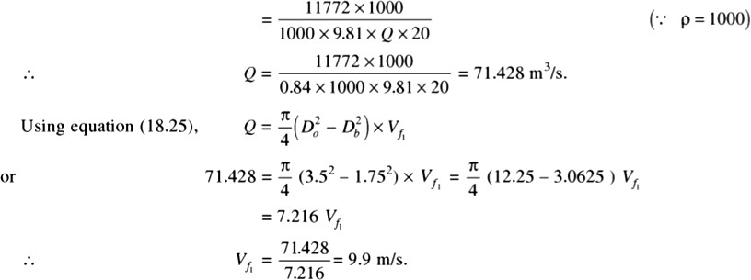
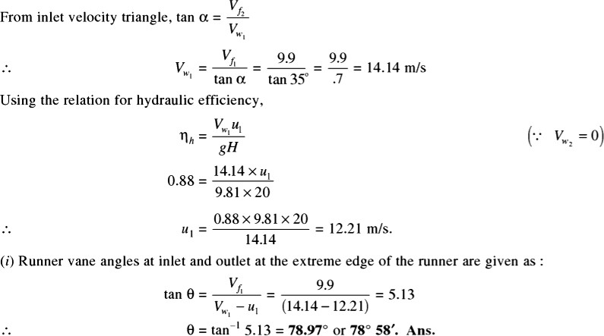
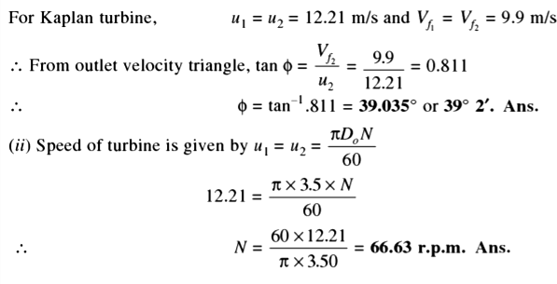

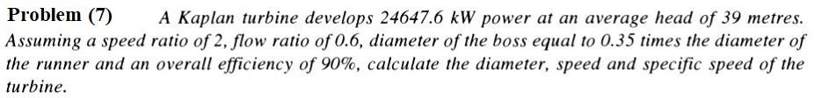
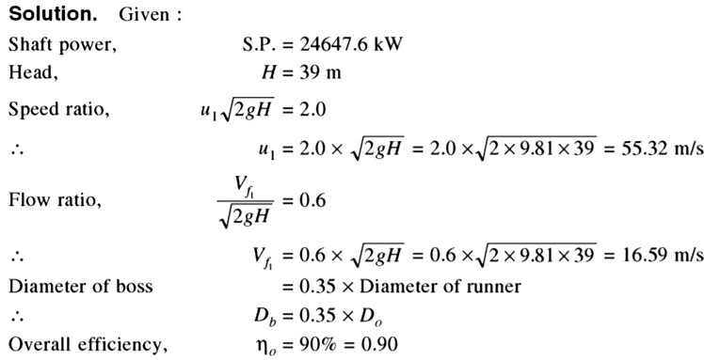
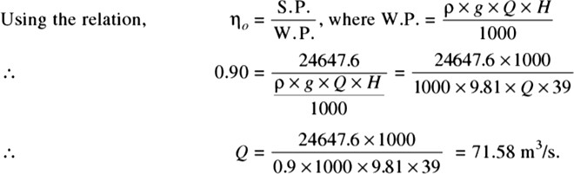
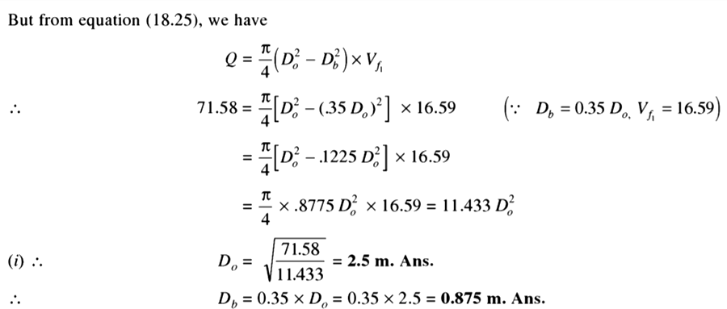
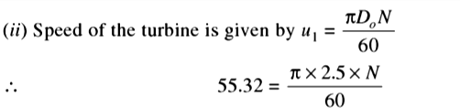

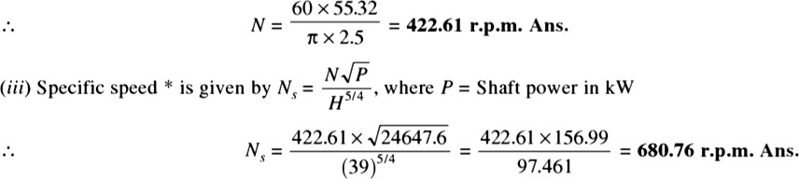

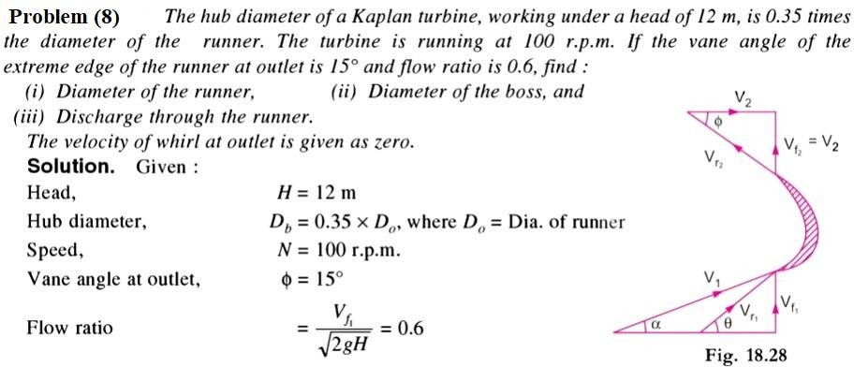
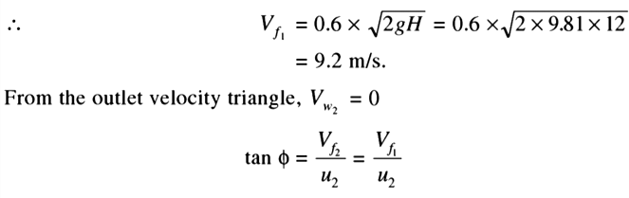
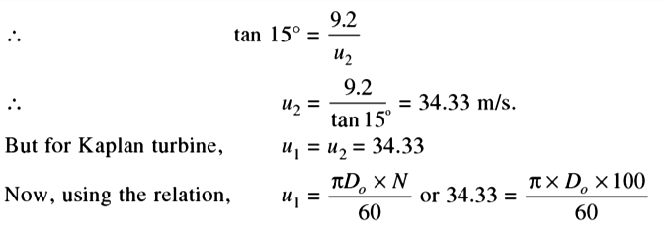
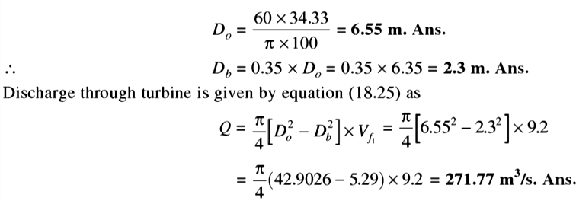

Difference between Impulse and Reaction turbine:

Impulse Turbine | Reaction Turbine
The water flows through the nozzles and impinges on the moving blades | The water flows first through guide mechanism and then through the moving blades
The water impinges on the buckets with kinetic energy | The water glides over the moving vanes with pressure and kinetic energy
The water may or may not be admitted over the whole circumference. | The water must be admitted over the whole circumference
The water pressure remains constant during its flow through the moving blades. | The water pressure is reduced during its flow through the moving blades.
The relative velocity of water while gliding over the blades remains constant. | The relative velocity of water while gliding over the moving blades increase
The blades are symmetrical | The blades are not symmetrical
The number of stages required is less for the same power developed. | The number of stages required is more for the same power developed

REFERENCE:
- Fluid Mechanics & Hydraulic Machines by R.K. Bansal (Book).
- https://youtu.be/UMz5GR7Nhqg?list=PLq7jO-L_k0yVmqNL4XVB9vOJ47_ysGYWn
- https://youtu.be/1eYcjdGrXYA?list=PLq7jO-L_k0yVmqNL4XVB9vOJ47_ysGYWn
- https://www.youtube.com/watch?v=BFoJOZbZ9FI&list=PLq7jO- L_k0yVmqNL4XVB9vOJ47_ysGYWn&index=13
- https://youtu.be/TyygDiQPzaA?list=PLq7jO-L_k0yVmqNL4XVB9vOJ47_ysGYWn
- https://youtu.be/RcdA2tGts_E?list=PLq7jO-L_k0yVmqNL4XVB9vOJ47_ysGYWn
- https://youtu.be/HWX06fwSJWM?list=PLq7jO-L_k0yVmqNL4XVB9vOJ47_ysGYWn

CENTRIGUGAL PUMP

Introduction:
  - It is a hydraulic machine in which force is transmitted by means of motion of fluid under pressure.
  - In this machine, mechanical energy is converted into hydraulic energy in the form of pressure energy by the action of centrifugal force on the fluid.
  - Its main purpose is to transfer fluids through an increase in pressure.
  - It acts as a reverse of an inward flow reaction turbine.
  - It is used in the field of agriculture, municipality, industries, power plants, petrochemicals, mining etc.

Construction:
Major components of Centrifugal pump are:

Casing:
It is an air tight passage which surrounds the impeller. It converts kinetic energy of water into pressure energy with its special design. It is classified as:
    - Volute casing
      - Volute casing is the spiral casing in which the area of flow increases from inlet to outlet. This gradual increase in area helps to reduce the velocity of flow and increase the pressure at outlet. Due to formation of eddies, there is a limitation of energy loss.
    - Vortex casing
      - In Vortex casing a circular chamber is provided in between the impeller and casing. This decreases the energy loss formation of eddies. It helps to increase the efficiency of the pump.
    - Casing with guide blades
      - In Casing with guide blades a series of guide blades mounted on a ring surrounds the impeller. This helps to control the velocity and pressure of water by adjusting the guide blades.

Impeller:
It is a wheel or rotor which is provided with a series of backward curved blades or vanes. It is mounted on the shaft powered by motor.

Suction pipe with foot valve and strainer:
It’s one end connects the inlet of the impeller and the other end is dipped into the sump of water. The foot valve fitted to the bottom of suction pipe is a one way valve that opens in the upward direction. The strainer fitted to the bottom of suction pipe is used to filter the unwanted particle present in the water to prevent the centrifugal pump from blockage.

Delivery pipe and delivery valve:
It’s one end connects the outlet of the pump and other end connects the point where water is delivered. A delivery valve is fitted with the outlet controls the flow from the pump into delivery pipe.

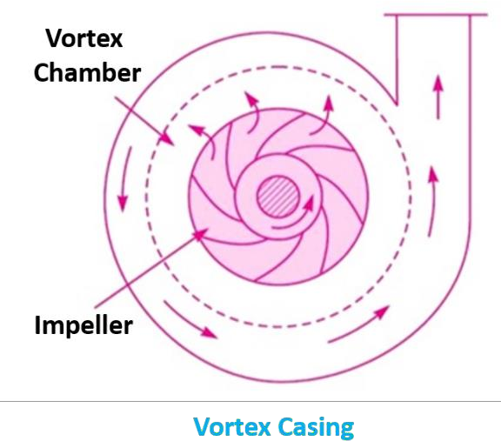

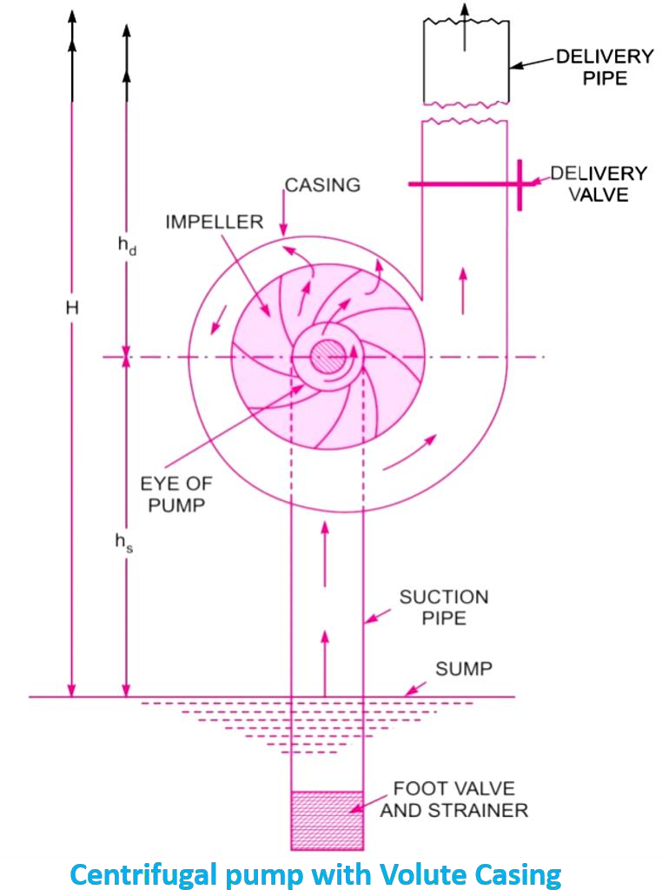
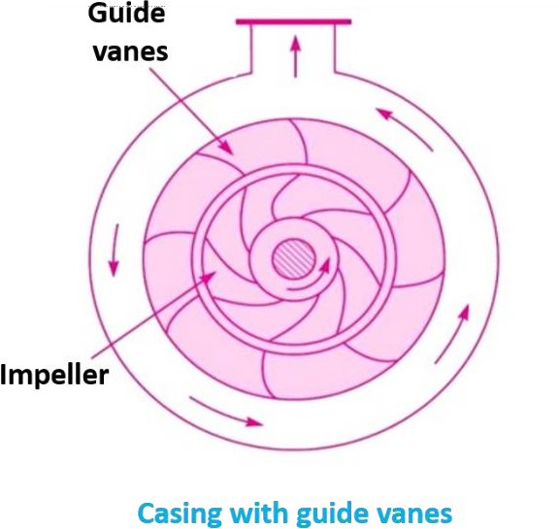
Working of Centrifugal Pump:
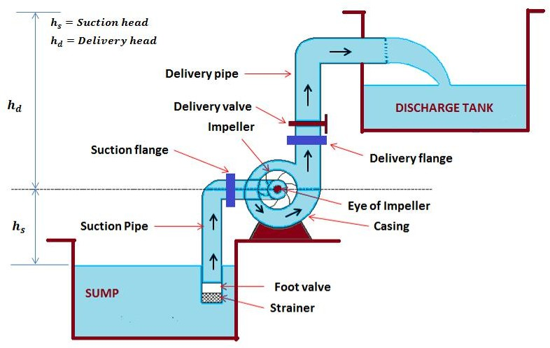

  - When the electric motor starts, the shaft of the pump coupled with the motor shaft rotates. It gives rotational motion to the impeller mounted on the shaft.
  - The rotating impeller drives the water inside it and produce centrifugal force. This creates velocity difference between the inlet and outlet.
  - It causes the rising of water from sump through suction pipe to eye of the impeller.
  - When water gets pressurized, the delivery valve opens to discharge water to desired height.
  - Priming is the operation in which water is feed into the casing and suction pipeline keeping the delivery valve closed, so that all the air from the pump is driven out and no air is left.

Velocity triangle of Centrifugal pump:
Consider the following terms for understanding the velocity triangle.

At inlet velocity triangle: | At outlet velocity triangle:
V1 = absolute velocity of water | V2 = absolute velocity of water
u1 = peripheral velocity of runner (bucket speed) | u2 = peripheral velocity of runner (bucket speed)
Vr1 = relative velocity of water | Vr2 = relative velocity of water
Vw1 = velocity of whirl | Vw2 = velocity of whirl
Vf1 = velocity of flow | Vf2 = velocity of flow
α = angle between the direction of the jet and the direction of motion of the vane (guide blade angle) | β = angle between the direction of the jet and the direction of motion of the vane (guide blade angle)
θ = angle made by the relative velocity Vr1 with the direction of motion (vane angle) | φ = angle made by the relative velocity Vr2 with the direction of motion (vane angle)
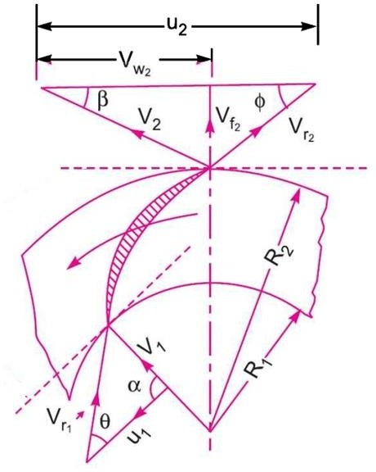

When water enters the impeller radially. at inlet

α = 90⁰ , Vw1 =0, Vf1 = V1

u = πD1 N1

¹ 60

and
u = πD2 N2

² 60

𝑉𝑜𝑙𝑢𝑚𝑒𝑜𝑓𝑤𝑎𝑡𝑒𝑟 𝑝𝑒𝑟 (𝑄) = 𝜋𝐷₁𝑁₁𝑉_{𝑓}1 = 𝜋𝐷₂𝑁₂𝑉_{𝑓}2

Let, W = Net work done by the jet on runner per second = ρaV1 x (Vw2 x u2) Work done per second per unit weight of water striking = (Vw2 x u2)/g

Heads of Centrifugal pump:

Suction head (hs)
It is the vertical distance between the centre line of pump and the water surface at sump level.

Delivery head (hd)
It is the vertical distance between the centre line of pump and the water surface at the discharge tank.

Static head (H)
It is the sum of suction and delivery head.

Manometric head (Hm)
It is the working head of the centrifugal pump. It is given by:
Hm = (Head imparted by impeller to the water – loss of head in the pump)

H = (Vw2 × u2 ) − loss of
m g

head

If loss of head is neglected
H = (Vw2 × u2 )
m g

Efficiencies of Centrifugal pump:

Manometric efficiency (ηman)
It is the ratio between manometric head and the head imparted by the impeller to the water.

η = Hm
= g Hm

^{m} ^{an} ⎛ Vw × u ⎞ Vw × u
⎜⎜ 2 2 ⎟⎟ 2 2
⎝ g ⎠

Mechanical efficiency (ηm)
It is the ratio between the power at the impeller and the power at the shaft.

Overall efficiency (ηo)
η = ρ× Q ×Vw2 × u2

^{m} S.P

It is the ratio between the power output of the pump and the power input of the pump.

ηo = ⎛
S.P
g H ⎞

Relation between ηman, ηm & ηo
⎜ m ⎟
⎝ Vw2 × u2 ⎠

ηo =ηm an ×ηm

Problem from Centrifugal Pump:
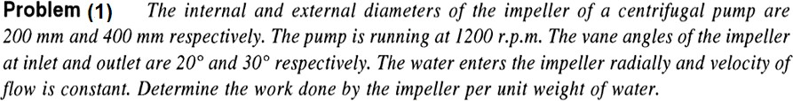

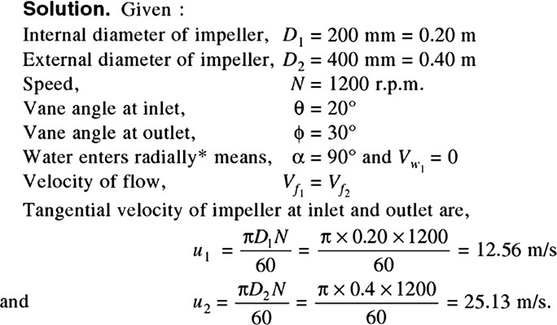 | 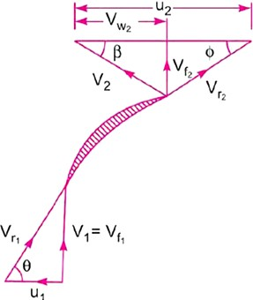
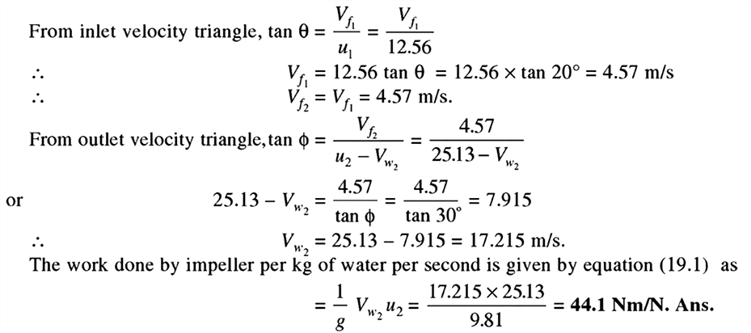

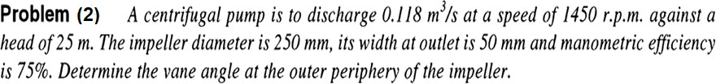

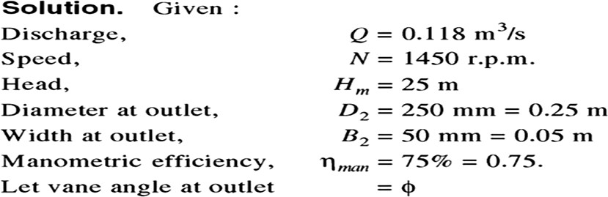  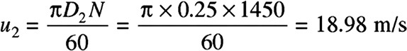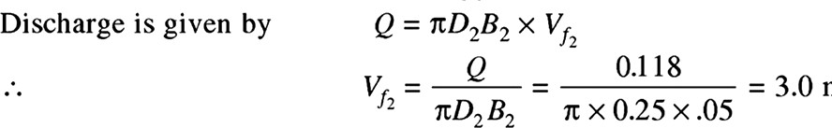 | 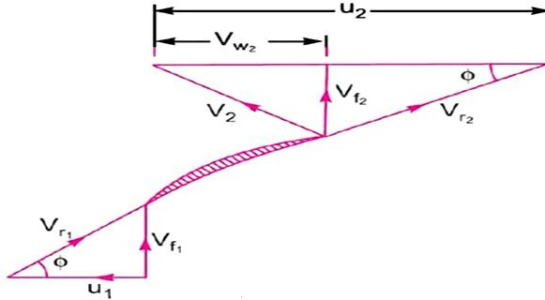
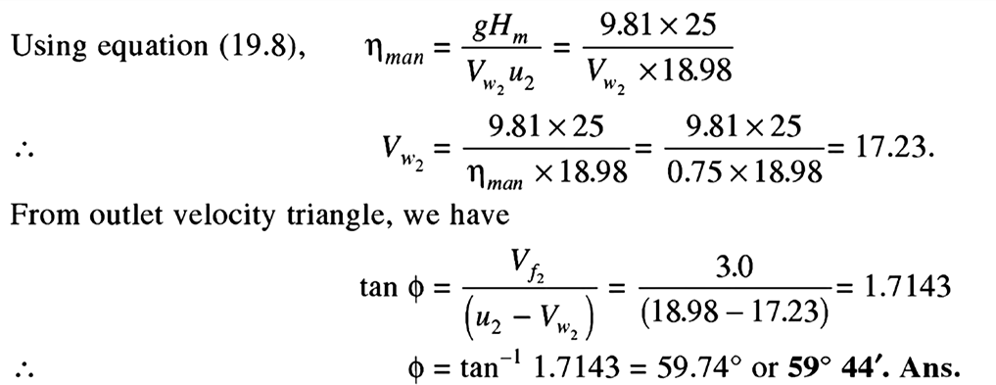
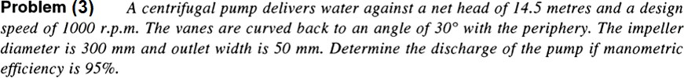
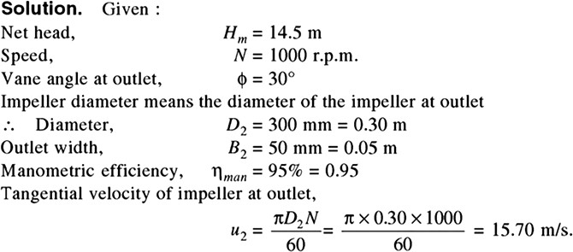
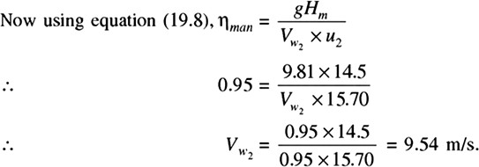

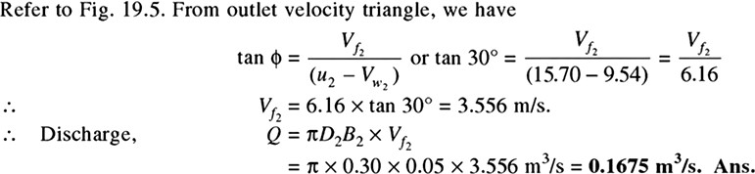
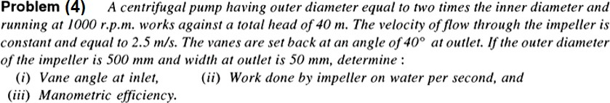

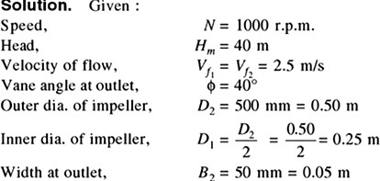  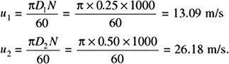 | 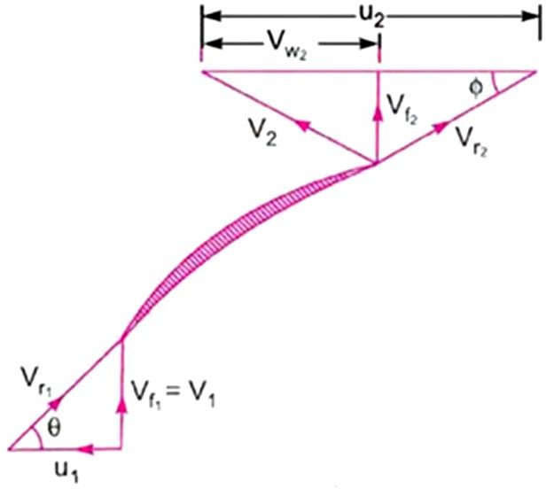
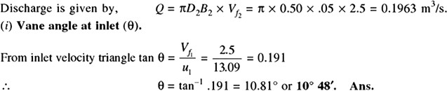
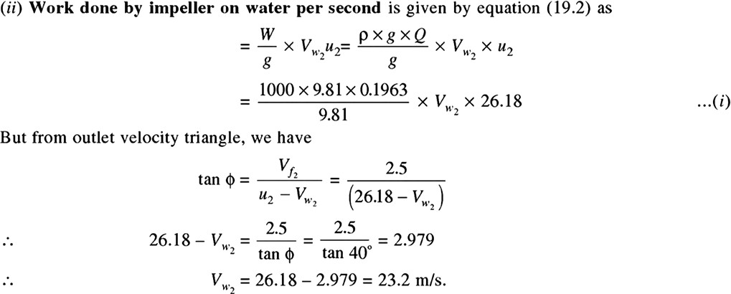

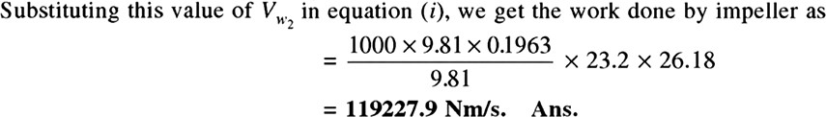
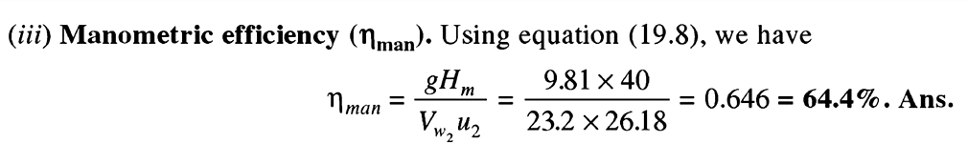

REFERENCE
- Fluid Mechanics & Hydraulic Machines by R.K. Bansal (Book)
- https://youtu.be/S7eGRy7zlj4?list=PLq7jO-L_k0yVmqNL4XVB9vOJ47_ysGYWn
- https://youtu.be/5KgIDLs4rGg?list=PLq7jO-L_k0yVmqNL4XVB9vOJ47_ysGYWn
- https://youtu.be/dPYq8Nj0awo?list=PLq7jO-L_k0yVmqNL4XVB9vOJ47_ysGYWn

RECIPROCATING PUMP

Introduction:
  - It is a hydraulic machine which converts mechanical energy into hydraulic energy (pressure energy).
  - It is a type of positive displacement pump.
  - It is suitable where small amount of water is to be delivered at higher pressure.
  - While working, it sucks water at low pressure into a cylinder containing a reciprocating piston. The piston exerts a thrust force on the water and increases its pressure.

Advantages:
  - It can deliver the required flow rate very precisely.
  - It gives a continuous rate of discharge.
  - It can deliver fluid at very high pressure.
  - It provides high suction lift.
  - No priming is needed.

Disadvantages:
  - It requires high maintenance
  - It gives low flow rate i.e. it discharges low amount of water..
  - These are heavy and bulky in size.
  - It has high initial cost.

Classification of Reciprocating pump:
  - According to sides in contact with water:
    - Single acting reciprocating pump
      - In single acting reciprocating pump water comes in contact of only one side of the piston. Suction and delivery of water occurs at one side.
    - Double acting reciprocating pump
      - In double acting reciprocating pump water comes in contact of both sides of the piston. Suction and delivery of water occurs at both sides.
  - According to number of cylinders used:
    - Single cylinder pump
    - Double cylinder pump
    - Multi cylinder pump

Construction of Reciprocating pump:
Major components of Reciprocating pump are:
  - A cylinder with piston, piston rod, connecting rod, crank and crank shaft
  - Suction pipe
  - Suction valve
  - Delivery pipe
  - Delivery valve

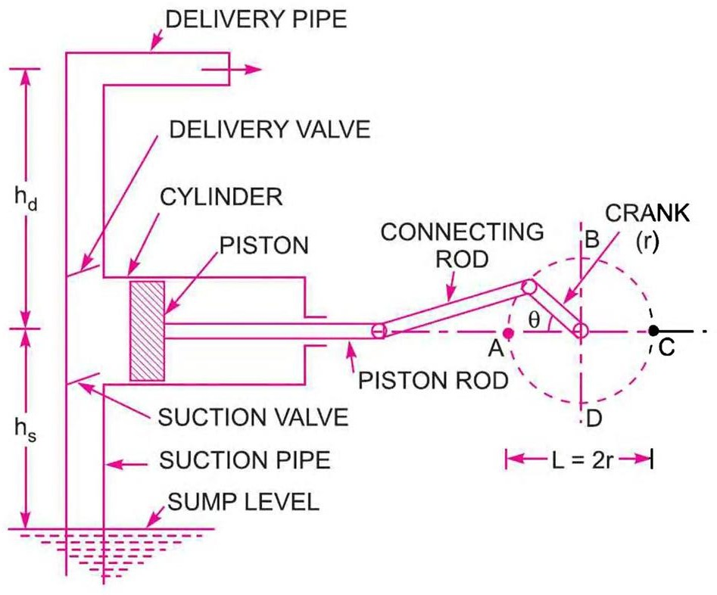

Working of Single acting reciprocating pump:
  - The above figure shows the single acting reciprocating pump.
  - It works in two strokes such as suction and delivery strokes.
  - During suction stroke, the piston moves backward and suction valve opens. So, water enter into the cylinder. During suction the delivery valve remains closed.
  - During delivery stroke, the piston moves forward and delivery valve opens. Suction valve remains closed. Piston exerts thrust on the water and increases water pressure.
  - Water with pressure energy escapes out of the cylinder through delivery pipe to the delivery point.

Work done of Single acting reciprocating pump:
Consider the following terms:
D = diameter of the cylinder
A = cross-sectional area of the piston = (π/4) × D² r = radius of crank
N =speed of crank in r.p.m L = length of stroke = 2 × r Hs = suction head
Hd = delivery head
H = Hs + Hd = total head
Q = discharge of pump per second ρ = density of water
Discharge of water in one revolution of crank = Volume of water delivered in one second = A × L
If, number of revolutions per sec = N/60
Discharge of pump per second, Q = A × L × (N/60)
- Weight of water delivered /sec,

W = ρ × g × A × L × (N/60)
- Work done by the pump /sec,
W × (Hs + Hd)

Working of Double acting reciprocating pump:

- When the piston moves right the suction valve of left side opens and suction valve of right side remains closed. The water is sucked into the cylinder at left side of piston.  - At this stroke delivery valve of left side remains closed and delivery valve of right side remains open. So, piston displaces the water with pressure energy at its right.  - Thus, suction occurs at left end of piston and discharge occurs at the right end.  - Similarly, when piston moves towards left, suction occurs at the right end and discharge occurs at the left end. | 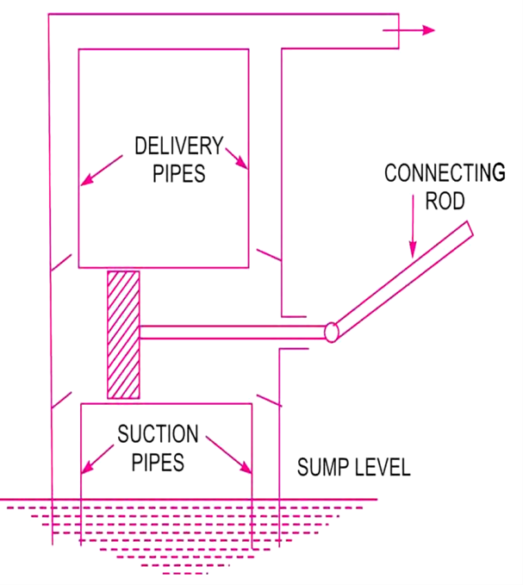

Work done of Double acting reciprocating pump:
Consider the following terms:
D = diameter of the cylinder
A = cross-sectional area of the piston = (π/4) × D² r = radius of crank
N =speed of crank in r.p.m L = length of stroke = 2 × r Hs = suction head
Hd = delivery head
H = Hs + Hd = total head
Q = discharge of pump per second ρ = density of water
Discharge of water in one revolution of crank = Volume of water delivered in one second = 2×A.L If, number of revolutions per sec = N/60
Discharge of pump per second, Q = 2×A × L × (N/60)
- Weight of water delivered /sec,

W = 2×ρ × g × A × L × (N/60)
- Work done by the pump /sec,
W × (Hs + Hd) = 2×ρ × g × A × L × (N/60) × (Hs + Hd)

Slip & Percentage of Slip:
Slip is the difference between the theoretical discharge (Qth) and actual discharge (Qact).
Slip = Qth – Qact
This is known as positive slip when, Qth > Qact. This is known as negative slip when, Qth < Qact
𝑄𝑡ℎ − 𝑄𝑎𝑐𝑡

𝑃𝑒𝑟𝑐𝑒𝑛𝑡𝑎𝑔𝑒 𝑜𝑓 𝑠𝑙𝑖𝑝 =
𝑄𝑡ℎ
× 100

Problem (1) A single acting reciprocating pump, running at 50 r.p.m delivers 0.01 m3/s of water. The diameter of the piston is 200 mm and stroke length 400 mm. Determine: (i) the theoretical discharge of the pump, (ii) coefficient of discharge, (iii) slip and the percentage of slip of the pump.
Solution: Given
Speed pf the pump, N = 50 r.p.m Actual discharge, Qa = 0.01 m³/s
Diameter of piston, D = 200 mm = 0.2 m Stroke length, L = 400 mm = 0.4 m
Cross-sectional area of piston, A = ^{𝜋} × 𝐷² = ^{𝜋} × 0.2² = 0.031416 m²
4 4
- Theoretical discharge of the pump, Qth = A × L × N = 0.031416 × 0.4 × 50 = 0.01047 𝑚³/𝑠

- Coefficient of discharge, 𝐶

= 𝑄𝑎𝑐𝑡 = 0.01
60 60

= 0.955

𝑑 𝑄𝑡ℎ

0.01047

- slip of the pump, 𝑄_{𝑡ℎ} − 𝑄_{𝑎𝑐𝑡} = 0.01047 − 0.01 = 0.00047 𝑚³/𝑠
Percentage of slip of the pump = 𝑄𝑡ℎ−𝑄𝑎𝑐𝑡 × 100 = 0.01047−0.01 × 100 = 4.489%

𝑄𝑡ℎ
0.01047

Problem (2) A double acting reciprocating pump, running at 40 r.p.m delivers 1 m3 of water per minute. The diameter of the piston is 200 mm and stroke length 400 mm. The delivery and suction head are 20 m and 5 m respectively. Find the slip of the pump and power required to drive the pump.
Solution: Given
Speed of the pump, N = 40 r.p.m

Actual discharge, 𝑄_{𝑎𝑐𝑡}
= 1𝑚³/𝑚𝑖𝑛 = 1 𝑚³/𝑠 = 0.01666 𝑚³/𝑠
60

Stroke length, L = 400 mm = 0.4 m Diameter of piston, D = 200 mm = 0.2 m Suction head, Hs = 5 m
Delivery head, Hd = 20 m
Cross-sectional area of piston, A = ^{𝜋} × 𝐷² = ^{𝜋} × 0.2² = 0.031416 m²
4 4
Theoretical discharge of the pump, Qth = 2×A × L × N = 2×0.031416 × 0.4 ×40 = 0.01675 𝑚³/𝑠
60 60
Slip of the pump, 𝑄_{𝑡ℎ} − 𝑄_{𝑎𝑐𝑡} = 0.01675 − 0.01666 = 0.00009 𝑚³/𝑠
Power required to drive the pump,
𝑃 = 2×𝞀 × g × A × L×N× (𝐻𝑠 + H𝑑) = 2×1000 × 9.81 × 0.031416 × 0.4×40× (5 + 20) = 4.109 𝑘𝑊
60000 60000

Difference between Centrifugal pump and Reciprocating pump:

Centrifugal pump | Reciprocating pump
1. Simple in construction | 1. Complicated in construction
2. Total weight of pump is less for a given discharge | 2. Total weight of pump is more for a given discharge
3. Suitable for large discharge and smaller heads | 3. Suitable for less discharge and higher heads
4. Required less floor area and simple foundation | 4. Required more floor area and heavy foundation
5. Less wear and tear | 5. More wear and tear
6. Maintenance cost is less | 6. Maintenance cost is high
7. Can run at higher speeds | 7. Can’t run at higher speeds
8. Its delivery is continuous | 8. Its delivery is pulsating
9.Needs priming | 9. Doesn’t need priming
10. It has less efficiency | 10. It has more efficiency

REFERENCE:
  - Fluid Mechanics & Hydraulic Machines by R.K. Bansal (Book)
  - https://youtu.be/H1AsPLYCyWk?list=PLq7jO-L_k0yVmqNL4XVB9vOJ47_ysGYWn
  - https://youtu.be/aiH_hwb8Ceg?list=PLq7jO-L_k0yVmqNL4XVB9vOJ47_ysGYWn
  - https://youtu.be/-JRsCoPWHkU?list=PLq7jO-L_k0yVmqNL4XVB9vOJ47_ysGYWn

PNEUMATIC CONTROL SYSTEM

Introduction:
Pneumatic systems are the power systems which are using compressed air as a working medium for the power transmission. The air compressor used in the Pneumatic system converts the mechanical energy of the prime mover into pressure energy of the compressed air. After compression, the compressed air obtained from the compressor is prepared and used to perform useful work. The air preparation includes filtration, cooling, water separation, drying, and adding lubricating oil mist. The compressed air is stored in compressed air reservoirs and transmitted through transmission lines: pipes and hoses. The pneumatic power is controlled by means of a set of valves such as the pressure, flow and directional control valves. Then, the pressure energy is converted to the required mechanical energy by means of the pneumatic cylinders and motors.

Advantages of Pneumatic Systems:

    - Air is used as a working medium in Pneumatic system which is unlimited in the atmosphere.
    - Compressed air can easily be stored and transmitted through pipe lines. It can be easily released into the atmosphere without further processing.
    - Pneumatic parts are proven to last longer and require less maintenance.
    - Pneumatic system components are relatively simple, which makes them suitable for less complicated automatic control systems.
    - Pneumatic systems can work in inflammable environments without the risk of fire or explosion.
    - Pneumatic system components are relatively inexpensive. So, it is cost-effective.

Disadvantages of Pneumatic Systems:

    - Air is a compressible gas. So, control and speed in a pneumatic system is more difficult in comparison to electric or hydraulic systems.
    - Pneumatic systems are less durable than hydraulic systems.
    - Pneumatic systems cannot operate underwater and are sensitive to changing temperatures and vibrations. Devices are known to fail over long periods of time.
    - Pneumatic systems are the loudest type of designs that other machines. Actuators that run the system are the source of the noise.

Basic Components of a Pneumatic System:
The functions of various components of a Pneumatic system are as follows:
    - Pneumatic actuator:
      - It converts the fluid power into mechanical power to perform useful work.
    - Compressor:
      - It is used to compress the fresh air drawn from the atmosphere.
    - Storage reservoir:
      - It is used to store a given volume of compressed air.
    - Valves:
      - These are used to control the direction, flow rate and pressure of compressed air.
    - External power supply (motor)
      - It is used to drive the compressor.
    - Piping system:
      - It carries the pressurized air from one location to another.

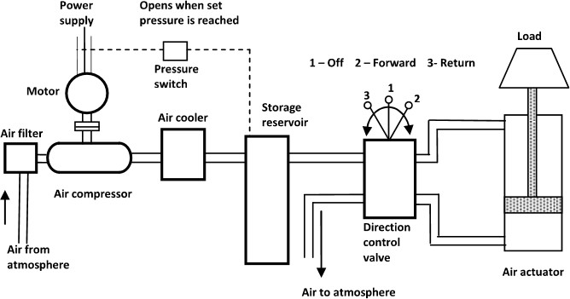

(Components of a Pneumatic System)
When the air compressor starts, it draws the air from the atmosphere through an air filter and raised required pressure and temperature of air. A cooler is provided to cool the air and moisture from the air is removed. This pressurised air is stored in a storage reservoir. A pressure switch is fitted with the storage reservoir to start and stop the electric motor when pressure falls and reaches the required level respectively. The pressurised air is transferred from the storage tank to one side of the piston and returned back from the other side of the piston to the tank. The direction of flow of air is controlled by the valve, which controls the motion in the actuator. The actuator is used to convert the fluid power into mechanical power to do useful work.

Comparison between a hydraulic and a pneumatic system:

Hydraulic System | Pneumatic System
1. It uses a pressurized liquid as a fluid. | 1. It uses compressed air as a fluid.
2. Pumps are used to provide pressurized liquids. | 2. Compressors are used to provide compressed air.
3. It is generally employed as closed system. | 3. It is generally employed as open system.
4. It operates at pressures up to 700 bar. | 4. It operates at pressures at 5-10 bar.
5. This system is heavy in weight. | 5. This system is light in weight.
6. Leakage of fluid affects the performance. | 6. There is no such effect of leakage.
7. Valve operations are difficult. | 7. Valve operations are easy.
8. There may be chance of fire hazards. | 8. This is free from fire hazards.
9. No special lubrication is required. | 9. Special lubrication is important.

AIR FILTER

Function:
    - To prevent entrance of solid contaminants to the system.
    - To condensate and remove the water vapour that is present in the air.
    - To arrest submicron particles that may pose a problem in the system components.
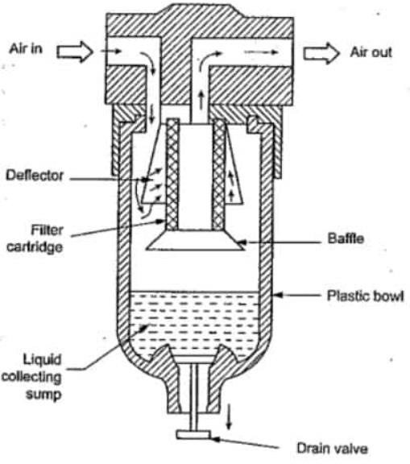

(Air Filter)

The construction and operation of a typical cartridge-type filter system is illustrated in Figure. It consists of the filter cartridge, deflector, plastic bowl, baffle, water drain valve.

Working:

The air to be filtered is allowed downward with a swirling motion that forces the moisture and the heavier particles to fall down. The deflector used in the filter mechanically separates the contaminants before they pass through the cartridge filter. The filter cartridge provides a random zig-zag passage for the airflow. This type of airflow arrests the solid particles in the cartridge passage. The water vapor gets condensed inside the filter and is collected at the bottom of the filter bowl. Also, heavier foreign particles that are separated from the air are collected at the bottom of the bowl. Then the accumulated water and other solid particles at the bottom of the filter bowl are drained off with the use of an on-off drain valve located at the bottom of the filter bowl.

AIR REGULATOR

Function:
The function of the air pressure regulator is to maintain working pressure virtually constant regardless of fluctuations of the line pressure and air consumption. When the pressure is too low, it results in poor efficiencies and when the pressure is too high, energy is wasted and equipment’s performance decay faster. In pneumatic system, pressure fluctuations occur due to variation in supply pressure or load pressure. It is therefore essential to regulate the pressure to match the requirement of load regardless of variation in supply pressure or load pressure.
Generally, pressure is regulated in pneumatic system at two places.
    - At the receiver tank and in the load circuits
Pressure regulation at the receiver tank is required as a safety measure for the system. In the load circuits, pressure regulator is used to regulate the pressure for downstream components such as valves and actuators.
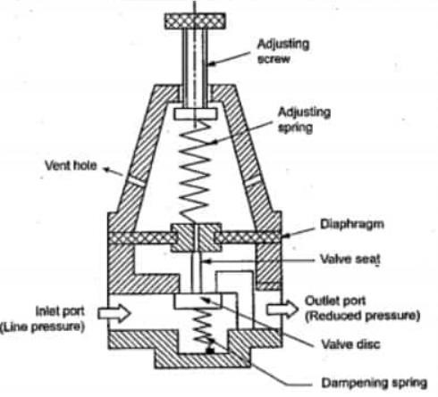

(Air Regulator)
There are two types of Pressure regulators: 1) Diaphragm type regulator, 2) Piston type regulator

AIR LUBRICATOR

Function:
The function of air lubricator is to add a controlled amount of oil with air to ensure proper lubrication of internal moving parts of pneumatic components.
Lubricants are used to
    - To reduce the wear of the moving parts
    - Reduce the frictional losses
    - Protect the equipment form corrosion
The lubricator adds the lubricating oil in the form of fine mist to reduce the friction and wear of moving parts of pneumatic components such as valves, packing used in air actuators
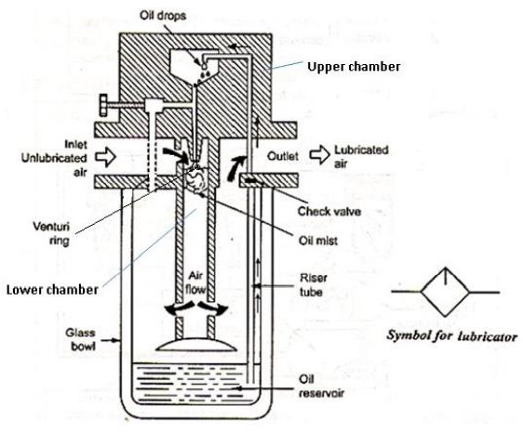

(Air Lubricator)
The air lubricator is shown in figure. As air enters the lubricator its velocity is increased by a venture ring. The pressure at the venture ring will be lower than the atmospheric pressure and the pressure on the oil is atmospheric. Due to this pressure difference between the upper chamber and lower chamber, oil will be drawn up in a riser tube. Oil droplets mix with the incoming air and form a fine mist. The needle valve is used adjust the pressure differential between across the oil jet and hence the oil flow rate. The air – oil mixture is forced to swirl as it leaves the central cylinder so that large particles of oil is goes back to bowl and only the mist goes to outlet.

Filter-Regulator-Lubricator Unit:
Filter, Pressure Regulator, and Lubricator are combined in a unit. These three units together are called FRL units or Service units. Compressed air from compressor comes in FRL unit wherein, the air is filtered, controlled, and lubricated. Such prepared and controlled air is delivered to the pneumatic system.

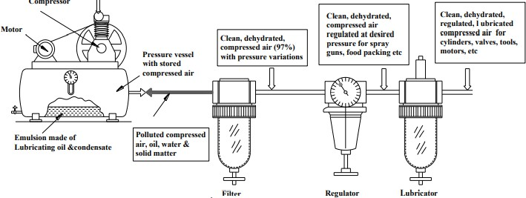

In most pneumatic systems, the compressed air is first filtered and then regulated to the specific pressure and made to pass through a lubricator for lubricating the oil. Thus, usually a filter, regulator and lubricator are placed in the inlet line to each air circuit. They may be installed as separate units, but more often they are used in the form of a combined unit.

Pressure Relief valve:
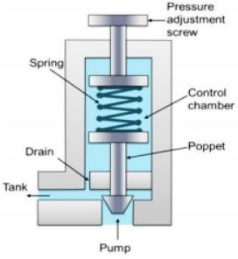

The pressure relief valves are used to protect the system components from excessive pressure. Its primary function is to limit the system pressure within a specified range. It is normally a closed type and it opens when the pressure exceeds a specified maximum value by diverting pump flow back to the tank. The simplest type valve contains a poppet held in a seat against the spring force as shown in Figure. This type of valves has two ports; one of which is connected to the pump and another is connected to the tank. The fluid enters from the opposite side of the poppet. When the system pressure exceeds the preset value, the poppet lifts and the fluid is escaped through the orifice to the storage tank directly. It reduces the system pressure and as the pressure reduces to the set limit again the valve closes.

HYDRAULIC CONTROL SYSTEM

Hydraulic System:
The hydraulic systems are used to employ pressurized liquid for transmitting energy and perform useful work. A hydraulic fluid is the transmitting medium of a hydraulic system. It performs the following functions.
    - Power transmission
    - Cooling and Lubrication
    - Sealing
    - Removal of impurities

Basic Components of a Hydraulic System:
The functions of various components of a Hydraulic system are as follows:
    - Hydraulic actuator:
      - It converts the fluid power into mechanical power to perform useful work. It may be of linear or rotary type.
    - Pump:
      - It is used to produce pressurised liquid. It forces the liquid into the different components of hydraulic circuit.
    - Reservoir:
      - It is used to store the hydraulic liquid.
    - Valves:
      - These are used to control the direction, flow rate and pressure of liquid.
    - External power supply (motor)
      - It is used to drive the pump.
    - Piping system:
      - It carries the liquid from one location to another.
    - Filter:
      - Filters are used to remove contaminants.
    - Pressure regulator:
      - It regulates the required level of pressure in the hydraulic fluid.
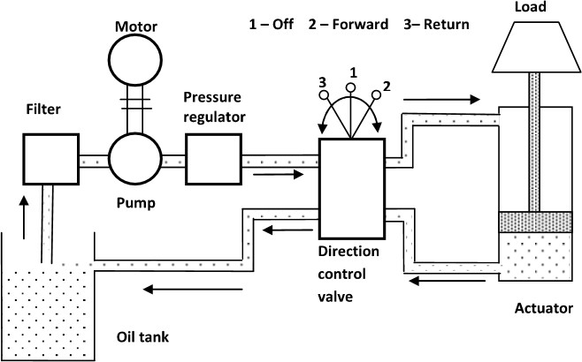
(Components of a Hydraulic System)

When the pump starts, it draws the oil from the oil tank through an oil filter and raised required pressure and temperature of oil. The oil pressure is regulated by the pressure regulator. The direction of flow of oil is controlled by the valve, which controls the motion in the actuator. The actuator is used to convert the fluid power into mechanical power to do useful work.

Gear Pumps
Gear pumps are less expensive but limited to pressures below 140 bar. It is noisy in operation than either vane or piston pumps. Gear pumps are invariably of fixed displacement type, which means that the amount of fluid displaced for each revolution of the drive shaft is theoretically constant. There are two types of gear pumps.

External Gear Pumps:
External gear pumps are the most popular hydraulic pumps in low-pressure ranges due to their long operating life, high efficiency and low cost. They are generally used in a simple machine. The most common form of external gear pump is shown in Figure. It consists of a pump housing in which a pair of precisely machined meshing gears runs with minimal radial and axial clearance. One of the gears, called a driver is driven by a prime mover. The driver drives another gear called a follower. As the teeth of the two gears separate, the fluid from the pump inlet gets trapped between the rotating gear cavities and pump housing. The trapped fluid is then carried around the periphery of the pump casing and delivered to outlet port. The teeth of precisely meshed gears provide almost a perfect seal between the pump inlet and the pump outlet. When the outlet flow is resisted, pressure in the pump outlet chamber builds up rapidly and forces the gear diagonally outward against the pump inlet. When the system pressure increases, imbalance occurs. This imbalance increases mechanical friction and the bearing load of the two gears. Hence, the gear pumps are operated to the maximum pressure rating stated by the manufacturer.
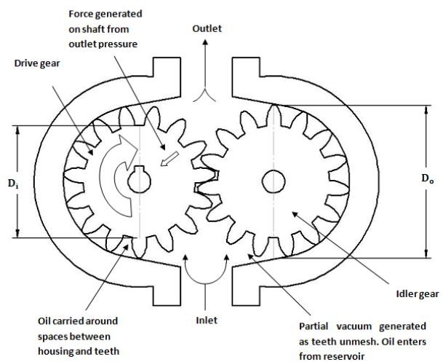

(Working of External Gear pump)

The advantages of external gear pump are as follows:
- They are self-priming.
- They give constant delivery for a given speed.
- They are compact and light in weight.
- Volumetric efficiency is high.

The disadvantages of external gear pump are as follows:
- The liquid to be pumped must be clean, otherwise it will damage pump.
- Variable speed drives are required to change the delivery.
- If they run dry, parts can be damaged because the fluid to be pumped is used as lubricant.

Internal Gear Pumps
Another form of gear pump is the internal gear pump, which is illustrated in the figure. They consist of two gears: An external gear and an internal gear. The crescent placed in between these acts as a seal between the suction and discharge. When a pump operates, the external gear drives the internal gear and both gears rotate in the same direction. The fluid fills the cavities formed by the rotating teeth and the stationary crescent. Both the gears transport the fluid through the pump. The crescent seals the low-pressure pump inlet from the high-pressure pump outlet. The fluid volume is directly proportional to the degree of separation and these units may be reversed without difficulty. The major use for this type of pump occurs when a through shaft is necessary, as in an automatic transmission. These pumps have a higher-pressure capability than external gear pumps.
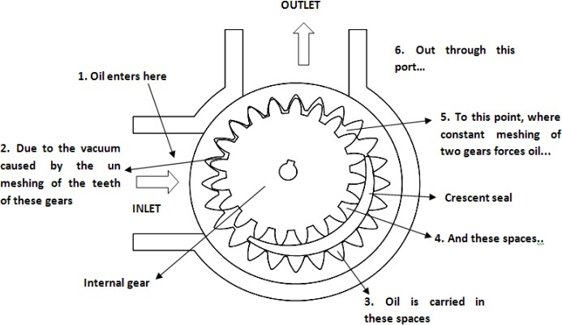
(Working of Internal Gear pump)

Vane Pumps
There are two types of vane pumps:
  - Unbalanced vane pump
  - Balanced vane pump
Unbalanced vane pumps are of two varieties:
    - Unbalanced vane pump with fixed delivery.
    - Unbalanced vane pump with pressure-compensated variable delivery.

Unbalanced Vane Pump with Fixed Delivery:
A simplified form of unbalanced vane pump with fixed delivery and its operation are shown in Figure. The main components of the pump are the cam surface and the rotor. The rotor contains radial slots splined to drive shaft. The rotor rotates inside the cam ring. Each radial slot contains a vane, which is free to slide in or out of the slots due to centrifugal force. The vane is designed to mate with surface of the cam ring as the rotor turns. The cam ring axis is offset to the drive shaft axis. When the rotor rotates, the centrifugal force pushes the vanes out against the surface of the cam ring. The vanes divide the space between the rotor and the cam ring into a series of small chambers. During the first half of the rotor rotation, the volume of these chambers increases, thereby causing a reduction of pressure. This is the suction process, which causes the fluid to flow through the inlet port. During the second half of rotor rotation, the cam ring pushes the vanes back into the slots and the trapped volume is reduced. This positively ejects the trapped fluid through the outlet port. In this pump, all pump action takes place in the chambers located on one side of the rotor and shaft, and so the pump is of an unbalanced design. The delivery rate of the pump depends on the eccentricity of the rotor with respect to the cam ring.
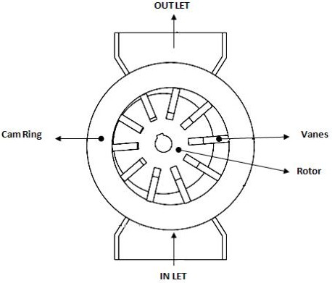

(Simple Vane pump)

Unbalanced Vane Pump with Pressure-Compensated Variable Delivery:
Schematic diagram of variable displacement vane pump is shown in Figure. The Variable displacement feature can be brought into vane pumps by varying eccentricity between the rotor and the cam ring. Here in this pump, the stator ring is held against a spring-loaded piston. The system pressure acts directly through a hydraulic piston on the right side. This forces the cam ring against a spring-loaded piston on the left side. If the discharge pressure is large enough, it overcomes the compensated spring force and shifts the cam ring to the left. This reduces the eccentricity and decreases the flow. If the pressure continues to increase, there is no eccentricity and pump flow becomes zero.
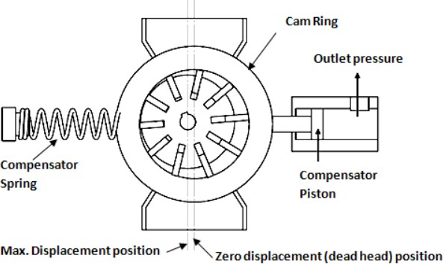

(Working of Variable displacement Vane pump)

Balanced Vane Pump with Fixed Delivery:
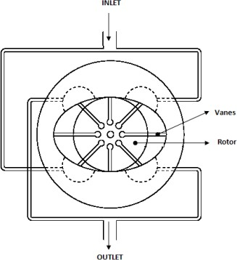

(Working of Balanced Vane pump)

A balanced vane pump is a very versatile design that has found widespread use in both industrial and mobile applications. The basic design principle is shown in Figure. The rotor and vanes are contained within a double eccentric cam ring and there are two inlet segments and two outlet segments during each revolution. This double pumping action not only gives a compact design, but also leads to another important advantage: although pressure forces acting on the rotor in the outlet area are high, the forces at the two outlet areas are equal and opposite, completely cancelling each other. As a result, there are no net loads on shaft bearings. Consequently, the life of this type of pump in many applications has been exceptionally good. Operating times of 24000 h or more in industrial applications are widespread. In more severe conditions encountered in mobile vehicles, 5000–10000h of trouble-free operation is frequently achieved.

The advantages of vane pumps are as follows:
- Vane pumps are self-priming, robust and supply constant delivery at a given speed.
- They provide uniform discharge with negligible pulsations.
- Their vanes are self-compensating for wear and vanes can be replaced easily.
- These pumps do not require check valves.
- They are light in weight and compact.
- They can handle liquids containing vapors and gases.
- Volumetric and overall efficiencies are high.
- Discharge is less sensitive to changes in viscosity and pressure variations.

The disadvantages of vane pumps are as follows:
- Relief valves are required to protect the pump in case of sudden closure of delivery.
- They are not suitable for abrasive liquids.
- They require good seals.
- They require good filtration systems and foreign particle can severely damage pump.

Piston Pumps:
Piston pumps are of the following two types:
  - Axial piston pump
  - Radial piston pump
Axial Piston pumps are of two designs:
    - Bent-axis-type piston pump
    - Swash-plate-type piston pump

HYDRAULIC ACTUATORS:
Hydraulic systems are used to control and transmit power. A pump driven by a prime mover such as an electric motor creates a flow of fluid, in which the pressure, direction and rate of flow are controlled by valves. An actuator is used to convert the energy of fluid back into the mechanical power. The amount of output power developed depends upon the flow rate, the pressure drop across the actuator and its overall efficiency. Thus, hydraulic actuators are devices used to convert pressure energy of the fluid into mechanical energy.
Depending on the type of actuation, hydraulic actuators are classified as follows:
- Linear actuator: For linear actuation (hydraulic cylinders).
- Rotary actuator: For rotary actuation (hydraulic motor).
- Semi-rotary actuator: For limited angle of actuation (semi-rotary actuator).

CONTROL VALVES:
In fluid power, controlling elements are called valves. There are three types of valves:
- Directional control valves (DCVs): They determine the path through which a fluid transverses a given circuit.
- Pressure control valves: They protect the system against overpressure, which may occur due to a sudden surge as valves open or close or due to an increase in fluid demand.
- Flow control valves: Shock absorbers are hydraulic devices designed to smooth out pressure surges and to dampen hydraulic shock.

Directional Control Valves:
A valve is a device that receives an external signal (mechanical, fluid pilot signal, electrical or electronics) to release, stop or redirect the fluid that flows through it. The function of a DCV is to control the direction of fluid flow in any hydraulic system. A DCV does this by changing the position of internal movable parts.
A DCV is mainly required for the following purposes:
  - To start, stop, accelerate, decelerate and change the direction of motion of a hydraulic actuator.
  - To permit the free flow from the pump to the reservoir at low pressure when the pump’s delivery is not needed into the system.
  - To vent the relief valve by either electrical or mechanical control.
  - To isolate certain branch of a circuit.

Classification of DCVs:
Based on fluid path, DCVs can be classified as follows:
  - Check valves.
  - Shuttle valves.
  - Two-way valves.
  - Three-way valves.
  - Four-way valves.

Based on design characteristics, DCVs can be classified as follows:
  - An internal valve mechanism that directs the flow of fluid. Such a mechanism can either be a poppet, a ball, a sliding spool, a rotary plug or a rotary disk.
  - Number of switching positions (usually 2 or 3).
  - Number of connecting ports or ways.
  - Method of valve actuation that causes the valve mechanism to move into an alternate position. Based on the control method, DCVs can be classified as follows:
  - Direct controlled DCV: A valve is actuated directly on the valve spool. This is suitable for small sized valves.
  - Indirect controlled DCV: A valve is actuated by a pilot line or using a solenoid or by the combination of electrohydraulic and electro-pneumatic means. The use of solenoid reduces the size of the valve. This is suitable for large-sized valves.
Based on the construction of internal moving parts, DCVs can be classified as follows:
  - Rotary spool type: In this type, the spool is rotated to change the direction of fluid. It has longitudinal grooves. The rotary spools are usually manually operated.
  - Sliding spool type: This consists of a specially shaped spool and a means of positioning the spool. The spool is fitted with precision into the body bore through the longitudinal axis of the valve body. The lands of the spool divide this bore into a series of separate chambers. The ports of the valve body lead into these chambers and the position of the spool determines the nature of inter-connection between the ports.
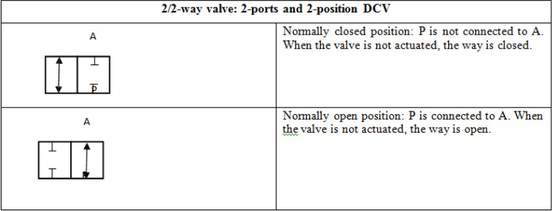
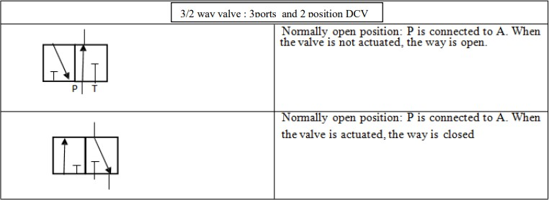

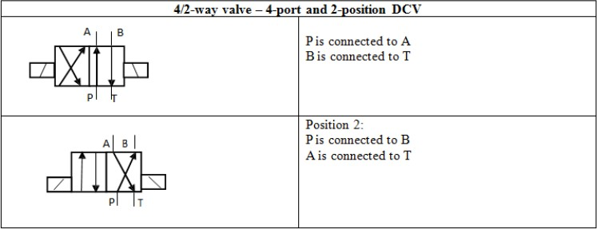
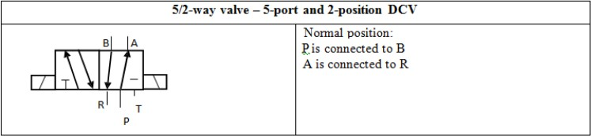

3/2-Way DCV (Normally Closed):
Three-way valves either block or allow flow from an inlet to an outlet. They also allow the outlet to flow back to the tank when the pump is blocked, while a two-way valve does not. A three-way valve has three ports, namely, a pressure inlet (P), an outlet to the system(A)and a return to the tank(T). Figure 1.10 shows the operation of a 3/2-way valve normally closed. In its normal position, the valve is held in position by a spring as shown in Fig. 1.10(a). In the normal position, the pressure port P is blocked and outlet A is connected to the tank. In the actuated position shown in Fig. 1.10(b), the pressure port is connected to the tank and the tank port is blocked.
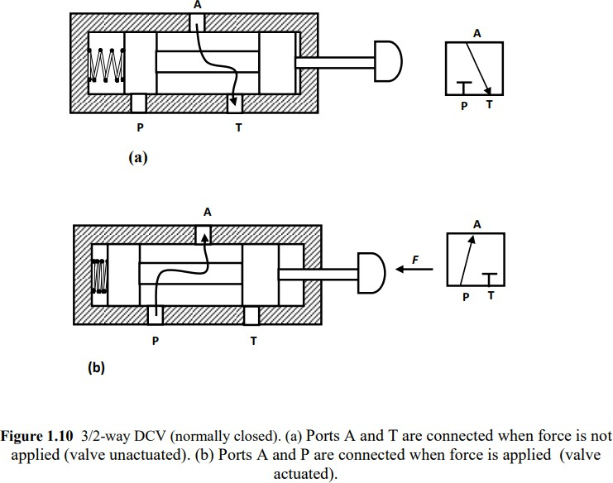

3/2-Way DCV (Normally Opened):
Figure 1.11 shows a three-way two-position DCV (normally open) with push button actuation and spring return. In the normal position, shown in Fig. 1.11(a), the valve sends pressure to the outlet and blocks the tank port in the normal position. In the actuated position, the pressure port is blocked and the outlet is vented to the tank.
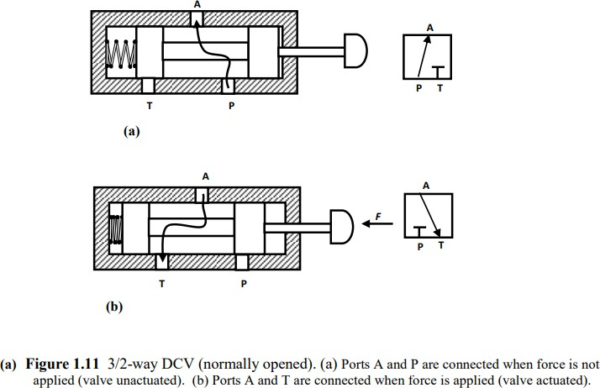

Check Valve
The simplest DCV is a check valve. A check valve allows flow in one direction, but blocks the flow in the opposite direction. It is a two-way valve because it contains two ports. The following figure shows the graphical symbol of a check valve along with its no-flow and free-flow directions.
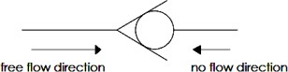

Pressure-control valves:
Pressure-control valves are used in hydraulic systems to control actuator force (force = pressure × area) and to determine and select pressure levels at which certain machine operations must occur. Pressure controls are mainly used to perform the following system functions:
  - Limiting maximum system pressure at a safe level.
  - Regulating/reducing pressure in certain portions of the circuit.
  - Unloading system pressure.
  - Assisting sequential operation of actuators in a circuit with pressure control.
  - Any other pressure-related function by virtue of pressure control.
  - Reducing or stepping down pressure levels from the main circuit to a lower pressure in a sub- circuit.

The various pressure control valves are:
  - Pressure-relief valve
  - Pressure-reducing valve
  - Unloading valve
  - Counterbalance valve
  - Pressure-sequence valve
  - Brake valve.

Pressure-Relief Valves:
Pressure-relief valves limit the maximum pressure in a hydraulic circuit by providing an alternate path for fluid flow when the pressure reaches a pre-set level. In a hydraulic circuit, a relief valve opens and bypasses fluid when pressure exceeds its setting.
Schematic diagram of simple relief valve is shown in Figure. It is normally a closed valve whose function is to limit the pressure to a specified maximum value by diverting pump flow back to the tank. A poppet is held seated inside the valve by a heavy spring. When the system pressure reaches a high enough value, the poppet is forced off its seat. This permits flow through the outlet to the tank as long as this high-pressure level is maintained. Note the external adjusting screw, which varies spring force and, thus, the pressure at which the valve begins to open.
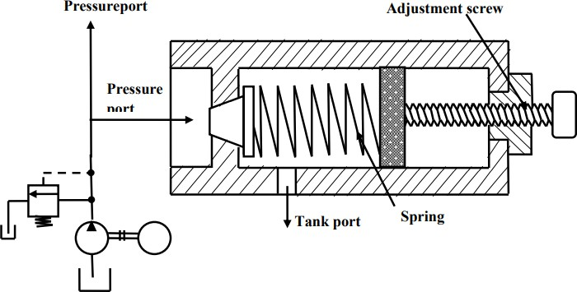

Pressure-Reducing Valve:

(A simple Pressure relief valve)

This is another type of pressure control valve. This type of valve (which is normally open) is used to maintain reduced pressures in specified locations of hydraulic systems. It is actuated by downstream pressure and tends to close as this pressure reaches the valve setting. Schematic diagram of pressure reducing valve is shown in Figure.
A pressure-reducing valve uses a spring-loaded spool to control the downstream pressure. If the downstream pressure is below the valve setting, the fluid flows freely from the inlet to the outlet. Note that there is an internal passageway from the outlet which transmits outlet pressure to the spool end opposite the spring. When the outlet (downstream) pressure increases to the valve setting, the spool moves to the right to partially block the outlet port. Just enough flow is passed to the outlet to maintain its preset pressure level. If the valve closes completely, leakage past the spool causes downstream pressure to build up above the valve setting.

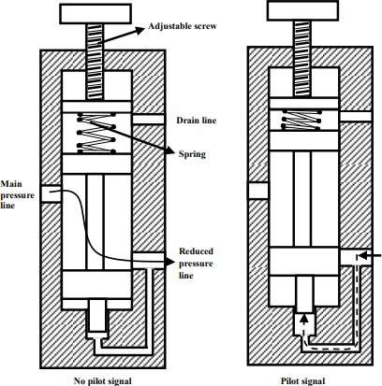

Flow-control valves:

(A Pressure reducing valve)

Flow-control valves control the rate of flow of a fluid through a hydraulic circuit. Flow-control valves accurately limit the fluid volume rate from fixed displacement pump to or from branch circuits. Their function is to provide velocity control of linear actuators, or speed control of rotary actuators.
Flow-control valves can be classified as follows:
- Non-pressure compensated
- Pressure compensated

Non-Pressure-Compensated Valves:
Non-pressure-compensated flow-control valves are used when the system pressure is relatively constant and motoring speeds are not too critical. The operating principle behind these valves is that the flow through an orifice remains constant if the pressure drops across it remains the same. In other words, the rate of flow through an orifice depends on the pressure drop across it.
The main disadvantage of this valve is that, the speed of the piston cannot be defined accurately using non-pressure-compensated flow-control valves when the working load varies.
Schematic diagram of non-pressure-compensated needle-type flow-control valve is shown in Fig. 1.3. It is the simplest type of flow-control valve. It consists of a screw (and needle) inside a tubelike structure. It has an adjustable orifice that can be used to reduce the flow in a circuit. The size of the orifice is adjusted by turning the adjustment screw that raises or lowers the needle. For a given opening position, a needle valve behaves as an orifice. Usually, charts are available that allow quick determination of the controlled flow rate for given valve settings and pressure drops. Sometimes needle valves come with an integrated check valve for controlling the flow in one direction only. The check valve permits easy flow in the opposite direction without any restrictions.

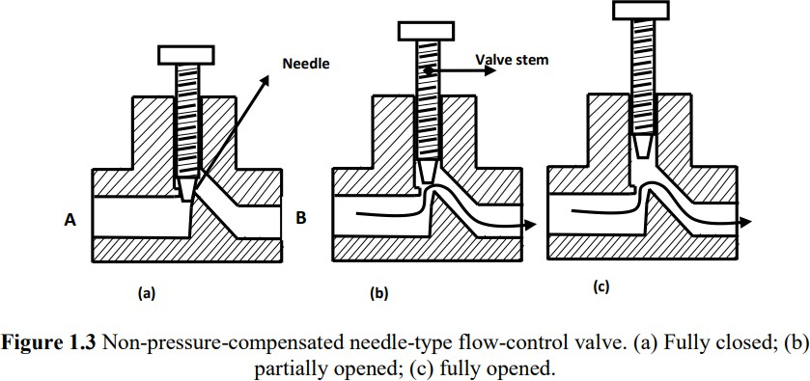

Pressure-Compensated Valves:
Pressure-compensated flow-control valves overcome the difficulty caused by non- pressurecompensated valves by changing the size of the orifice in relation to the changes in the system pressure. This is accomplished through a spring-loaded compensator spool that reduces the size of the orifice when pressure drop increases. Once the valve is set, the pressure compensator acts to keep the pressure drop nearly constant.
Schematic diagram of a pressure compensated flow-control valve is shown in Fig. 1.5. A pressure- compensated flow-control valve consists of a main spool and a compensator spool. The adjustment knob controls the main spool’s position, which controls the orifice size at the outlet. The upstream pressure is delivered to the valve by the pilot line A. Similarly, the downstream pressure is ported to the right side of the compensator spool through the pilot line B. The compensator spring biases the spool so that it tends toward the fully open position. If the pressure drops across the valve increases, that is, the upstream pressure increases relative to the downstream pressure, the compensator spool moves to the right against the force of the spring. This reduces the flow that in turn reduces the pressure drop and tries to attain an equilibrium position as far as the flow is concerned.
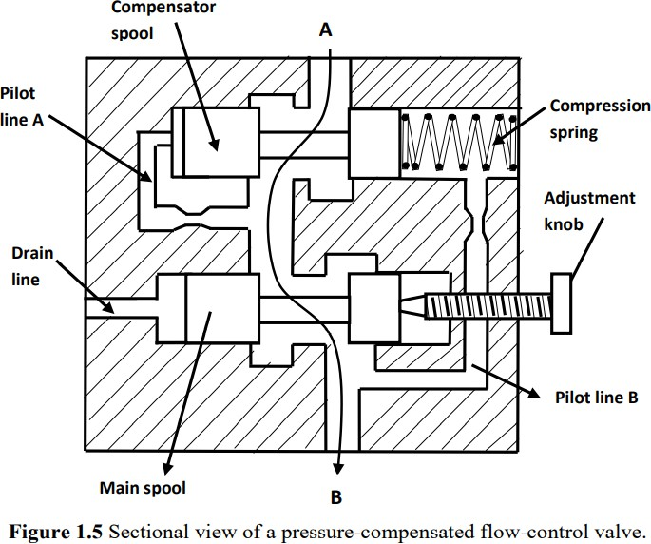

Speed-Controlling Circuits:
In hydraulic operations, it is necessary to control the speed of the actuator so as to control the force, power, timing and other factors of the operation. Actuator speed control is achieved by controlling the rate of flow into or out of the cylinder.
Speed control by controlling the rate of flow into the cylinder is called meter-in control. Speed control by controlling the rate of flow out of the cylinder is called meter-out control.

Meter-In Circuit:
The following figure shows a meter-in circuit with control of extend stroke. The inlet flow into the cylinder is controlled using a flow-control valve. In the return stroke, however, the fluid can bypass the needle valve and flow through the check valve and hence the return speed is not controlled. This implies that the extending speed of the cylinder is controlled whereas the retracing speed is not.
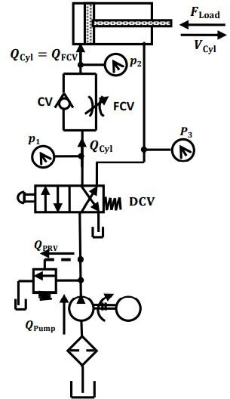

Meter-Out Circuit:
The following figure shows a meter-out circuit for flow control during the extend stroke. When the cylinder extends, the flow coming from the pump into the cylinder is not controlled directly. However, the flow out of the cylinder is controlled using the flow-control valve (metering orifice). On the other hand, when the cylinder retracts, the flow passes through the check valve unopposed, bypassing the needle valve. Thus, only the speed during the extend stroke is controlled. Both the meter-in and meter-out circuits mentioned above perform the same operation (control the speed of the extending stroke of the piston), even though the processes are exactly opposite to one another.

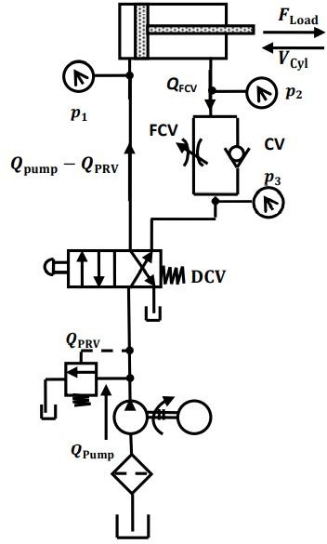

Bleed-Off Circuit:
Compared to meter-in and meter-out circuits, a bleed-off circuit is less commonly used. Figure 1.10 shows a bleed-off circuit with extend stroke control. In this type of flow control, an additional line is run through a flow-control valve back to the tank. To slow down the actuator, some of the flow is bleed off through the flow-control valve into the tank before it reaches the actuator. This reduces the flow into the actuator, thereby reducing the speed of the extend stroke. The main difference between a bleed-off circuit and a meter-in/meter-out circuit is that in a bleed-off circuit, opening the flow- control valve decreases the speed of the actuator, whereas in the case of a meter-in/meter-out circuit, it is the other way around.

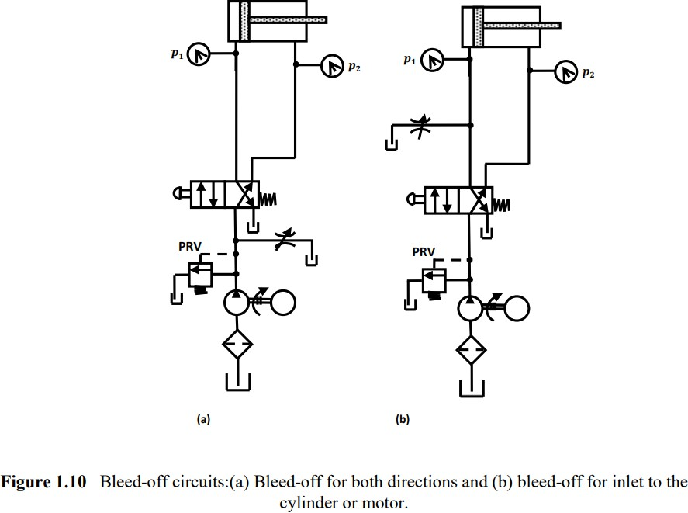

Hydraulic Circuit:
A hydraulic circuit is a group of components such as pumps, actuators, control valves, conductors and fittings arranged to perform useful work. There are three important considerations in designing a hydraulic circuit:
- Safety of machine and personnel in the event of power failures.
- Performance of given operation with minimum losses.
- Cost of the component used in the circuit.

Control of a Single-Acting Hydraulic Cylinder:
The following figure shows that the control of a single-acting, spring return cylinder using a three- way two-position manually actuated, spring offset direction-control valve (DCV). In the spring offset mode, full pump flow goes to the tank through the pressure-relief valve (PRV). The spring in the rod end of the cylinder retracts the piston as the oil from the blank end drains back into the tank. When the valve is manually actuated into its next position, pump flow extends the cylinder. After full extension, pump flow goes through the relief valve. Deactivation of the DCV allows the cylinder to retract as the DCV shifts into its spring offset mode.

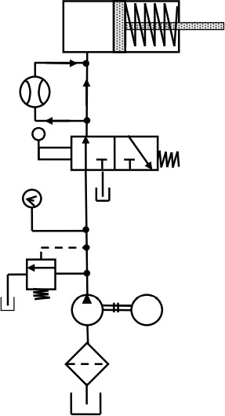

(Control of a single-acting cylinder)

Control of a Double-Acting Hydraulic Cylinder:
The circuit diagram to control double-acting cylinder is shown in the following figure. The control of a double-acting hydraulic cylinder is described as follows: 1. When the 4/3 valve is in its neutral position (tandem design), the cylinder is hydraulically locked and the pump is unloaded back to the tank. 2. When the 4/3 valve is actuated into the flow path, the cylinder is extended against its load as oil flows from port P through port A. Oil in the rod end of the cylinder is free to flow back to the tank through the four-way valve from port B through port T. 3. When the 4/3 valve is actuated into the right-envelope configuration, the cylinder retracts as oil flows from port P through port B. Oil in the blank end is returned to the tank via the flow path from port A to port T. At the ends of the stroke, there is no system demand for oil. Thus, the pump flow goes through the relief valve at its pressure level setting unless the four-way valve is deactivated.

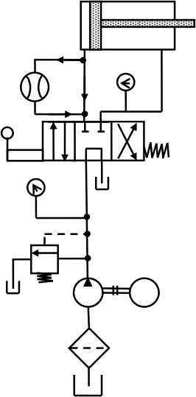

(Control of a double-acting cylinder)

HYDRAULIC PNEUMATIC SYMBOLS
Hydraulics pneumatics symbols play very important role in design and implementation of the systems. These symbols designate the components and way they should be interconnected. Without hydraulics pneumatics symbols it would have very difficult to represent and express a hydraulic circuit.

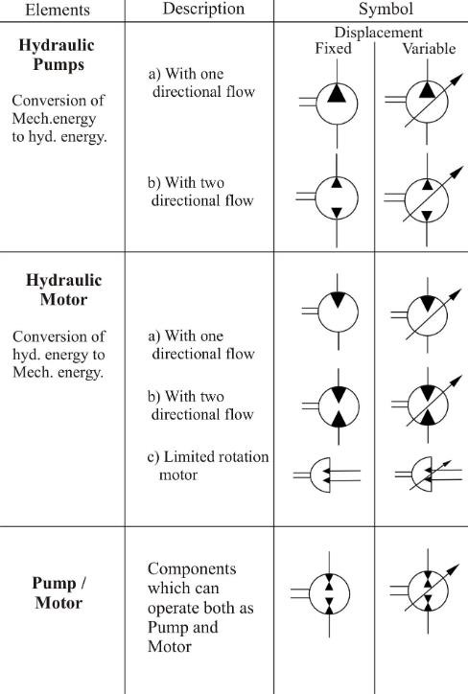

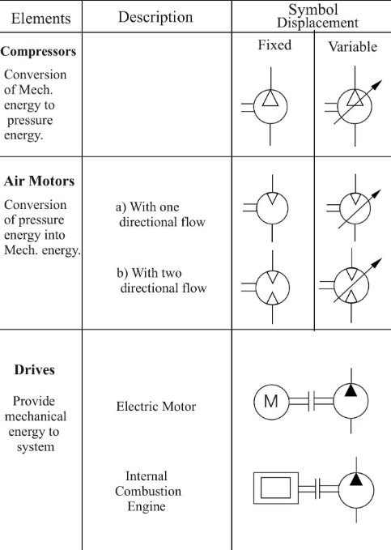

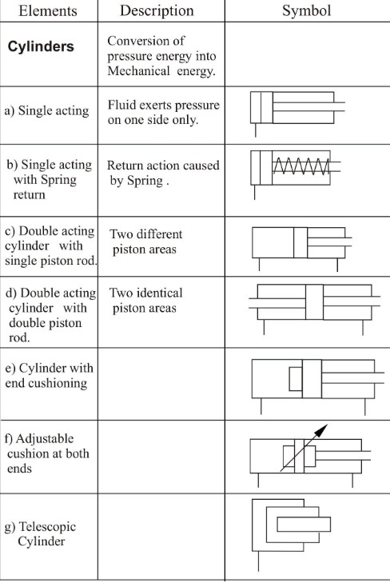

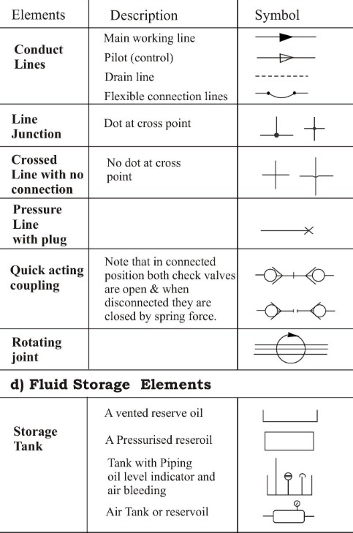

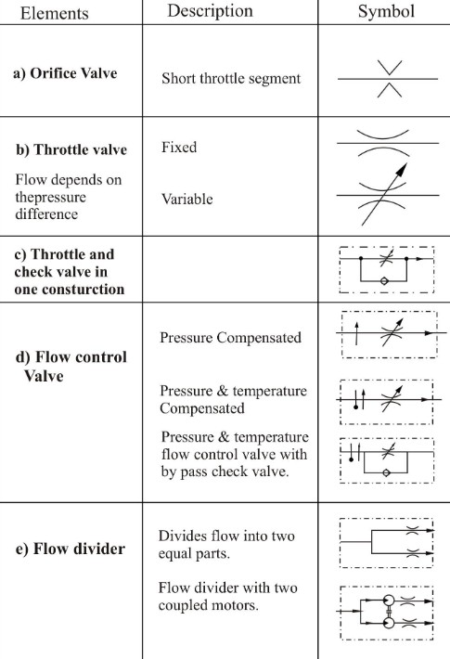

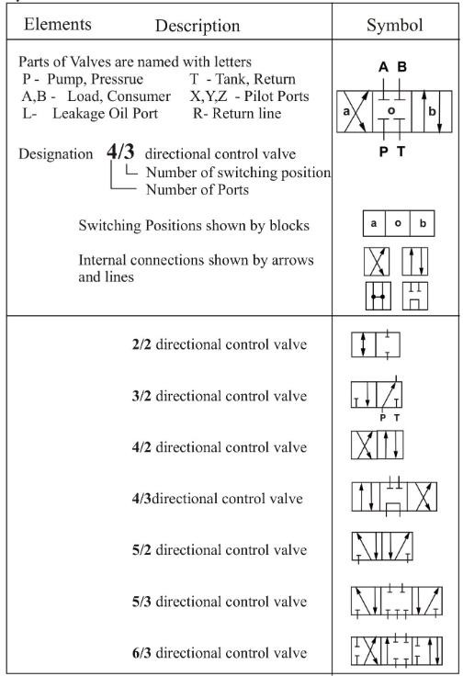

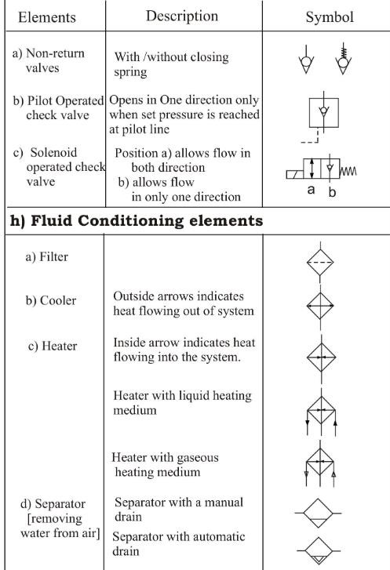

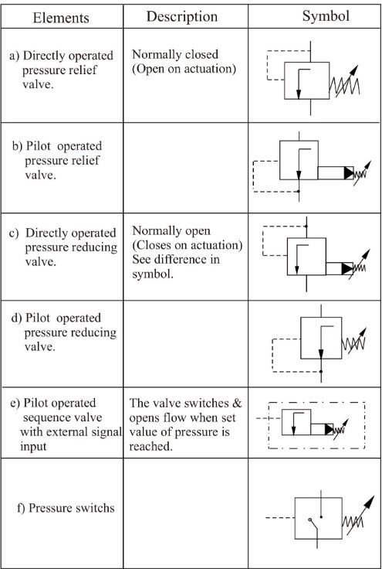

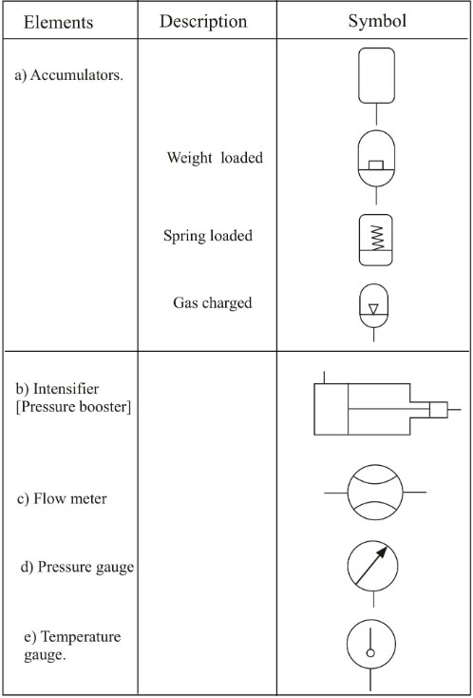

REFERENCE:
- Text book of Hydraulics & Hydraulic Machines by R.S. Khurmi (Book)
- Hydraulic & Pneumatic Control by S. Sundaram (Book).
- https://youtu.be/8xd7cWvMrvE?list=PLbMVogVj5nJTKwm1WjlutrAEZrLE995Ja
- https://youtu.be/2 g1Fntx4o?list=PLbMVogVj5nJTKwm1WjlutrAEZrLE995Ja
- https://youtu.be/EWPVrljCgpk?list=PLbMVogVj5nJTKwm1WjlutrAEZrLE995Ja
- https://youtu.be/yx3DzindtXU?list=PLbMVogVj5nJTKwm1WjlutrAEZrLE995Ja
- https://youtu.be/gruZTqln1cY?list=PLbMVogVj5nJTKwm1WjlutrAEZrLE995Ja
- https://youtu.be/2 g1Fntx4o?list=PLbMVogVj5nJTKwm1WjlutrAEZrLE995Ja
- https://youtu.be/EWPVrljCgpk?list=PLbMVogVj5nJTKwm1WjlutrAEZrLE995Ja
- https://youtu.be/yx3DzindtXU?list=PLbMVogVj5nJTKwm1WjlutrAEZrLE995Ja
- https://youtu.be/UGozt4Lum4Q?list=PLbMVogVj5nJTKwm1WjlutrAEZrLE995Ja
- https://youtu.be/3YQVPFpXHQQ?list=PLbMVogVj5nJTKwm1WjlutrAEZrLE995Ja

