DEPARTMENT OF MECHANICAL ENGINEERING

LECTURE NOTES

ON

ENGINEERING MATERIAL
3rd SEMESTER, MECHANICAL

By

Er. Santosh Nayak
Lecture in Mechanical Engineering
B.IE.T, MOHADA

Engineering Material-1

- Structure – Property relation
- Classification of material
- Metals
- Ceramics
- Polymers
- Composites
- Advanced materials

Structure – Property relation

One aspect of materials science is the investigation of relationships that exist between the structures and properties of materials.

In contrast, materials engineering is, on the basis of these structure–property correlations, designing or engineering the structure of a material to produce a predetermined set of properties.

Four components are important in the science and engineering of materials—namely, structure and properties, processing and performance. With regard to the relationships of these four components, the structure of a material will depend on how it is processed. Furthermore, a material’s performance will be a function of its properties.

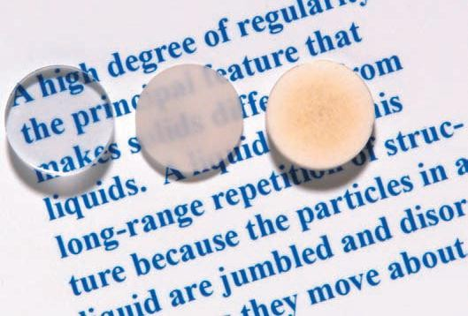
These differences in optical properties are a consequence of differences in structure of these materials, which have resulted from the way the materials were processed.

- All of these specimens are aluminum oxide

- the left most one is a single crystal—that is, has a high degree of perfection—which gives
rise to its transparency.

- The centre one is composed of numerous and very small single crystals that are all connected; the boundaries between these small crystals scatter a portion of the light reflected from the printed page, which makes this material optically translucent.

- Finally, the specimen on the right is composed not only of many small, interconnected crystals, but also of a large number of very small pores or void spaces.

- Thus, the structures of these three specimens are different in terms of crystal boundaries and pores, which affect the optical transmittance properties produced using different processing technique and hence performance of each material will be different wrt optical transparency.

CLASSIFICATION OF MATERIALS

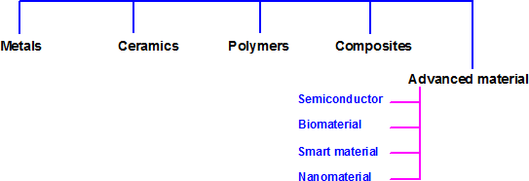

Metals

  - Materials in this group are composed of one or more metallic elements (e.g., iron, aluminium, copper, titanium, gold, and nickel), and often also non-metallic elements (e.g., carbon, nitrogen, and oxygen) in relatively small amounts.

  - Atoms are densely packed

  - With regard to mechanical characteristics, these materials are relatively stiff
and strong, yet are ductile

  - good conductors of electricity and heat, and are not transparent to visible light

  - a polished metal surface has a lustrous appearance.

  - some of the metals (i.e., Fe, Co, and Ni) have desirable magnetic properties

Ceramics

- Ceramics are compounds between metallic and nonmetallic elements

- they are mostly oxides, nitrides, and carbides (ex: aluminum oxide (or alumina, Al2O3), silicon dioxide (or silica, SiO₂), silicon carbide (SiC), silicon nitride (Si₃N₄), and, in addition, what some refer to as the traditional ceramics—those composed of clay minerals (i.e., porcelain), glass etc)

- With regard to mechanical behaviour, ceramic materials are relatively stiff and strong— stiffness and strengths are comparable to those of the metals.

- they are typically very hard, exhibit extreme brittleness (lack of ductility) and are highly susceptible to fracture

- However, newer ceramics are being engineered to have improved resistance to fracture; these materials are used for cookware, cutlery, and even automobile engine parts.

- ceramic materials are typically insulative to the passage of heat and electricity (i.e., have low electrical conductivities), and are more resistant to high temperatures and harsh environments than metals and polymers.

- With regard to optical characteristics, ceramics may be transparent, translucent, or
opaque, and some of the oxide ceramics (e.g., Fe₃O₄) exhibit magnetic behaviour

Polymers

  - they have very large molecular structures, often chain like in nature, that often have a backbone of carbon atoms.

  - Some of the common and familiar polymers are polyethylene (PE), nylon, poly vinyl chloride (PVC), polycarbonate (PC), polystyrene (PS), and silicone rubber.

  - These materials typically have low densities, whereas their mechanical characteristics are generally dissimilar to the metallic and ceramic materials—they are not as stiff nor as strong as these other material types

  - many of the polymers are extremely ductile and flexible (i.e., plastic), which means they are easily formed into complex shapes.

  - they are relatively inert chemically and unreactive in alarge number of environments.

  - One major drawback to the polymers is their tendency to soften and/or decompose at modest temperatures, which, in some instances, limits their use. Furthermore, they have low electrical conductivities and are nonmagnetic.

Composites

- A composite is composed of two (or more) individual materials, which come fromthe categories previously discussed—metals, ceramics, and polymers.

- The design goal of a composite is to achieve a combination of properties that is not displayed by any single material, and also to incorporate the best characteristics of each of the component materials.

- A large number of composite types are represented by different combinations of metals, ceramics, and polymers.

- some naturally occurring materials are composites—for example, wood and bone.

- One of the most common and familiar composites is fiberglass, in which small glass fibers are embedded within a polymeric material

- The glass fibers are relatively strong and stiff (but also brittle), whereas the polymer is more flexible. Thus, fiberglass is relatively stiff, strong, and flexible. In addition, it has a low density

- Another technologically important material is the carbon fiber–reinforced polymer (CFRP) composite— carbon fibers that are embedded within a polymer. These materials are stiffer and stronger than glass fiber–reinforced materials, but more expensive used in some aircraft and aerospace applications, as well as high-tech sporting equipment (e.g., bicycles, golf clubs, tennis rackets, etc)

ADVANCED MATERIALS
  - Materials that are utilized in high-technology (or high-tech) applications are sometimes
termed advanced materials.

  - By high technology we mean a device or product that operates or functions using relatively intricate and sophisticated principles; examples include electronic equipment (camcorders, CD/DVD players, etc.), computers, fiber-optic systems, spacecraft, aircraft, and military rocketry.

Semiconductors

  - Semiconductors have electrical properties that are intermediate between the electrical conductors (i.e., metals and metal alloys) and insulators (i.e., ceramics and polymers).

  - the electrical characteristics of these materials are extremely sensitive to the presence of minute concentrations of impurity atoms.

Biomaterials

- Biomaterials are employed in components implanted into the human body to replace
diseased or damaged body parts.

- These materials must not produce toxic substances and must be compatible with body tissues (i.e., must not cause adverse biological reactions)

- For example, some of the biomaterials that are utilized in dental implants.

Smart Materials
The adjective smart implies that these materials are able to sense changes in their
environment and then respond to these changes in predetermined manners
For example, one type of smart system is used in helicopters to reduce aerodynamic cockpit noise that is created by the rotating rotor blades.

Nanomaterials
- Nanomaterials may be any one of the four basic types—metals, ceramics, polymers, and composites.

- the nano-prefix denotes that the dimensions of these structural entities are on the order
of a nanometer (10–9 m)

- With the change in size a dramatic change in their properties are observed.

- For example, materials that are opaque in the macroscopic domain may become transparent on the nanoscale; some solids become liquids, chemically stable materials become combustible, and electrical insulators become conductors.

- Because of these unique and unusual properties, nanomaterials are finding niches in electronic, biomedical, sporting, energy production, and other industrial applications.

- one type of nanocomposite is currently being used in high-performance tennis balls. These balls retain their original pressure and bounce twice as long as conventional ones. Air permeation through the walls of the ball is inhibited by a factor of two due to the presence of a flexible and very thin (10 to 50 µm) nanocomposite barrier coating that covers the inner core

- For the carbon black to provide significant reinforcement in automobile tires, the particle size must be extremely small, with diameters between 20 and 50 nm

Engineering material-2

Material Properties
  - Physical properties

  - Chemical properties

  - Mechanical properties

  - Thermal properties

Physical properties

Physical properties are the properties based on the physical nature such as colour, dimensions, appearance, density, porosity etc.

Dimension is meant by the size of the material. It is measured in terms of length, breadth, width, height, diameter, radius etc. It is measured in S.I. unit scale such as mm, cm, Angstrom, nanometre, micron etc.

Colour of the material depends upon the wavelength of light that the material absorbs. Colour is an important property to identify the originality, quality of the material. Besides colour is also introduced into various materials as colouring pigments and dyes to produce attractive artificial colours

Appearance is a general characteristic which includes lusture, grains or marks, textures etc. Lusture is the ability of the material to reflect light. Usually metals have metallic lusture. Similarly the quality of the textile material or clothe can be studied by its texture.

Density is the weight of unit volume of a material that can be calculated by the
formula,

Density = Mass / Volume

Each material has a specific density. Hence density is made use in

- The study of purity of the purity of the material
- Pore volume
- Metallurgical studies

Porosity of a material is the ratio of the total volume of pores to the total volume of the material. Porosity of refractories prevents thermal conduction due to the air pockets but it leads to thermal spalling (i.e.-It is the process by which surface material cracks and breaks off due to variation of temperature). Porosity in metals leads to dry corrosion. Porosity in ceramics also leads to the weakening of the material.

Chemical properties

It is related to the structure of materials and their arrangements. The following are
the important chemical properties to be considered.

Composition: composition of a metal or any other material is the made up constituent atoms and their quantity or percentage. The composition of stainless steel is given as, Fe- 60-70%, Cr-18%, C-0.08%, Ni-8-24%. In material selection, the engineer should have a good knowledge about the structure of the material in order to assess various qualities based on their factor. The percentage of various alloying elements such as, C, Cr, Ni, V, Mo, Si, Mn etc. alters different properties of steel.

Crystal structure: The Change in structure of material with temperature during
processing and/or operation also alters the material properties.
For example, iron is a soft and ductile crystalline material (δ-Fe) normally exist as BCC type arrangement between 1400-1539oC, whereas, above 908oC upto 1400oC it changes to FCC known as γ-Fe, which is nonmagnetic. These different forms of iron- α, γ and δ have different characteristics based on their crystal structures at different temperatures. These changes on heating can be reverted on cooling. Hence the same element (Fe) existing at different physical forms at different conditions (temperature) due to the molecular or atomic arrangement is called as allotropy.

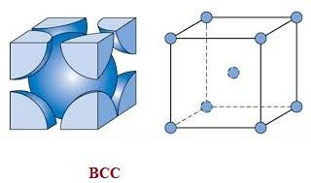
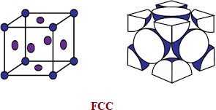

Microstructure:

The microstructure of materials can be magnified and viewed with the help of metallurgical microscope. Before fixing the sample, it has to be etched or polished in order to have a clear picture of the microstructure. Recently electron microscopes are used for the structural studies. This study reveals the structure, shape of the crystal. Steel exist in several microstructure at different conditions such as, austenite, cementite, ferrite etc.

Corrosion resistance:

Corrosion is essentially the degradation of a material by reaction with environment. There are mainly two kinds of corrosion namely dry and wet or electrochemical corrosion. Various chemical factors such as chemical nature of material, its reactive tendency, nature of environment are the main chemical factors contributing to corrosion or corrosion resistance of the metal or alloy.

Chemical reactivity:

Chemical inertness of materials is an important factor to be addressed for various purposes. Polymers and ceramics are preferred over metals and alloys in various fields mainly due to their inertness towards acids, alkalis and other organic chemicals. Chemical inertness is again an indirect indication of corrosion resistance.

Mechanical properties

Mechanical properties are the characteristics of the materials that describe the behaviour under the action of external forces. Most of the mechanical properties can be experimentally determined. The selection of materials mainly depends on the mechanical properties since it determine the behaviour of engineering materials under applied forces.

Elasticity

Elastic deformation is nonpermanent, which means that when the applied load is released, the piece returns to its original shape. This property is called as elasticity.

Deformation in which stress and strain are proportional is called elastic deformation;

Stress α strain (Hook’s law)
Or Stress = Y Strain (where, Y = modulus of elasticity or Young’s modulus)
(Stress= Load / Area ; Strain = change in length / original length)

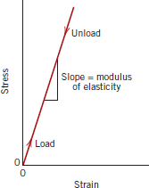
a plot of stress (ordinate) versus strain (abscissa) results in a linear relationship. From the graph it is evident that Application of the load corresponds to moving from the origin up and along the straight line. Upon release of the load, the line is traversed in the opposite direction, back to the origin.

The slope of this linear segment corresponds to the modulus of elasticity E. This modulus may be thought of as stiffness, or a material’s resistance to elastic deformation. The greater the modulus, the stiffer the material, or the smaller the elastic strain that results from the application of a given stress.

Plasticity

Plastic deformation is a permanent deformation i.e. recovery is impossible i.e.- upon removal of the stress they do not return to their original positions.. In this case Hook’s law is not valid. As the material is deformed beyond the elastic limit, the stress is no longer proportional to strain (Hooke’s law, ceases to be valid), and permanent, non recoverable, or plastic deformation occurs.

Yield Strength

- A structure or component that has plastically deformed, or experienced a permanent change in shape, may not be capable of functioning as intended. It is therefore desirable to know the stress level at which plastic deformation begins, or where the phenomenon of yielding occurs.

- Yield strength is the point below which the deformation is entirely elastic or it is the point beyond which plastic deformation begins (or the phenomenon of yielding occurs). In other words the ability to resist plastic deformation is called as yield strength.

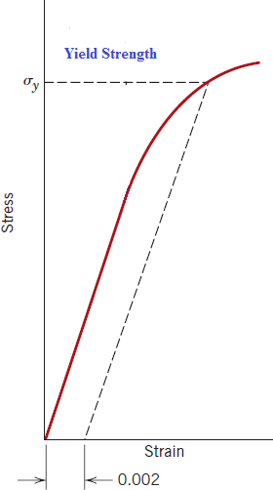
The point of intersection obtained by drawing a straight line at 0.002 strain offset represent yield strength

Tensile Strength

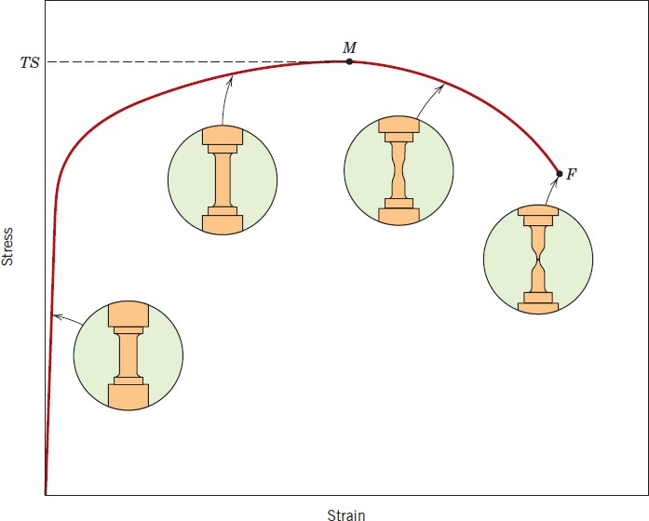
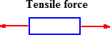

After yielding, the stress necessary to continue plastic deformation in metals increases to a maximum, point M and then decreases to the eventual fracture, point F as represented in Figure. The tensile strength TS is the stress at the maximum on the engineering stress–strain curve. This corresponds to the maximum stress that can be sustained by a structure in tension; if this stress is applied and maintained, fracture will result.

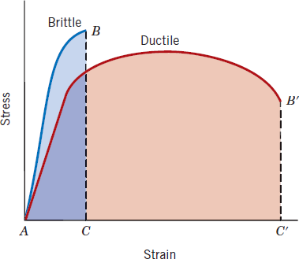
Ductility

Ductility is another important mechanical property. It is a measure of the degree of plastic deformation that has been sustained at fracture. A metal that experiences very little or no plastic deformation upon fracture is termed brittle. It is the ability of a material to be drawn as wire without being rupture. It is a tensile property.

Resilience
Resilience is the capacity of a material to absorb energy when it is deformed elastically and then, upon unloading, to have this energy recovered.

R = Energy output / Energy Input

For perfectly elastic body this ratio of energy recovered to energy given up is found to be one.

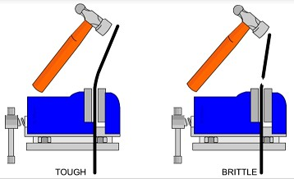
Toughness
Toughness is as the ability of a material to absorb energy and plastically deform (bending operation) before fracturing.

Malleability

It is the capacity of a material to withstand deformation under compression
without being ruptured. Exp- rolling operation. It is a compressive property.

Fatigue

It shows the ability of the material to repeated fluctuation of loads. Fatigue is a kind of failure in metal and alloys, which is caused by repeated fluctuating loads. This is an important property to be noted for the proper maintenance of machine parts, bridges, air crafts etc.

Creep

The permanent deformation that results in material when it is subjected to loading for a longer period of time is called as creep. Machines such as turbine rotors in jet engines, steam generators etc undergo permanent deformation at an elevated temperature.

Wear resistance

It is essential for machines working very close to each other under heavy loads. It is defined as the materials ability to resist wear, tear and abrasion. Graphite tools steel, high carbon and high chrome steel etc. Possess good wear resistance and used as cutting tools.

Shear Strength

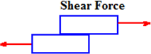
Shear strength determines the materials tendering to withstand forces acting tangential causing crystal dislocations due to relative movement of the layers.

(Shear stress that acts parallel to a surface. It can cause one objects to slide over the other. It also tends to deform originally rectangular objects to parallelograms. The most common definition is that shear acts to change the angles in objects. It is otherwise known as tangential stress.)

Compressive strength

The compression strength is mainly useful for materials like ceramics and polymers. It gives the detail regarding breaking power. It is defined as the the maximum value of compressive stress applied to break it off by crushing.
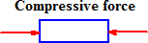

Impact Strength
It is essential for machine parts working under dynamic loading. It is a combination of toughness and strength of the material and it is the capacity to resist or absorb shock energy. Impact strength depends on structure, rate of loading, temperature.

Thermal properties

Melting point Specific heat
It represent the heat absorbing power of the material from its surrounding i.e.- the quantity of heat
required to raise the temperature of 1 gm of a material by one degree.
J/ Kg oC

Heat capacity
the quantity of heat required to raise the temperature of of a material by one degree.

J/ Kg oC
Thermal expansion
The coefficient of thermal expansion is the amount of expansion in unit length of a solid material by 1K rise of temperature of the material.
cm/K

Thermal conductivity
The rate at which heat can flow through a material under uniform temperature gradient.

Thermal spalling
Crack or peeling of surface due to variation in temperature.

Processing Properties

Weldability : metal with good weldability can be welded efficiently so as to perform their function well in the fabricated structure. The thermal conductivity as well as coefficient of thermal expansion of the component to be weald and the metallic base infrastructure of the machines are two important factor for efficient welding.

Solderabilty : Soldering can be done in most of the metals or alloys effectively provided the purity of the metal surface is maintained and the choice of solder and the flux. Solders are generally alloys of tin and lead.

Castability : To produced moulded articles castability or mouldability is an important factor. It is the character of the material which gives flawless casting or moulded articles.

Machinability : property of a material such that it can be easily machined by a tool or with little energy producing the required shaped product. EX- machinability of aluminium is enhanced by addition of small amount of sulfur and lead.

Workability or Formability: It is based on the internal structure of metal or alloys. Workability of metals or alloys are processes such as forging, rolling, drawing etc that improves the internal structure of the metal or alloys for fabrication process.

FACTORS AFFECTING SELECTION OF MATERIALS

Properties of materials
The most important factor affecting selection of materials for engineering design is the properties of the materials in relation to their intended use. The important properties are-
- Mechanical
- Thermal
- Chemical
- Electrical Radiation

Performance requirement
The material of which a certain part is composed must be capable of performing the desired function without any failure. For example, a component part to be used in a furnace must be of that material which can withstand high temperature.
Materials Reliability
Reliability is the degree of probability that a product and the material of which it is made will remain stable enough to function in service for the intended life of the product without failure. A material if it corrodes nder certain conditions, then, it is neither reliable nor stable for those conditions.
Safety
A material must safely perform its function otherwise the failure of the product made out of it may be catastrophic in air-planes and high pressure systems. As another exp, materials that give off sparks when struck are safety hazards in a coal mine.

Engineering material-3

  - Crystalline and Amorphous solid

  - Unit cell, Space lattice, Bravais lattice

  - Simple / primitive, FCC, BCC unit cell

  - Crystal Defects and its impact on material properties

- Crystalline and Amorphous solid

Solids are classified into two types depending upon the arrangements of their constituent particles
Crystalline - definite / proper arrangement of the constituent particles
Amorphous - haphazard arrangement of the constituent particles

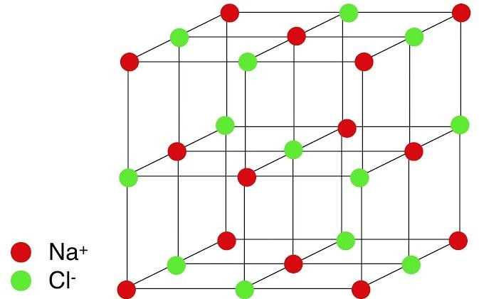

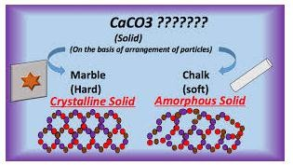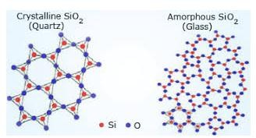
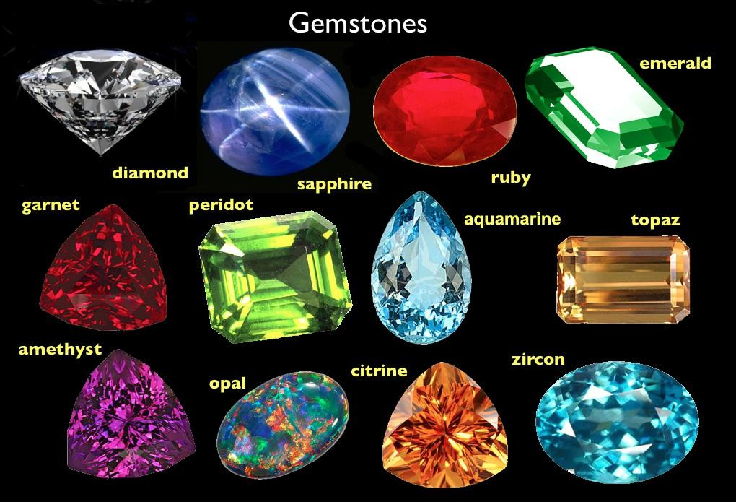

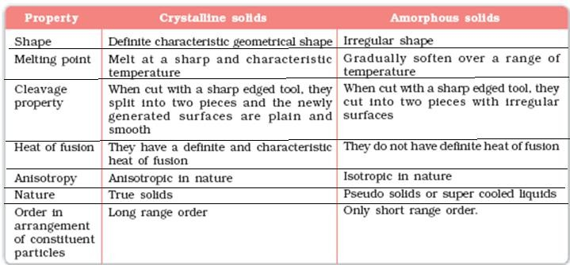

- Isotropy and Anisotropy
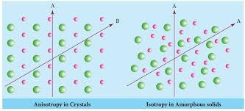

Property changes with the change in direction of measurement – Anisotropy ( shown by crystalline solid)

Properties independent of direction of measurement – Isotropy (Amorphous solid)

- Unit cell, Space lattice, Bravais lattice

So far crystals are concerned, the smallest building block of a crystal is called as unit cell. If each atoms/ ions are considered as point, the arrangement of these points (called as lattice points) in three dimensional space is called as space lattice or crystal lattice.

There are seven types of simple/primitive units cell categorised on the basis of their inter axial parameters i.e.- edge length (a,b,c) and angles(α β γ) and wrt the arrangement of the constituent particles the crystal arrangements are grouped under 14 catagories called as Bravais lattice

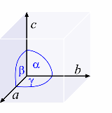

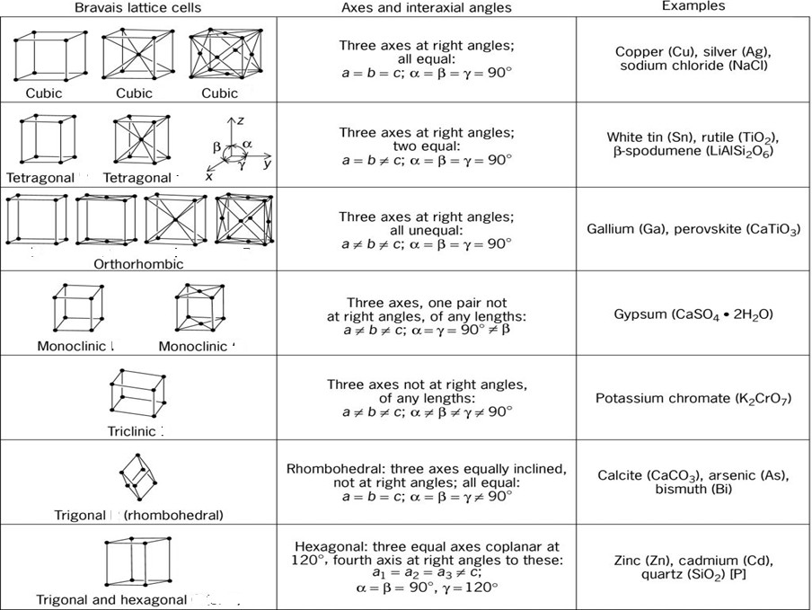

Number of particles in a unit cell

Simple / Primitive : There are 8 corners in a cubic unit cell and each corner contains one atom. Each corner is associated with neighbouring 8 unit cells i.e. each corner is common to eight unit cells.

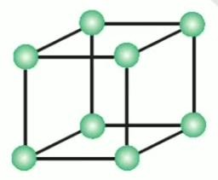

Hence share of each corner = 1/8 ^{th} of an atom
Thus, total contribution by 8 corner of a cubic unit cell = 8 x (1/8) = 1 atom

Face centered cubic (FCC):

Along with each corner, the centre of six faces of the unit cell contains one atom. Thus, contribution by corner points = 8 x 1/8 = 1 atom
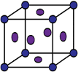

Since, each face is common to two adjacent unit cells, each unit cell has 50% share of an atom. Thus, contribution by each face = ½ of an atom
Hence, contribution of face point = ½ x 6 = 3 atoms Therefore, total contribution = 1 + 3 = 4 atoms

Body centered cubic (BCC):

Along with each corner, the centre of the body of the unit cell contains one atom. Thus, contribution by corner points = 8 x 1/8 = 1 atom

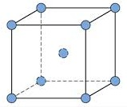

contribution of body point = 1 atoms Total contribution = 1 + 1 = 2 atoms

- Crystal Defects / Imperfetions

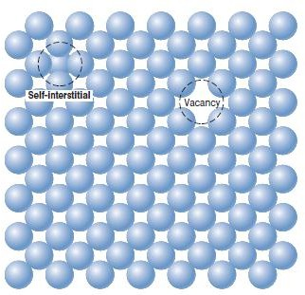
An idealized solid does not exist; all contain large numbers of various defects or imperfections. As a matter of fact, many of the properties of materials are profoundly sensitive to deviations from crystalline perfection; the influence is not always adverse, and often specific characteristics are deliberately fashioned by the introduction of controlled amounts or numbers of particular defects ( just like doping in semiconductors to design p-type and n-type ).

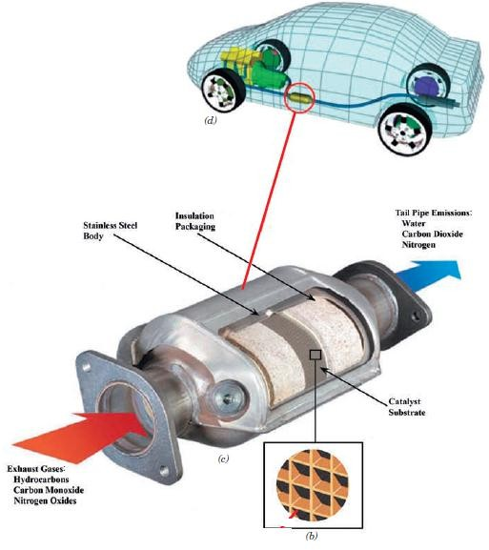
Applied importance of solid
imperfection (an example)
- Atomic defects are responsible for reductions of gas pollutant emission from today’s automobile engines.
- A catalytic converter is the pollutant reducing device that is located in the automobile’s exhaust system.
- Molecules of pollutant gases become attached to surface defects of crystalline metallic materials found in the catalytic converter. While attached to these sites, the molecules experience chemical reactions that convert them into other non- or less-polluting substances.

  - Classification of defects

- Point Defects

- Vacancies
- Interstitialcies
- Impurities
- Electronic defects

- Line Defects

- Edge dislocation
- Screw dislocation

- Interfacial/surface defects

- Grain boundaries
- Tilt boundaries
- Twin biundaries

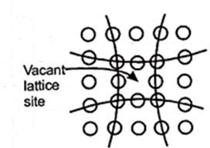
- Point Defects

represent one or more vacant lattice site.

- Vacancies –

  - A vacancy or vacant site represents an unoccupied atom position within a crystal lattice. In simple words vacancy represent empty atom sites.

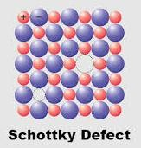
  - Vacancies may occur as aresult of imperfect packing duriing crystallization or from thermal vibrations of atoms at an elevated temperature bacause as thermal energy is increased there is a higher probability that individual atoms will jump out of their position of lowest energy.

  - Vacancies may be single, or two or more of them may
condense into a di-vacancy or tri-vacancy.

  - Schottky defect is an example of it. Here, an atom or ion is removed from its normal lattice site and replaced in an average position on the surface of the crystal. Thus a hole or vacant site is formed in the original lattice point.

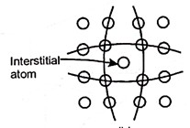
- Interstitialcies–
  - An interstitial defect arises when an atom occupies a definite position in the lattice that is not normally occupied in the perfect crystal.

  - In this defect, atom occupy position in between the atoms of the ideal crystal i.e.- the interstitial position

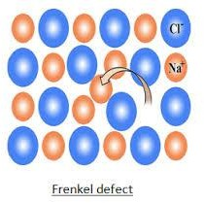
  - The interstitial atom may be either a normal atoms of the crystal or a foreign atom.

  - Interstitial atom tends to push the surrounding atoms farther apart, unless the interstitial atom is smaller than the rest of the atoms in the crystal.

  - Frankel defect is closely related to interstitialcies, where an ion displaced from its normal lattice site occupy an interstitial position.

c ) Impurities

- Impurity gives rise to compositional defect.

- Impurities may be small particle (such as slag in metals) or foreign metal atoms in the lattice.

- Impurity atoms are introduced into the crystal as substitutional or interstitial atoms.

- Impurity defects occur in metallic, covalent and ionic solids and play a vital role in many solid state processes such as electrical and thermal conductivities.

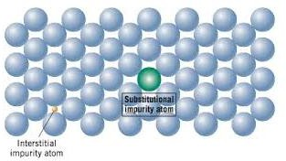

- A controlled addition of impurity to a very pure crystal is the basis of producing many electronic devices. (p and n type semiconductor)
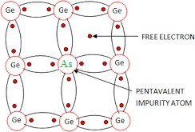

n – type semiconductor

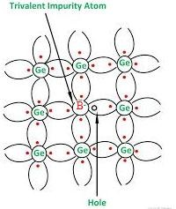
p – type semiconductor

- Electronic defects
  - Electronic defects are the result of errors in charge distribution in solids.

  - These defects are free to move in the crystal under the influence of an electrical field, thereby accounting for some electromnic conductivity of certain solids and their increased reactivity.

  - A vacancy or an interstitial impurity may produce the excess or the deficit of positive or negative charges, by an excess of metal ions as in ZnO, where there is an excess of interstitial zinc ion.

    - Line defects

A dislocation may be defined as a disturbed region between two relatively perfect parts of a crystal. Dislocation is a line defect in a crystal structure whereby a part-plane of atoms is displaced from its symmetrically stable positions. The dislocation is responsible for the slip, by which most of the metals deform plastically. There are basically two types of dislocations,

      - Edge dislocation

a) Screw dislocation

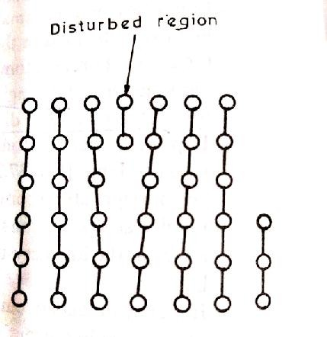
- Edge dislocation

  - This defect occurs when an extra half plane of atoms is introduced into the crystal structure.

  - Atoms above the dislocation lines (the imaginary line that separates the dislocated portion from the normal portion) are squeezed together and these below are pulled apart. Magnitude of this distortion decreases at distances away from the dislocation line.

  - Edge dislocation is perpendicular to the Burger’s vector and moves in the direction of the dislocation.

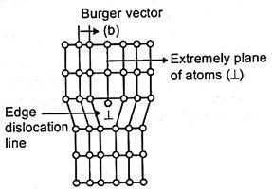
  - For extra half plane of atoms included on botto portion of the crystal (negative dislocation), th symbol is (T) and if it is included from top of th crystal (positive dislocation), the symbol is 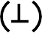
m e e

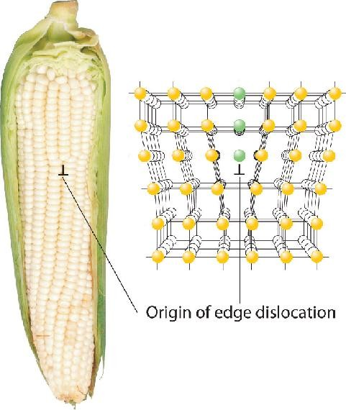

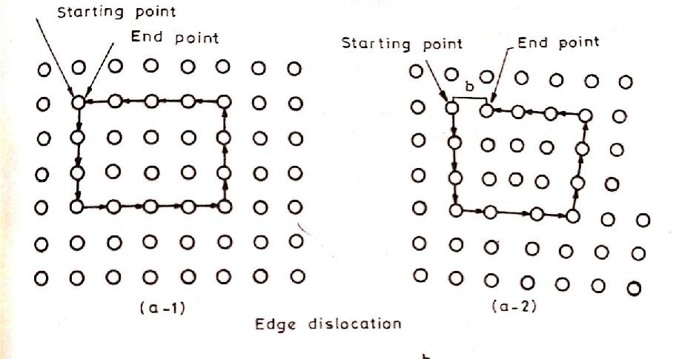

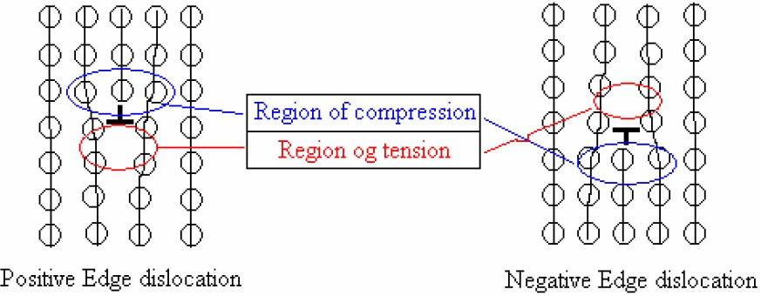

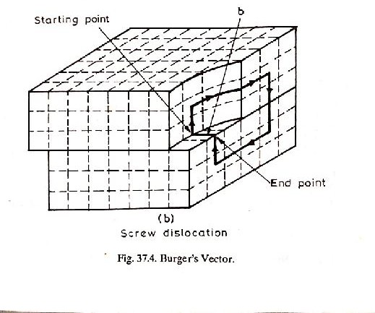
a) Screw dislocation

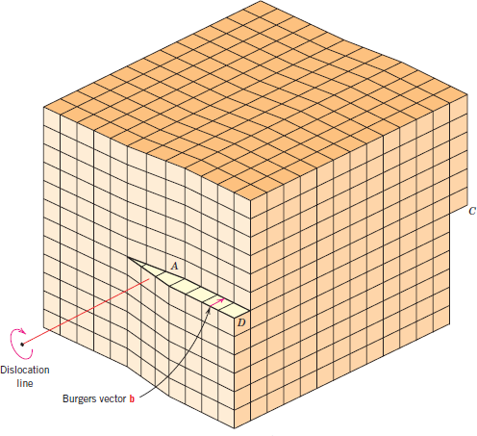

- In this dislocation, the distortion follows a helical path or screw path and hence the name given.

- Screw dislocation lies parallel to the Burgers vector.

- Screw dislocation moves in a direction perpendicular to the Burgers vector.

- The forces (shear force) required to form and move screw dislocation is more than that of edge dislocation, but , are less than those required to exceed the elastic limit of the crystal.

- If the dislocation is or the screw path is clockwise , then it is represented as and if it is anticlockwise then it is given

Dislocation arise in crystals as a result of,
- Growth accident
- Thermal stresses
- Phase transformations
- Segregation of solute atoms causing mismatches etc.

- Interfacial/surface defects

Interfacial defects are boundaries that have two dimensions and normally separate regions of the materials that have different crystal structures and/or crystallographic orientations. These imperfections include , grain boundaries, tilt boundaries, twin boundaries, and stacking faults.

a) Grain Boundaries
- Grain boundaries are the planar imperfection in polycrystalline materials that involves boundary separating two small grains or crystals having different crystallographic orientations .
- In grain boundaries the atomic packing is imperfect. At the grain boundary between two adjacent grains there is a transition zone which is not aligned with either grain type.
- Most atoms at the boundaries are at highly strained and distorted positions and their free energy is higher than that of the atoms in the regular, undisturbed part of the crystal.
- Various degrees of crystallographic misalignment between adjacent grains are possible . When this orientation mismatch is slight, on the order of a few degrees (less than 10º) , then the term small- (or low-) angle grain boundary is used and if it is greater than 10- 15º it is called as high angle boundaries.

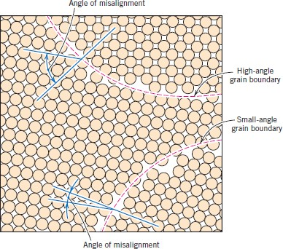

      - Tilt boundaries

One simple small-angle grain boundary is Tilt boundary which is considered as an array of edge dislocation. ϴ represents the angle of misorientation or angle of tilt.
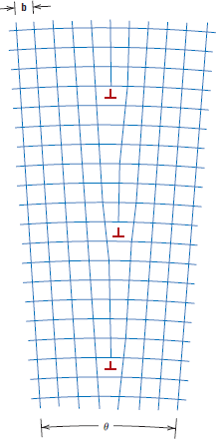
Tan ϴ = b /D
B= length of Burger’s vector D= Dislocation spacing

      - Twin boundaries

A twin boundary is a special type of grain boundary across which there is a specific mirror plane symmetry; that is, atoms on one side of the boundary are located in mirror-image positions of the atoms on the other side
A twin boundary separates two parts of crystal having the same orientation and they look like mirror image of each other.

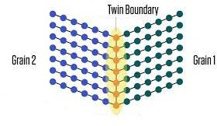

Stacking fault

- Stacking fault is a dissimilarity in the packing sequence of the layers of atoms in closed packed structure (such as in fcc and hcp).
- For example, instead of a regular sequence ABC ABC there may be a change as ABCACAB due to stacking fault. It is possible for one atom layer to be out of sequence relative to the atoms of the layers above and below giving a defect.

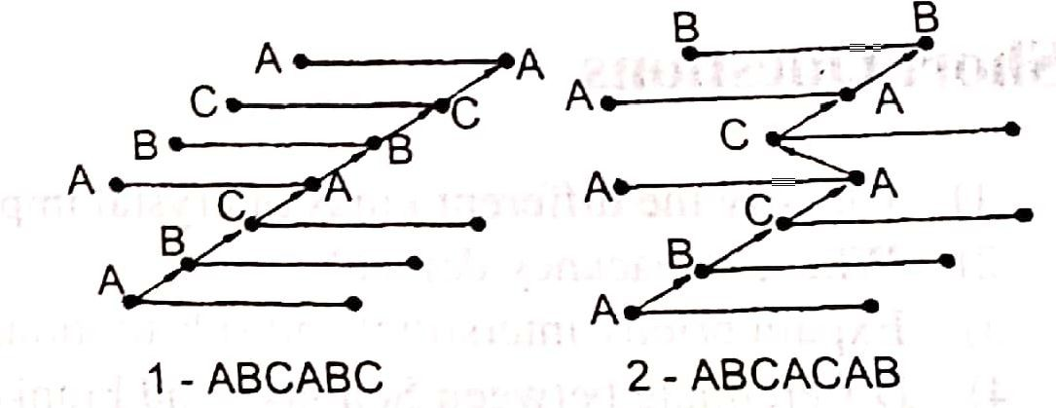

The study of imperfections has two fold purpose, namely
  - A better understanding of them and how they affect metal properties.
  - Exploration of possibilities of minimizing or eliminating these defects.

Effect of imperpection on metal properties

The role of imperpections in the behaviour of engineering materials is vital. The
imperfections account for,
        - Flow and fracture characteristics
        - Crystal growth
        - Electrical properties including semi-conducting behaviour
        - Diffusion mechanisms
        - Creep characteristics of real metals and alloys
        - Annealing and precipitation
        - Oxidation and corrosion
        - Yield strength, fracture strength, plasiticity, thermal conductivity etc.

Engineering material-4

          - Phase diagram related terminology

          - Utility of Phase diagram

          - Phase diagrams of alloy system

          - Classification of phase diagram

          - Fe-C equilibrium diagram

Phase : A phase may be defined as a homogeneous portion of a system that has uniform
physical and chemical characteristics. Every pure material is considered to be a phase;
so also is every solid, liquid, and gaseous solution.

For example, the sugar–water syrup solution just discussed is one phase, and solid sugar is another. Oil and water form a two phase system. If more than one phase is present in a given system, each will have its own distinct properties, and a boundary separating the phases will exist. When water and ice are present in a container, two separate phases exist; they are physically dissimilar (one is a solid, the other is a liquid) but identical in chemical makeup. Also, when a substance can exist in two or more polymorphic forms (e.g., having both FCC and BCC structures), each of these structures is a separate phase because their respective physical characteristics differ.

Component : The term component is frequently used in this discussion; components are pure metals and/or compounds of which an alloy is composed. For example, in a copper–zinc brass, the components are Cu and Zn.

Microstructure: Microstructure is subject to direct microscopic observation, using optical or electron microscopes. Many times, the physical properties and, in particular, the mechanical behavior of a material depend on the microstructure.

PHASE EQUILIBRIA

- Equilibrium is another essential concept that is best described in terms of a thermodynamic quantity called the free energy. A system is at equilibrium if its free energy is at a minimum under some specified combination of temperature, pressure, and composition.

- The term phase equilibrium, often used in the context of this discussion, refers to equilibrium as it applies to systems in which more than one phase may exist. Phase equilibrium is reflected by a constancy with time in the phase characteristics of a system.

Example: Suppose that a sugar–water syrup is contained in a closed vessel and the solution is in contact with solid sugar at 20ºC. If the system is at equilibrium, the composition of the syrup is 65 wt% C12H22O11 and 35 wt% H2O , and the amounts and compositions of the syrup and solid sugar will remain constant with time. Now, If the temperature of the system is suddenly raised to 100ºC (say)—this equilibrium or balance
is temporarily upset in that the solubility limit has been increased to 80 wt% C12H22O11 . Thus, some of the solid sugar will go into solution in the syrup. This will continue until the new equilibrium syrup concentration is established at the higher temperature.

Phase diagrams of alloy system
  - One reason that a knowledge and understanding of phase diagrams is important to the engineer relates to the design and control of heat-treating procedures; some properties of materials are functions of their microstructures, and, consequently, of their thermal histories.
  - The understanding of phase diagrams for alloy systems is extremely important because there is a strong correlation between microstructure and mechanical properties.
  - In addition, phase diagrams provide valuable information about melting, casting, crystallization, and other phenomena.

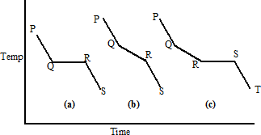
Cooling curve

The basis of phase diagram is time-temperature-transformation (T-T-T) curves or cooling curves. In two component alloy system the following three types of cooling curves are observed.

- Pure metal :

Cooling curve of pure metal is denoted by the first curve. The stage PQ denotes the cooling process of the liquid metal. The constancy of QR shows the solidification of the metal. The RS stage shows the cooling of the solid metal.

- Binary solid solution:

The second curve shows the cooling curve of binary solid solution or the alloy system. The stage PQ shows the cooling of the binary solid solution or liquid alloy. The solidification or freezing stage QR denotes a variable freezing range shown by the slope of th curve. This is due to the fact that the alloy does not solidify at constant temperature due to the changes in the composition of solid and liquid phases.
- Binary Eutectic system:
The curve PQRST denotes the cooling curve of a binary eutectic system. In this system, the two components are completely soluble in liquid state but are insoluble in solid state. PQ represnts cooling of the binary liquid alloy. QR represents solidification of one of the component which is in excess. RS is the eutectic point at which the two components of the alloy system crystallize or solidify simultaneously. The stage ST represents cooling of the solids.

Classification of phase diagrams

- The phase diagrams are classified broadly on the basis of number of components.

- One component (unary) Ex- Water system
- Two component (Binary) Ex- Fe- C system
- Three component (Ternary) Ex- Fe-Cr-Ni system

- Phase diagrams are also classified on the basis of the relationship of the components in the liquid and solid states.

- Components completely soluble in liquid as well as in solid state – Isomorphous system

- Components completely soluble in in the liquid state but partially soluble in the solid state -
Partial eutectic

- Components completely soluble in in the liquid state but inoluble in the solid state –
Eutectic

- Components react as solid and liquid phases to produce a new solid phase – Peritectic

- Component of a solid phase is converted into two or more inimately mixed solids on cooling
– Eutectoid solid1 = Solid2 + solid3
- Components of two solid solutions react to produce a third solid phase- Peritectoid
solid1 + Solid2 = solid3

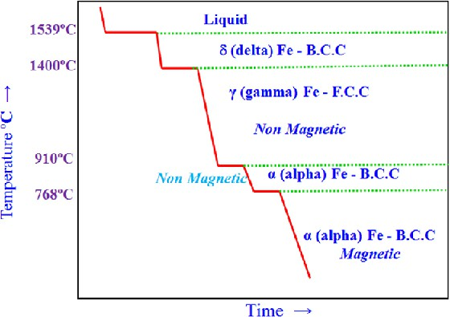
Cooling curve of pure iron

The melting point of iron is 1539ºC. It exist in different allotropic modifications with more than one type of crystal structure.

- Iron on cooling below 1539ºC solidifies as δ-Fe, which exist in BCC crystal structure.
- At 1400ºC δ-Fe (BCC) gets changes to ϒ –Fe which exist in FCC crystal type. The ϒ –Fe does not have any magnetic behaviour and hence becomes nonmagnetic.
- It exist in the ϒ –Fe (FCC) form until the temperature drops to 910ºC. At 910ºC ϒ –Fe (FCC) gets change to α – Fe (BCC) , but it is also non magnetic in nature.
- At aout 768ºC the α – Fe becomes magnetic without any change in its structure.

Iron(Fe) – Carbon(C) system

Alloys of iron and carbon constitute steel and cast iron. If the cabon content is below 2% in iron, steel is produced and if it exceeds 2% then cast iron is produced. Depending upon the carbon percentages steel is again divided in to the following three types.

Types of steel | Carbon percentage | Application
Mild steels or low carbon steels | 0.008 – 0.1  0.1 – 0.2  0.2 – 0.3 | Chains, rivets, nails etc ship hulls  Iron bridge
Medium carbon steels | 0.3 – 0.4  0.4 – 0.5  0.5 – 0.6 | Axles, wheel Rail  Chisels
High carbon steels | 0.6 – 0.9  1.0 – 1.1  1.1 – 1.2  1.2 – 1.4 | Hammer, saw Axes  Razor blade  Files, Scissors, Knives etc

Microconstituents of Iron and steel

Steel has 9 microconstituents, these are,
- Austenite
- Ferrite
- Cementite
- Ledeburite
- Peralite
- Bainite
- Martensite
- Troosite
- Sorbite

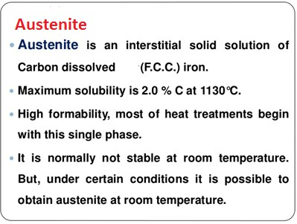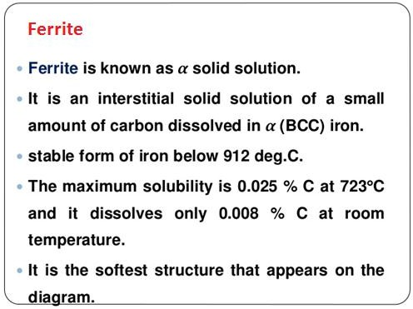

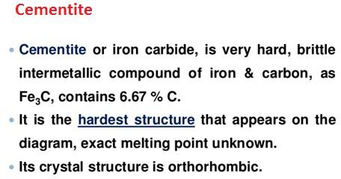

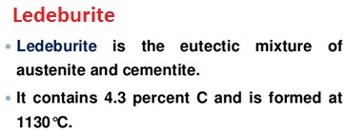

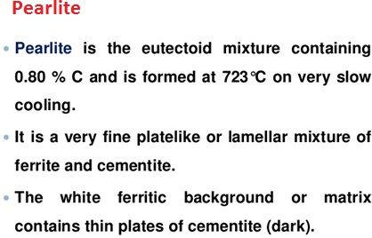

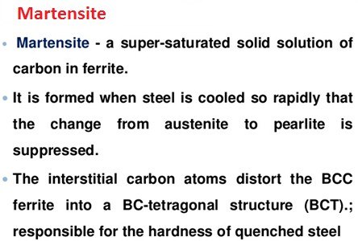

Bainite
Bainite is formed at cooling rates slower than that for martensite formation and faster than that for ferrite and pearlite formation. Generally bainite is feathery and is known as acicular bainite.
Troosite
Nodular troosite is a mixture of radial lamellae of ferrite and cementite. It differ from pearlite only in the degree of fineness of structure and carbon content. It is formed by the cooling of Austenite at a rate slower than that which produced Martensite structure and faster than that which will produce a sorbite structure.
Sorbite
It constitute a mixture of ferrite and finely divided cementite.
Pearlite, Troosite and sorbite are all ferrite-cementite mixture having a lamellar structure distinguishable from each other in their degree of dispersion of cementite in ferrite matrix.

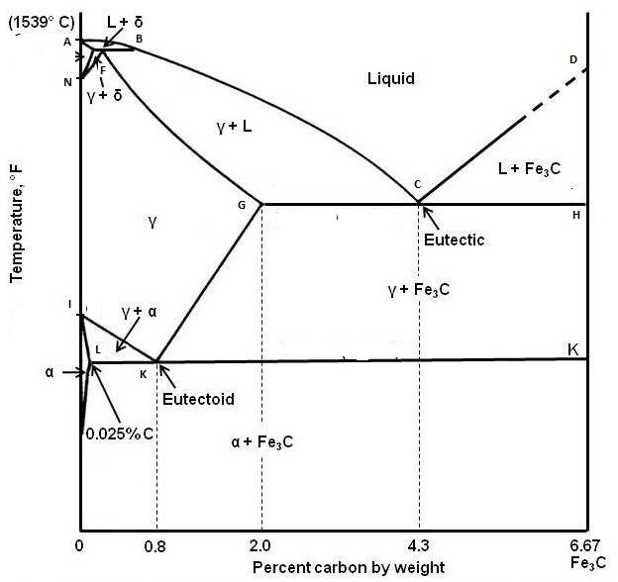

The equilibrium phase diagram of Fe-C system is between a metal and a non-metal. And the phase diagram extends only up to 6.7% carbon content. Pure iron melts at 1539ºC. The phase diagram areas depict the existence of the forms with in it. The curves or lines show the equilibrium between the two phases on either side.

- The curve ABCD depicts the liquidus line above which iron exists in liquid phase. Only the
melting point of an iron-carbon system can be found out with the help of this line.

- The curve AEFGCH is the solidus line and below which various iron-carbon compositions
exists in solid form only.

- With the above phase diagram it is evident that with increasing carbon content, the melting point of iron-carbon alloy is depressed to 1147ºC at 4.3% C. Further as the carbon content increases upto 6.67% with the increase in formation of cementite, the melting point further rises.

- Within the area AEB the alloy exists as δ-iron along with liquid.

- The region GFBC represents Austenite and liquid; DCH represents (Fe₃C) cementite + liquid. The region NFGKI represents Austenite form of iron. The region ILK represents Austenite and Ferrite.
- The transformation of ϒ-iron (Austenite) to ferrite is represented by the curve IK. The transformation of Austenite to cementite is represented by the curve GK. The line LK at 723º C depicts the eutectoid point K where, Austenite transformed to pearlite. At this point austenite, ferrite and cementite exists in equilibrium.
- The carbon percentage upto 0.088% C are regarded as somewhat pure from of iron. The steel exists in the range of 0.88%C-2%C and above 2%C exists cast iron. The steel upto 0.8%C is known as hypoeutectoid steel and from 0.8C to 2% is known as hypereutectoid steel.

  - The ‘Austenite’ from is not stable below the IK and GK curve.

  - At the temperature 1147º C the eutectic transformation of austenitic Fe3C to ledeburite and cementite takes place. The eutectic liquid with 4.3%C on cooling freezes to ledeburite. At the eutectic point ‘C’ austenite, ledeburite and cementite exist in equilibrium.

  - Upto 0.8%C the steel consists mainly of ferrite and pearlite composition and from 0.8C to 2%C the steel consists of pearlite and cementite composition. Above 2% C compostion the main composition of the cast iron will be cementite and ledeburite. Pearlite also exist in small amount along with the above two mentioned forms upto 4.35% carbon.

The following g types of reactions of the equilibrium systems based on the phase diagram takes place in the iron-carbon thermal equilibrium.
Eutectic reaction (1147ºC) Eutectoid reaction (723ºC) Peritectic reaction(1485ºC)

Eutectic reaction (1147ºC)
Components that are completely soluble in liquid phase are insoluble in solid phase. General
eutectic reaction is as follows,
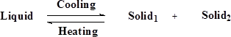
The liquid iron present while reaching the temperature 1147ºC forms Austenite and cementite crystalline forms. This mixture is called as ledeburite.

Eutectoid reaction (723ºC)
An eutectoid reaction is an isothermal reversible reaction where a solid phase forms two new solid phases. The general reaction is as presented below.

In this reaction the crystalline austenite on cooling below 723ºC (eutectoid point) solidifies as pearlite which is an alternating layer of two solid structures namely ferrite and cementite.

Peritectic reaction(1485ºC)
It is an isothermal reversible reaction in which a liquid and a solid phase react to form another solid phase on cooling. The general reaction is as presented below.

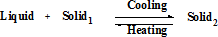
On cooling below 1539ºC the liquid iron transforms gradually to 1400ºC when the carbon content is 0.5%. When liquid iron having (0.1%) carbon content is cooled to a temperature of 1485ºC the δ iron transforms into Austenite.

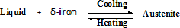

Engineering material- 5

Polymers -

- Introduction to Polymer, monomer, Natural and artificial polymer, homopolymer, copolymer with examples
- Properties of polymers
- Thermoplastic and Thermosetting Polymers
- Properties of elastomers

Introduction
Poly = many ; mer = unit
Thus, a polymer is a high molecular mass compound (giant molecules) which is formed out of several smaller unit (monomer) bonded to each other by means of covalent bond.
Mono = one ; mer = unit
A monomer is the smallest structural and functional unit of a polymer.

Properties of polymers-
- Low density
- Good corrosion resistance
- Low coefficient of friction
- Good mouldability
- Excellent surface finish
- Economical
- Poor tensile srength
- Poor temperature resistance
- Low mechnical properties. That can be improved by means of fiber reinforcement.

Classification:
- Depending upon their origin polymers classified into two types, such as natural polymer (obtained through nature, ex- wood, bone, starch, cellulose, cotton, silk, rubber, leather etc.) and artificial or synthetic polymer (obtained through synthesis and which does not occur naturally, ex- polythene, PVC, polystyrene, Teflon etc.)
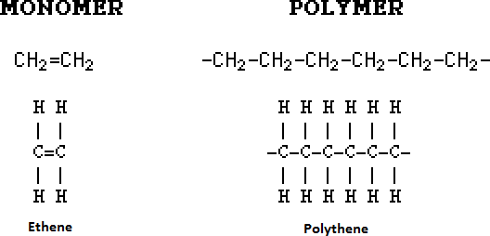
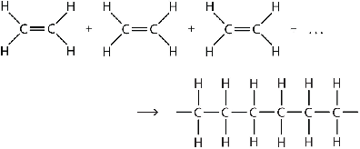

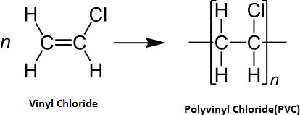
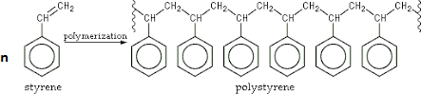
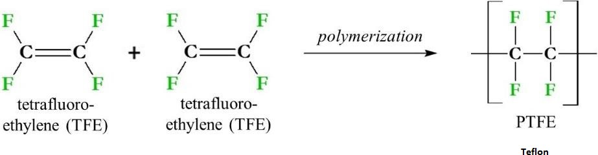

- Depending upon the type of monomer used in the process of polymerisation, polymers are again classified into two types such as, homopolymer and copolymer.
Homopolymer – Contains only one type of polymer Ex- polythene, pvc, polystyrene et.
Copolymer - Contains more than one type of polymers Ex- SBR (Styrene butadiene
rubber), ABS (Acrylonitrile butadiene styrene), Bakelite etc.

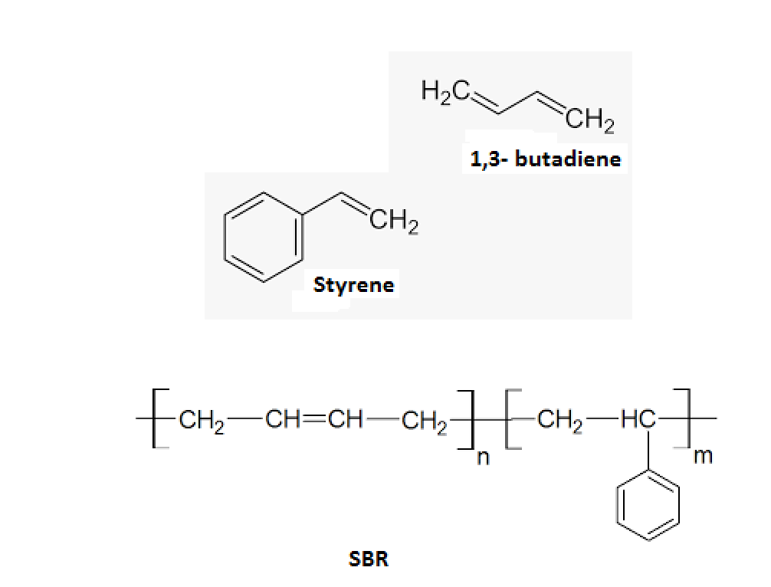
SBR (Styrene butadiene rubber) - Contains two types of polymer : Styrene and 1,3-butadiene

ABS (Acrylonitrile butadiene styrene) - Contains three types of polymer : Styrene and 1,3-butadiene, Acrylonitrile
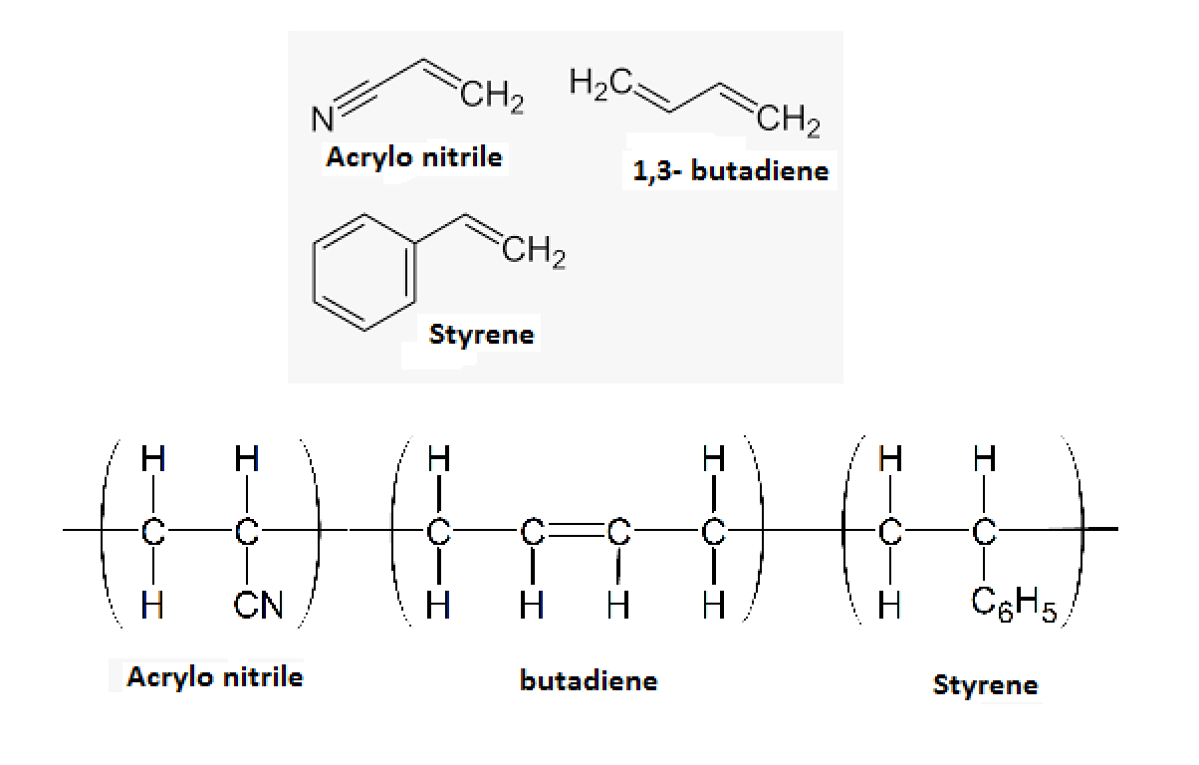

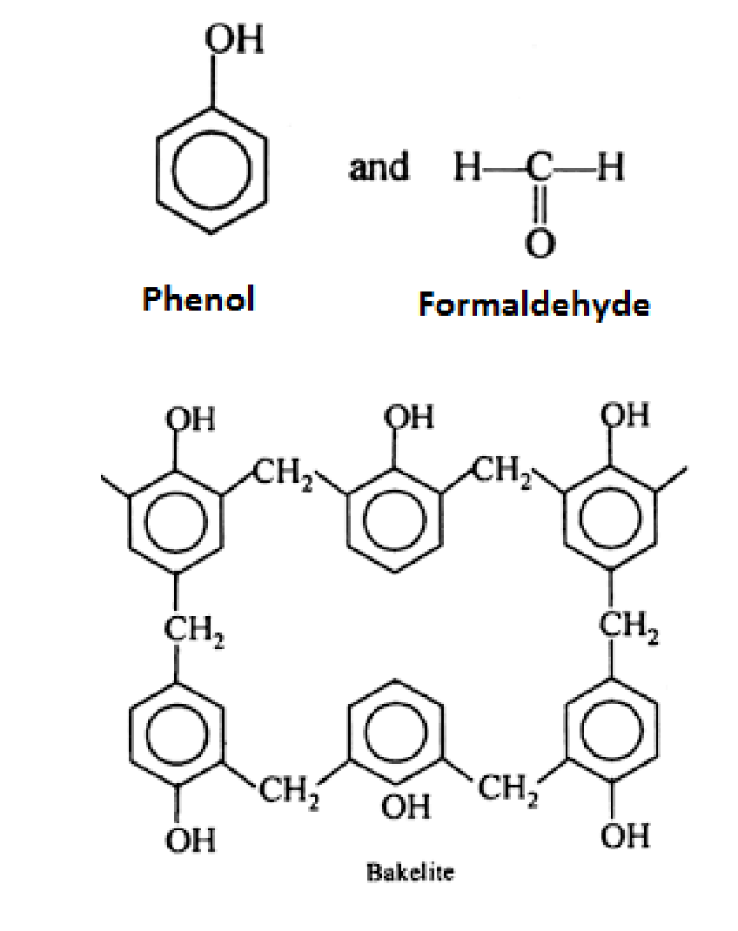
Bakelite (Phenol- formaldeyde resin) - Contains two types of polymer : Phenol and formaldeyde

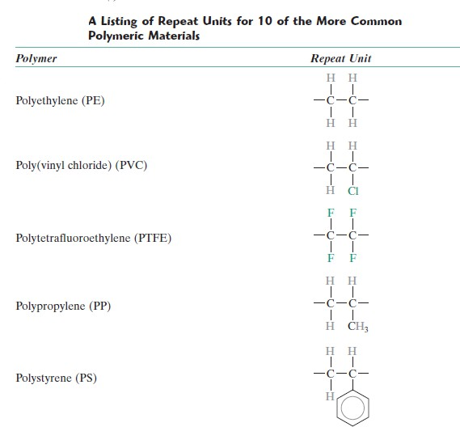

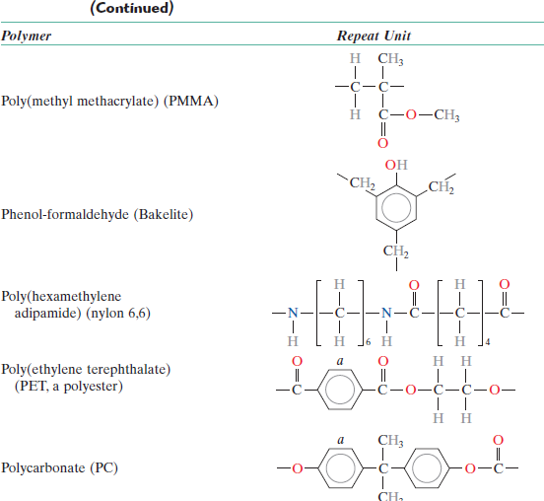

- The response of a polymer to mechanical forces at elevated temperatures is related to its dominant molecular structure. In fact, one classification scheme for these materials is according to behaviour with rising temperature. Thermoplastics (or thermoplastic polymers) and Thermosets (or thermosetting polymers) are the two subdivisions.

Thermoplastic polymers

  - Thermoplastics soften when heated (and eventually liquefy) and harden when cooled—processes that are totally reversible and may be repeated.

  - On a molecular level, as the temperature is raised, secondary bonding forces are diminished (by increased molecular motion) so that the relative movement of adjacent chains is facilitated when a stress is applied.

  - Irreversible degradation results when a molten thermoplastic polymer is raised to too high a temperature.

  - In addition, thermoplastics are relatively soft. Most linear polymers and those having some branched structures with flexible chains are thermoplastic.

  - These materials are normally fabricated by the simultaneous application of heat and pressure.

  - Examples of common thermoplastic polymers include polyethylene, polystyrene,
poly(ethylene terephthalate), and poly(vinyl chloride).

Thermosetting polymers

    - Thermosetting polymers are network polymers.

    - They become permanently hard during their formation and do not soften upon heating.

    - Network polymers have covalent crosslinks between adjacent molecular chains. During heat treatments, these bonds anchor the chains together to resist the vibrational and rotational chain motions at high temperature. Thus, the materials do not soften when heated.

    - Crosslinking is usually extensive, in that 10 to 50% of the chain repeat units are crosslinked. Only heating to excessive temperatures will cause severance of these crosslink bonds and polymer degradation.

    - Thermoset polymers are generally harder and stronger than thermoplastics and
have better dimensional stability.

    - Bakelite is an example. It is used in electrical switches and the bad smell due to electrical short circuit is due to polymer degradation.

Elastomers(Rubber)

      - An elastomer is a polymeric material that may experience large and reversible elastic deformation.
      - Elastomers commonly referred to as rubbers, are hydrocarbons.
      - The difference between plastic and elastomers is largely depends upon their properties of stretching and extensibility.
      - The American Society for Testing and Materials (ASTM) defines as elastomer as “a polymeric material which at room temperature can be stretched to at least twice its length and upon immediate release of the stress will return quickly to approximately its original length.
      - The major distinguishing characteristic of elastomers is their great extensibility and high-energy storing capacity.
      - In order to obtain real elastic properties, the rubbers must be vulcanized.

Vulcanization
Vulcanization is irreversible chemical reaction involving sulfur or other suitable agent wherein crosslinks are formed between molecular chains in rubber materials. The rubbers modulus of elasticity and strength is enhanced. The cross linking process in elastomers is called as vulcanization.

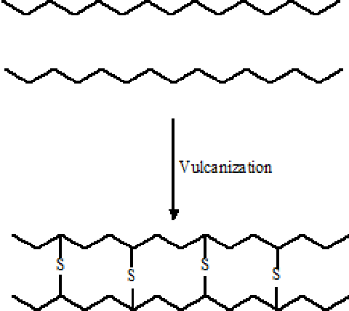
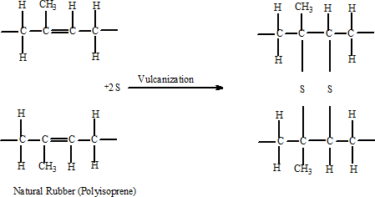

Characteristics of Rubbers

- Non crystalline in nature
- Nonconductors of electricity
- Bad conductors of heat
- High resistance to chemicals and corrosive environment.
- Relatively low softening temperatures.
- They exhibit viscoelestic behaviour generally to a greater extent than plastics.
- They oxidize or age causing deterioration and changes in properties generally more so than plastics.

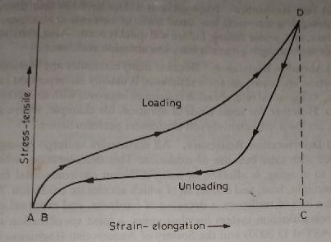
Properties of Elastomers

- Resilience and Hysteresis :
  - Resilience is a measure of an elestomer’s capacity to store energy and is defined as the ratio of energy output to energy input expressed as percentage.
  - Because some input energy is always lost through internal friction, resilience values must always be less than 1 (or, 100 percent). This loss of energy in the form of frictional heat is known as hysteresis.
  - The given figure shows the stress-strain curve of an elastomer through a cycle of loading and unloading. Area, ACD under the load curve is the input energy and area BCD is the energy output. Hysteresis or heat energy loss is represented by the area ABD.
  - It is evident from the curves that resilience has an inverse relationship to the hysteresis i.e.- the lower the energy loss, the lower will be the hysteresis.

- Hardness
    - Hardness is on eof the mst important properties in the specification of rubbers.
    - Hardness can also be varied to meet specific needs.
    - The shore durometer test is the standard method for measuring elastomer hardness.
    - On the durometer scale , which runs from 0 to 100, the higher the number the harder the material.
    - There are rough relationships between hardness and several mechanical properties of elestomers. For, exp, the lower the hardness, the less tendency there is for the elastomer to creep or flow. Elongation decreases as the hardness increases.
    - Tensile strength generally increases with the hardness up to about 50 on the durometer scale and then falls off if hardness continues to increase.

- Compression set or Creep

    - This characteristic refers to the percentage of deflection or distortion remaining in an elastomer after a load is removed.
    - It is dependent on many factors such as strain rate, temperature, type and size of ,loading.

- Tear resistance
    - Elastomers have low tear strength. If tear strength is extremely low, small nicks or cuts can causes catastrophic failure. Also, elastomers with poor tear strength generally have low abrasion resistance. As a general rule abrasion resistance increases with the increase in hardness.

- Deterioration resistance

    - All elastomers undergo change in properties with time because of oxidation.

    - This deterioration, which is referred to as aging, is affected by many different environmental factors such as sunlight, heat and ozone, all of which accelerate the aging process.

- Oil Resistance
    - This is an important criteria in the selection of elastomers because many of their applications involve an environment of hydrocarbon fluids such as oil and gasoline. Resistance to oil is based on how much the elastomer swells in the presence of oil.

Engineering material- 6

Composite material -

      - Introduction and classification
      - Particle reinforced and Fiber reinforced composite

Ceramics -

      - Introduction and classification
      - Properties

Composite Materials

A composite is considered to be any multiphase material that exhibits a significant proportion of the properties of both constituent phases such that a better combination of properties is realized. According to this principle of combined action, better property combinations are fashioned by the judicious combination of two or more distinct materials.

For example,

        - pearlitic steels have a microstructure consisting of alternating layers of a-ferrite and cementite. The ferrite phase is soft and ductile, whereas cementite is hard and very brittle. The combined mechanical characteristics of the pearlite (reasonably high ductility and strength) are superior to those of either of the constituent phases.

        - A number of composites also occur in nature. For example, wood consists of strong and flexible cellulose fibers surrounded and held together by a stiffer material called lignin.
        - Also, bone is a composite of the strong yet soft protein collagen and the hard, brittle mineral apatite.
In designing composite materials, scientists and engineers have creatively combined various metals, ceramics, and polymers to produce a new generation of extraordinary materials. Most composites have been created to improve combinations of mechanical characteristics such as stiffness, toughness, and ambient and high-temperature strength.
Many composite materials are composed of just two phases; one is termed the matrix, which is continuous and surrounds the other phase, often called the dispersed phase. The properties of composites are a function of the properties of the constituent phases, their relative amounts, and the geometry of the dispersed phase. Dispersed phase geometry in this context means the shape of the particles and the particle size, distribution, and orientation

classification of composite materials

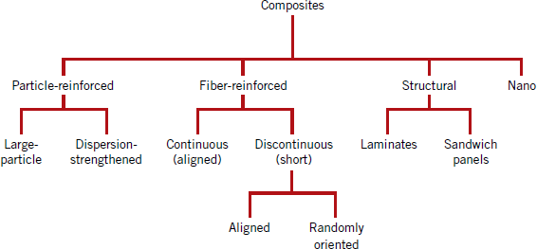

- The dispersed phase for particle-reinforced composites is equiaxed (i.e., particle dimensions are approximately the same in all directions)
- For fiber-reinforced composites, the dispersed phase has the geometry of a fiber i.e. a large length-to-diameter ratio.
- Structural composites are multilayered and designed to have low densities and high degrees of structural integrity.
- For nanocomposites dimensions of the dispersed phase particles are on the order of nanometers.

Particle-Reinforced Composites
large-particle and dispersion-strengthened composites are the two subclassifications of particle-reinforced composites. The distinction between these is based on the reinforcement or strengthening mechanism.
Large-particle composites
- The term large is used to indicate that particle–matrix interactions cannot be treated on the atomic or molecular level; rather, continuum mechanics is used.
- For most of these composites, the particulate phase is harder and stiffer than the matrix.
- These reinforcing particles tend to restrain movement of the matrix phase in the vicinity of each particle. In essence, the matrix transfers some of the applied stress to the particles, which bear a fraction of the load.
- The degree of reinforcement or improvement of mechanical behavior depends on strong bonding at the matrix–particle interface.
- Some polymeric materials to which fillers have been added are really large-particle composites. Again, the fillers modify or improve the properties of the material and/or replace some of the polymer volume with a less expensive material—the filler.

- Another familiar large-particle composite is concrete, which is composed of cement (the matrix) and sand and gravel (the particulates).
- Particles can have quite a variety of geometries, but they should be of approximately the same dimension in all directions (equiaxed). For effective reinforcement, the particles should be small and evenly distributed throughout the matrix. Furthermore, the volume fraction of the two phases influences the behavior; mechanical properties are enhanced
with increasing particulate content.
- Large-particle composites are used with all three material types (metals, polymers, and
ceramics) . The cermets are examples of ceramic–metal composites.

  - The most common cermet is cemented carbide, which is composed of extremely hard particles of a refractory carbide ceramic such as tungsten carbide (WC) or titanium carbide (TiC) embedded in a matrix of a metal such as cobalt or nickel. These composites are used extensively as cutting tools for hardened steels.
  - The hard carbide particles provide the cutting surface but, being extremely brittle, are not capable of withstanding the cutting stresses. Toughness is enhanced by their inclusion in the ductile metal matrix, which isolates the carbide particles from one another and prevents particle-to-particle crack propagation. Both matrix and particulate phases are quite resistant to the high temperatures generated by the cutting action on materials that are extremely hard. No single material could possibly provide the combination of properties possessed by a cermet.

    - Both elastomers and plastics are frequently reinforced with various particulate materials. Use of many modern rubbers would be severely restricted without reinforcing particulate materials such as carbon black. Carbon black consists of very small and essentially spherical particles of carbon, produced by the combustion of natural gas or oil in an atmosphere that has only a limited air supply. When added to vulcanized rubber, this extremely inexpensive material enhances tensile strength, toughness, and tear and abrasion resistance. Automobile tires contain on the order of 15 to 30 vol% carbon black. For the carbon black to provide significant reinforcement, the particle size must be extremely small, with diameters between 20 and 50 nm; also, the particles must be evenly distributed throughout the rubber and must form a strong adhesive bond with the rubber matrix.

Dispersion-strengthened composites

- For dispersion-strengthened composites, particles are normally much smaller, with diameters between 0.01 and 0.1 m (10 and 100 nm).
- Particle–matrix interactions that lead to strengthening occur on the atomic or molecular level. The mechanism of strengthening is similar to that for precipitation hardening. Whereas the matrix bears the major portion of an applied load, the small dispersed particles hinder or impede the motion of dislocations. Thus, plastic deformation is restricted such that yield and tensile strengths, as well as hardness, improve.
- Metals and metal alloys may be strengthened and hardened by the uniform dispersion of several volume percent of fine particles of a very hard and inert material. The dispersed phase may be metallic or nonmetallic; oxide materials are often used. Again, the strengthening mechanism involves interactions between the particles and dislocations within the matrix, as with precipitation hardening.

- The dispersion strengthening effect is not as pronounced as with precipitation hardening; however, the strengthening is retained at elevated temperatures and for extended time periods because the dispersed particles are chosen to be unreactive with the matrix phase. For precipitation-hardened alloys, the increase in strength may disappear upon heat treatment as a consequence of precipitate growth or dissolution of the precipitate phase.
- The high-temperature strength of nickel alloys may be enhanced significantly by the addition of about 3 vol% thoria (ThO2) as finely dispersed particles; this material is known as thoria-dispersed (or TD) nickel. The same effect is produced in the aluminum– aluminum oxide system. A very thin and adherent alumina coating is caused to form on the surface of extremely small (0.1 to 0.2 m thick) flakes of aluminum, which are dispersed within an aluminum metal matrix; this material is termed sintered aluminum powder (SAP).

Fiber-Reinforced Composites

Technologically, the most important composites are those in which the dispersed phase is in the form of a fiber. Design goals of fiber-reinforced composites often include high strength and/or stiffness on a weight basis. These characteristics are expressed in terms of specific strength and specific modulus parameters, which correspond, respectively, to the ratios of tensile strength to specific gravity and modulus of elasticity to specific gravity. Fiber-reinforced composites with exceptionally high specific strengths and moduli have been produced that use low-density fiber and matrix materials. The mechanical characteristics of a fiber-reinforced composite depend not only on the properties of the fiber, but also on the degree to which an applied load is transmitted to the fibers by the matrix phase. Important to the extent of this load transmittance is the magnitude of the interfacial bond between the fiber and matrix phases.

Some critical fiber length is necessary for effective strengthening and stiffening of the composite material. This critical length lc is dependent on the fiber diameter d and its ultimate (or tensile) strength σ*f and on the fiber–matrix bond strength (or the shear yield strength of the matrix, whichever is smaller) τc according to the relation,
lc = σ*f d / 2 τc
For a number of glass and carbon fiber–matrix combinations, this critical length is on the order of 1 mm, which ranges between 20 and 150 times the fiber diameter. When a stress equal to σ*f is applied to a fiber having just this critical length, the maximum fiber load is achieved only at the axial center of the fiber. As fiber length l increases, the fiber reinforcement becomes more effective. Fibers for which l >> lc (normally l > 15lc) are termed continuous; discontinuous or short fibers have lengths shorter than this. For discontinuous fibers of lengths significantly less than lc, the matrix deforms around the fiber such that there is virtually no stress transference and little reinforcement by the fiber.

INFLUENCE OF FIBER ORIENTATION AND CONCENTRATION

The arrangement or orientation of the fibers relative to one another, the fiber concentration, and the distribution all have a significant influence on the strength and other properties of fiber-reinforced composites.

With respect to orientation, two extremes are possible:

  - a parallel alignment of the longitudinal axis of the fibers in a single direction,
  - a totally random alignment.

Continuous fibers are normally aligned (Figure a), whereas discontinuous fibers may be aligned (Figure b), randomly oriented (Figure c), or partially oriented. Better overall composite properties are realized when the fiber distribution is uniform.

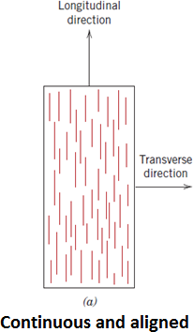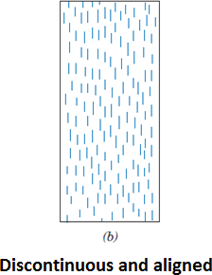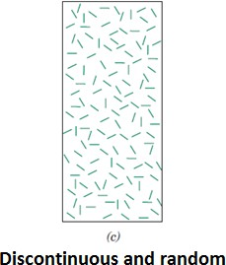

THE FIBER PHASE

On the basis of diameter and character, fibers are grouped into three different classifications: whiskers, fibers, and wires.

    - Whiskers are very thin single crystals that have extremely large length-to-diameter ratios. As a consequence of their small size, they have a high degree of crystalline perfection and are virtually flaw-free, which accounts for their exceptionally high strengths;
    - They are among the strongest known materials. In spite of these high strengths, whiskers are not used extensively as a reinforcement medium because they are extremely expensive.
    - Whisker materials include graphite, silicon carbide, silicon nitride, and aluminum oxide

    - Fibers are either polycrystalline or amorphous and have small diameters; fibrous materials are generally either polymers or ceramics.
    - the polymer aramids ( a class of heat-resistant and strong synthetic fibers), glass, carbon, boron, aluminum oxide, and silicon carbide are exapmles.

    - Wires have relatively large diameters
    - typical materials include steel, molybdenum, and tungsten.
    - Wires are used as a radial steel reinforcement in automobile tires, in wire-wound high- pressure hoses.

THE MATRIX PHASE

The matrix phase of fibrous composites may be a metal, polymer, or ceramic. In general, metals and polymers are used as matrix materials because some ductility is desirable; for ceramic-matrix composites, the reinforcing component is added to improve fracture toughness. For fiber-reinforced composites, the matrix phase serves several functions.
      - It binds the fibers together and acts as the medium by which an externally applied stress is transmitted and distributed to the fibers; only a very small proportion of an applied load is sustained by the matrix phase. Furthermore, the matrix material should be ductile. In addition, the elastic modulus of the fiber should be much higher than that of the matrix.
      - The second function of the matrix is to protect the individual fibers from surface damage as a result of mechanical abrasion or chemical reactions with the environment.
      - The matrix phase serves as a barrier to crack propagation i.e.- the matrix separates the fibers and, by virtue of its relative softness and plasticity, prevents the propagation of brittle cracks from fiber to fiber, which could result in catastrophic failure; in other words,

Ceramics
The term ceramic comes from the Greek word keramikos, which means “burnt stuff” indicating that desirable properties of these materials are normally achieved through a high- temperature heat treatment process called firing.

Up until the past 60 or so years, the most important materials in this class were termed the “traditional ceramics,” those for which the primary raw material is clay; products considered to be traditional ceramics are china, porcelain, bricks, tiles, and, in addition, glasses and high-temperature ceramics. Of late, significant progress has been made in understanding the fundamental character of these materials and of the phenomena that occur in them that are responsible for their unique properties. Consequently, a new generation of these materials has evolved, and the term ceramic has taken on a much broader meaning. To one degree or another, these new materials have a rather dramatic effect on our lives; electronic, computer, communication, aerospace, and a host of other industries rely on their use.

Nature of Ceramic materials

        - Ceramics are inorganic, non-metallic materials that are processed and/or used at high temperature.
        - They have been subjected to heat treatment.
        - They are generally hard and brittle material that withstand compression very well but do not hold up well under tension compared to the metals.
        - They are abrasive resistant, heat resistant and can sustain large compressive loads even at high temperatures.
        - Many ceramics are chemically inert even at high temperatures, as is shown by their good oxidation and corrosion resistance even at high temperature.

Types of ceramics

There are a great number of different types of ceramic materials and these may be grouped according to their method of production or uses. Some common types of ceramics are,
      - White ware which includes china and porcelain
      - Structural clay products
      - Glass
      - Refractory materials, which are capable of withstanding very high temperature
Examples :
All types of glass products including fibers
- Cements, limes and plaster
- Abrasives and some types of cutting tools
- Bricks, tile, drain pipes
- Many types of electrical insulations
- Dinner-ware, sanitary ware etc.

Books Referred :

- Engg. Material by O. P. Khanna
- Engg. Material and Metallurgy by C. Daniel Yesudian and D. G. Haris Samuel
- Material Science and engineering By William D Callister
- e- material freely available on internet.

