COURSE MATERIAL

DIPLOMA 3RD SEMESTER MECHANICAL ENGINEERING
SESSION : 2023-24

STRENGTH OF MATERIALS

Prepared by:
Er. PRADYUMNA MAHARANA

BHARAT INSTITUTE OF ENGINEERING & TECHNOLOGY

DEPARTMENT OF MECHANICAL ENGINEERING

Lecturer Notes

UNIT 1
SIMPLE STRESSES & STRAINS

Course Objectives:
- To understand the nature of stresses induced in material under different loads.

Course Outcomes:
- Determine the simple stresses and strains when members are subjected to axial loads.

Simple Stresses and Strains

Expressions for stresses and strains is derived with the following assumptions:

- For the range of forces applied the material is elastic i.e. it can regain its original shape and size, if the applied force is removed.
- Material is homogeneous i.e. every particle of the material possesses identical mechanical properties.
- Material is isotropic i.e. the material possesses identical mechanical property at any point in any direction.
Presenting the typical stress-strain curve for a typical steel, the commonly referred terms like limits of elasticity and proportionality, yield points, ultimate strength and strain hardening are explained. Linear elastic theory is developed to analyse different types of members subject to axial, shear,
thermal and hoop stresses.

MEANING OF STRESS
When a member is subjected to loads it develops resisting forces. To find the resisting forces developed a section plane may be passed through the member and equilibrium of any one part may be considered. Each part is in equilibrium under the action of applied forces and internal resisting forces. The resisting forces may be conveniently split into normal and parallel to the section plane. The resisting force parallel to the plane is called shearing resistance. The intensity of resisting force normal to the sectional plane is called intensity of Normal Stress (Ref. Fig.).

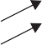Shearing Force
Section Plane

Resisting Force
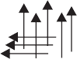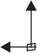Normal to Plane p q

  - Members Subject to Forces

  - Internal Resistances Developed

Fig.

In practice, intensity of stress is called as ‘‘stress’’ only. Mathematically
Normal Stress = p = lim ΔR

ΔA → 0 ΔA

= dR dA

...(1)

where R is normal resisting force.
The intensity of resisting force parallel to the sectional plane is called Shearing Stress (q).

Shearing Stress = q = lim
ΔA → 0

ΔQ
Δ A

= dQ dA

...(2)

where Q is Shearing Resistance.
Thus, stress at any point may be defined as resistance developed per unit area. From equations
    - and (2), it follows that
dR = pdA
or R = ∫ pdA ...(3a)
and Q = ∫ qdA ...(3b)
At any cross-section, stress developed may or may not be uniform. In a bar of uniform cross- section subject to axial concentrated loads as shown in Fig. 2a, the stress is uniform at a section away from the applied loads (Fig. 2b); but there is variation of stress at the section near the applied loads (Fig. 2c).

P P

(a)

PA

- Variation of Stresses Away from Ends

- Variation of Stresses Near Ends

Fig. 2
Similarly stress near the hole or at fillets will not be uniform as shown in Figs. 3 and 4. It is very common that at some points in such regions maximum stress will be as high as 2 to 4 times the average stresses.

P P

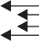P

Fig. 3. Stresses in a Plate with a Hole Fig. 4

UNIT OF STRESS
When Newton is taken as unit of force and millimetre as unit of area, unit of stress will be N/mm². The other derived units used in practice are kN/mm², N/m², kN/m² or MN/m². A stress of one N/m² is known as Pascal and is represented by Pa.
Hence, 1 MPa = 1 MN/m² = 1 × 10⁶ N/(1000 mm)² = 1 N/mm².
Thus one Mega Pascal is equal to 1 N/mm². In most of the standard codes published unit of stress has been used as Mega Pascal (MPa or N/mm²).
AXIAL STRESS
Consider a bar subjected to force P as shown in Fig. 5. To maintain the equilibrium the end forces applied must be the same, say P.

P P
Axis of the Bar
A Sectional Plane

- Bar Subjected to Pulls

R

P

P
R

- Resisting Force Developed
Fig. 5. Tensile Stresses
The resisting forces acting on a section are shown in Fig. 5b. Now since the stresses are uniform

where A is the cross-sectional area.
R = ∫ pdA = p ∫ dA = pA ...(4)

Considering the equilibrium of a cut piece of the bar, we get
P = R ...(5)
From equations (4) and (5), we get
P = pA
p =P/A
Thus, in case of axial load ‘P’ the stress developed is equal to the load per unit area. Under this type of normal stresses the bar is being extended. Such stress which is causing extension of the bar is called tensile stress.
A bar subjected to two equal forces pushing the bar is shown in Fig. 6. It causes shortening of the bar. Such forces which are causing shortening, are known as compressive forces and corresponding stresses as compressive stresses.

P P

Axis of the Bar
- 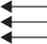Bar Subjected to Compressive Forces P R
- Resisting Force Developed

Fig.6. Compressive Stresses
Now R = ∫ pdA = p ∫ dA (as stress is assumed uniform) For equilibrium of the piece of the bar
P = R = pA
or p = P as in equation 6
A
Thus, whether it is tensile or compressive, the stress developed in a bar subjected to axial forces, is equal to load per unit area.

STRAIN
No material is perfectly rigid. Under the action of forces a rubber undergoes changes in shape and size. This phenomenon is very well known to all since in case of rubber, even for small forces deformations are quite large. Actually all materials including steel, cast iron, brass, concrete, etc. undergo similar deformation when loaded. But the deformations are very small and hence we cannot see them with naked eye. There are instruments like extensometer, electric strain gauges which can measure extension of magnitude 1/100th, 1/1000th of a millimetre. There are machines like universal testing machines in which bars of different materials can be subjected to accurately known forces of magnitude as high as 1000 kN. The studies have shown that the bars extend under tensile force and shorten under compressive forces as shown in Fig. 8.7. The change in length per unit length is known as linear strain. Thus,
Linear Strain = Change in Length
Original Length

e = Δ
L

...(7)

b′ b

L
(Original Length)

(Shortening) L
(Original Length)

(Extension)

b′ b
b

Fig. 7

When changes in longitudinal direction is taking place changes in lateral direction also take place. The nature of these changes in lateral direction are exactly opposite to that of changes in longitudinal direction i.e., if extension is taking place in longitudinal direction, the shortening of lateral dimension takes place and if shortening is taking place in longitudinal direction extension takes place in lateral directions (See Fig. 7). The lateral strain may be defined as changes in the lateral dimension per unit lateral dimension. Thus,
Lateral Strain = Change in Lateral Dimension
Original Lateral Dimension

= b′ − b = δb

...(8)

b b
STRESS-STRAIN RELATION
The stress-strain relation of any material is obtained by conducting tension test in the laboratories on standard specimen. Different materials behave differently and their behaviour in tension and in compression differ slightly.
Behaviour in Tension
Mild steel. Figure 8 shows a typical tensile test specimen of mild steel. Its ends are gripped into universal testing machine. Extensometer is fitted to test specimen which measures extension over the length L₁, shown in Fig. 8. The length over which extension is mesured is called gauge length.
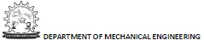
The load is applied gradually and at regular interval of loads extension is measured. After certain load, extension increases at faster rate and the capacity of extensometer to measure extension comes to an end and, hence, it is removed before this stage is reached and extension is measured from scale on the universal testing machine. Load is increased gradually till the specimen breaks.

Cone

L1 L2
Cup

Fig. 8. Tension Test Specimen Fig. 9. Tension Test Specimen after Breaking

Load divided by original cross-sectional area is called as nominal stress or simply as stress. Strain is obtained by dividing extensometer readings by gauge length of extensometer (L₁) and by dividing scale readings by grip to grip length of the specimen (L₂). Figure 810 shows stress vs strain diagram for the typical mild steel specimen. The following salient points are observed on stress-strain curve:
D
F
B
E
A C
Stress
      - Limit of Proportionality (A): It is the limiting value of the stress up to which
stress is proportional to strain. 0
      - Elastic Limit: This is the limiting value
of stress up to which if the material is

F’ Strain
Fig. 10

stressed and then released (unloaded) strain disappears completely and the original length is regained. This point is slightly beyond the limit of proportionality.
      - Upper Yield Point (B): This is the stress at which, the load starts reducing and the extension increases. This phenomenon is called yielding of material. At this stage strain is about 0.125 per cent and stress is about 250 N/mm².
      - Lower Yield Point (C): At this stage the stress remains same but strain increases for some time.
      - Ultimate Stress (D): This is the maximum stress the material can resist. This stress is about 370–400 N/mm². At this stage cross-sectional area at a particular section starts reducing very fast (Fig. 8.9). This is called neck formation. After this stage load resisted and hence the stress developed starts reducing.
      - Breaking Point (E): The stress at which finally the specimen fails is called breaking point.
At this strain is 20 to 25 per cent.
If unloading is made within elastic limit the original length is regained i.e., the stress-strain curve
follows down the loading curve shown in Fig. 8.6. If unloading is made after loading the specimen beyond elastic limit, it follows a straight line parallel to the original straight portion as shown by line FF′ in Fig. 10. Thus if it is loaded beyond elastic limit and then unloaded a permanent strain (OF) is left in the specimen. This is called permanent set.
Stress-strain relation in aluminium and high strength steel. In these elastic materials there is no clear cut yield point. The necking takes place at ultimate stress and eventually the breaking point is lower than the ultimate point. The typical stress-strain diagram is shown in Fig. 11. The stress p at which if unloading is made there will be 0.2 per cent permanent set is known as 0.2 per cent proof stress and this point is treated as yield point for all practical purposes.

F
py

F’
Stress
Stress
0.2

Strain

Strain

Fig. 11. Stress-Strain Relation in Fig. 12. Stress-Strain Relation
Aluminium and High Strength Steel for Brittle Material
Stress-strain relation in brittle material. The typical stress-strain relation in a brittle material like cast iron, is shown in Fig. 12.
In these material, there is no appreciable change in rate of strain. There is no yield point and no necking takes place. Ultimate point and breaking point are one and the same. The strain at failure is very small.
Percentage elongation and percentage reduction in area. Percentage elongation and percentage reduction in area are the two terms used to measure the ductility of material.
- Percentage Elongation: It is defined as the ratio of the final extension at rupture to original length expressed, as percentage. Thus,

Percentage Elongation = L′ − L
L

× 100 ...(9)

where L – original length, L′– length at rupture.
The code specify that original length is to be five times the diameter and the portion considered must include neck (whenever it occurs). Usually marking are made on tension rod at every ‘2.5 d’ distance and after failure the portion in which necking takes place is considered. In case of ductile material percentage elongation is 20 to 25.
- Percentage Reduction in Area: It is defined as the ratio of maximum changes in the cross- sectional area to original cross-sectional area, expressed as percentage. Thus,

Percentage Reduction in Area =
A − A′
A

× 100 ...(10)

where A–original cross-sectional area, A′–minimum cross-sectional area. In case of ductile material, A′ is calculated after measuring the diameter at the neck. For this, the two broken pieces of the specimen are to be kept joining each other properly. For steel, the percentage reduction in area is 60 to 70.
Behaviour of Materials under Compression
As there is chance to bucking (laterally bending) of long specimen, for compression tests short specimens are used. Hence, this test involves measurement of smaller changes in length. It results into lesser accuracy. However precise measurements have shown the following results:
- In case of ductile materials stress-strain curve follows exactly same path as in tensile test up to and even slightly beyond yield point. For larger values the curves diverge. There will not be necking in case of compression tests.
- For most brittle materials ultimate compresive stress in compression is much larger than in tension. It is because of flows and cracks present in brittle materials which weaken the material in tension but will not affect the strength in compression.

NOMINAL STRESS AND TRUE STRESS
So far our discussion on direct stress is based on the value obtained by dividing the load by original cross-sectional area. That is the reason why the value of stress started dropping after neck is formed in mild steel (or any ductile material) as seen in Fig. 10. But actually as material is stressed its cross-sectional area changes. We should divide load by the actual cross-sectional area to get true stress in the material. To distinguish between the two values we introduce the terms nominal stress and true stress and define them as given below:

Nominal Stress = Load
Original Cross-sectional Area
True Stress = Load
Actual Cross-sectional Area
...(11a)

...11b)

So far discussion was based on nominal stress. That is why after neck formation started (after ultimate stress), stress-strain curve started sloping down and the breaking took place at lower stress (nominal). If we consider true stress, it is increasing continuously as strain increases as shown in Fig. 13.
True Stress-Strain Curve
Nominal Stress-Strain Curve
Strain
Stress

Fig. 13. Nominal Stress-Strain Curve and True Stress-Strain Curve for Mild Steel.

FACTOR OF SAFETY
In practice it is not possible to design a mechanical component or structural component permitting stressing up to ultimate stress for the following reasons:
- Reliability of material may not be 100 per cent. There may be small spots of flaws.
- The resulting deformation may obstruct the functional performance of the component.
- The loads taken by designer are only estimated loads. Occasionally there can be overloading. Unexpected impact and temperature loadings may act in the lifetime of the member.
- There are certain ideal conditions assumed in the analysis (like boundary conditions). Actually ideal conditions will not be available and, therefore, the calculated stresses will not be 100 per cent real stresses.
Hence, the maximum stress to which any member is designed is much less than the ultimate stress, and this stress is called Working Stress. The ratio of ultimate stress to working stress is called factor of safety. Thus

Factor of Safety = Ultimate Stress
Working Stress

...(8.12)

In case of elastic materials, since excessive deformation create problems in the performance of the member, working stress is taken as a factor of yield stress or that of a 0.2 proof stress (if yield point do not exist).
Factor of safety for various materials depends up on their reliability. The following values are commonly taken in practice:
- For steel – 1.85
- For concrete – 3
- For timber – 4 to 6

HOOKE’S LAW
Robert Hooke, an English mathematician conducted several experiments and concluded that stress is proportional to strain up to elastic limit. This is called Hooke’s law. Thus Hooke’s law is, up to elastic limit
p ∝ e (13a)
where p is stress and e is strain
Hence, p = Ee (13b)
where E is the constant of proportionality of the material, known as modulus of elasticity or Young’s modulus, named after the English scientist Thomas Young (1773–1829).
However, present day sophisticated experiments have shown that for mild steel the Hooke’s law holds good up to the proportionality limit which is very close to the elastic limit. For other materials, Hooke’s law does not hold good. However, in the range of working stresses, assuming Hooke’s law to hold good, the relationship does not deviate considerably from actual behaviour. Accepting Hooke’s law to hold good, simplifies the analysis and design procedure considerably. Hence Hooke’s law is widely accepted. The analysis procedure accepting Hooke’s law is known as Linear Analysis and the design procedure is known as the working stress method.

EXTENSION/SHORTENING OF A BAR
Consider the bars shown in Fig. 14

P P
L Δ

P P
L Δ

From equation (8.6), Stress p = P
A
Fig. 14

From equation (8.7), Strain, e = From Hooke’s Law we have,
Δ
L

E = Stress = p = P/ A = PL

Strain e Δ/ L AΔ
or Δ = PL (14)
AE
Example 1. A circular rod of diameter 16 mm and 500 mm long is subjected to a tensile force 40 kN. The modulus of elasticity for steel may be taken as 200 kN/mm². Find stress, strain and elongation of the bar due to applied load.
Solution: Load P = 40 kN = 40 × 1000 N
E = 200 kN/mm² = 200 × 10³ N/mm²
L = 500 mm
Diameter of the rod d = 16 mm

Therefore, sectional area A =
πd ² = π × 162
4 4

= 201.06 mm²

Stress p = P = 40 × 1000
= 198.94 N/mm²

A

Strain e = p =
E
201.06
198.94
200 × 10³

= 0.0009947

Elongation Δ = PL =
AE
4.0 × 1000 × 500
201.06 × 200 × 10³

= 0.497 mm

Example 2. A Surveyor’s steel tape 30 m long has a cross-section of 15 mm × 0.75 mm. With this, line AB is measure as 150 m. If the force applied during measurement is 120 N more than the force applied at the time of calibration, what is the actual length of the line?
Take modulus of elasticity for steel as 200 kN/mm².
Solution: A = 15 × 0.75 = 11.25 mm²
P = 120 N, L = 30 m = 30 × 1000 mm
E = 200 kN/mm² = 200 × 10³ N/mm²

Elongation Δ = PL =
AE
Hence, if measured length is 30 m.
120 × 30 × 1000
11.25 × 200 × 10³

= 1.600 mm

Actual length is 30 m + 1.600 mm = 30.001600 m

∴ Actual length of line AB = 150
30

× 30.001600 = 150.008 m

Example 3. A hollow steel tube is to be used to carry an axial compressive load of 160 kN. The yield stress for steel is 250 N/mm². A factor of safety of 1.75 is to be used in the design. The following three class of tubes of external diameter 101.6 mm are available.
Class Thickness

Light Medium
3.65 mm
  - mm

Heavy 4.85 mm
Which section do you recommend?
Solution: Yield stress = 250 N/mm² Factor of safety = 1.75 Therefore, permissible stress

p = 250
1.75
= 142.857 N/mm²

Load P = 160 kN = 160 × 10³ N

but

p = P A

i.e. 142.857 = 160 × 103
A
160 10³
∴ A = = 1120 mm
×
2
142.857
For hollow section of outer diameter ‘D’ and inner diameter ‘d’
A = π (D² – d²) = 1120
4
π (101.6² – d²) = 1120
4

d² = 8896.53 ∴ d = 94.32 mm

∴ t =

D − d = 101.6 − 94.32

= 3.63 mm

2 2
Hence, use of light section is recommended.
Example 4. A specimen of steel 20 mm diameter with a gauge length of 200 mm is tested to destruction. It has an extension of 0.25 mm under a load of 80 kN and the load at elastic limit is 102 kN. The maximum load is 130 kN.
The total extension at fracture is 56 mm and diameter at neck is 15 mm. Find
- The stress at elastic limit.
- Young’s modulus.
- Percentage elongation.
- Percentage reduction in area.
- Ultimate tensile stress.
Solution: Diameter d = 20 mm
Area A = πd 2 = 314.16 mm²
4

    - Stress at elastic limit =
Load at elastic limit Area

102 × 10³
=
314.16
= 324.675 N/mm²

    - Young’s modulus E = Stress
Strain

within elastic limit

= P/ A = 80 × 10³ / 314.16

Δ/ L
0.25/ 200

= 203718 N/mm²
    - Percentage elongation = Final extension
Original length

= 56
200

× 100 = 28

    - Percentage reduction in area

= Initial area − Final area
Initial area

π × 20² − π × 15²

× 100

= 4 π
4
4
× 20²
× 100 = 43.75

    - Ultimate Tensile Stress = Ultimate Load
Area

= 130 × 10³
314.16

= 413.80 N/mm².

BARS WITH CROSS-SECTIONS VARYING IN STEPS
A typical bar with cross-sections varying in steps and subjected to axial load is as shown in Fig. 15(a). Let the length of three portions be L₁, L₂ and L₃ and the respective cross-sectional areas of the portion be A₁, A₂, A₃ and E be the Young’s modulus of the material and P be the applied axial load.
Figure 15(b) shows the forces acting on the cross-sections of the three portions. It is obvious that to maintain equilibrium the load acting on each portion is P only. Hence stress, strain and extension of each of these portions are as listed below:

P P
L1
L2
L3
A3
3
A2
2
A1
1

(a)

P P P P P

Section Through 1 Section Through 2 Section Through 3

(b)

Fig.15. Typical Bar with Cross-section Varying in Step

Portion | Stress | Strain | Extension
1 | p = P  1 A1 | e = p1 = P  ¹ E A1E  e = p2 = P  2 E A2E  e = p3 = P  ³ E A3E | Δ = PL1  ¹ A1E
2 | p = P  2 A2 |  | Δ = PL2  ² A2E
3 | p = P  3 A3 |  | Δ = PL3  ³ A3E
Hence total change in length of the bar

Δ = Δ + Δ

+ Δ = PL1 + PL2

- PL3

...(15)

1 2 3
A1E

A2 E
A3 E

Example 5. The bar shown in Fig. 16 is tested in universal testing machine. It is observed that at a load of 40 kN the total extension of the bar is 0.280 mm. Determine the Young’s modulus of the material.

P P

150 mm
d₂ = 20 mm
d₃ = 25 mm
d₁ = 25 mm
250 mm
150 mm

Fig. 16

Solution: Extension of portion 1, PL1 = 40 × 103 × 150

A1E

PL2

π × 25² E
4
40 × 10³ × 250

Extension of portion 2,
=
A2 E
π × 20² E
4

Extension of portion 3, PL3 = 40 × 103 × 150

A3E
π × 25² E
4

40 × 10³ × 4 ç150 + 250 + 150 y

Total extension =
E π (t625 400 625 )j

0.280 =

40 × 10³ × 4 × 1.112

E π E
E = 200990 N/mm²
BARS WITH CONTINUOUSLY VARYING CROSS-SECTIONS
When the cross-section varies continuously, an elemental length of the bar should be considered and general expression for elongation of the elemental length derived. Then the general expression should be integrated over entire length to get total extension.

Example 8. A bar of uniform thickness ‘t’ tapers uniformly from a width of b₁ at one end to b₂ at other end in a length ‘L’ as shown in Fig. 18. Find the expression for the change in length of the bar when subjected to an axial force P.

P P
b1
b
b2
x
dx
L
t

b

Cross-section

Fig. 19
Solution: Consider an elemental length dx at a distance x from larger end. Rate of change of breadth

is b1 − b2 .
L

Hence, width at section x is b = b₁

– b1 − b2
L

x = b1

– kx

where k = b1 − b2
L
∴ Cross-section area of the element = A = t(b₁ – kx) Since force acting at all sections is P only,

Extension of element = Pdx AE

= Pdx
(b₁ − kx)tE

[where length = dx]

Total extension of the bar =
jL Pdx = P jL dx

0 (b1 − kx)tE tE 0 (b1 − kx)
P j 1 r yL
0

= tE j − k jjLjlog (b₁ − kx)j

P r j b − b yL

= j− log b1 − ¹ ² xjj
tEk L L 0

= P [– log b

+ log b ] = P log b1
2

tEk
² ¹ tEk b

= PL
tE(b1 − b2 )
log b1 (16)
b2

A tapering rod has diameter d₁ at one end and it tapers uniformly to a diameter d₂ at the other end in a length L as shown in Fig. 20. If modulus of elasticity of the material is E, find its change in length when subjected to an axial force P.

P P
d
d1
b
d2
x dx
L

Cross-section

Fig. 20
Solution: Change in diameter in length L is d₁ – d₂

∴ Rate of change of diameter, k = d1 − d2
L
Consider an elemental length of bar dx at a distance x from larger end. The diameter of the bar at this section is
d = d₁ – kx.

Cross-sectional area A =

πd ²
4
= π (d1 – kx)²
4

∴ Extension of the element = P dx

π (d 4 1
- kx)² E

Extension of the entire bar Δ =
jL P dx

0 π (d − kx)² E
4 1
= 4P jL dx
πE
0 (d1 − kx)²
4P j 1 L

= πEk j d − kx jj
1 0
4P j 1 1

= πE(d − d ) j d − d jj , since d1 – kL = d2
1 2 2 1
L

Δ = 4PL × (d1 − d2 )

= 4PL

. ...(17)

πE(d1 − d2 ) d1d2
πEd1d2

Example 6. A steel flat of thickness 10 mm tapers uniformly from 60 mm at one end to 40 mm at other end in a length of 600 mm. If the bar is subjected to a load of 80 kN, find its extension. Take E = 2 × 10⁵ MPa. What is the percentage error if average area is used for calculating extension?

Solution: Now,
t = 10 mm
b₁ = 60 mm b₂ = 40 mm

L = 600 mm P = 80 kN = 80000 N
Now, 1 MPa = 1 N/mm²
Hence E = 2 × 10⁵ N/mm² Extension of the tapering bar of rectangular section

Δ = PL
tE(b1 − b2 )

log b1 b2

= 80000 × 600
10 × 2 × 10⁵ (60 − 40)
= 0.4865 mm
log 60
40

If averages cross-section is considered instead of tapering cross-section, extension is given by
Δ = PL
Aav E

Now Aav
= 60 × 10 + 40 × 10
2
= 500 mm²

Δ = 80000 × 600
500 × 2 × 10⁵

= 0.480 mm

∴ Percentage error =
0.4865 − 0.48
0.4865

× 100

SHEAR STRESS
= 1.348
Q

Figure 22 shows a bar subject to direct shearing force i.e., the force parallel to the cross-section of bar. The section of a rivet/bolt subject to direct shear
is shown in Fig. 23. Let Q be the shearing force P
and q the shearing stress acting on the section. Then, R
with usual assumptions that stresses are uniform we
get,
Q
Fig. 22. Direct Shear Force on a Section

Q Q
Q R

i.e.,

Q

For equilibrium

Fig. 23. Rivet in Direct Shear

R = ∫ q dA = q ∫ dA = qA Q = R = qA
q = Q A

Q

...(18)

Thus, the direct stress is equal to shearing force per unit area.

POISSON’S RATIO
When a material undergoes changes in length, it undergoes changes of opposite nature in lateral directions. For example, if a bar is subjected to direct tension in its axial direction it elongates and at the same time its sides contract (Fig. 27).

ΔL

Fig. 27. Changes in Axial and Lateral Directions
If we define the ratio of change in axial direction to original length as linear strain and change in lateral direction to the original lateral dimension as lateral strain, it is found that within elastic limit there is a constant ratio between lateral strain and linear strain. This constant ratio is called Poisson’s ratio. Thus,

Poisson’s ratio = Lateral strain
Linear strain

...(19)

It is denoted by 1 , or μ. For most of metals its value is between 0.25 to 0.33. Its value for steel
m
is 0.3 and for concrete 0.15.
VOLUMETRIC STRAIN
When a member is subjected to stresses, it undergoes deformation in all directions. Hence, there will be change in volume. The ratio of the change in volume to original volume is called volumetric strain.

Thus ev
where eV = Volumetric strain
δ_{V} = Change in volume
V = Original volume

= δV V

...(20)

It can be shown that volumetric strain is sum of strains in three mutually perpendicular directions.
i.e., ev = ex + ey + ez

For example consider a bar of length L, breadth b and depth d as shown in Fig. 28.

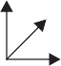x
d
b
L
z
y

Fig. 28
Now, V = Lbd
Since volume is function of L, b and d.
δV = δL bd + L δb d + Lb δd
δV = δv V Lbd

e = δL + δb + δd
^{V} L b d
eV = ex + ey + e z
Now, consider a circular rod of length L and diameter ‘d’ as shown in Fig. 29.

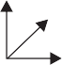x

d
z
y

Volume of the bar V = π
4

d²L
L

Fig. 29

∴ δV = π
4
∴ πδV = 2 δd

2dδd L + π
4

+ δL
d² δL (since v is function of d and L).

d ² L
4

e
d

= e + e
L

+ e ; since e

= e = δd

V x y z
y z d

In general for any shape volumetric strain may be taken as sum of strains in three mutually perpendicular directions.
ELASTIC CONSTANTS
Modulus of elasticity, modulus of rigidity and bulk modulus are the three elastic constants. Modulus of elasticity (Young’s Modulus) ‘E’ has been already defined as the ratio of linear stress to linear strain within elastic limit. Rigidity modulus and Bulk modulus are defined in this article.
Modulus of Rigidity: It is defined as the ratio of shearing stress to shearing strain within elastic limit and is usually denoted by letter G or N. Thus

G = q
φ

...(21)

where G = Modulus of rigidity
q = Shearing stress and φ = Shearing strain
Bulk Modulus: When a body is subjected to identical stresses p in three mutually perpendicular directions, (Fig. 30), the body undergoes uniform changes in three directions without undergoing distortion of shape. The ratio of change in volume to original volume has been defined as volumetric strain (ev). Then the bulk modulus, K is defined as
K = p ev
where p = identical pressure in three mutually perpendicular directions
e = Δv , Volumetric strain
v v
Δ_{v} = Change in volume
v = Original volume
Thus bulk modulus may be defined as the ratio of identical pressure ‘p’ acting in three mutually perpendicular directions to corresponding volumetric strain.
p p

p
p
p
p

p p p

p

p p
- (b)
Fig. 30

Figure 30 shows a body subjected to identical compressive pressure ‘p’ in three mutually perpendicular directions. Since hydrostatic pressure, the pressure exerted by a liquid on a body within it, has this nature of stress, such a pressure ‘p’ is called as hydrostatic pressure.

RELATIONSHIP BETWEEN MODULUS OF ELASTICITY AND MODULUS OF RIGIDITY
Consider a square element ABCD of sides ‘a’ subjected to pure shear ‘q’ as shown in Fig. 8.31. AEC′D shown is the deformed shape due to shear
q. Drop perpendicular BF to diagonal DE. Let φ be the shear strain and
G modulus of rigidity.

Now, strain in diagonal BD = DE − DF
DF
= EF DB
q
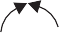E B C′ C
F′
q
ϕ
A D
a

a
q

Fig. 31

=
EF
AB 2

Since angle of deformation is very small we can assume ∠BEF = 45°, hence EF = BE cos 45°

∴ Strain in diagonal BD =
EF = BE cos 45°
BD
AB 2

= a tan φ cos 45°
2
a
= 1 tan φ = 1 φ (Since φ is very small)
2 2

= 1 × q , since φ = q
...(1)

2 G G
Now, we know that the above pure shear gives rise to axial tensile stress q in the diagonal direction of DB and axial compression q at right angles to it. These two stresses cause tensile strain along the diagonal DB.
Tensile strain along the diagonal DB = q + μ q = q (1 + μ) ...(2)
E E E
From equations (1) and (2), we get
1 × q = q (1 + μ)
2 G E
E = 2G(1 + μ) ...(22)

RELATIONSHIP BETWEEN MODULUS OF ELASTICITY AND BULK MODULUS
Consider a cubic element subjected to stresses p p
in the three mutually perpendicular direction x, y, p
z as shown in Fig. 32.
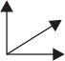
Now the stress p in x direction causes tensile z
y

strain p
E
in x direction while the stress p in y and x p p

z direction cause compressive strains μ p
E
in x p

direction.
Hence, e

= p − μ p − μ p p

^{x} E E E

Similarly ey

= p (1 − 2μ)
E

= p (1 − 2μ)
E
Fig. 32

ez =

p (1 − 2μ) ...(1)
E

∴ Volumetric strain e_{v} = e_{x} + e_{y} + e_{z} = 3 p (1 − 2μ)
E
From definition, bulk modulus K is given by

K = p ev
= 3 p (1 − 2μ)
E
p

or E = 3K(1 – μ) ...(2)
Relationship between EGK:
We know E = 2G(1 + μ) ...(a)
and E = 3K(1 – 2μ) ...(b)
By eliminating μ between the above two equations we can get the relationship between E, G, K, free from the term μ.

From equation (a) μ =
E − 1 2G

Substituting it in equation (b), we get
E = 3K jr1 − 2 j E − 1 yj
L 2G j
= 3Kj1 − E + 2 = 3Kj3 − E
G j G j

= 9K – 3KE
G

∴ E j1 + 3K

= 9K

G j

or E j G + 3K
= 9K ...(c)

G j
or E =

9KG G + 3K

...(23a)

Equation (c) may be expressed as
9 = G + 3K E KG

Example 7. A circular rod of 25 mm diameter and 500 mm long is subjected to a tensile force of 60 kN. Determine modulus of rigidity, bulk modulus and change in volume if Poisson’s ratio =
  - and Young’s modulus E = 2 × 10⁵ N/mm².
Solution: From the relationship
E = 2G(1 + μ) = 3k(1 – 2μ)

We get, G = E
= 2 × 10⁵
= 0.7692 × 105 N/mm2

2(1 + μ) 2(1 + 0.3)
E 2 × 10⁵
and K = 3(1 + 2μ) = 3(1 − 2 × 0.3) = 1.667 × 105 N/mm2

Longitudinal stress =
P 60 × 10³
= 122.23 N/mm
π
= 2
A × 25²
4

Linear strain = Stress = 122.23

= 61.115 × 10^{–5}

E 2 × 10⁵
Lateral strain = ey = – μex and ez = – μex
Volumetric strain ev = ex + ey + ez
= ex(1 – 2μ)

= ev
= 61.115 × 10^{–5} (1 – 2 × 0.3)
= 24.446 × 10^{–5}

but Change in volume
v

∴ Change in volume = ev × v

= 24.446 × 10–5 × π
4

× (252) × 500

= 60 mm³
Example 8. A 400 mm long bar has rectangular cross-section 10 mm × 30 mm. This bar is subjected to
    - 15 kN tensile force on 10 mm × 30 mm faces,
    - 80 kN compressive force on 10 mm × 400 mm faces, and
    - 180 kN tensile force on 30 mm × 400 mm faces.
Find the change in volume if E = 2 × 10⁵ N/mm² and μ = 0.3.

z
y
x
180 kN
80
30
15 kN

10
80 kN
15 kN
400
180 kN

Fig 33

Example 9. In a laboratory, tensile test is conducted and Young’s modulus of the material is found to be 2.1 × 10⁵ N/mm². On the same material torsion test is conducted and modulus of rigidity is found to be 0.78 × 10⁵ N/mm². Determine Poisson’s Ratio and bulk modulus of the material.
[Note: This is usual way of finding material properties in the laboratory].
Solution: E = 2.1 × 10⁵ N/mm²
G = 0.78 × 10⁵ N/mm²
Using relation E = 2G(1 + μ)
we get 2.1 × 10⁵ = 2 × 0.78 × 10⁵ (1 + μ)
1.346 = 1 + μ
or μ = 0.346
From relation E = 3K(1 – 2μ)
we get 2.1 × 10⁵ = 3 × K(1 – 2 × 0.346)
K = 2.275 × 10⁵ N/mm²
Example 10. A material has modulus of rigidity equal to 0.4 × 10⁵ N/mm² and bulk modulus equal to 0.8 × 10⁵ N/mm². Find its Young’s Modulus and Poisson’s Ratio.
Solution: G = 0.4 × 10⁵ N/mm²
K = 0.8 × 10⁵ N/mm²
Using the relation E = 9GK
3K + G

From the relation we get
9 × 0.4 × 10⁵ × 0.8 × 10⁵
E = 3 × 0.8 × 10⁵ + 0.4 × 10⁵
E = 1.0286 × 10⁵ N
E = 2G(1 + μ)
1.0286 × 10⁵ = 2 × 0.4 × 10⁵(1 + μ)
1.2857 = 1 + μ

or μ = 0.2857

COMPOSITE/COMPOUND BARS
Bars made up of two or more materials are called composite/compound bars. They may have same length or different lengths as shown in Fig. 34. The ends of different materials of the bar are held together under loaded conditions.

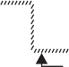P P Rigid
connection

Material 1
Material 2 Material 1
Material 2

P

Fig. 34

Rigid support

Consider a member with two materials. Let the load shared by material 1 be P₁ and that by material 2 be P₂. Then
- From equation of equilibrium of the forces, we get
P = P₁ + P₂ ...24a)
- Since the ends are held securely, we get
Δl1 = Δl2
where Δl₁ and Δl₂ are the extension of the bars of material 1 and 2 respectively

i.e. P1 L1
A1 E1
= P2 L2
A2 E2

...24b)

Using equations 8.24(a) and (b), P₁ and P₂ can be found uniquely. Then extension of the system

can be found using the relation Δl = P1 L1
A1E1
or Δl = P2 L2
A2 E2
since Δl = Δl₁
= Δl2.

The procedure of the analysis of compound bars is illustrated with the examples below:
Example 11. A compound bar of length 600 mm consists of a strip of aluminium 40 mm wide and 20 mm thick and a strip of steel 60 mm wide × 15 mm thick rigidly joined at the ends. If elastic modulus of aluminium and steel are 1 × 10⁵ N/mm² and 2 × 10⁵ N/mm², determine the stresses developed in each material and the extension of the compound bar when axial tensile force of 60 kN acts.

Solution: The compound bar is shown in the figure 8.36.
Data available is
L = 600 mm
P = 60 kN = 60 × 1000 N
Aa = 40 × 20 = 800 mm²
As = 60 × 15 = 900 mm²
Ea = 1 × 10⁵ N/mm², Es = 2 × 10⁵ N/mm².

Let the load shared by aluminium strip be Pa and that shared by steel be Ps. Then from equilibrium condition
Pa + Ps = 60 × 1000 ...(1)
From compatibility condition, we have
Δ_{a} = Δ_{s}

P_{a} L = P_{s} L

Aluminium
l

Stee 600 mm

Aa Ea As Es

i.e. Pa × 600 = Ps × 600
800 × 1 × 10⁵ 900 × 2 × 10⁵

Ps = 2.25 Pa ...(2)
Substituting it in eqn. (1), we get

60 kN

Pa + 2.25 Pa = 60 × 1000
i.e. Pa = 18462 N.
∴ Ps = 2.25 × 18462 = 41538 N.

∴ Stress in aluminium strip = Pa = 18462
Fig. 35

Aa 800
= 23.08 N/mm²

Stress in steel strip = Ps = 41538
= 46.15 N/mm²

As 900
Extension of the compound bar = Pa L = 18462 × 600
A_{a} E_{a} 800 × 1 × 10⁵

Δl = 0.138 mm.
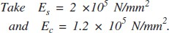
Example 12. A compound bar consists of a circular rod of steel of 25 mm diameter rigidly fixed into a copper tube of internal diameter 25 mm and external diameter 40 mm as shown in Fig. 36. If the compound bar is subjected to a load of 120 kN, find the stresses developed in the two materials.

Fig. 36

Copper tube

Steel rod

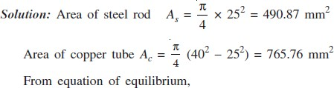

Ps + Pc = 120 × 1000
where Ps is the load shared by steel rod and Pc is the load shared by the copper tube.
From compatibility condition, we have
Δ_{s} = Δ_{c}

P_{s} L = P_{c} L
...(1)

As Es Ac Ec

P_{s} = P_{c}
490.87 × 2 × 10⁵ 765.76 × 1.2 × 10⁵

∴ Ps = 1.068 Pc
From eqns. (1) and (2), we get
...(2)

1.068 Pc + Pc = 120 × 1000
∴ P = 120 × 1000

= 58027 N

^{c} 2.068
∴ Ps = 1.068 Pc = 61973 N

∴ Stress in copper = 58027
9765.76
= 75.78 N/mm²

Stress in steel = 61973
490.87
= 126.25 N/mm²

Example 13. Three pillars, two of aluminium and one of steel support a rigid platform of 250 kN as shown in Fig. 38. If area of each aluminium pillar is 1200 mm² and that of steel pillar is 1000 mm², find the stresses developed in each pillar.
250 kN
Take Es = 2 × 10⁵ N/mm² and Ea = 1 × 10⁶ N/mm².
Aluminium
Aluminium
Solution: Let force shared by each aluminium pillar be Pa and that shared by steel pillar be Ps .
160 mm
240 mm
Steel
∴ The forces in vertical direction = 0 →
Pa + Ps + Pa = 250

2Pa + Ps = 250
From compatibility condition, we get
Δ_{s} = Δ_{a}

Ps Ls = Pa La
...(1)

Fig. 38

As Es Aa Ea
P_{s} × 240 = P_{a} × 160
1000 × 2 × 10⁵ 1200 × 1 × 10⁵

∴ Ps = 1.111 Pa
From eqns. (1) and (2), we get
Pa (2 + 1.111) = 250
...(2)

∴
Hence from eqn. (1),
Pa = 80.36 kN

Ps = 250 – 2 × 80.36 = 89.28 kN

∴ Stresses developed are

σ

= P_{s} = 89.28 × 1000

= 89.28 N/mm²

s As
1000

σ = 80.36 × 1000
ª 1200
= 66.97 N/mm²

Example 14. A steel bolt of 20 mm diameter passes centrally through a copper tube of internal diameter 28 mm and external diameter 40 mm. The length of whole assembly is 600 mm. After tight fitting of the assembly, the nut is over tightened by quarter of a turn. What are the stresses introduced in the bolt and tube, if pitch of nut is 2 mm? Take Es = 2 × 10⁵ N/mm² and Ec = 1.2 × 10⁵ N/mm².
Copper tube
Copper tube
Steel bolt

600 mm (a)

Fig. 39

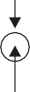
Steel bolt (b)

Solution: Figure 8.40 shows the assembly. Let the force shared by bolt be Ps and that by tube be
Pc. Since there is no external force, static equilibrium condition gives
Ps + Pc = 0 or Ps = – Pc
i.e., the two forces are equal in magnitude but opposite in nature. Obviously bolt is in tension and tube is in compression.

Let the magnitude of force be P. Due to quarter turn of the nut, the nut advances by 1
4

× pitch

= 1 × 2 = 0.5 mm.
4
[Note. Pitch means advancement of nut in one full turn]
During this process bolt is extended and copper tube is shortened due to force P developed. Let
Δ_{s} be extension of bolt and Δ_{c} shortening of copper tube. Final position of assembly be Δ, then
Δ_{s} + Δ_{c} = Δ

i.e.
Ps Ls + Pc Lc
= 0.5

As Es Ac Ec

P × 600 + P × 600 (π / 4) × 20² × 2 × 10⁵ (π / 4) (40² − 28² ) × 1.2 × 10⁵
= 0.5

P × 600 rj 1 + 1 jy = 0.5
(π/ 4) × 10⁵ L20² × 2 (40² − 28² ) × 1.2
∴ P = 28816.8 N

∴ ps =
P_{s} =
As
28816.8
(π / 4) × 20²
= 91.72 N/mm²

p = Pc =
c Ac
28816.8

(π / 4) (40² − 28² )
= 44.96 N/mm²

THERMAL STRESSES
Every material expands when temperature rises and contracts when temperature falls. It is established experimentally that the change in length Δ is directly proportional to the length of the member L and change in temperature t. Thus
Δ ∝ tL
= α tL ...(8.25)
The constant of proportionality α is called coefficient of thermal expansion and is defined as change in unit length of material due to unit change in temperature. Table 8.1 shows coefficient of thermal expansion for some of the commonly used engineering materials:
Table 1

Material | Coefficient of thermal expansion
Steel | 12 × 10^{–6}/°C
Copper | 17.5 × 10^{–6}/°C
Stainless steel | 18 × 10^{–6}/°C
Brass, Bronze | 19 × 10^{–6}/°C
Aluminium | 23 × 10^{–6}/°C
If the expansion of the member is freely permitted, as shown in Fig. 8.41, no temperature stresses are induced in the material.
L
αtL

Fig. 40 Free Expansion Permitted

If the free expansion is prevented fully or partially the stresses are induced in the bar, by the support forces. Referring to Fig. 41,
L
(a)
αtL

R P

Fig. 41
If free expansion is permitted the bar would have expanded by
Δ = α tL
Since support is not permitting it, the support force P develops to keep it at the original position.
Magnitude of this force is such that contraction is equal to free expansion, i.e.
PL
AE = α tL
or p = E α t (26)
which is the temperature stress. It is compressive in nature in this case.

Consider the case shown in Fig. 8.43 in which free expansion is prevented partially.

δ

L

δ
αtL

R = P P

Fig. 42

In this case free expansion = α tL
Expansion prevented Δ = α tL – δ

The expansion is prevented by developing compressive force P at supports
PL
∴ AE = Δ = α tL – δ. ...(27)
Example 15. A steel rail is 12 m long and is laid at a temperature of 18°C. The maximum temperature expected is 40°C.
- Estimate the minimum gap between two rails to be left so that the temperature stresses do not develop.
- Calculate the temperature stresses developed in the rails, if:
  - No expansion joint is provided.
  - If a 1.5 mm gap is provided for expansion.
- If the stress developed is 20 N/mm², what is the gap provided between the rails? Take E = 2 × 10⁵ N/mm² and α = 12 × 10^{–6}/°C.
Solution:
- The free expansion of the rails
= α tL = 12 × 10^{–6} × (40 – 18) × 12.0 × 1000
= 3.168 mm
∴ Provide a minimum gap of 3.168 mm between the rails, so that temperature stresses do not develop.

- (a) If no expansion joint is provided, free expansion prevented is equal to 3.168 mm.
i.e. Δ = 3.168 mm
PL
∴ AE = 3.168

∴ p =

P = 3.168 × 2 × 10⁵
A 12 × 1000

= 52.8 N/mm²

(b) If a gap of 1.5 mm is provided, free expansion prevented Δ = α tL – δ = 3.168 – 1.5 = 1.668 mm.

∴ The compressive force developed is given by PL
AE

= 1.668

or p =

P 1.668 × 2 × 10⁵
=
A 12 ×1000

= 27.8 N/mm²

- If the stress developed is 20 N/mm2, then p = P
A
= 20

If δ is the gap, Δ = α tL – δ

∴ PL
AE
= 3.168 – δ

i.e. 20 × 12 × 1000
2 × 10⁵
= 3.168 – δ

∴ δ = 3.168 – 1.20 = 1.968 mm

Example 16. The composite bar shown in Fig. 43 is rigidly fixed at the ends A and B. Determine the reaction developed at ends when the temperature is raised by 18°C. Given
Ea = 70 kN/mm² Es = 200 kN/mm²
α_{a} = 11 × 10^{–6}/°C
α_{s} = 12 × 10^{–6}/°C

A = 600 mm2 A = 400 mm2
Steel

Aluminium
a
s

1.5 m
3.0 m (a)

(b)

Fig.43

Solution: Free expansion = α_{a} tLa + α_{s}tLs
= 11 × 10^{–6} × 18 × 1500 + 12 × 10^{–6} × 18 × 3000
= 0.945 mm
Since this is prevented
Δ = 0.945 mm.
Ea = 70 kN/mm² = 70000 N/mm² ;
Es = 200 kN/mm² = 200 × 1000 N/mm²
If P is the support reaction,
Δ = PLa + PLs
Aa Ea As Es
i.e. 0.945 = Prj 1500 + 3000 yj

L600 × 70000
0.945 = 73.214 × 10^{–6} P
or P = 12907.3 N
400 × 200 × 1000

THERMAL STRESSES IN COMPOUND BARS
When temperature rises the two materials of the compound bar experience different free expansion. Since they are prevented from seperating, the two bars will have common position. This is possible only by extension of the bar which has less free expansion and contraction of the bar which has more free expansion. Thus one bar develops tensile force and another develops the compressive force. In this article we are interested to find such stresses.
Consider the compound bar shown in Fig. 45(a). Let α₁, α₂ be coefficient of thermal expansion and E₁, E₂ be moduli of elasticity of the two materials respectively. If rise in temperature is ‘t’,
Free expansion of bar 1 = α₁ tL
Free expansion of bar 2 = α₂ tL
Let α₁ > α₂. Hence the position of the two bars, if the free expansions are permitted are at AA and
BB as shown in Fig.

P1
d2tL
C
B
Bar -2
Δ2
P2
B
A
Δ1
A
α1tL
C
Bar-1
Bar -2
Bar-1

Fig. 45

Since the two bars are rigidly connected at the ends, the final position of the end will be somewhere between AA and BB, say at CC. It means Bar–1 will experience compressive force P₁ which contracts it by Δ₁ and Bar–2 experience tensile force P₂ which will expand it by Δ₂.
The equilibrium of horizontal forces gives,
P₁ = Pc, say P
From the Fig. 8.46 (b), it is clear,
α₁ tL – Δ₁ = α₂ tL + Δ₂
∴ Δ₁ + Δ₂ = α₁ tL – α₂ tL = (α₁ – α₂) tL. If the cross-sectional areas of the bars are A₁ and A₂, we get

PL A1 E1
- A2 E2
= (α₁ – α₂) t L ...(8.28)

From the above equation force P can be found and hence the stresses P₁ and P₂ can be determined.

Example 17. A bar of brass 20 mm is enclosed in a steel tube of 40 mm external diameter and 20 mm internal diameter. The bar and the tubes are initially 1.2 m long and are rigidly fastened at both ends using 20 mm diameter pins. If the temperature is raised by 60°C, find the stresses induced in the bar, tube and pins.
Given: Es = 2 × 10⁵ N/mm² Eb = 1 × 10⁵ N/mm²
α_{s} = 11.6 × 10^{–6}/°C
α_{b} = 18.7 × 10^{–6}/°C.
Solution:

A
Pin
αstL
B
Δs
C
Δb
1200 mm
B
C
Steel tube
20
Brass rod
40
A

αbtb
Fig. 46

t = 60° Es = 2 × 10⁵ N/mm² Eb = 1 × 10⁵ N/mm²
α_{s} = 11.6 × 10^{–6}/°C α_{b} = 18.7 ×10^{–6}/°C
A = π (40² – 20²) A = π × 20²
s 4 b 4
= 942.48 mm² = 314.16 mm²
Since free expansion of brass (α_{b} tL) is more than free expansion of steel (α_{s} tL), compressive force Pb develops in brass and tensile force Ps develops in steel to keep the final position at CC (Ref: Fig. 46).
Horizontal equilibrium condition gives Pb = Ps, say P. From the figure, it is clear that
Δ_{s} + Δ_{b} = α_{b} tL – α_{s}tL = (α_{b} – α_{s})tL.
where Δ_{s} and Δ_{b} are the changes in length of steels and brass bars.

∴ PL
As Es
- Ab Eb
= (18.7 – 11.6) × 10^{–6} × 60 × 1200.

P × 1200
rj 1 + 1 yj

= 7.1 × 10^{–6} × 60 × 1200

L942.48 × 2 × 10⁵
∴ P = 11471.3 N

∴ Stress in steel = P = 11471.3
314.16 × 1 × 10⁵

= 12.17 N/mm²

As

and Stress in brass = P Ab
942.48
= 11471.3
314.16

= 36.51 N/mm²

The pin resist the force P at the two cross-sections at junction of two bars.
∴ Shear stress in pin = P
2 × Area of pin

= 11471.3
2 × π/ 4 × 20²

= 18.26 N/mm²

IMPORTANT FORMULAE

- If stress is uniform
p = P A
- (i) Linear strain = Change in length
Original length
(ii) Lateral strain = Change in lateral dimension
Original lateral dimension
- Poisson’s ratio = Lateral strain , within elastic limit.
Linear strain

- Percentage elongation = L′ − L × 100.
L
- Percentage reduction in area = A − A′ × 100.
A
- Nominal stress = Load .
Original cross-sectional area

- True stress = Load .
Actual cross-sectional area

- Factor of safety = Ultimate stress
Working stress
However in case of steel, = Yield stress .
Working stress

- Hooke’s Law, p = Ee.

- Extension/shortening of bar = PL .
AE

- Extension of flat bar with linearly varying width and constant thickness = PL
tE(b1 − b2 )

log b1 .
b2

- Extension of linearly tapering rod = 4PL =
PL .

- Direct shear stress = Q .
A
πE d1d2

(π/ 4 d₁d₂ ) E

- Volumetric strain ev

= δV V
= ex
+ ey
+ ez.

15. E = 2G (1 + μ) = 3K (1 – 2μ)
or 9 = 3 1 .
E G K
+
- Extension due to rise in temperature:

- Thermal force, P is given by
Δ = α tL

PL

AE = extension prevented.

Tutorial questions

- Draw stress strain diagram for ductile materials and indicate all salient features on it. Explain the various mechanical properties can be estimated from that diagram.
- Derive the relations between E,G,K
- Derive the expression for the elongation for the circular tapered bar
- Two parallel walls 6m apart are stayed together by a 25 mm diameter steel rod at 80⁰C passing through washers and nuts at ends. If the rod cools down to 22⁰C, calculate the pull induced in the rod, if
  - the walls do not yield and
  - the total yield at ends is 1.5 mm
E steel = 2×10⁵N/mm², α steel = 11×10−6 per⁰C.
- A)A metallic rod of 1 cm diameter, when tested under an axial pull of 10 kN was found to reduce its diameter by 0.0003 cm. The modulus of rigidity for the
rod is 51 KN/mm². Find the Poisson’s ratio, modulus of elasticity and Bulk Modulus.

b) An aluminium bar 60 mm diameter when subjected to an axial tensile load 100 kN elongates 0.20 mm in a gage length 300 mm and the diameter is decreased
by 0.012 mm. Calculate the modulus of elasticity and the Poisson’s ratio of the material.
- A specimen of diameter 13 mm and gauge length 50 mm was tested under tension. At 20 kN load, the extension was observed to be 0.0315 mm. Yielding occurred at a load of 35 kN and the ultimate load was 60 KN. The final gauge length at fracture was 70 mm. Calculate young’s modulus, yield stress, ultimate strength and percentage elongation.

DEPARTMENT OF MECHANICAL ENGINEERING

Assignment Questions

- Determine the young’s modulus and Possion’s ratio of a metallic bar of length 25cm breadth 3cm depth 2cm when the beam is subjected to an axial compressive load 240KN. The decrease in length is given by 0.05cm and increase in breadth 0.002
- Write the differences among Gradual, Sudden, Impact and Shock loadings with the help of expressions

- A steel rod and two copper rods together support a load of 370 kN as shown in fig. The cross sectional area of steel road is 2500 mm² and of each copper road is 1600 mm². Find the stresses in the roads. Take E for steel is 2x10⁵ N/mm² and for copper is 1x10⁵ N/mm²

- A vertical tie, fixed rigidly at the top end consist of a steel rod 2.5 m long and 20 mm diameter encased throughout in a brass tube 20 mm internal diameter and 30 mm external diameter. The rod and the casing are fixed together at both ends. The compound rod is loaded in tension by a force of 10 kN. Calculate the maximum stress in steel and brass. Take Es=2x10⁵N/mm² and Eb=1x10⁵N/mm²
- A steel tube 50mm in external diamerter and 3mm thick encloses centrally a solid copper bar of 35mm diameter. The bar and the tube are rigidly connected together at the ends at a temperature of 20 ⁰C. Find the stress in each metal when heated to 170⁰C. Also find the increase in length, if the original length of the assembly is 350mm. Take αs=1.08 x 10⁻⁵ per ⁰C and αc=1.7 x 10 ⁻⁵ per ⁰C . Take Es =2X10⁵ N/mm² , Ec =1X10⁵ N/mm²

DEPARTMENT OF MECHANICAL ENGINEERING

UNIT 2
SHEAR FORCE & BENDING MOMENT DIAGRAMS

Course Objectives:
  - To plot the variation of shear force and bending moments over the beams under different types of loads.

Course Outcomes:

- Draw the shear force and bending moment diagrams for the beam subjected to different loading conditions.

Shear force
UNITII

SHEAR FORCE AND BENDING MOMENT DIAGRAMS

The algebraic sum of the vertical forces at any section of a beam to the right or left of the section is known as shear force
Bending moment

The algebraic sum of the moments of all the forces acting to the right or left of the section is known as beading moment

Shear force and bending moment diagrams

A shear force diagram is one which shows the variation of the shear force along the length of the, beam. And a bending moment diagram is one which shows the variation of the bending moment along the length of the beam.
Important points for Shear force and bending moment

- Shear Force (V) ≡ equal in magnitude but opposite in direction to the algebraic sum (resultant) of the components in the direction perpendicular to the axis of the beam of all external loads and support reactions acting on either side of the section being considered.
- Bending Moment (M) equal in magnitude but opposite in direction to the algebraic sum of the moments about (the centroid of the cross section of the beam) the section of all external loads and support reactions acting on either side of the section being considered.
Notation and sign convention

  - Shear force (V)

Positive Shear Force

A shearing force having a downward direction to the right hand side of a section or upwards to the left hand of the section will be taken as ‘positive’. It is the usual sign conventions to be followed for the shear force. In some book followed totally opposite sign convention.
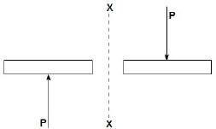

The upward direction shearing force which is on the left hand of the section XX is positive shear
force

The downward direction shearing force which is on the right hand of the section XX is positive shear force.

Negative Shear Force

A shearing force having an upward direction to the right hand side of a section or downwards to the left hand of the section will be taken as ‘negative’.
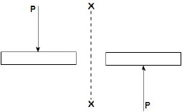

The downward direction shearing force which is on the left hand of the section XX is negative shear force.
The upward direction shearing force which is on the right hand of the section XX is negative shear force.

Bending Moment (M) Positive Bending Moment
A bending moment causing concavity upwards will be taken as ‘positive’ and called as sagging bending moment.

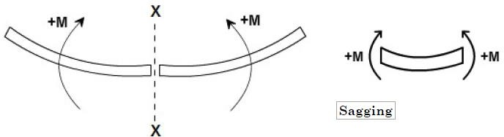

- If the bending moment of the left hand of the section XX is clockwise then it is a positive bending moment.
- If the bending moment of the right hand of the section XX is anti-clockwise then it is a positive bending moment.
- A bending moment causing concavity upwards will be taken as ‘positive’ and called as sagging bending moment
Negative Bending Moment

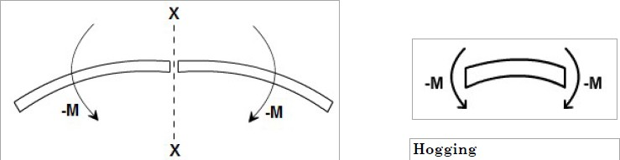

- If the bending moment of the left hand of the section XX is anti-clockwise then it is a negative bending moment.
- If the bending moment of the right hand of the section XX is clockwise then it is a negative bending moment.
- Hogging
A bending moment causing convexity upwards will be taken as ‘negative’ and called as hogging bending moment.
Relation between S.F (Vx), B.M. (Mx) & Load (w)

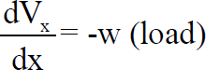

The value of the distributed load at any point in the beam is equal to the slope of the shear force curve. (Note that the sign of this rule may change depending on the sign convention used for the external distributed load).
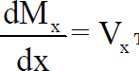

The value of the shear force at any point in the beam is equal to the slope of the bending moment curve.
Procedure for drawing shear force and bending moment diagram Construction of shear force diagram
- From the loading diagram of the beam constructed shear force diagram.
- First determine the reactions.
- Then the vertical components of forces and reactions are successively summed from the left end of the beam to preserve the mathematical sign conventions adopted. The shear at a section is simply equal to the sum of all the vertical forces to the left of the section.
- The shear force curve is continuous unless there is a point force on the beam. The curve then “jumps” by the magnitude of the point force (+ for upward force).
- When the successive summation process is used, the shear force diagram should end up with the previously calculated shear (reaction at right end of the beam). No shear force acts through the beam just beyond the last vertical force or reaction. If the shear

force diagram closes in this fashion, then it gives an important check on mathematical calculations. i.e. The shear force will be zero at each end of the beam unless a point force is applied at the end.

Construction of bending moment diagram

  - The bending moment diagram is obtained by proceeding continuously along the length of beam from the left hand end and summing up the areas of shear force diagrams using proper sign convention.
  - The process of obtaining the moment diagram from the shear force diagram by summation is exactly the same as that for drawing shear force diagram from load diagram.
  - The bending moment curve is continuous unless there is a point moment on the beam. The curve then “jumps” by the magnitude of the point moment (+ for CW moment).
  - We know that a constant shear force produces a uniform change in the bending moment, resulting in straight line in the moment diagram. If no shear force exists along a certain portion of a beam, then it indicates that there is no change in moment takes place. We also know that dM/dx= Vx therefore, from the fundamental theorem of calculus the maximum or minimum moment occurs where the shear is zero.
  - The bending moment will be zero at each free or pinned end of the beam. If the end is built in, the moment computed by the summation must be equal to the one calculated initially for the reaction.

A Cantilever beam with a concentrated load ‘P’ at its free end
Shear force:
At a section a distance x from free end consider the forces to the left, then (Vx) = - P (for all values of x) negative in sign
i.e. the shear force to the left of the x-section are in downward direction and therefore negative.
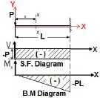
Bending Moment:

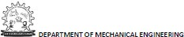

Bending Moment
Taking moments about the section gives (obviously to the left of the section)
Mx = -P.x
(negative sign means that the moment on the left hand side of the portion is in the anticlockwise direction and is therefore taken as negative according to the sign convention)
so that the maximum bending moment occurs at the fixed end i.e.
Mmax = - PL(at x = L)

A Cantilever beam with uniformly distributed load over the whole length

When a cantilever beam is subjected to a uniformly distributed load whose intensity is given w /unit length.
Shear force:
Consider any cross-section XX which is at a distance of x from the free end. If we just take the resultant of all the forces on the left of the X-section, then
Vx = -w.x for all values of ‘x'.
At x = 0, Vx = 0
At x = L, Vx = -wL (i.e. Maximum at fixed end)
Plotting the equation Vx = -w.x, we get a straight line because it is a equation of a straight line y
(Vx) = m(- w) .x
Bending Moment:
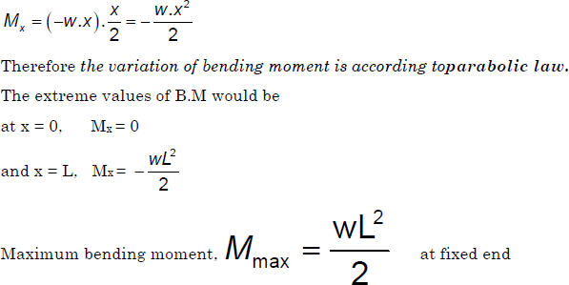
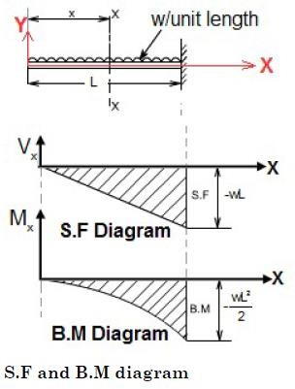
Bending Moment at XX is obtained by treating the load to the left of XX as a concentrated load of the same value (w.x) acting through the centre of gravity at x/2. Therefore, the bending moment at any cross-section XX is

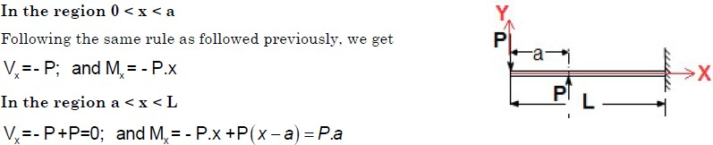
A Cantilever beam loaded as shown below draw its S.F and B.M diagram

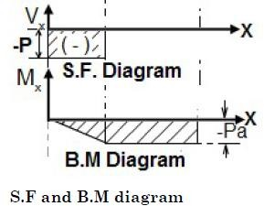
Example 1:A cantilever bean of 5 m length. It carries a uniformly distributed load 3 KN/m and a concentrated load of 7 kN at the free end and 10 kN at 3 meters from the fixed end.

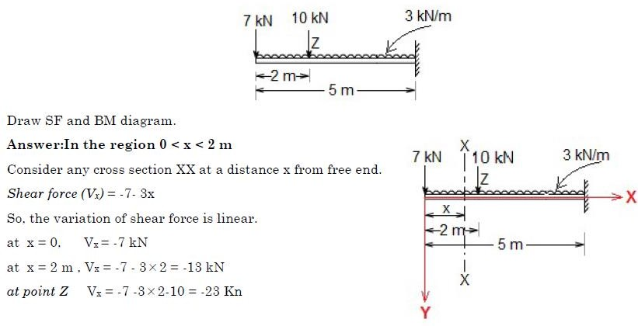
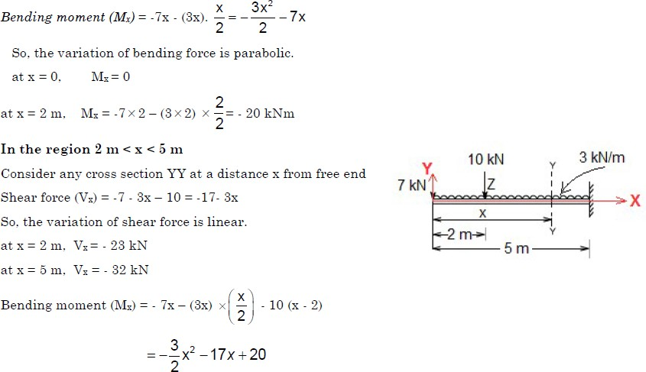

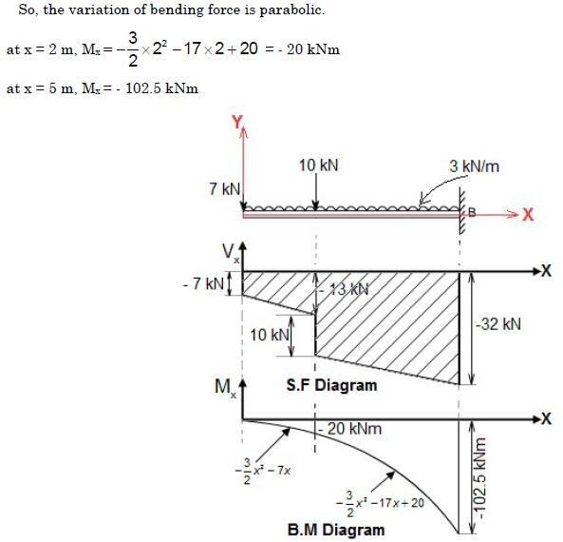

A Cantilever beam carrying uniformly varying load from zero at free end and w/unit length at the fixed end

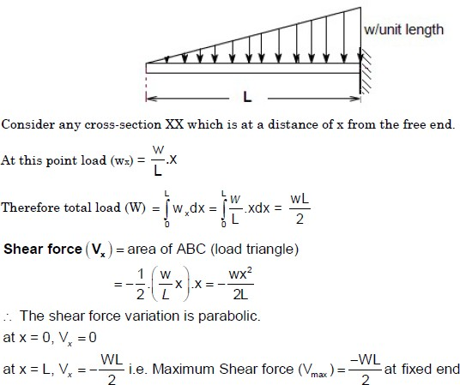
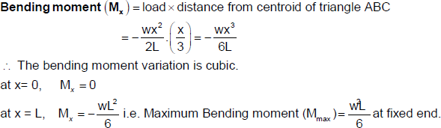

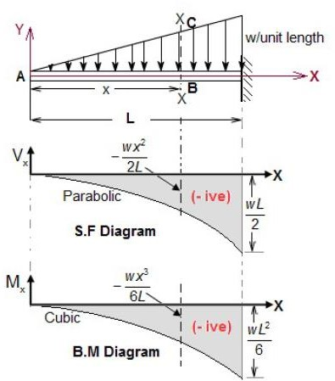

A Simply supported beam with a concentrated load ‘P’ at its mid span

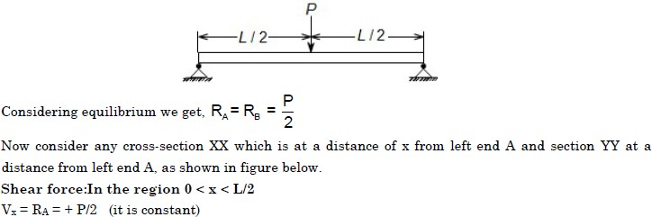

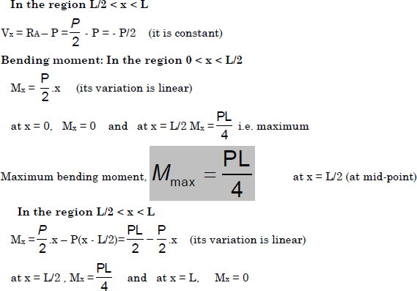
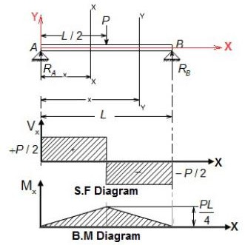

A Simply supported beam with a concentrated load ‘P’ is not at its mid span

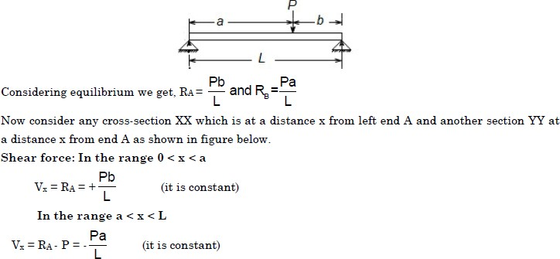
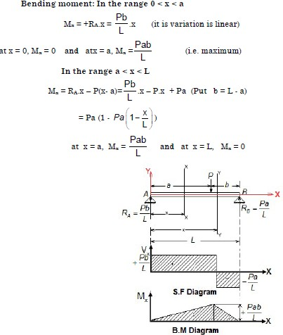

A Simply supported beam with a uniformly distributed load (UDL) through out its length
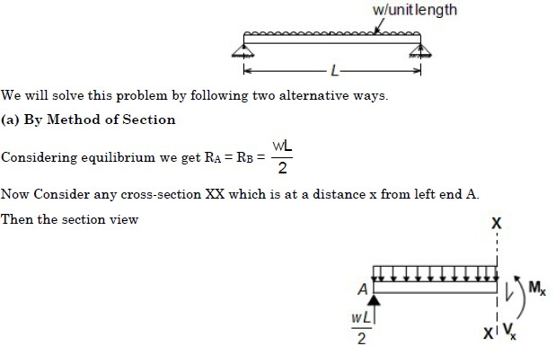
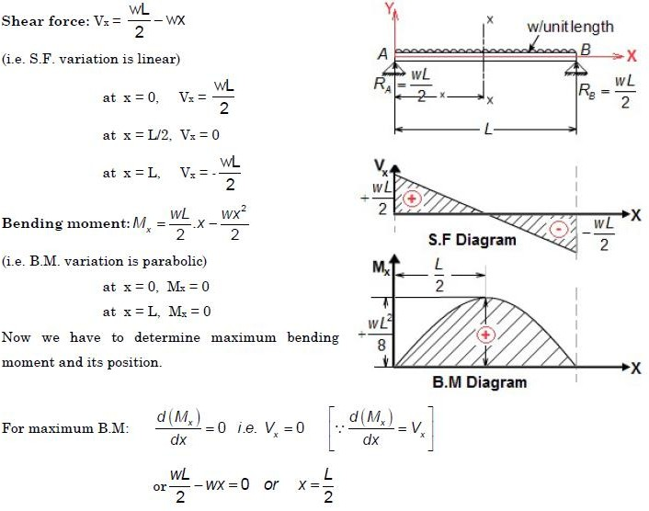

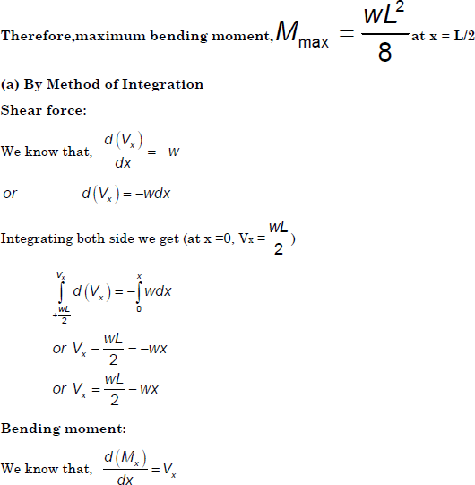
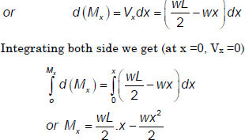

Example 2 :A loaded beam as shown below. Draw its S.F and B.M diagram
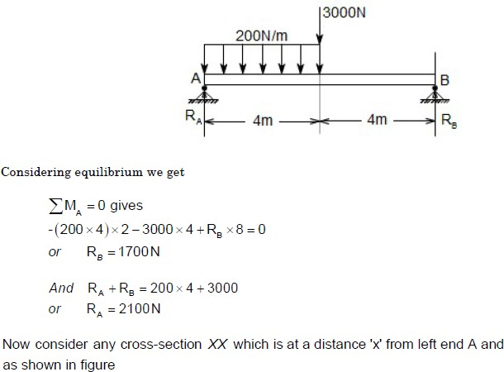

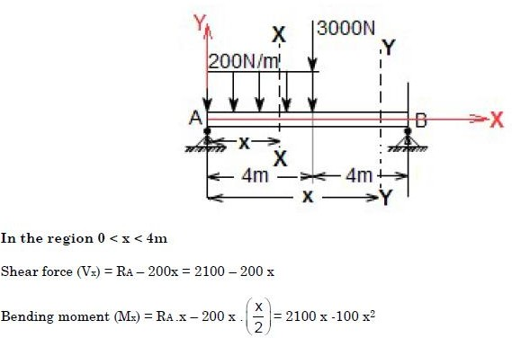
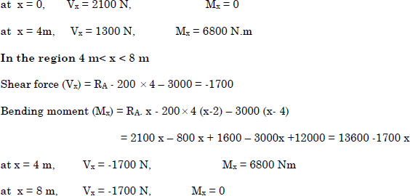

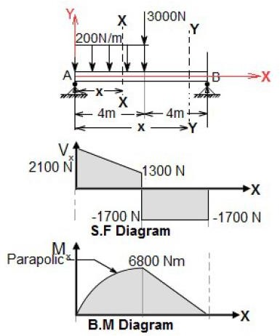

Shear force and bending moment diagrams for over-hanging beams

If the end portion of a beam is extended beyond the support, such beam is known as overhanging beam. In case of overhanging beams, the B.M. is positive between the two sup- ports, whereas the S.M. is negative for the over-hanging portion. Hence at some point, the
B.M. is zero after changing its sign from positive to negative or vice-versa. That point is known as the point of Contraflexure or point of inflexion
Point of Contraflexure:

It is the point where the B.M. is zero after changing its sign from positive to negative or vice- versa.

Overhanging Beam Subjected to a Concentrated Load at Free End

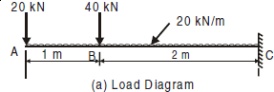
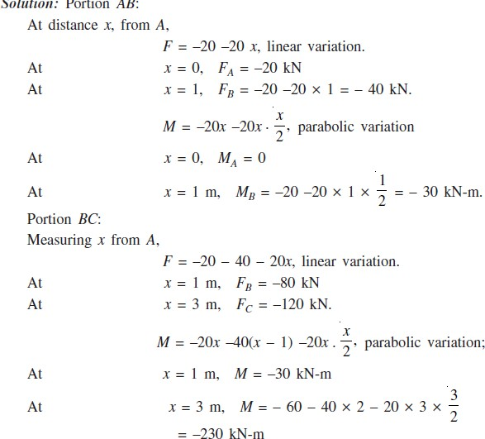
Draw shear force and bending moment diagram for the cantilever beam shown in Fig.

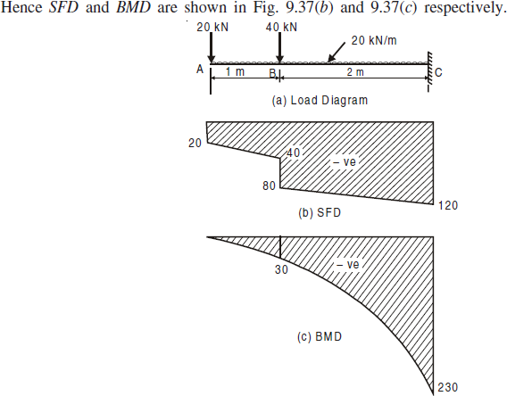

Statically determinate & Statically Indeterminate beams

Beams for which reaction forces and internal forces cannot be found out from static equilibrium equations alone are called statically indeterminate beam. This type of beam requires deformation equation in addition to static equilibrium equations to solve for unknown forces.
Statically determinate - Equilibrium conditions sufficient to compute reactions.

Statically indeterminate - Deflections (Compatibility conditions) along with equilibrium equations should be used to find out reactions.

Tutorial Questions

- A cantilever of length 2.0 m carries a uniformly distributed load of 1 kN/m run over a length of 1.5 m from the free end. Draw the shear force and bending moment diagrams for the cantilever.
- An overhanging beam ABC of length 7 m is simply supported at A and B over a span of 5 m and portion BC overhangs by 2 m. Draw the shearing force and bending moment diagrams abd determine the point of contra-flexure if it is subjected to uniformly distributed loads of 3 KN/m over the portion AB and a concentrated load of 8 kN at C.
- A beam of span 10m is simply supported at two points 6m apart with equal over-hang on either side. Both the overhanging portions are loaded with a uniformly
distributed load of 2 kN/m run and the beam also carries a concentrated load of
10 N at the midspan. Construct the SF and BM diagrams and locate the points of inflexion, if any.
- Sketch the shear force and bending moment diagrams showing the salient values for the loaded beam shown in the figure below.
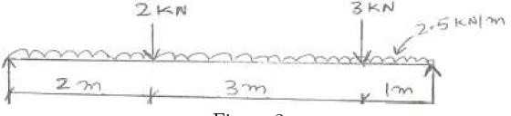
- A Simply supported beam of span,9 m hL of 15 KN/m over 4 m from the left support and a concentrated load of 20KN at the center. Draw SF and BM diagrams
- A Beam of length 12m is supported at left end and the other support is at a distance of 8m from the left support leaving a overhanging length of 4m on the right side.It carries a UDL of 10 KN/m over the entire length and a concentrated load of 8 KN at the right extreme end. Draw the shear force and bending moment diagrams and find the position of Contra flexure point
- Draw the B. M. D and S. F.D
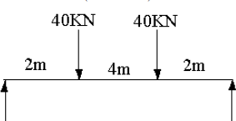

Assignment Questions
  - A cantilever beam of 2 m long carries a uniformly distributed load of 1.5kN/m over a length of 1.6 m from the free end. Draw shear force and bending moment diagrams for the beam
  - A simply supported beam 6 m long is carrying a uniformly distributed load of 5kN/m over a length of 3 m from the right end. Draw shear force and bending moment diagrams for the beam and also calculate the maximum bending moment on the beam
  - A simply supported beam of 16m long carries the point loads of 4KN, 5KN and 3KNat distances 3m, 7m and 10m respectively from the left support. Calculate the maximum shear force
and bending moment. Draw the SFD and BMD.
  - A horizontal beam of 10m long is carrying a uniformly distributed load of 1kN/m. The beam is supported on two supports 6m apart. Find the position of supports, so that bending moment on the beam is small as possible. Also draw the SFD & BMD for the beam
  - A beam of length l carries a uniformly distributed load of w per unit length. The beam is supported on two supports at equal distances from the two ends. Determine the position of the supports, if the B.M, to which the beam is subjected to , is as small as possible. Draw the SFD & BMD for the beam.
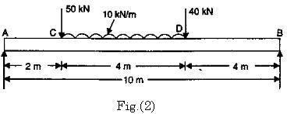
  - A simply supported beam of length 10m, carries the uniformly distributed load and two point loads as shown in Fig.(2) Draw the S.F and B.M diagram for the beam and also calculate the Maximum bending moment

UNIT 3
FLEXURAL & SHEAR STRESSES

Course Objectives:
    - To understand the behavior of beams subjected to shear loads.

Course Outcomes:

    - Evaluate stresses induced in different cross-sectional members subjected to shear loads.

UNIT III
Stresses in Beams
As seen in the last chapter beams are subjected to bending moment and shear forces which vary from section to section. To resist them stresses will develop in the materials of the beam. For the simplicity in analysis, we consider the stresses due to bending and stresses due to shear separately.

Neutral layer
Under compression
Under tension

Neutral axis

- Sagging moment case

Neutral axis
Under tension
Neutral layer
Under compression

- Hogging moment case

Fig. 1. Nature of Stresses in Beams

Due to pure bending, beams sag or hog depending upon the nature of bending moment as shown in Fig. 10.1. It can be easily observed that when beams sag, fibres in the bottom side get stretched while fibres on the top side are compressed. In other words, the material of the beam is subjected to tensile stresses in the bottom side and to compressive stresses in the upper side. In case of hogging the nature of bending stress is exactly opposite, i.e., tension at top and compression at bottom. Thus bending stress varies from compression at one edge to tension at the other edge. Hence somewhere in between the two edges the bending stress should be zero. The layer of zero stress due to bending is called neutral layer and the trace of neutral layer in the cross-section is called neutral axis [Refer Fig. 1].

ASSUMPTIONS
Theory of simple bending is developed with the following assumptions which are reasonably acceptable:
- The material is homogeneous and isotropic.
- Modulus of elasticity is the same in tension and in compression.
- Stresses are within the elastic limit.
- Plane section remains plane even after deformations.
- The beam is initially straight and every layer of it is free to expand or contract.
- The radius of curvature of bent beam is very large compared to depth of the beam.

BENDING EQUATION
There exists a define relationship among applied moment, bending stresses and bending deformation (radius of curvature). This relationship can be derived in two steps:
  - Relationship between bending stresses and radius of curvature.
  - Relationship between applied bending moment and radius of curvature.
- Relationship between bending stresses and radius of curvature: Consider an elemental length AB of the beam as shown in Fig. 2(a). Let EF be the neutral layer and CD the bottom most layer. If GH is a layer at distance y from neutral layer EF, initially AB = EF = GH = CD.

φ

R

A B A′ B′
E′ F′
E G |  | F H

y
G′ H′
C D C′ D′
- (b)

Fig. 2

Let after bending A, B, C, D, E, F, G and H take positions A′, B′, C′, D′, E′, F′, G′ and H′ respectively as shown in Fig. 2(b). Let R be the radius of curvature and φ be the angle subtended by C′ A′ and D′B′ at centre of radius of curvature. Then,
EF = E′F′, since EF is neutral axis
= Rφ ...(i)
Strain in GH = Final length – Initial length
Initial length

= G′ H′ − GH
GH
But GH = EF (The initial length)
= Rφ

and
G′H′ = (R + y) φ

∴ Strain in layer GH =
(R + y) φ − Rφ
Rφ

= y R
Since strain in GH is due to tensile forces, strain in GH = f/E
where f is tensile stress and E is modulus of elasticity.
From eqns. (ii) and (iii), we get

...(ii)

...(iii)

f = y
E R

or f = E

...(1)

y R
- Relationship between bending moment and radius of curvature: Consider an elemental area
δa at distance y from neutral axis as shown in Fig. 3.

Fig. 3
y
From eqn. 1, stress on this element is

f = E R
∴ Force on this element

= E R

y ...(i)

y δa

Moment of resistance of this elemental force about neutral axis
= E y δa y
R
= E y² δa
R
∴ Total moment resisted by the section M′ is given by
∑
M′ = E y ² δa R

= E R
y² δa

From the definition of moment of inertia (second moment of area) about centroidal axis, we know
∑
I = Σy² δa
∴ M′ = E I
R
From equilibrium condition, M = M′ where M is applied moment.
∴ M = E I
R

or M = E
I R
From eqns. (10.1) and (10.2), we get

...(2)

M = f = E I y R

...(3)

where M = bending moment at the section
I = moment of inertia about centroid axis
f = bending stress
y = distance of the fibre from neutral axis
E = modulus of elasticity and
R = radius of curvature of bent section. Equation (3) is known as bending equation.
LOCATING NEUTRAL AXIS
Consider an elemental area δa at a distance y from neutral axis [Ref. Fig. 3].
If ‘f ’ is the stress on it, force on it = f δa
But f = E y, from eqn. (1).
R

∴ Force on the element = E
R

y δa

Hence total horizontal force on the beam
∑
= E y δa R

= E Σy δa R
Since there is no other horizontal force, equilibrium condition of horizontal forces gives
E Σy δa = 0
R

As E R

is not zero,

Σy δa = 0

...(i)

If A is total area of cross-section, from eqn. (i), we get
∑

y δa A

= 0 ...(ii)

Noting that Σyδa is the moment of area about neutral axis, Σyδa should be the distance of
A
centroid of the area from the neutral axis. Hence Σyδa = 0 means the neutral axis coincides with
A
the centroid of the cross-section.

MOMENT CARRYING CAPACITY OF A SECTION From
bending equation, we have
M = f
I y

i.e., f = M
I
y ...(i)

Hence bending stress is maximum, when y is maximum. In other words, maximum stress occurs in the extreme fibres. Denoting extreme fibre distance from neutral fibre as ymax equation (i) will be

M
fmax = I
ymax
...(ii)

In a design fmax is restricted to the permissible stress in the material. If fper is the permissible stress, then from equation (ii),

M
fper = I

ymax

∴ M = I
ymax
fper

The moment of inertia I and extreme fibre distance from neutral axis ymax are the properties of
section. Hence I is the property of the section of the beam. This term is known as modulus of
ymax
section and is denoted by Z. Thus

and

Z = I
ymax
M = fper Z
Note : If moment of inertia has unit mm4 and ymax has mm, Z has the unit mm3.

...(4)

...(5)

The eqn. (5) gives permissible maximum moment on the section and is known as moment carrying capacity of the section. Since there is definite relation between bending moment and the loading given for a beam it is possible to find the load carrying capacity of the beam by equating maximum moment in the beam to moment carrying capacity of the section. Thus
Mmax = fper Z ...(6)
If permissible stresses in tension and compressions are different for a material, moment carrying capacity in tension and compression should be found separately and equated to maximum values of moment creating tension and compression separately to find the load carrying capacity. The lower of the two values obtained should be reported as the load carrying capacity.

SECTION MODULI OF STANDARD SECTIONS
Section modulus expressions for some of the standard sections are presented below:
  - Rectangular section: Let width be ‘b’ and depth be ‘d’ as shown in Fig. 4.

Since N-A is in the mid depth
ymax = d/2

I = 1
12

∴ Z = I

bd ³

=
b

1/12 bd ³ N A
ymax | G | d/2
 |  | d/2

ymax
d / 2

i.e., Z = 1/6 bd² ...(10.7)

Fig. 4

B
  - Hollow rectangular section. Figure 5 shows a typical hollow rectangular section with symmetric opening. For this,
ymax
b
D/2
G
d
D/2

BD³
I =
12
- bd ³
12
= 1 ( BD³
12

bd ³ )
A
N
−

ymax = D/2

I

1 (BD³ − bd ³ )

∴ Z =
ymax
= 12
D / 2

i.e. Z =

- BD³ − bd ³

...(10.8)
Fig. 5

6 D

  - Circular section of diameter ‘d’. Typical section is shown in Fig. 6. For this,

I = π d⁴
64
ymax = d/2
N
d
G

ymax = d/2

I
A

= π/64 d ⁴

∴ Z =
ymax

d /2

Fig. 6

i.e.,
Z = π d³
32

  - Hollow circular tube of uniform section. Referring to Fig. 7,

I = π D⁴ − π d ⁴
64 64
ymax
G
A
d

D
π 4 4 N
= 64 (D – d )
ymax = D/2
∴ I π (D⁴ − d ⁴ )

Z = =
ymax 64
D/ 2
Fig. 7

π D⁴ − d⁴
i.e., Z = 32 D ...(9)
  - Triangular section of base width b and height ‘h’. Referring to Fig. 8,
ymax = 2h/3
G
A
h

bh³

I =

ymax =

∴ Z =

36

- h
3

I
ymax

bh²

= bh³ / 36 N
2/ 3 h

i.e., Z =
24 ...10)
b

Fig. 8

Example 1. A simply supported beam of span 3.0 m has a cross-section 120 mm × 180 mm. If the permissible stress in the material of the beam is 10 N/mm², determine
  - maximum udl it can carry
  - maximum concentrated load at a point 1 m from support it can carry. Neglect moment due to self weight.

Solution:

Here b = 120 mm, d = 180 mm, I = 1
12

bd³, ymax =

d
2
∴ Z = 1 bd ²
6

= 1 × 120 × 180²
6
fper = 10 N/mm²
∴ Moment carrying capacity of the section
= fper × Z

= 648000 mm³

In this case, we know that maximum moment occurs at mid span and is equal to Mmax =
Equating it to moment carrying capacity, we get,
wL²
.
8

= 10 × 648000 N-mm

w/m

- Let maxiwm×um3²udl bea₆m can carry be w/metre length as shown in Fig. 9.
8 × 10 = 10 × 648000

∴ w = 5.76 kN/m.
- Concentrated load at distance 1 m from the sup- port be P kN. Referring to Fig. 10.

3 m

Fig. 9

M = P × a × b = P × 1 × 2 P

max
L

= 2P kN-m
3

= 2P × 10⁶
3
3

N-mm

a = 1m b = 2 m
L = 3 m
Fig. 10

Equating it to moment carrying capacity, we get

2P × 10⁶
3

= 10 × 648000

∴ P = 9.72 kN-m.
Example 2. A circular steel pipe of external diameter 60 mm and thickness 8 mm is used as a simply supported beam over an effective span of 2 m. If permissible stress in steel is 150 N/mm², determine the maximum concentrated load that can be carried by it at mid span.
Solution:
External diameter D = 60 mm Thickness = 8 mm

P = ?
8 mm

60 mmmm

2 m

  - (b)
Fig. 11

∴ Internal diameter
I =
64
= 60 – 2 × 8 = 44 mm.

π (60⁴ – 44⁴) = 452188 mm⁴

ymax = 30 mm.

∴ Z = I = 452188

= 15073 mm³.

ymax 30
Moment carrying capacity
M = fper Z = 150 × 15073 N-mm.
Let maximum load it can carry be P kN.

Then maximum moment = PL
4

= P × 2
4

kN-m

= 0.5 P ×10⁶ N-mm.
Equating maximum bending moment to moment carrying capacity, we get 0.5P × 10⁶ = 150 × 15073
∴ P = 4.52 kN.

Example 3: Figure 12 (a) shows the cross-section of a cantilever beam of 2.5 m span. Material used is steel for which maximum permissible stress is 150 N/mm². What is the maximum uniformly distributed load this beam can carry?
Solution: Since it is a symmetric section, centroid is at mid depth.
I = MI of 3 rectangles about centroid

180 mm
10 mm
10 mm

400 mm
w/m = ?
2 m
10 mm
- (b)

Fig. 12

= 1 × 180 × 10³ + 180 × 10 (200 – 5)²
12
+ 1 × 10 × (400 − 20)³ + 10 × (400 – 20) × 0²
12
+ 1 × 180 × 10³ + 180 × 10 (200 – 5)²
12
= 182.6467 × 10⁶ mm⁴
[Note: Moment of above section may be calculated as difference between MI of rectangle of size 180 × 400 and 170 × 380. i.e.,

I = 1
12

× 180 × 400³ – 1
12
× 170 × 380³

ymax = 200 mm.

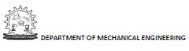
Z = I
∴
ymax
= 182.6467 × 10⁶
200

= 913233 mm³.

∴ Moment carrying capacity
= fper × Z
= 180 × 913233
= 136985000 N-mm.
If udl is w kN/m, maximum moment in cantilever
= wL = 2w kN-mm
= 2w × 10⁶ N-mm
Equating maximum moment to movement carrying capacity of the section, we get 2w × 10⁶ = 136985000
∴ w = 68.49 kN/m
Example 4. Compare the moment carrying capacity of the section given in example 10.3 with equivalent section of the same area but
- square section
- rectangular section with depth twice the width and
- a circular section.
Solution:
Area of the section = 180 × 10 + 380 × 10 + 180 × 10
= 7400 mm²
- Square section
If ‘a’ is the size of the equivalent square section,
a² = 7400 ∴ a = 86.023 mm.
Moment of inertia of this section
= 1 × 86.023 × 86.023³
12

= 4563333 mm⁴

Z = I = 4563333

= 106095.6 mm³

ymax
86.023/2

Moment carrying capacity = fZ = 150 × 106095.6
= 15.914 × 10⁶ N-mm

Moment carrying capacity of I section
∴ Moment carrying capacity of equivalent square section
- Equivalent rectangular section of depth twice the width. Let b be the width
∴ Depth d = 2b.
Equating its area to area of I-section, we get
b × 2b = 7400
b = 60.8276 mm
ymax = d/2 = b = 60.8276

= 136985000
15.914 × 10⁶
= 8.607.

M = f

I
ymax
= 150 × 1
12
× b × (2b)³
b

= 150 × 8
12

b³ = 150 × 8
12

× 60.8276³

= 22506193 N-mm.

Moment carrying capacity of I section
∴ Moment carrying capacity of this section
= 136985000
22506193

= 6.086.

- Equivalent circular section. Let diameter be d.

Then,

πd ²
4 = 7400
d = 97.067

I = π d⁴
64
ymax = d/2

∴ Z = I = π

d ³.

ymax 32

M = fper
Z = 150 × π
32
× 97.067³ = 13468024

∴ Moment carrying capacity of I section = 136985000
= 10.17.

Moment carrying capacity of circular section 13468024

[Note. I section of same area resists more bending moment compared to an equivalent square, rectangular or circular section. Reason is obvious because in I-section most of the area of material is in heavily stressed zone.]
Example 15. A symmetric I-section of size 180 mm × 40 mm, 8 mm thick is strengthened with 240 mm × 10 mm rectangular plate on top flange as shown is Fig. 13. If permissible stress in the material is 150 N/mm², determine how much concentrated load the beam of this section can carry at centre of 4 m span. Given ends of beam are simply supported.
Solution: Area of section A
= 240 × 10 + 180 × 8 + 384 × 8 + 180 × 8 = 8352 mm²
240 mm
10 mm

180 mm

Fig. 13
8 mm thick

400 mm
Let centroid of the section be at a distance y from the bottom most fibre. Then
A y = 240 × 10 × 405 + 180 × 8 × (400 – 4) + 384 × 8 × 200 + 180 × 8 × 4
i.e., 8352 y = 2162400
∴ y = 258.9 mm

I = 1
12

× 240 × 10³ + 240 × 10 (405 – 258.9)²

+ 1 × 180 × 8³ + 180 × 8 (396 – 258.9)²
12

1
+ 12

+ 1
12

× 8 × 384³ + 8 × 384 (200 – 258.9)²

× 180 × 8³ + 180 × 8 (4 – 258.9)²

= 220.994 × 10⁶ mm⁴
∴ ytop = 405 – 258.9 = 146.1 mm
ybottom = 258.9 mm.
∴ ymax = 258.9 mm

∴ Z =
I
ymax
= 220.994 × 10⁶
258.9

= 853588.3

∴ Moment carrying capacity of the section
= fper Z = 150 × 853588.3
= 128038238.7 N-mm
= 128.038 kN-m.
Let P kN be the central concentrated load the simply supported beam can carry. Then max bending movement in the beam

= P × 4
4

= P kN-m

Equating maximum moment to moment carrying capacity, we get
P = 128.038 kN.

Example 6. The cross-section of a cast iron beam is as shown in Fig. 14(a). The top flange is in compression and bottom flange is in tension. Permissible stress in tension is 30 N/mm² and its value in compression is 90 N/mm². What is the maximum uniformly distributed load the beam can carry over a simply supported span of 5 m?
Solution:
Cross-section area A = 75 × 50 + 25 × 100 + 150 × 50
= 13750 mm²
Let neutral axis lie at a distance y from bottom most fibre. Then
Ay = 75 × 50 × 175 + 25 × 100 × 100 + 150 × 50 × 25
13750 × y = 1093750
∴ y = 79.54 mm

75 mm fc
50 mm
100 mm
–y
50 mm

25

150 mm

(a)
Fig. 14
ft

∴ I = 1
12
× 75 × 50³ + 75 × 50 (175 – 79.54)²

+ 1 × 25 × 100³ + 25 × 100 (100 – 79.54)²
12
+ 1 × 150 × 50³ + 150 × 50 (25 – 79.54)²
12
= 61.955493 × 10⁶ mm⁴.
Extreme fibre distances are
y_{bottom} = y = 79.54 mm.
ytop = 200 – y = 200 – 79.54 = 120.46 mm.
Top fibres are in compression. Hence from consideration of compression strength, moment carrying capacity of the beam is given by

M1 = fper in compression ×

61.955493 × 10⁶

I

ytop

= 90 ×

120.46

= 46.289178 × 10⁶ N-mm
= 46.289178 kN-m.
Bottom fibres are in tension. Hence from consideration of tension, moment carrying capacity of the section is given by

M2 = fper in tension ×

I

ybottom

30 × 61.955493 × 10⁶
= 79.54
= 21.367674 × 10⁶ N-mm
= 21.367674 kN-m.
Actual moment carrying capacity is the lower value of the above two values. Hence moment carrying capacity of the section is
= 21.367674 kN-m.
Maximum moment in a simply supported beam subjected to udl of w/unit length and span L is
wL²
=
8
Equating maximum moment to moment carrying capacity of the section, we get maximum load carrying capacity of the beam as
52
w × = 21.367674
8
∴ w = 6.838 kN/m.

SHEAR STRESS DISTRIBUTION

Expression for Shear Stress

Consider an elemental length ‘δx’ of beam shown in Fig. 15 (a). Let bending moment at section A-A be M and that at section B-B be M + δM. Let CD be an elemental fibre at distance y from neutral axis and its thickness be δy. Then,
Bending stress on left side of elemental fibre

= M y
I

M

M + δM

A B

C

D δy y
b

y_{t} δy
y

A B
x δx
- (b)
C D
q
M + δM
I

M yb dy
I

yb dy

C D
(c)

Fig. 15
∴ The force on left side of element
= M y b δy
I
Similarly, force on right side on elemental fibre

= M + δM
I

y bdy

∴ Unbalanced horizontal force on right side of elemental fibre

= M + δM
I

y bδy – M
I

y bδy

= δM I

yb δy

There are a number of such elemental fibres above CD. Hence unbalanced horizontal force on section CD

yt dM
=
j
y I
= jyt dM
y
I
y b δy
y b dy = δM jytyb dy
I
y

Let intensity of shearing stress on element CD be q. [Refer Fig. 15 (c)]. Then equating resisting shearing force to unbalanced horizontal force, we get
q b δx = δM jytyb dy
∴ q = δM 1 jytyb dy
I
y
δx bI
y
As δx → 0, q = dM 1 (a y )
dx bI

where a y = Moment of area above the section under consideration about neutral axis.

But we know dM = F
dx

∴ q = F
bI

(a y ) ...(11)

The above expression gives shear stress at any fibre y distance above neutral axis.

Variation of Shear Stresses Across Standard Sections
Variation of shear stresses across the following three cases are discussed below:
  - Rectangular
  - Circular and
  - Isosceles triangle.
- Rectangular section. Consider the rectangular section of width ‘b’ and depth shown in Fig. 10.18(a). Let A-A be the fibre at a distance y from neutral axis. Let the shear force on the section be F.

Parabolic variation
d/2 A
A
y
d/2
b

qmax = 1.5 qav

  - (b)

Fig. 16

From equation (11), shear stress at this section is

q = F bI

(a y )

where (a y ) is the moment of area above the section about the neutral axis. Now,
a = b(d/2 – y)

y = y + 1
2

(d/2 – y) = 1
2
(d/2 + y)

∴ a y = b
2

= b
2

I = 1
12

(d/2 – y) × 1
2

(d²/4 – y²)

bd³

(d/2 + y)

∴ q = F b
b 1 bd ³ 2
12

(d²/4 – y²)

= 6F
bd ³

(d²/4 – y²)

This shows shear stress varies parabolically. When y = ± d/2, q = 0

At y = 0, q

max

= 6F
bd ³

d 2 = 1.5 F
4 bd

F
where qav = bd
= 1.5 qav
is average shear stress.

Thus in rectangular section maximum shear stress is at neutral axis and it is 1.5 times average shear stress. It varies parabolically from zero at extreme fibres to 1.5 qav at mid depth as shown in Fig. 16(b).
- Circular section. Consider a circular section of diameter ‘d’ as shown in Fig. 17(a) on which a shear force F is acting. Let A-A be the section at distance ‘y’ from neutral axis at which shear stress is to be found. To find moment of area of the portion above A-A about neutral axis, let us consider an element at distance ‘z’ from neutral axis. Let its thickness be dz. Let it be at an angular distance φ and A-A be at angular distance θ as shown in figure.

b/2 b/2

Parabolic variation
dz
A
Z φ
θ
A
y
Ne ax
d
d/2
d/2

utral is
qmax = 4/3 qav

  - (b)

Fig. 17

Width of element b = 2. d
2
cos φ

= d cos φ

∴
∴ Area of the element

z = d
2

dz = d
2
sin φ

cos φ dφ

a = bdz = d cos φ . d
2
cos φ dφ

d 2 2
= 2 cos
φ dφ

Moment of this area about neutral axis
= area × z

d 2 2
= 2 cos
d 3 2

φ dφ

d sin φ
2

= 4 cos
φ sin φ dφ

∴ Moment of area about section A-A about neutral axis

(a y ) =
jπ/ 2 d 2

cos² φ sin φ dφ

d ³ r− cos³ φ yπ/ 2
θ
4

= 4 jL
3 j θ

[Since if cos φ = t, dt = – sin φ dφ and – t³/3 is integration]

d 3 r π y
∴ y
(a ) = j− cos² + cos³ θj
4 × 3 L 2

= d
12

πd ⁴
cos³ θ

Now I =
64

∴ q = F
bI

(a y )

= F × d ³
cos³ θ

d cos θ π d ⁴ 12 64

= 64
12

= 16
3
F
πd ²

F
πd ²
cos² θ

[1 – sin² θ]

16 F r j y 2 y
= 3 πd ² j1 − j d / 2 jj j
L
16 F r 4y² y

= 3 πd ² jL1 −
d 2 j

Hence shear stress varies parabolically.
At y = ± d/2, q = 0

y = 0, q = qmax = 16 3

F
πd ²

= 4 F
3 π/ 4 d ²

= 4 F
3 Area

= 4 q
3

av.

where qav = average shear stress.
Thus in circular sections also shear stress varies parabolically from zero at extreme edges to the
maximum value of 4 qav at mid depth as shown in Fig. 17(b).
3

- Isosceles triangular section. Consider the isosceles triangular section of width ‘b’ and

height ‘h’ as shown in Fig. 18(a). Its centroid and hence neutral axis is at 2h from top
3
fibre. Now shear stress is to be found at section A-A which is at a depth ‘y’ from top fibre.
b′

h/2
qmax = 1.5qav qcentroid = 4/3qav
b
y 2y/3

g
G

h
2h/3
h/3

2h/3
  - (b)

Fig. 18

At A-A width b = y b
h
′

Area above A-A a = 1 2

b′y

= 1 b y2
2 h
Its centroid from top fibre is at 2 y .
3
∴ Distance of shaded area above the section A-A from neutral axis y = 2h − 2 y .

∴ a y = 1 b

3 3
y2 j 2h − 2 y

2 h 3 3 j

=

Moment of inertia of the section

I =

1 b

3 h

bh³
36

y² (h – y)

.

∴ Shear stress at A-A

q = F a y
bI

= F × 1 b

y² (h – y)

y b h
- bh³ 3 h
36

= 12 F
bh ³
Hence at y = 0, q = 0
At y = h, q = 0

At centroid, y = 2h
3

y(h – y)

q = 12 F 2h (h – 2h/3)

bh³ 3
= 8 F = 4 F
3 bh 3 1/ 2 bh

= 4 q
- av
where qav is average shear stress.

For q

max

, dq = 0
dy

i.e., 12 F
bh³

(h – 2y) = 0

i.e., at y = h/2

and hence q

= 12 F . h

(h – h/2)

max
bh³ 2

= 12 F = 3F
- bh bh

= 1.5 F
1/ 2 bh
= 1.5 qav.
Thus in isosceles triangular section shear stress is zero at extreme fibres, it is maximum of 1.5

qav
at mid depth and has a value 4
3
qav
at neutral axis. The variation of shear stress is as shown in

Fig. 18(b).

SHEAR STRESSES IN BUILT-UP SECTIONS

In sections like I, T and channel, shear stresses at various salient points are calculated and the shear stress variation diagram across depth is plotted. It may be noted that at extreme fibres shear stress is zero since (a y ) term works out to be zero. However it may be noted that the procedure explained below is for built up section with at least one symmetric axis. If there is no symmetric axis along the depth analysis for shear stress is complex, and that is treated beyond the scope to this book.

Example 7. Draw the shear stress variation diagram for the I-section shown in Fig. 10.21(a) if it is subjected to a shear force of 100 kN.

180 mm

29.10
10 mm
10 mm
10 mm

400 mm
19.217
1.068

80 mm (a)

Fig. 19

Solution: Due to symmetry neutral axis is at mid depth.

I = 1
12

× 180 × 10³ + 180 × 10 × (200 – 5)²

+ 1 × 10 × 380² + 10 × 380 × (200 –200)²
12

+ 1 × 180 × 10³ + 180 × 10 × (200 – 5)²
12
= 182.646666 × 10⁶ mm⁴
Shear stress at y = 200 mm is zero since a y = 0. Shear stress at bottom of top flange
= F (a y )
bI
= 100 × 1000 × (180 × 10 × 195)
180 × 182.646666 × 10⁶
= 1.068 N/mm²
Shear stress in the web at the junction with flange

= 100 × 1000
10 × 182.646666 × 10⁶
= 19.217 N/mm²

(180 × 10 × 195)

Shear stress at N-A
= 100 × 1000 × jr180 × 10 × 195 + 10 × (200 − 10) × 190 yj

10 × 182.646666 L 2
= 29.10 N/mm².
Symmetric values will be there on lower side. Hence shear stress variation is as shown in Fig. 19(b).
Example 8. A beam has cross-section as shown in Fig. 20(a). If the shear force acting on this is 25 kN, draw the shear stress distribution diagram across the depth.
120 mm
2.9 N/mm2
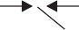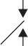29 N/mm2
12 mm
120 mm
12 mm

31.17 N/mm2

    - (b)

Fig. 20
Solution: Let y be the distance of centroid of the section from its top fibre. Then
yt = Moment of area about top fibre
Total area
1 20 × 12 × 6 + (120 − 12) × 12 × j12 + 120 − 12
j2

=

= 34.42 mm
120 × 12 + (120 − 12) × 12

∴ Moment of inertia about centroid

I = 1
12

× 120 × 12³ + 120 × 12 (34.42 – 6)²

1 3 j

108 2

+ × 12 × 108
12
+ 12 × 108 34.42 − 2 j

= 2936930 mm⁴
Shear stresses are zero at extreme fibres. Shear stress at bottom of flange:
Area above this level, a = 120 × 12 = 1440 mm² Centroid of this area above N-A
y = 34.42 – 6 = 28.42 mm
Width at this level b = 120 mm.

∴ qbottom of flange
= 25 × 1000
120 × 2936930
= 2.90 N/mm²

× 1440 × 28.42

Shear stress at the same level but in web, where width b = 12 mm

Shear stress at neutral axis:
= 25 × 1000
12 × 2936930
= 29.0 N/mm²

× 1440 × 28.42

For this we can consider a y term above this section or below this section. It is convenient to consider the term below this level.
a = 12 × (120 – 34.42) = 1026.96 mm²
The distance of its centroid from N-A

= 120 − 34.42 = 42.79 mm.
2

Width at this section b = 12 mm.
∴ q = 25 × 1000
12 × 2936930
= 31.17 N/mm²

× 1026.96 × 42.79

Hence variation of shear stress across the depth is as shown in Fig. 10.22(b).

Example 9. The unsymmetric I-section shown in Fig. 21(a) is the cross-section of a beam, which is subjected to a shear force of 60 kN. Draw the shear stress variation diagram across the depth.
2.61 N/mm2 2
100 mm
20
yt
20 mm
160
20

200 mm
13.03 N/mm
18.37 N/mm2

2.04 N/mm2
150 mm

15.24 N/mm2

- (b)
Fig. 21
Solution: Distance of neutral axis (centroid) of the section from top fibre be yt. Then
100 × 20 × 10 + (200 − 20 − 20) × 20 × j20 + 160
2 j
y = + 150 × 20 × (200 − 10)
^{t} 100 × 20 + 160 × 20 + 150 × 20
= 111 mm

I = 1
12
× 100 × 20³ + 100 × 20 (111 – 10)²

+ 1 × 20 × 160³ + 160 × 20 (111 – 100)²
12
+ 1 × 150 × 20³ + 150 × 20 (111 – 190)²
12

= 46505533 mm⁴
Shear stress at bottom of top flange
= F a y
bI

= 60 × 1000
100 × 46505533
= 2.61 N/mm²
∴ Shear stress at the same level, but in web
= 60 × 1000
20 × 46505533
= 13.03 N/mm²
× 100 × 20 × (111 – 10)

× 100 × 20 (111 – 10)

Shear stress at neutral axis:

a y = a y of top flange + a y of web above N-A

= 100 × 20 × (111 – 10) + 20 × (111 – 20) ×
= 284810 mm³.

111 − 20
2

∴ Shear stress at neutral axis

= F
bI

(a y )

= 60 × 1000
20 × 46505533
= 18.37 N/mm².
Shear stress at junction of web and lower flange:
× 284810

Considering the lower side of the section for finding a y , we get
a y = 150 × 20 × (190 – 111) = 237000 mm³

∴ q = 60 × 1000
20 × 46505533
= 15.28 N/mm²
At the above level but in web, shear stress

× 237000

= 60 × 1000
150 × 46505533
= 2.04 N/mm²

× 237000

At extreme fibres shear stress is zero. Hence variation of shear across the depth of the section is as shown in Fig. 21.

- Bending equation: M =
I
IMPORTANT FORMULAE

f = E .
y R

- Modulus of section Z = I .
ymax
- Moment carrying capacity of section = fper Z.
- Section modulus of various sections:

  - Rectangular: 1 bd² (ii) Hollow rectangular: 1 BD3 − bd 3
6 6 D
(iii) Solid circular section: π d³ (iv) Hollow circular section: π D4 − d 4

32

(v) Solid triangular section: bh2
24

- Shear stress in a beam q = F (ay )
bI
32 D

- In rectangular sections,
qmax = 1.5 qav, at y = d/2
4
In circular sections qmax = 3 qav , at centre

In triangular section, q

max

= 1.5 q

h
_{av}, at y = 2 .

Tutorial Question
- Derive the equation of bending moment and write down the assumptions for theory of simple bending.
- A simply supported beam carries a U.D.L. of intensity 2.5 kN/metre over entire
span of 5 meters. The cross-section of the beam is a T-section having the dimensions Top ange: 125 mm cm X 25 mm
Web: 175 mm cm X25 mm
Calculate the maximum shear stress for the section of the beam.
- A cantilever beam of length 10 m has a cross section of 100 mm X 130 mm has a UDL of 10 KN/m over a length of 8 m from the left support and a concentrated load of 10 KN at the right end. Find the bending stress in the beam
- A beam of T - section is having flange 120mm × 15mm and web 100mm × 15mm. It is subjected to a shear force of 24kN. Draw shear stress distribution across the depth marking values at salient points.
- An I section is having overall depth as 550mm and overall width as 200mm. The thickness of the flanges is 25mm where as the thickness of the web is 20mm. If the section carries a shear force of 45kN, calculate the shear stress values at salient points and draw the sketch showing variation of shear stress.

Assignment Questions

  - An I section beam 350 x 150 mm as shown in Fig. has a web thickness of 10 mm and a flange thickness of 20 mm. If the shear force acting on the section is 40kN, find the maximum shear stress developed in the I section

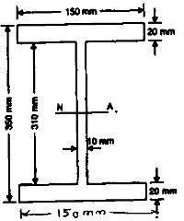
  - A rectangular beam 300 mm deep is simply supported over a span of 4m. Determine the
uniformly distributed load per meter which the beam may carry, if the bending stress should not exceed 120 N/mm². Take I = 8x10⁶ mm⁴.
  - An I-section beam 350mmX200mm has a web thickness of 12.5mm and a flange thickness of 25mm. It carries a shearing force of 200kN at a section. Sketch the shear stress distribution across the section.
  - A rolled steel joist 200mmx160mm wide has flange 22mm thick and web 12mm thick. Find the proportion, in which the flanges and web resist shear force.
  - A simply supported beam of 2m span carries a U.D.L. of 140 kN/m over the whole span. The cross section of the beam is T-section with a flange width of 120mm, web and flange thickness of 20mm and overall depth of 160mm. Determine the maximum shear stress in the beam and draw the shear stress distribution for the section.
  - A simply supported symmetric I-section has flanges of size 200 mmX 15 mm and its overall depth is 520 mm. Thickness of web is 10mm. It is strengthened with a plate of size 250 mm X 12mm on compression side. Find the moment of resistance of the section if permissible stress is 160 M Pa. How much uniformly distributed load it can carry if it is used as a cantilever of span 3.6m.

UNIT 4
DEFLECTION OF BEAMS

Course Objectives:
    - To understand the behavior of beams under complex loading.

Course Outcomes:
    - Evaluate the deflections in beams subjected to different loading conditions.

Deflection of Beam

Methods to compute deflections in beam
      - Double integration method (without the use of singularity functions)
      - Macaulay’s Method (with the use of singularity functions)
      - Moment area method
Assumptions in Simple Bending Theory
        - Beams are initially straight
        - The material is homogenous and isotropic i.e. it has a uniform composition and its mechanical properties are the same in all directions
        - The stress-strain relationship is linear and elastic
        - Young’s Modulus is the same in tension as in compression
        - Sections are symmetrical about the plane of bending
        - Sections which are plane before bending remain plane after bending

Non-Uniform Bending
        - In the case of non-uniform bending of a beam, where bending moment varies from section to section, there will be shear force at each cross section which will induce shearing stresses
        - Also these shearing stresses cause warping (or out-of plane distortion) of the cross section so that plane cross sections do not remain plane even after bending
Elastic line or Elastic curve
We have to remember that the differential equation of the elastic line is

2
d y

EI dx2
=M x

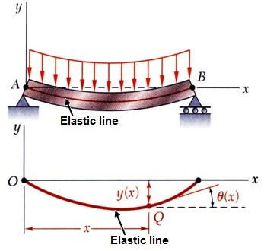
Proof: Consider the following simply supported beam with UDL over its length.
From elementary calculus we know that curvature of a line (at point Q in figure)
d2 y

1 =
R 

dx2
 dy 2 3/2
where R = radius of curvature

1+  dx  

   
For small deflection,

1 d2 y

dy  0 dx

or 
R dx2

Bending stress of the beam (at point Q)
⬧ = (M_{x} ).y
x I
From strain relation we get
1 =  x and  =  x

R y ^{x} E
 1 = Mx R EI
d²y M

Therefore
dx²
= x
EI

or EI
d²y
dx² Mx
=

General expression
d ² y
From the equation EI
dx²
d ⁴ y

= Mx

we may easily find out the following relations.

- EI
dx⁴ d ³ y
= 
Shear force density (Load)

- EI dx3
d ² y
- EI dx2
= Vx

= Mx
Shear force

Bending moment

- dy = θ = slope dx
- y =  = Deflection, Displacement
- Flexural rigidity = EI

Double integration method (without the use of singularity functions)

          - Vx= 
dx

          - Mx = Vx dx
d ² y
          - EI dx2 = Mx

          -  = Slope = 1
⇩
EI

Mxdx

          -  = Deflection =  dx
- step procedure to solve deflection of beam problems by double integration method
Step 1: Write down boundary conditions (Slope boundary conditions and displacement boundary conditions), analyze the problem to be solved
d ² y
Step 2: Write governing equations for, EI dx2 = Mx
Step 3: Solve governing equations by integration, results in expression with unknown integration constants
Step 4: Apply boundary conditions (determine integration constants)

Following table gives boundary conditions for different types of support.

Types of support and Boundary Conditions |  | Figure
Clamped or Built in support or Fixed end :  ( Point A)  Deflection,( y ) = 0  Slope,( ) = 0  Moment, (M )  0 i.e.A finite value |  | 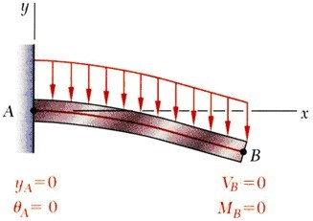
Free end: (Point B)  Deflection, ( y )  0 i.e.A finite value Slope,( )  0 i.e.A finite value Moment, (M ) = 0 |  | 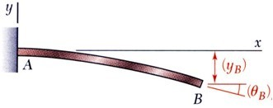
Roller (Point B) or Pinned Support (Point A) or Hinged or Simply supported.  Deflection,( y ) = 0  Slope,( )  0 i.e.A finite value  Moment, (M ) = 0 |  | 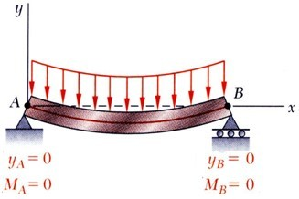
End restrained against rotation but free to deflection  Deflection, ( y )  0 i.e. A finite value  Slope,( ) = 0  Shear force,(V ) = 0 |  | 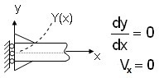
Flexible support  Deflection, ( y )  0 i.e. A finite value  Slope,( )  0 i.e.A finitevalue  Moment,(M ) = k dy  ^{r} dx  Shear force,(V ) = k.y | 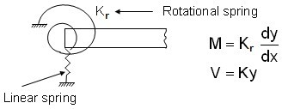

Using double integration method we will find the deflection and slope of the following loaded beams one by one.
  - A Cantilever beam with point load at the free end.
  - A Cantilever beam with UDL (uniformly distributed load)
  - A Cantilever beam with an applied moment at free end.
  - A simply supported beam with a point load at its midpoint.
  - A simply supported beam with a point load NOT at its midpoint.
  - A simply supported beam with UDL (Uniformly distributed load)
  - A simply supported beam with triangular distributed load (GVL) gradually varied load.
  - A simply supported beam with a moment at mid span.
  - A simply supported beam with a continuously distributed load the intensity of which at any
  x 
point ‘x’ along the beam is wx = w sin L 

 

A Cantilever beam with point load at the free end.
We will solve this problem by double integration method. For that at first we have to calculate (Mx). Consider any section XX at a distance ‘x’ from free end which is left end as shown in figure.
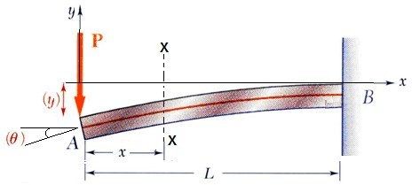
 Mx = - P.x
We know that differential equation of elastic line
d2 y
EI dx2 = Mx = P.x
Integrating both side we get
d2 y
EI dx2 =  P x dx
dy x2

or EI
= P.
dx 2
+ A (i)

Again integrating both side we get
 x2 
EI dy =  P 2 + A  dx

or EIy = -
 
Px3
+
Ax +B (ii)
6

Where A and B is integration constants.
Now apply boundary condition at fixed end which is at a distance x = L from free end and we also know that at fixed end
at x = L, y = 0

at x = L,
dy = 0 dx

from equation (ii) EIL = -
PL3 6
PL2

+ AL +B

.... .....(iii)

from equation (i) EI.(0) = -
+ A …..(iv)
2

Solving (iii) & (iv) we get A =
PL2 2

and B = -
PL3 3

Therefore, y = -
Px3 + PL2 x  PL3 6EI 2EI 3EI

The slope as well as the deflection would be maximum at free end hence putting x = 0 we get
PL3

ymax = -

3EI
(Negative sign indicates the deflection is downward)

PL2

(Slope)max =  max =

2EI

Remember for a cantilever beam with a point load at free end.
PL³

Downward deflection at free end, ( ) =
PL²
❑ =( )
And slope at free end,
2EI

3EI

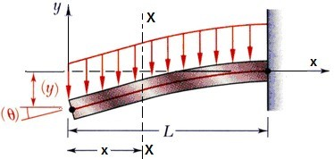
A Cantilever beam with UDL (uniformly distributed load)
We will now solve this problem by double integration method, for that at first we have to calculate (Mx). Consider any section XX at a distance ‘x’ from free end which is left end as shown in figure.

Mx = (w.x).
x =  wx2 2 2

We know that differential equation of elastic line
d2 y wx2
EI dx2 =  2
Integrating both sides we get
d2 y wx2
EI dx2 =   2 dx

or EI
dy wx3
A (i)
=  +
dx 6

Again integrating both side we get

EI dy =  
⇩ 
wx3 6

A  dx
+

 
wx4

or EIy = -
24
+ Ax + B (ii)

[where A and B are integration constants]

Now apply boundary condition at fixed end which is at a distance x = L from free end and we also know that at fixed end.
at x = L, y = 0

at x = L,
dy = 0
dx

-wL3

+wL3

from equation (i) we get EI (0) =
+ A or A =
6 6

from equation (ii) we get EI.y = -

wL4
wL4 24

+ A.L + B

or B = -
8
The slope as well as the deflection would be maximum at the free end hence putting x = 0, we get

ymax = 

(slope)
wL4 8EI
= max =
[Negative sign indicates the deflection is downward] wL3

max
6EI

Remember: For a cantilever beam with UDL over its whole length,
4
( ) = wL
8EI

Maximum deflection at free end

Maximum slope,
( ) = wL
3
6EI

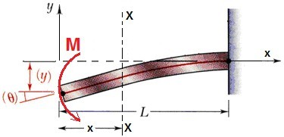
A Cantilever beam of length ‘L’ with an applied moment ‘M’ at free end.
Consider a section XX at a distance ‘x’ from free end, the bending moment at section XX is (Mx) = -M
We know that differential equation of elastic line

d2 y

or EI
dx2
= M

Integrating both side we get
2
d y
or EI dx2 = M dx
or EI dy = Mx + A ...(i)
dx

Again integrating both side we get
EI dy =  (M x +A) dx
Mx2
or EI y =  + Ax + B ...(ii)
2
Where A and B are integration constants.
applying boundary conditions in equation (i) &(ii)

at x = L,
dy = 0 gives A = ML dx

at x = L, y = 0 gives B =
ML2
– ML2
=  ML2

2 2
Mx2

MLx ML2

Therefore deflection equation is y = - Which is the equation of elastic curve.
( )
=
ML²
2EI

Maximum deflection at free end


( ) = ML
EI
Maximum slope at free end
+ 
2EI EI 2EI

(It is downward)

Let us take a funny example: A cantilever beam AB of length ‘L’ and uniform flexural rigidity EI has a bracket BA (attached to its free end. A vertical downward force P is applied to free end C of the bracket. Find the ratio a/L required in order that the deflection of point A is zero.
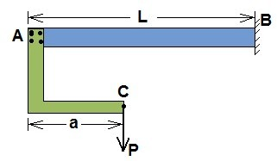
We may consider this force ‘P’ and a moment (P.a) act on free end A of the cantilever beam.

Due to point load ‘P’ at free end ‘A’ downward deflection ( ) =
PL3 3EI

Due to moment M = P.a at free end ‘A’ upward deflection ( ) =
ML2
= (P.a)L2

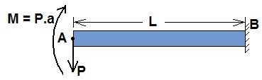
2EI 2EI
For zero deflection of free end A

PL3 3EI
(P.a)L2
=
2EI

or a = 2
L 3

A simply supported beam with a point load P at its midpoint.
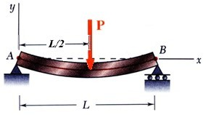
A simply supported beam AB carries a concentrated load P at its midpoint as shown in the figure.
We want to locate the point of maximum deflection on the elastic curve and find its value.
In the region 0 < x < L/2
Bending moment at any point x (According to the shown co-ordinate system)
Mx =  P .x
 2 
 
and In the region L/2 < x < L
Mx = P (x  L / 2)
2
We know that differential equation of elastic line
d2 y P

EI = .x
dx2 2
Integrating both side we get
d2 y P
⇩ 
or EI dx2 = 2 x dx
dy P x2
(In the region 0 < x < L/2)

or EI = . + A (i)
dx 2 2
Again integrating both side we get

EI dy =
 P x2 + 

⇩   4
A  dx

or EI y =
 
Px3
+
Ax + B (ii)
12

[Where A and B are integrating constants]

Now applying boundary conditions to equation (i) and (ii) we get
at x = 0, y = 0

at x = L/2,

PL²
dy = 0 dx

A = - and B = 0 16



Px3 PL12

Equation of elastic line, y = - x
12 16

Maximum deflection at mid span (x = L/2) ( )=
PL²
❑ =( )
at each end
and maximum slope
16EI

PL³ 48EI

A simply supported beam with a point load ‘P’ NOT at its midpoint.
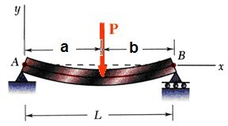
A simply supported beam AB carries a concentrated load P as shown in the figure.
We have to locate the point of maximum deflection on the elastic curve and find the value of this deflection. Taking co-ordinate axes x and y as shown below
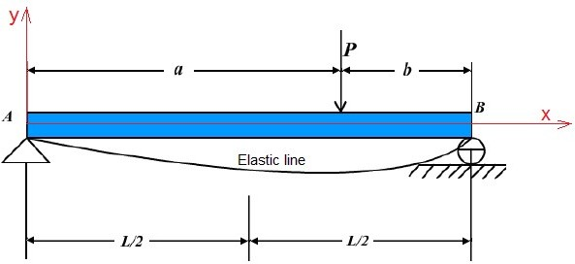

For the bending moment we have

In the region 0  x  a, M

=  P.a .x

x  L 

And, In the region a  x  L, Mx
 
=  P.a (L - x)
L

So we obtain two differential equation for the elastic curve. d2 y P.a

EI dx2 =
.x for 0  x  a
L

d2 y P.a

and EI = 
dx2
.(L - x)
L
for a  x  L

Successive integration of these equations gives
dy P.a x2

EI =
dx
L . 2 + A1
......(i) for o  x  a

EI dy =P.a x - P.a x2 + A ......(ii) for a  x  L

dx L 2
P.a x3

EI y = . +A x+B
L 6 1 1
......(iii) for 0  x  a

x2 P.a x3

EI y =P.a 
2
L . 6 + A2 x + B2 .....(iv) for a  x  L

Where A1, A2, B1, B2are constants of Integration.
Now we have to use Boundary conditions for finding constants:
BCS (a) at x = 0, y = 0
- at x = L, y = 0
- at x = a,  dy  = Same for equation (i) & (ii)
 dx 
 
- at x = a, y = same from equation (iii) & (iv)
( )

We get
A = Pb L²  b² ; A
1 6L 2
( )
= P.a 2L² + a² 6L

and B = 0; B = Pa3 / 6EI
1 2
Therefore we get two equations of elastic curve

EI y = -
Pbx L2  b2  x2 6L
..... (v) for 0  x  a

EI y =
( )
Pb  L  (x - a)3 + (L2  b2 ) x - x3  . ...(vi) for a  x  L

  
6L b
  
For a > b, the maximum deflection will occur in the left portion of the span, to which equation (v) applies. Setting the derivative of this expression equal to zero gives

x = = =
a(a+2b)
3
(L-b)(L+b)
3
L²  b²
3

at that point a horizontal tangent and hence the point of maximum deflection substituting this value of x
P.b(L²  b² )^{3/2}
9 3. EIL

into equation (v), we find,

Case –I: if a = b = L/2 then
ymax =

Maximum deflection will be at x =
L²  (L/2)2
3
= L/2

i.e. at mid point
P.(L/2) {L
– (L/2) }

PL³

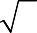and y_{max} = ( ) = =
9 3 EIL
2
2
3/ 2
48EI

A simply supported beam with UDL (Uniformly distributed load)
A simply supported beam AB carries a uniformly distributed load (UDL) of intensity w/unit length over its whole span L as shown in figure. We want to develop the equation of the elastic curve and find the maximum deflection  at the middle of the span.
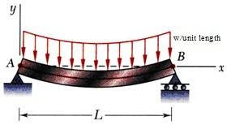
Taking co-ordinate axes x and y as shown, we have for the bending moment at any point x
wL x2

Mx =
.x - w.
2 2

Then the differential equation of deflection becomes
d2 y wL x2

EI dx2 = Mx =
.x - w.
2 2

Integrating both sides we get
dy wL x2 w x3
EI = .  . + A (i)
dx 2 2 2 3
Again Integrating both side we get

EI y =
wL . x
– w . x

+ Ax + B

.....(ii)

2 6 2 12
3
4
Where A and B are integration constants. To evaluate these constants we have to use boundary conditions. at x = 0, y = 0 gives B = 0

at x = L/2,
dy = 0
dx
wL3
gives A = 
24

Therefore the equation of the elastic curve

y = wL
3  w
4  wL3
wx ⬆ 3 

2 + 3 

.x
12EI
.x
24EI
12EI
.x = L
24EI

2L.x x ✗

The maximum deflection at the mid-span, we have to put x = L/2 in the equation and obtain

Maximum deflection at mid-span, (It is downward)
4
( ) = 5wL
384EI

And Maximum slope A = B at the left end A and at the right end b is same putting x = 0 or x = L Therefore
3
( ) = wL
24EI

we get Maximum slope

A simply supported beam with triangular distributed load (GVL) gradually varied load.
A simply supported beam carries a triangular distributed load (GVL) as shown in figure below. We have to find equation of elastic curve and find maximum deflection ( ) .
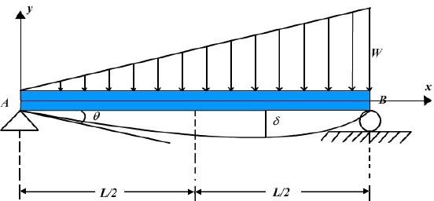

In this (GVL) condition, we get

EI

4
load =  .x
d y = w

.....(i)

dx4 L
Separating variables and integrating we get
d3 y wx2

EI dx3 = (Vx ) = 
+ A (ii)
2L

Again integrating thrice we get
d2 y wx3

EI dx2 =Mx =  6L + Ax +B
.....(iii)

EI dy
wx4 Ax2
=  + +Bx +C

.....(iv)

dx 24L 2
wx5 Ax3 Bx2

EI y = 
+ + + Cx +D (v)
120L 6 2

Where A, B, C and D are integration constant.
Boundary conditions at x = 0, Mx = 0, y = 0
at x = L, Mx = 0, y = 0 gives

A = wL ,
6

B = 0,

C = -
7wL3
360

, D = 0

Therefore y = -
wx 360EIL
{7L⁴  10L²x² + 3x⁴}

(negative sign indicates downward deflection)

To find maximum deflection  , we have dy = 0
dx


wL4

And it gives x = 0.519 L and maximum deflection (
) = 0.00652
EI

A simply supported beam with a moment at mid-span
A simply supported beam AB is acted upon by a couple M applied at an intermediate point distance ‘a’ from the equation of elastic curve and deflection at point where the moment acted.
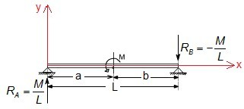

Considering equilibrium we get R
= M and R = M

A L B L

Taking co-ordinate axes x and y as shown, we have for bending moment

In the region

In the region
0  x  a, Mx

a  x  L, Mx
= M.x L

= M x - M L

So we obtain the difference equation for the elastic curve
for 0 x a
d2 y M EI dx2 = L .x
d2 y M

and EI
dx2
= .x  M for a  x  L L

Successive integration of these equation gives
dy M x2

EI = .
dx L 2
+ A1
....(i) for 0  x  a

dy M x2

EI = =
dx L
- - Mx+ A2
.....(ii) for a  x  L

M x3

and EI y = . L
⬧ + A1x + B1
......(iii) for 0  x  a

M x3 Mx2

EI y =
L
⬧  2
+ A2 x + B2
......(iv) for a  x  L

Where A1, A2, B1 and B2 are integration constants.
To finding these constants boundary conditions
- at x = 0, y = 0
- at x = L, y = 0
- at x = a,  dy  = same form equation (i) & (ii)
 dx 
 
- at x = a, y = same form equation (iii) & (iv)
ML Ma2 ML Ma2

A1 = M.a +
+
- 2L
, A2 =
+
3 2L

B1 = 0, B2 =
Ma2 2

With this value we get the equation of elastic curve
y = - Mx 6aL - 3a2  x2  2L2 6L
{ }
 deflection of x = a,

for 0  x  a

y = Ma 3aL - 2a2  L2 3EIL
{ }

A simply supported beam with a continuously distributed load the intensity

of which at any point ‘x’ along the beam is
w = wsin   x 

x  
L
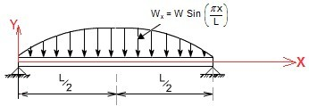
 
At first we have to find out the bending moment at any point ‘x’ according to the shown co-ordinate system.
We know that

d(Vx ) = w sin  x 
dx  L 
 
Integrating both sides we get
d(V ) =  w sin  x  dx +A
⇩ x   L 
 
or V = + wL .cos  x  + A
L
❐
x  
 
and we also know that

d(M_{x} ) = V

= wL cos  x  + A

dx ^{x} 
 L 

 
Again integrating both sides we get

d(M ) =
wL cos  x  + 

A dx

⇩ x   
 L  

or Mx =
wL²
❐ 2
   
sin   x  + Ax +B
 L 
 

Where A and B are integration constants, to find out the values of A and B. We have to use boundary conditions
at x = 0, Mx = 0
and at x = L, Mx = 0
wL²   x 
From these we get A = B = 0. Therefore Mx =  2 sin L 
 
So the differential equation of elastic curve
d2 y wL2   x 
EI dx2 = Mx =  2 sin L 
 
Successive integration gives

dy wL3
  x 

EI = 
dx  3
cos  + C (i)
 
L

EIy
=  wL4
❐ 4
sin  x  + Cx + D (ii)
 
 L 

Where C and D are integration constants, to find out C and D we have to use boundary conditions at x = 0, y = 0
at x = L, y = 0 and that give C = D = 0

dy wL3
  x 

Therefore slope equation
EI = 
dx  3
cos L 

 
wL4   x 
 

and Equation of elastic curve
y =   4EI sin L 
(-ive sign indicates deflection is downward)

Deflection will be maximum if sin   x  is maximum
 
L
 

sin   x  = 1 or x = L/2
 L 
 
 WL4

and Maximum downward deflection ( ) =

Macaulay's Method
❐ 4EI
(downward).

- When the beam is subjected to point loads (but several loads) this is very convenient method for determining the deflection of the beam.
- In this method we will write single moment equation in such a way that it becomes continuous for entire length of the beam in spite of the discontinuity of loading.
- After integrating this equation we will find the integration constants which are valid for entire length of the beam. This method is known as method of singularity constant.

Procedure to solve the problem by Macaulay’s method
Step – I: Calculate all reactions and moments
Step – II: Write down the moment equation which is valid for all values of x. This must contain brackets.
Step – III: Integrate the moment equation by a typical manner. Integration of (x-a) will be

(x-a)2
2
 x²
not  2
– ax  and integration of (x-a)2 will be
(x-a)3
so on.
3

 

Step – IV: After first integration write the first integration constant (A) after first terms and after second time integration write the second integration constant (B) after A.x . Constant A and B are valid for all values of x.
Step – V: Using Boundary condition find A and B at a point x = p if any term in Macaulay’s method, (x-a) is negative (-ive) the term will be neglected.

(i) Let us take an example: A simply supported beam AB length 6m with a point load of 30 kN is applied at a distance 4m from left end A. Determine the equations of the elastic curve between each change of load point and the maximum deflection of the beam.
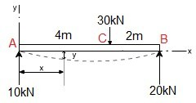
Answer: We solve this problem using Macaulay’s method, for that first writes the general momentum equation for the last portion of beam BC of the loaded beam.
d2 y
EI dx2 = Mx = 10x -30 (x - 4) N.m (i)
By successive integration of this equation (using Macaulay’s integration rule
(x  a)2
e.g  (x  a) dx = 2 )
We get

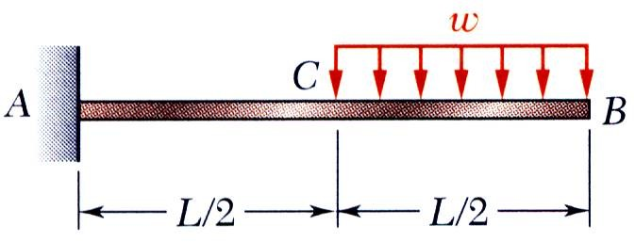
Example:

For the beam and loading shown, determine the slope and deflection at point B.

Superpose the deformations due to Loading I and Loading II as shown.
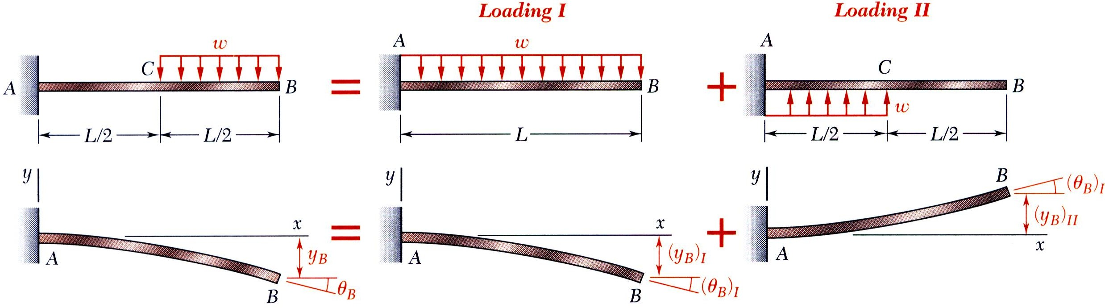
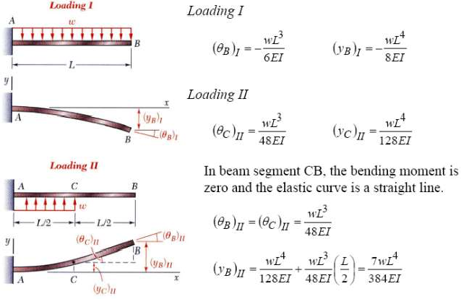

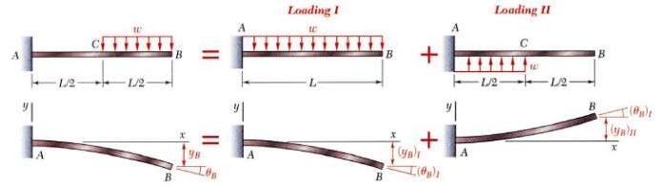
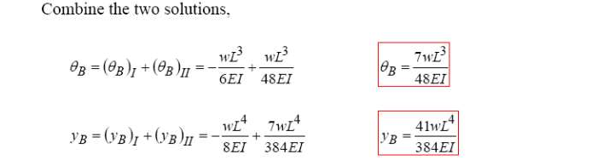

Tutorial Questions

- A cantilever 3m long has moment of inertia 800 Cm⁴ for 1m length from the free end, 1600 cm⁴ for the next 1m length 2400 Cm⁴ for the last 1m. length. At the free
end a load of 1 KN acts on the cantilever. Determine the slope and deflections at the free end of the cantilever E= 210 GN/ m2
- A simply supported beam of span 6m carries two point loads of 60KN and 50KN at 1m and 3m respectively from the left end. Find the position and magnitude of max. deflection. Take E= as 200 GPa and I =8500cm⁴. Also determine the value of deflection at the same point if one more load of 60KN is placed over the left support.
- A beam AB of 8 m span is simply supported at the ends. It carries a point load of 10 kN at a distance of 1 m from the end A and a uniformly distributed load of 5 kN/m for a length of 2 m from the end B. If I = 10 _ 106 m4, Using Macaulay`s Method, Determine:
  - Deection at the mid-span,
  - Maximum deection, and
  - Slope at the end A.
- A simply supported beam of span 6m carries two point loads of 60KN and 50KN at 1m and 3m respectively from the left end. Find the position and magnitude of max. deflection. Take E= as 200 GPa and I =8500cm⁴. Also determine the value of deflection at the same point if one more load of 60KN is placed over the left support.
- A simply supported beam of 8m carries a partial u d l of intensity 5KN/m and length 2m, sarting from 2m from the left end. Find slope at left support and central deflection. Take E= 200Gpa and I=8×10⁸mm⁴

Assignment Questions

- A simply supported beam of 8m carries a partial u d l of intensity 5KN/m and length 2m, sarting from 2m from the left end. Find slope at left support and central deflection. Take E= 200Gpa and I=8×10⁸mm⁴
- A simply supported beam span 14m, carrying concentrated loads of 12KN and 8KN at two points 3mts and 4.5m from the two ends respectively. Moment of Inertia I for the beam is 160 x10³ mm⁴ and E = 210KN/mm². Calculate deflection of the beam at points under the two loads by macaulay’s method
- A Cantilever beam AB 6 mts long is subjected to u.d.l of w KN/m spread over the entire length. Assume rectangular cross-section with depth equal to twice the breadth. Determine the minimum dimension of the beam so that the vertical deflection at free end does not exceed 1.5 cm and the maximum stress due to bending does not exceed 10 KN/cm². E = 2 X 10⁷ N/ cm².
- A beam section is 10m long and is simply supported at ends. It carries concentrated loads of100kN and 60kN at a distance of 2m and 5m respectively from the left end. Calculate the deflection under the each load find also the maximum deflection. Take I = 18 X 10⁸mm⁴ and E = 200kN/mm².
- A simply supported beam of span 6m carries two point loads of 60KN and 50KN at 1m and 3m respectively from the left end. Find the position and magnitude of max. deflection. Take E= as 200 GPa and I =8500cm⁴. Also determine the value of deflection at the same point if one more load of 60KN is placed over the left support.

UNIT 5
TORSION OF CIRCULAR SHAFTS &THIN CYLINDERS

Course Objectives:

  - To analyze the cylindrical shells under circumferential and radial loading

Course Outcomes:

  - Analyze the thin cylindrical shells.

Unit v

Torsion of Circular Shafts
The product of this turning force and the distance between the point of application of the force and the axis of the shaft is known as torque, turning moment or twisting moment. And the shaft is said to be subjected to torsion. Due to this torque, every cross-section of the shaft is subjected to some shear stress.

Assumptions for Shear Stress in a Circular Shaft Subjected to Torsion

- The material of the shaft is uniform throughout.
- The twist along the shaft is uniform.
- Normal cross-sections of the shaft, which were plane and circular before the twist, remain plane and circular even after the twist.
- All diameters of the normal cross-section, which were straight before the twist, remain straight with their magnitude unchanged, after the twist.

Torsional Stresses and Strain
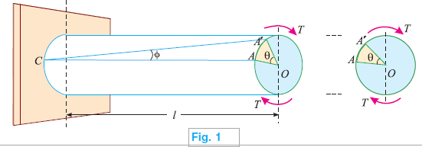

Consider a circular shaft fixed at one end and subjected to a torque at the other end as shown in Fig.1

T = Torque in N-mm,

l = Length of the shaft in mm and

R = Radius of the circular shaft in mm.

As a result of this torque, every cross-section of the shaft will be subjected to shear stresses. Let the line CA on the surface of the shaft be deformed to CA′ and OA to OA′ as shown in Fig.1

∠ACA′ = φ in degrees

∠AOA′ = θ in radians

τ = Shear stress induced at the surface and

C = Modulus of rigidity, also known as torsional rigidity of the shaft material.

We know that shear strain = Deformation per unit length

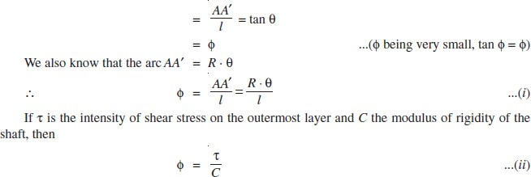

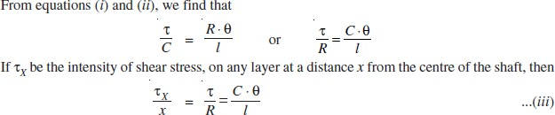

Strength of a Solid Shaft
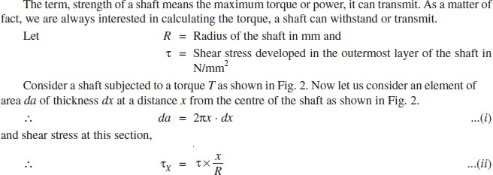

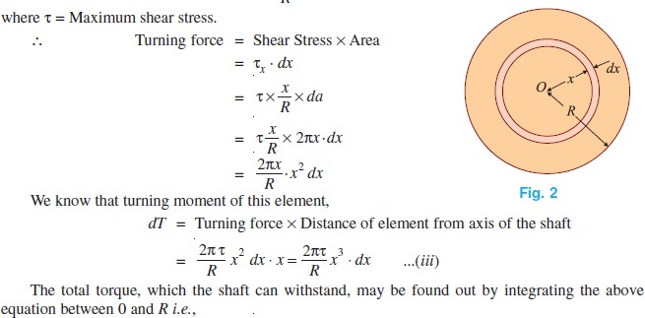
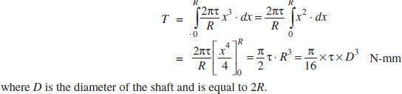
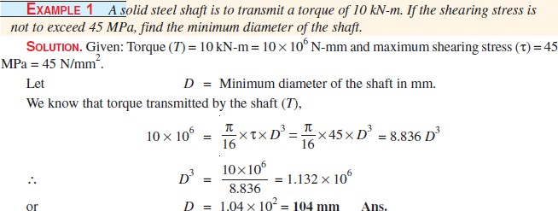

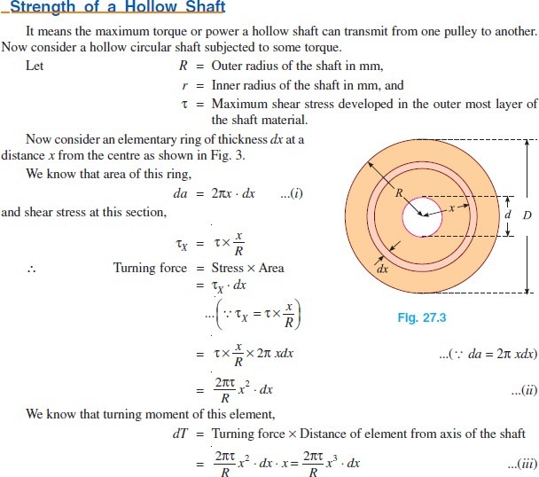

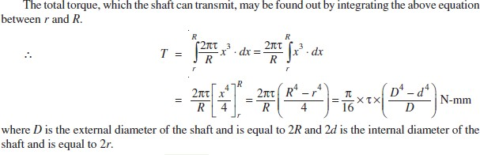

Power Transmitted by a Shaft

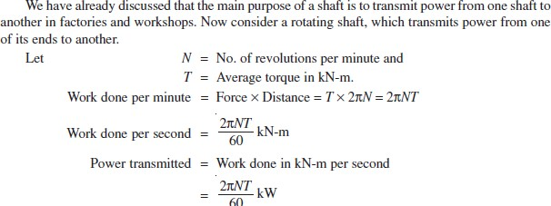
Example 2: A hollow shaft is to transmit 200 kW at 80 r.p.m. If the shear stress is not to exceed 60 MPa and internal diameter is 0.6 of the external diameter, find the diameters of the shaft.
SOLUTION. Given : Power (P) = 200 kW ; Speed of shaft (N) = 80 r.p.m. ; Maximum shear stress (τ) = 60 MPa = 60 N/mm2 and internal diameter of the shaft (d) = 0.6D (where D is the external diameter in mm).
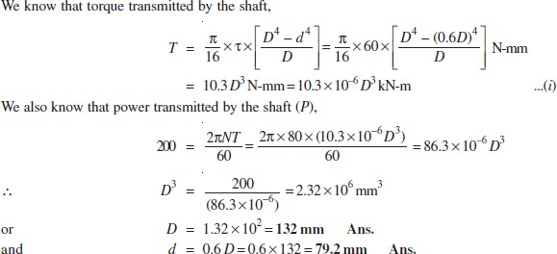

Polar Moment of Inertia
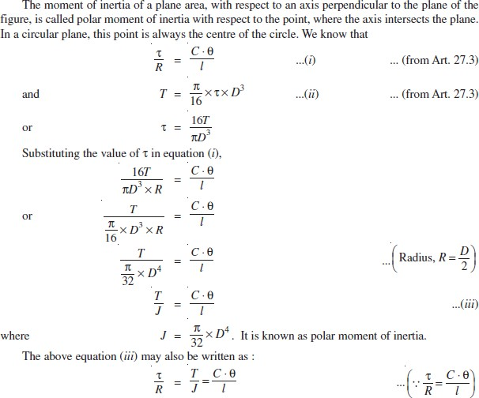

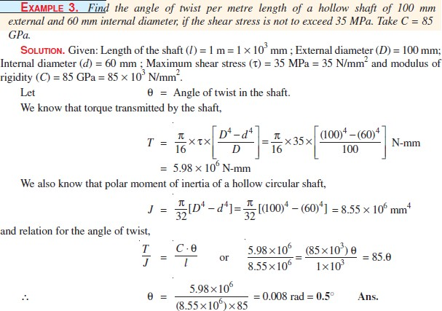
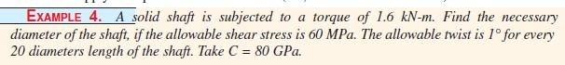

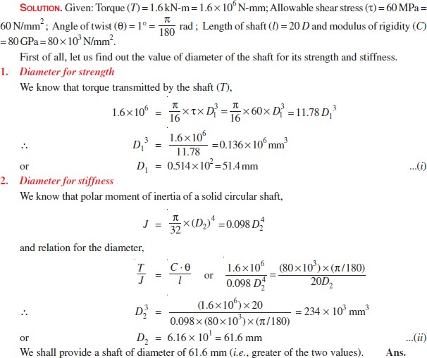
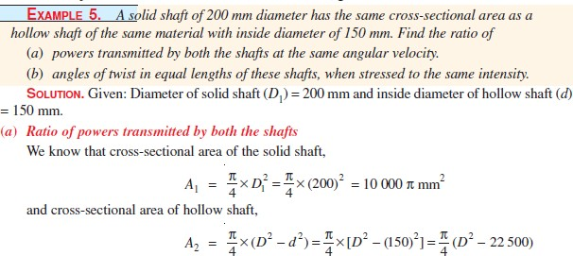

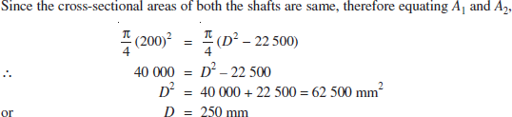

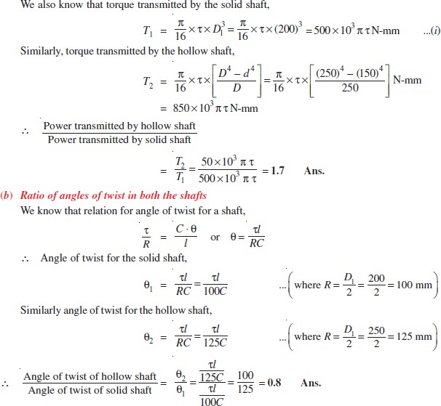

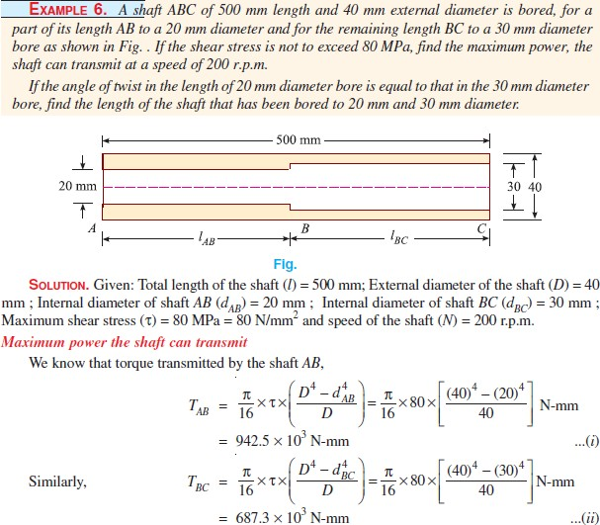

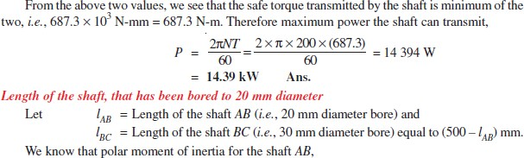

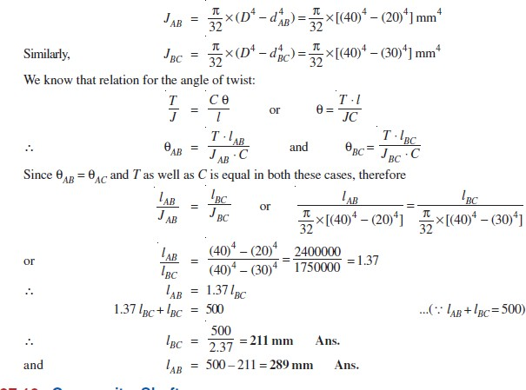

Thin Cylinders
In general, if the thickness of the wall of a shell is less than 1/10th to 1/15th of its diameter, it is known as a thin shell.
Stresses in a Thin Cylindrical Shell
The walls of the cylindrical shell will be subjected to the following two types of tensile stresses:
- Circumferential stress
- Longitudinal stress.

Circumferential Stress

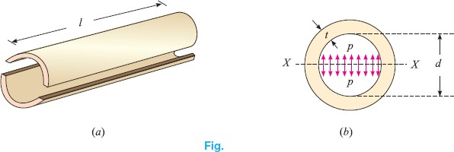

Consider a thin cylindrical shell subjected to an internal pressure as shown in Fig.(a) and (b). We know that as a result of the internal pressure, the cylinder has a tendency to split up into two troughs as shown in the figure.
Let l= Length of the shell

d = Diameter of the shell,

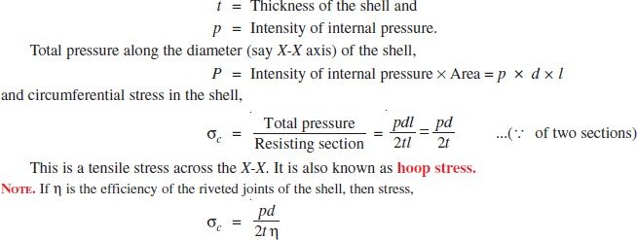

Longitudinal Stress
Consider the same cylindrical shell, subjected to the same internal pressure as shown in Fig.
- and (b). We know that as a result of the internal pressure, the cylinder also has a tendency to split into two pieces as shown in the figure.
Let p = Intensity of internal pressure, l = Length of the shell,
d = Diameter of the shell and t = Thickness of the shell.

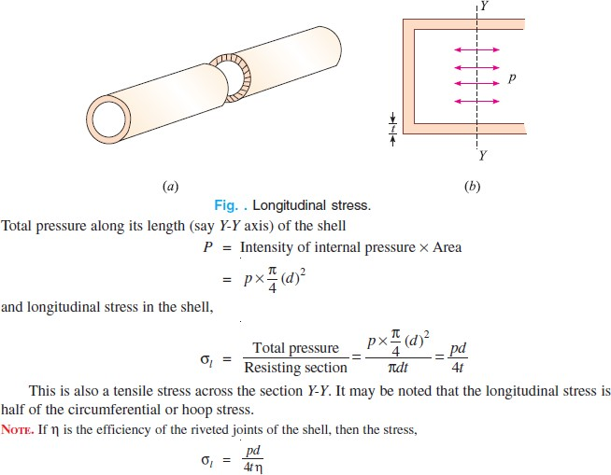

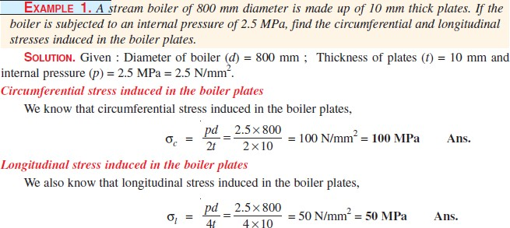

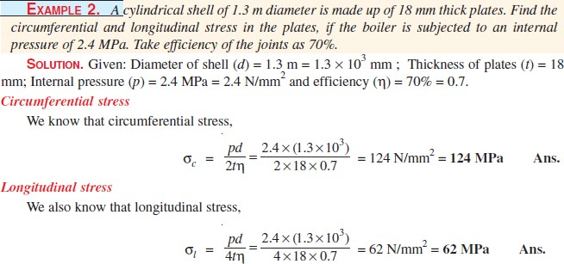
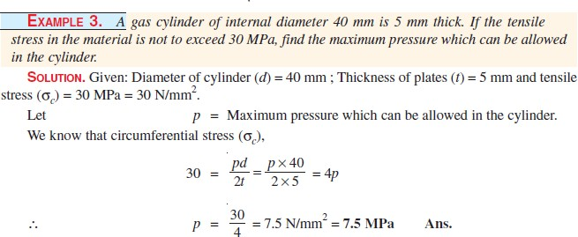

Change in Dimensions of a Thin Cylindrical Shell due to an Internal Pressure
Thin cylindrical shell subjected to an internal pressure, its walls will also be subjected to lateral strain. The effect of the lateral strains is to cause some change in the dimensions (i.e., length and diameter) of the shell. Now consider a thin cylindrical shell subjected to an internal pressure.
Let l = Length of the shell,

d = Diameter of the shell,

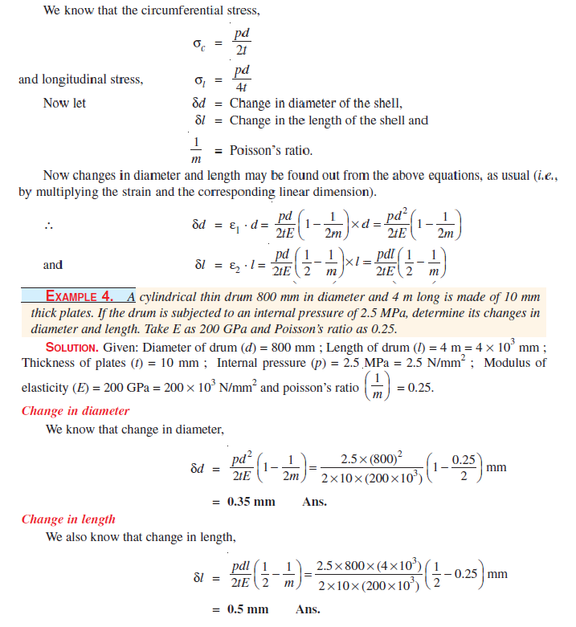
t = Thickness of the shell and p = Intensity of the internal pressure.
Change in Volume of a Thin Cylindrical Shell due to an Internal Pressure

A little consideration will show that increase in the length and diameter of the shell will also increase its volume. Now consider a thin cylindrical shell subjected to an internal
pressure.

Let l = Original length

d = Original diameter,

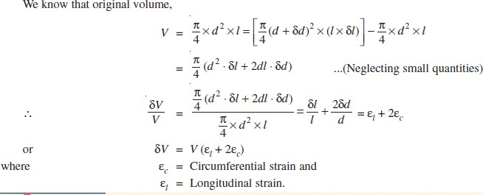
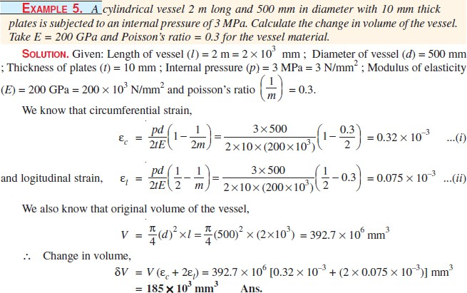
δl = Change in length due to pressure and δd = Change in diameter due to pressure.

Tutorial Questions

- Derive an expression for the shear stress produced in a circular shaft which is subjected to torsion. What are the assumptions made in the above derivation ?
- a)Derive the formula for the hoop stress in a thin cylindrical shell subjected to an internal pressure.
b) A gas cylinder of thickness 25 mm and has an internal diameter of 1500 mm. The tensile stress in the gas cylinder material is not to exceed 100 N/mm2. Calculate the allowable internal pressure of the gas inside the cylinder.
- A thin cylindrical shell is 3m long and 1m in internal diameter. It is subjected to internal pressure of 1.2 MPa. If the thickness of the sheet is 12mm, find the circumferential stress, longitudinal stress, changes in diameter, length and volume. Take E=200 GPa and μ= 0.3.
- A Hollow shaft is to transmit 400 KW power at 120 rpm. If the shear stress is not exceed 60 N/mm² and internal diameter is 0.65 of external diameter. Find the internal and external diameters assuming maximum torque is 1.5 times the mean
- A hollow shaft of diameter ratio 3/8 is to transmit 395 kW at 120 rpm. The maximum torque being 24% greater than the mean, the shear stress is not to exceed 65 MPa and the twist in a length of 6 m is not to exceed 3 degrees. Calculate its external and internal diameters which
4
would satisfy both the above said conditions. Take G=9.2×10 MPa.

Assignment Questions

- A cylindrical vessel 2m long and 500mm in diameter with 10mm thick plates is subjected to an internal pressure of 3MPa.Calculate the change in volume of the vessel .Take E=200GPa and poissons ratio=0.3 for the vessel material.
- A shaft is to be transmitted 100KW at 240 rpm. If the allowable shear stresses of the material is 60MPa. The shaft is not to twist more than 1⁰ in a length of 3.5 mts. Find the diameter of the shaft based on strength and stiffness criteria. The modulus of rigidity of the material (N) is 80 X 10³N/mm².
- A cylindrical vessel 3m long and 500mm in diameter with 10mm thick plates is subjected to an internal pressure of 3MPa.Calculate the change in volume of the vessel .Take E=210GPa and Poisson’s ratio=0.3 for the vessel material
- A thin cylindrical shell is 3m long and 1m in internal diameter. It is subjected to internal pressure of 1.2 MPa. If the thickness of the sheet is 12mm, find the circumferential stress, longitudinal stress, changes in diameter, length and volume. Take E=200 GPa and μ= 0.3.
- A thin cylindrical shell is 3m long and 1m in internal diameter. It is subjected to internal pressure of 1.2 MPa. If the thickness of the sheet is 12mm, find the circumferential stress, longitudinal stress, changes in diameter, length and volume. Take E=200 GPa and μ= 0.3.
- A hallow shaft of outside diameter 80 mm and inside diameter 50 mm is made of aluminium having shear modulus G = 27GPa. When the shaft is subjected to a torque T = 4.8 kN-m, what is the maximum shear strain and maximum normal strain in the bar?

